Requesting an Amendment (UR Contract) | Virtual Gateway Customer Service  1-800-421-0938
Authorized personnel can request an amendment through EIM to adjust a rate schedule or client capacity limit.  To request an amendment:  - Select the Contracts module.  The Contracts Search page appears.  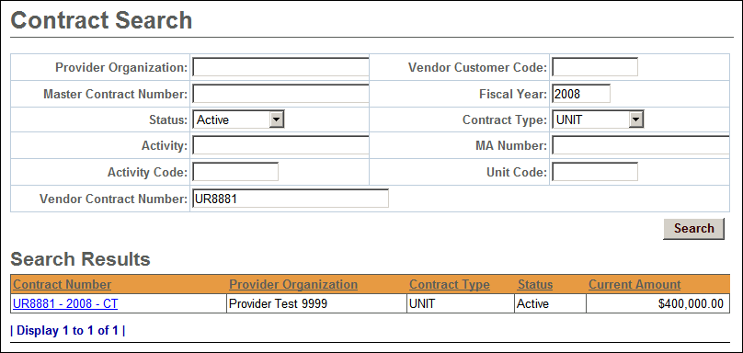  - Enter search criteria for identified contract.  - Click .  The search results appear below.  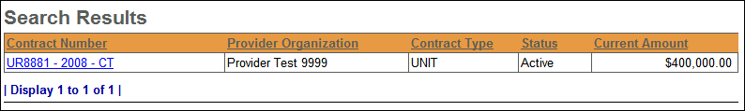  - Click the Contract Number link.  The Contracts Summary page appears. | - Select Request Amendment from the navigation bar.  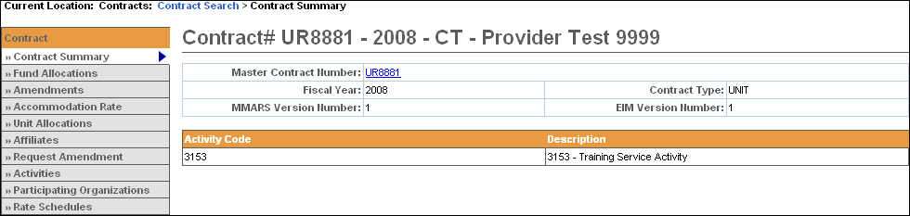  - Select a Budget Number from the drop down box; click Select.  The Request Amendment page appears.  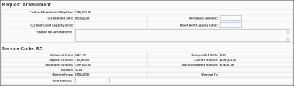  - Enter amendment information, including a reason for the amendment.  - Click.  The Amendment page appears with a confirmation message displaying. Notification is sent to designated agency staff by email.

