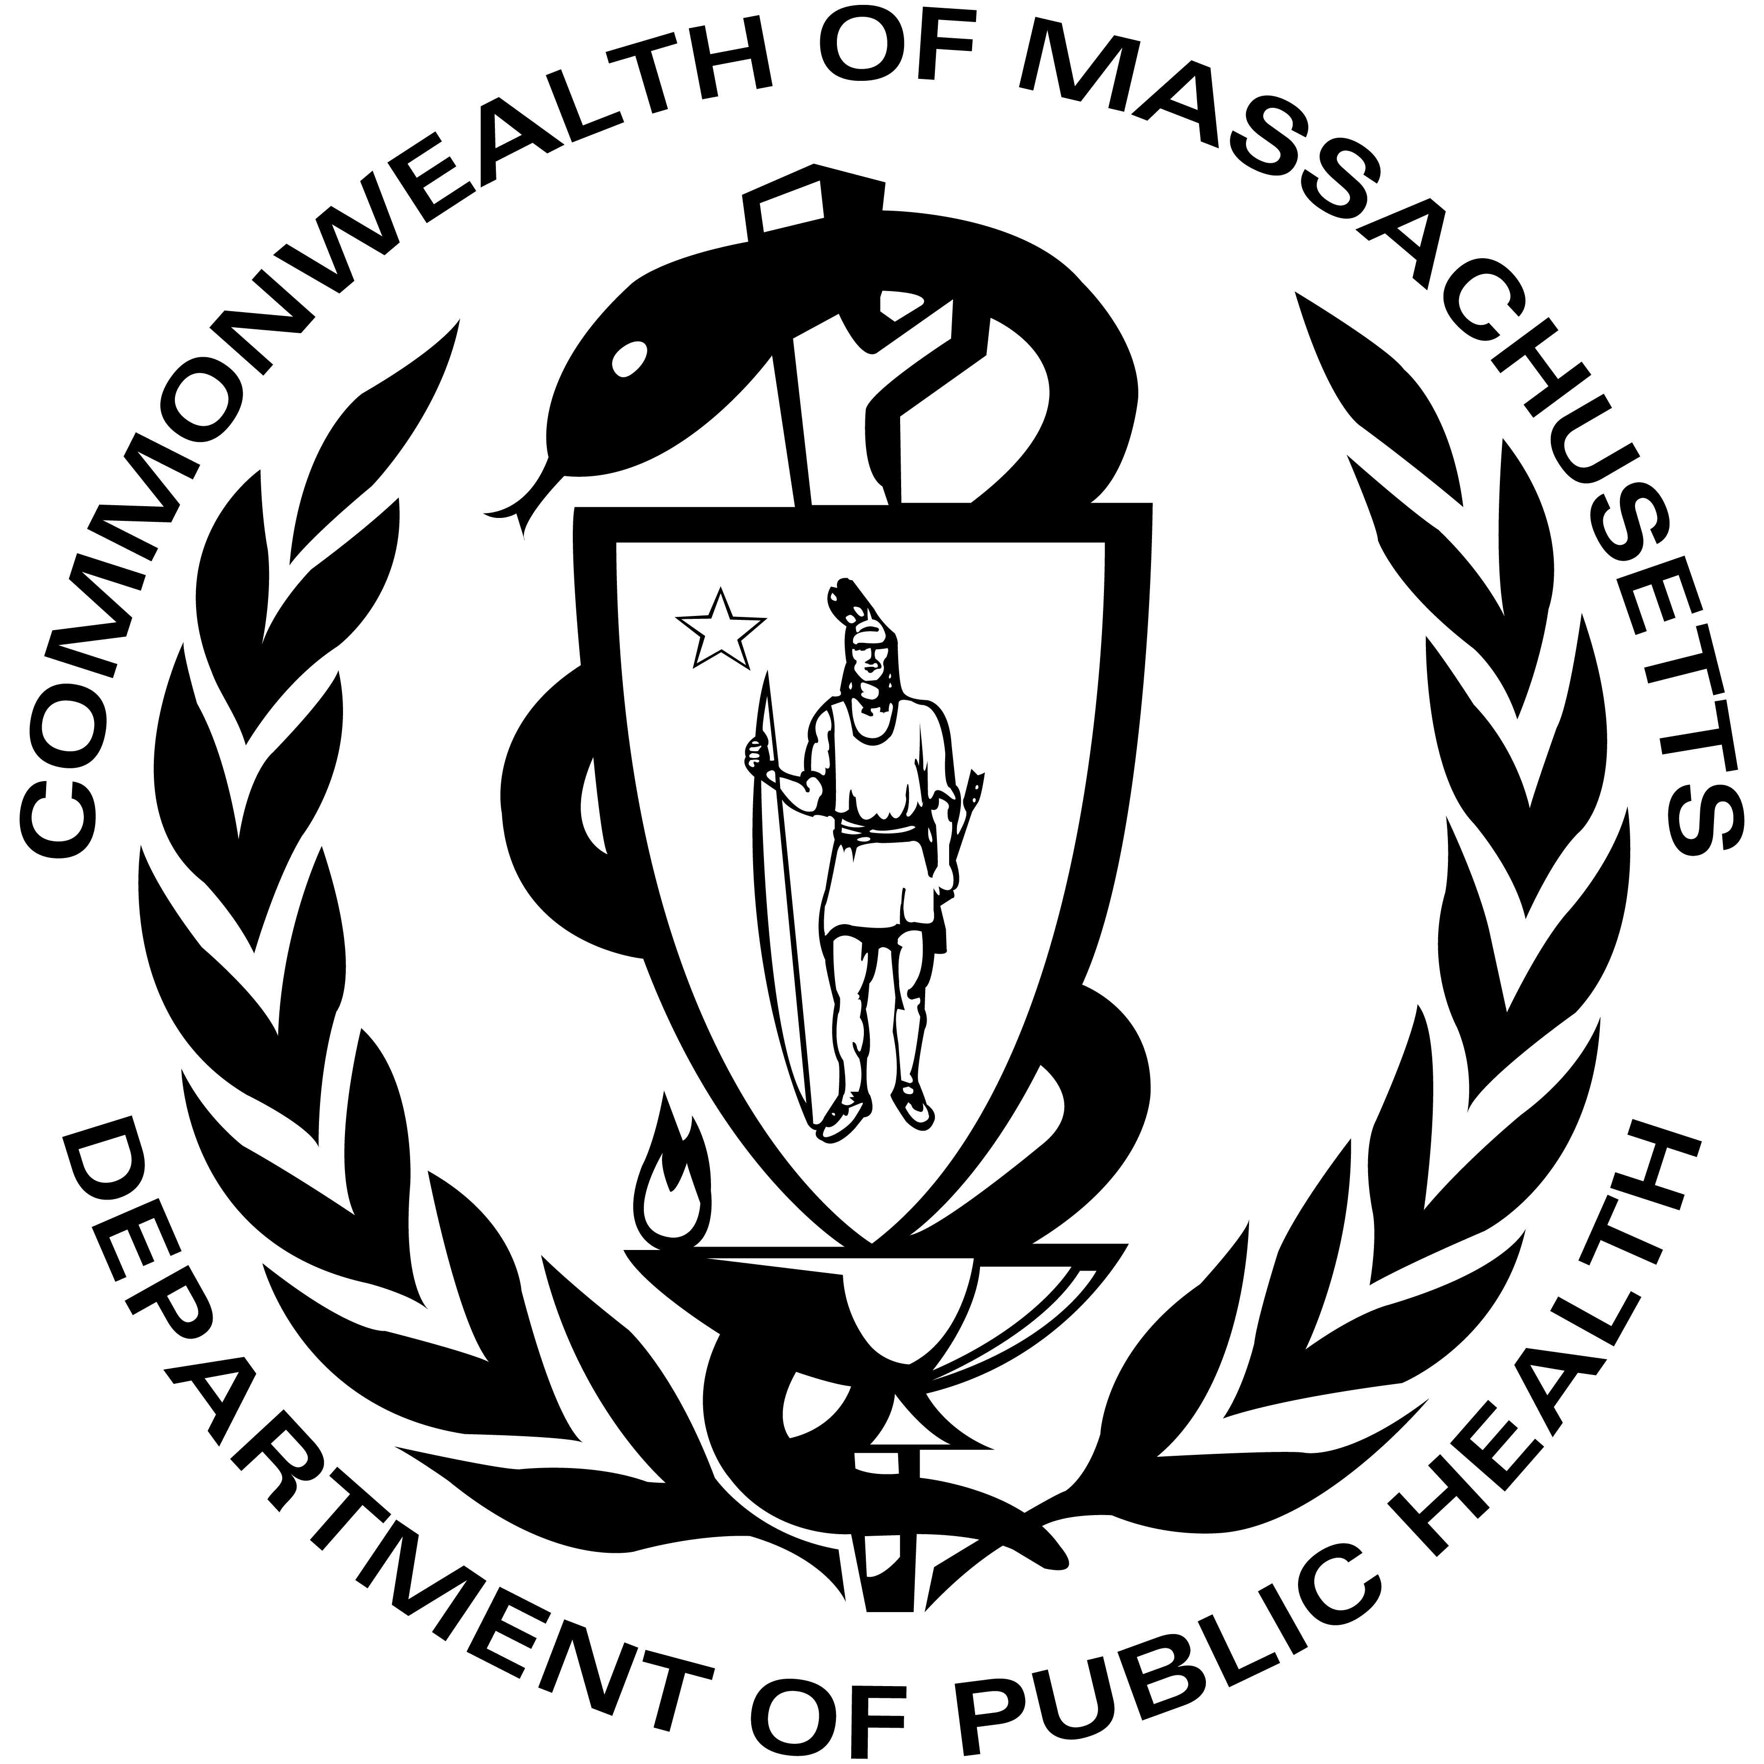 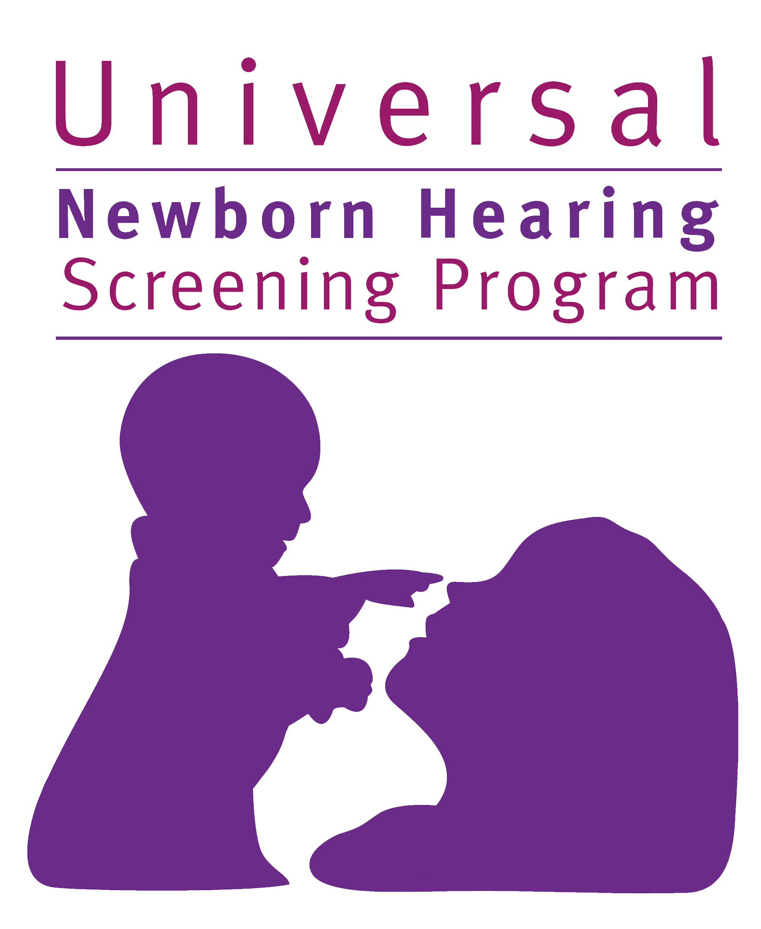

***An Afternoon Chat with***

**Caitlin Parton**

Thursday,

February 4th at 4pm

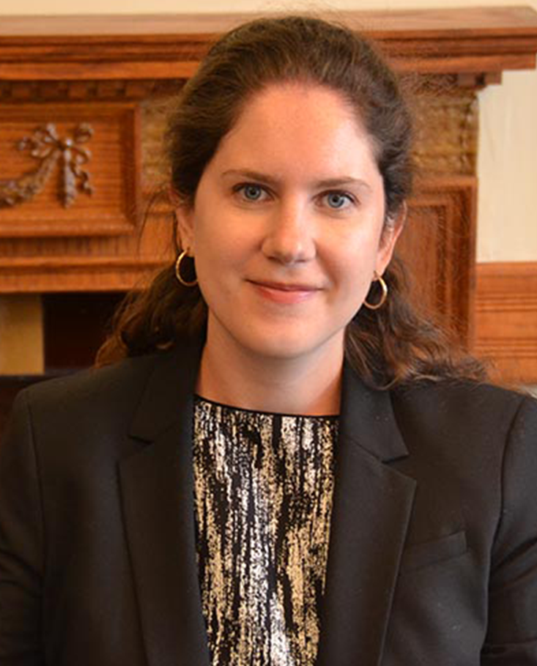

February 4th at 4:00 PM

FREE

EVENT!

Registration is required

The Massachusetts Universal Newborn Hearing Screening Program presents   
an event for families who have a child who is deaf or hard of hearing

Caitlin Parton is an attorney and advocate for people who are deaf and hard of hearing. Caitlin will talk about the Americans with Disabilities Act (ADA), as well as the rights covered by the Individuals with Disabilities Education Act (IDEA), setting goals and protecting the rights of our children using tools such as a 504 plan and Individualized Education Program (IEP). Please join us!

For a link to this FREE online event, please RSVP to:

Sarah Stone at sarah.stone@mass.gov

or (617) 624-5912



If you are deaf or hard of hearing, or are a person with a disability

who requires accommodation, please contact:

Sarah Stone | (617) 624-5912 | sarah.stone@mass.gov