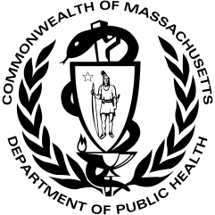 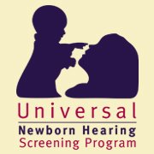

The Massachusetts Universal Newborn Hearing Screening Program presents   
an event for families who have a child who is deaf or hard of hearing:

**Family Event**

**On-line with Authors and Illustrators**

**Debbie, Grace and Brynne Blackington**

FREE

EVENT!

Registration is required

Saturday February 20th

10-11AM

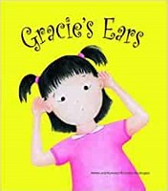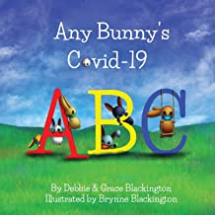

**Please join us on Zoom for this FREE fun caregiver/child event! Learn how a book is created and then make your own art. Basic craft supplies like paper and crayons**

**will be required.**

Space is limited.

To receive the link, please RSVP to:

Sarah Stone

[sarah.stone@mass.gov](mailto:sarah.stone@mass.gov)

(617) 624-5912



If you are deaf or hard of hearing, or are a person with a disability

who requires accommodation, please contact:

Sarah Stone | (617) 624-5912 | sarah.stone@mass.gov