Background/Introduction

INDOOR AIR QUALITY ASSESSMENT

University of Massachusetts Medical School
Center for Health Law and Economics
The Schrafft Center
529 Main St, 6th and 7th Floor
Charlestown, MA 02129

Prepared by:
Massachusetts Department of Public Health
Bureau of Environmental Health
Indoor Air Quality Program
August 2015

In response to a request from Katharine London, Principal Associate, UMass Center for Health Law and Economics (CHLE), the Massachusetts Department of Public Health (MDPH), Bureau of Environmental Health (BEH) conducted an indoor air quality (IAQ) assessment at the CHLE office space in the Schrafft Center located at 529 Main Street, Charlestown, Massachusetts. On June 18, 2015, a visit to conduct an IAQ assessment was made by Ruth Alfasso, Environmental Engineer/Inspector and Jason Dustin, Environmental Analyst/Inspector, from BEH’s IAQ Program.
The CHLE occupies office space on the sixth and seventh floors of the Schrafft Center which was originally built in 1928 as a candy factory/warehouse on the Charlestown waterfront. It currently houses a number of state agencies and private businesses. It was reported that the CHLE has occupied this space since February 2014 and that the space was newly remodeled at that time. The space contains offices, open workstations, reception/waiting room, conference rooms, storage areas and kitchen/lounge areas. Ceilings consist of suspended ceiling tiles. Floors consist of wall-to-wall carpeting in the majority of areas. Windows are not openable.

Methods
Air tests for carbon monoxide, carbon dioxide, temperature and relative humidity were conducted with the TSI, Q-Trak, IAQ Monitor, Model 7565. Air tests for airborne particle matter with a diameter less than 2.5 micrometers were taken with the TSI, DUSTTRAK™ Aerosol Monitor Model 8520. Screening for total volatile organic compounds (TVOCs) was conducted using a RAE Systems, MiniRAE 2000 Model, Photoionization Detector. BEH/IAQ staff also performed a visual inspection of building materials for water damage and/or microbial growth.

Results
The employee population of the CHLE office is approximately 16. The tests were taken during normal operations and appear in Table 1.

Discussion

Ventilation
Carbon dioxide levels were below 800 parts per million (ppm) in all 30 areas tested (Table 1), indicating adequate air exchange on the day of the assessment. Fresh air for the space is provided by large air handling units (AHUs) located on the roof. Outside air is drawn into the AHUs and ducted to ceiling-mounted supply diffusers (Picture 1). Return air is drawn back into ceiling vents (Picture 2) and returned to the AHUs. Return vents are also equipped with additional filters installed in the vents (Picture 3).
Thermostats control the heating, ventilating and air conditioning (HVAC) system. Thermostats have fan settings of “on” and “automatic”. The automatic fan setting on the thermostat activates the HVAC system at a pre-set temperature. Once a pre-set temperature is measured by the thermostat, the HVAC system is deactivated. CHLE staff reported complaints regarding the air quality in the conference rooms. Some conference rooms and other areas were found to have thermostat fans set to “automatic” (Picture 4) which would limit the amount of fresh air entering the room especially during a large meeting. All thermostats should be set to the fan “on” setting to provide for continuous ventilation and filtration during occupied hours.
Ventilation in restrooms is provided by exhausts vented directly to fans on the roof or exterior wall. Restrooms in the common area outside the CHLE space were examined and some restroom exhaust vents were found to be off or drawing weakly. Lack of exhaust ventilation in restrooms can lead to odors and moisture migrating to adjacent areas.
To maximize air exchange, the MDPH recommends that both supply and exhaust ventilation operate continuously during periods of occupancy. In order to have proper ventilation with a mechanical supply and exhaust system, the systems must be balanced to provide an adequate amount of fresh air to the interior of a room while removing stale air from the room. It is recommended that HVAC systems be re-balanced every five years to ensure adequate air systems function (SMACNA, 1994). The date of last balancing of this system was not known at the time of the visit, although it is likely balancing occurred prior to occupancy in February of 2014.
Minimum design ventilation rates are mandated by the Massachusetts State Building Code (MSBC). Until 2011, the minimum ventilation rate in Massachusetts was higher for both occupied office spaces and general classrooms, with similar requirements for other occupied spaces (BOCA, 1993). The current version of the MSBC, promulgated in 2011 by the State Board of Building Regulations and Standards (SBBRS), adopted the 2009 International Mechanical Code (IMC) to set minimum ventilation rates. Please note that the MSBC is a minimum standard that is not health-based. At lower rates of cubic feet per minute (cfm) per occupant of fresh air, carbon dioxide levels would be expected to rise significantly. A ventilation rate of 20 cfm per occupant of fresh air provides optimal air exchange resulting in carbon dioxide levels at or below 800 ppm in the indoor environment in each area measured. MDPH recommends that carbon dioxide levels be maintained at 800 ppm or below. This is because most environmental and occupational health scientists involved with research on IAQ and health effects have documented significant increases in indoor air quality complaints and/or health effects when carbon dioxide levels rise above the MDPH guidelines of 800 ppm for schools, office buildings and other occupied spaces (Sundell et al., 2011). The ventilation must be on at all times that the room is occupied. Providing adequate fresh air ventilation with open windows and maintaining the temperature in the comfort range during the cold weather season is impractical. Mechanical ventilation is usually required to provide adequate fresh air ventilation.
Carbon dioxide is not a problem in and of itself. It is used as an indicator of the adequacy of the fresh air ventilation. As carbon dioxide levels rise, it indicates that the ventilating system is malfunctioning or the design occupancy of the room is being exceeded. When this happens, a buildup of common indoor air pollutants can occur, leading to discomfort or health complaints. The Occupational Safety and Health Administration (OSHA) standard for carbon dioxide is 5,000 parts per million parts of air (ppm). Workers may be exposed to this level for 40 hours/week, based on a time-weighted average (OSHA, 1997).
The MDPH uses a guideline of 800 ppm for publicly occupied buildings. A guideline of 600 ppm or less is preferred in schools due to the fact that the majority of occupants are young and considered to be a more sensitive population in the evaluation of environmental health status. Inadequate ventilation and/or elevated temperatures are major causes of complaints such as respiratory, eye, nose and throat irritation, lethargy and headaches. For more information concerning carbon dioxide, please see Appendix A.
Temperature readings during the assessment ranged from 72ºF to 77ºF (Table 1), which are all within the MDPH recommended comfort guidelines. The MDPH recommends that indoor air temperatures be maintained in a range of 70ºF to 78ºF in order to provide for the comfort of building occupants. In many cases concerning indoor air quality, fluctuations of temperature in occupied spaces are typically experienced, even in a building with an adequate fresh air supply. Several CHLE staff members complained of overheating in office spaces, particularly on the south side of the building which is likely due to direct sunlight exposure on windows. Use of adjustable blinds and shades and/or the application of tinted window film should help to prevent heat complaints due to solar gain.
The relative humidity measured during the assessment ranged from 35 to 41 percent, which is within or close to the lower end of the MDPH recommended comfort range. The MDPH recommends a comfort range of 40 to 60 percent for indoor air relative humidity. Relative humidity levels in the building would be expected to drop during the winter months due to heating. The sensation of dryness and irritation is common in a low relative humidity environment. Low relative humidity is a very common problem during the heating season in the northeast part of the United States.

Microbial/Moisture Concerns
Several water-damaged ceiling tiles and walls were observed in offices/work areas (Pictures 5 to 8; Table 1). Some of the water-damaged ceiling tiles appeared to have been stained and then painted. Water-damaged ceiling tiles should be removed and replaced once the source of water has been identified and remediated. CHLE staff reported that carpeting in the reception area had been moistened by leaks in the past and a musty odor was detected in this area. Due to this odor, it is likely that the carpet was not properly dried within 48 hours following those leaks. It was further reported by CHLE staff that the roof had been leaking for some time before finally being repaired approximately two weeks prior to this assessment.
The US EPA and the American Conference of Governmental Industrial Hygienists (ACGIH) recommend that porous materials be dried with fans and heating within 24 to 48 hours of becoming wet (US EPA, 2001; ACGIH, 1989). If porous materials are not dried within this time frame, mold growth may occur. Once mold has colonized porous materials, they are difficult to clean and should be removed and discarded.
Plants were observed in several areas (Pictures 9 and 10; Table 1). Plants can be a source of pollen and mold, which can be respiratory irritants to some individuals. Plants should be properly maintained, over-watering of plants should be avoided and drip pans should be inspected periodically for mold growth and cleaned or replaced as necessary.
Water coolers were observed on carpeted areas (Picture 11). Spills or leaks from these appliances can moisten carpeting. They should be located in a non-carpeted area or on waterproof mats.

Other IAQ Evaluations
Indoor air quality can be negatively influenced by the presence of respiratory irritants, such as products of combustion. The process of combustion produces a number of pollutants. Common combustion emissions include carbon monoxide, carbon dioxide, water vapor, and smoke (fine airborne particle material). Of these materials, exposure to carbon monoxide and particulate matter with a diameter of 2.5 micrometers (μm) or less (PM2.5) can produce immediate, acute health effects upon exposure. To determine whether combustion products were present in the indoor environment, BEH/IAQ staff obtained measurements for carbon monoxide and PM2.5.

Carbon Monoxide
Carbon monoxide is a by-product of incomplete combustion of organic matter (e.g., gasoline, wood and tobacco). Exposure to carbon monoxide can produce immediate and acute health effects. Several air quality standards have been established to address carbon monoxide and prevent symptoms from exposure to these substances. The MDPH established a corrective action level concerning carbon monoxide in ice skating rinks that use fossil-fueled ice resurfacing equipment. If an operator of an indoor ice rink measures a carbon monoxide level over 30 ppm, taken 20 minutes after resurfacing within a rink, that operator must take actions to reduce carbon monoxide levels (MDPH, 1997).
The American Society of Heating Refrigeration and Air-Conditioning Engineers (ASHRAE) has adopted the National Ambient Air Quality Standards (NAAQS) as one set of criteria for assessing indoor air quality and monitoring of fresh air introduced by HVAC systems (ASHRAE, 1989). The NAAQS are standards established by the US EPA to protect the public health from six criteria pollutants, including carbon monoxide and particulate matter (US EPA, 2006). As recommended by ASHRAE, pollutant levels of fresh air introduced to a building should not exceed the NAAQS levels (ASHRAE, 1989). The NAAQS were adopted by reference in the Building Officials & Code Administrators (BOCA) National Mechanical Code of 1993 (BOCA, 1993), which is now an HVAC standard included in the Massachusetts State Building Code (SBBRS, 2011). According to the NAAQS, carbon monoxide levels in outdoor air should not exceed 9 ppm in an eight-hour average (US EPA, 2006).
Carbon monoxide should not be present in a typical, indoor environment. If it is present, indoor carbon monoxide levels should be less than or equal to outdoor levels. During the assessment outdoor carbon monoxide concentrations were measured at 1.3 ppm, likely due to traffic. Indoor levels were all non-detect (ND, Table 1).

Particulate Matter
The US EPA has established NAAQS limits for exposure to particulate matter. Particulate matter includes airborne solids that can be irritating to the eyes, nose and throat. The NAAQS originally established exposure limits to PM with a diameter of 10 μm or less (PM10). In 1997, US EPA established a more protective standard for fine airborne particulate matter with a diameter of 2.5 μm or less (PM2.5). This more stringent PM2.5 standard requires outdoor air particle levels be maintained below 35 μg/m³ over a 24-hour average (US EPA, 2006). Although both the ASHRAE standard and BOCA Code adopted the PM10 standard for evaluating air quality, MDPH uses the more protective PM2.5 standard for evaluating airborne PM concentrations in the indoor environment.
Outdoor PM2.5 concentrations were measured at 18 μg/m³ (Table 1). PM2.5 levels indoors ranged from 1 to 17 μg/m³, which are below the NAAQS PM2.5 level of 35 μg/m³. Frequently, indoor air levels of particulate matter (including PM2.5) can be at higher levels than those measured outdoors. A number of activities that occur indoors and/or mechanical devices can generate particulate matter during normal operations. Sources of indoor airborne particulate matter may include but are not limited to particles generated during the operation of fan belts in the HVAC system; use of stoves and/or microwave ovens in kitchen areas; use of photocopiers, fax machines and computer printing devices; and operation of an ordinary vacuum cleaner and heavy foot traffic indoors.

Volatile Organic Compounds
Indoor air concentrations can be greatly impacted by the use of products containing volatile organic compounds (VOCs). VOCs are carbon-containing substances that have the ability to evaporate at room temperature. For example, chemicals evaporating from a paint can stored at room temperature would most likely contain VOCs. Frequently, exposure to low levels of total VOCs (TVOCs) may produce eye, nose, throat and/or respiratory irritation in some sensitive individuals. In order to determine if VOCs were present, testing for TVOCs was conducted. Outdoor TVOC concentrations were ND on the day of the assessment (Table 1). No measureable levels of TVOCs were detected in the building during the assessment (Table 1).
Several areas had dry erase boards and related materials (Table 1). Materials such as dry erase markers and dry erase board cleaners may contain VOCs, such as methyl isobutyl ketone, n-butyl acetate and butyl-cellusolve (Sanford, 1999), which can be irritating to the eyes, nose and throat.
Hand sanitizer was also observed in office areas (Table 1); these products may contain ethyl alcohol and/or isopropyl alcohol, which are highly volatile and may be irritating to the eyes and nose. Sanitizing products may also contain fragrances to which some people may be sensitive.
Cleaning products, air freshening sprays and scented products were also observed. Cleaning products, air fresheners and other air deodorizers contain chemicals that can be irritating to the eyes, nose and throat of sensitive individuals. Many air fresheners contain 1,4-dichlorobenzene, a VOC which can reduce lung function (NIH, 2006). Furthermore, deodorizing agents do not remove materials causing odors, but rather mask odors that may be present in the area. Cleaning products should be properly labeled and stored in an appropriate area. In addition, a Material Safety Data Sheet (MSDS) should be available at a central location for each product in the event of an emergency.

Other Conditions
Other conditions that can affect IAQ were observed during the assessment. Room 701 was an otherwise empty office or storeroom that had a collection of paints and supplies stored inside. In addition, there were several missing ceiling tiles in the space (Pictures 12 and 13). Paints and other cleaning supplies/chemicals should be stored in a room with a dedicated exhaust supply. Missing ceiling tiles should be replaced to avoid the migration of odors and unconditioned air throughout the office area.
In some areas, accumulations of items were seen on floors, windowsills, tabletops, counters, bookcases and desks, which provide a source for dusts to accumulate. These items (e.g., papers, folders, boxes) make it difficult for custodial staff to clean. Items should be relocated and/or be cleaned periodically to avoid excessive dust build-up.
Most areas of the office space had wall-to-wall carpeting. The Institute of Inspection, Cleaning and Restoration Certification (IICRC) recommends that carpeting be cleaned annually (or semi-annually in soiled high traffic areas) (IICRC, 2012). Regular cleaning with a high efficiency particulate arrestance (HEPA) filtered vacuum in combination with an annual cleaning will help to reduce accumulation and potential aerosolization of materials from the carpeting.

Conclusions/Recommendations
In view of the findings at the time of the visit, the following recommendations are made:
- Examine areas of leakage and determine if source(s) of water have been repaired (e.g., the roof); if not, repair as needed. Ensure any water-damaged ceiling tiles are replaced. Examine the area above ceiling tiles for mold growth. Disinfect areas of water leaks with an appropriate antimicrobial, as needed.
- Remove and discard water-damaged porous building materials (gypsum wallboard, carpeting, paper-backed insulation, etc.) in a manner consistent with recommendations found in “Mold Remediation in Schools and Commercial Buildings” published by the US Environmental Protection Agency (US EPA, 2001).
- Operate all ventilation systems throughout the building continuously during periods of occupancy to maximize air exchange. This would include leaving thermostat fan settings in the “on” mode (not auto) for continuous airflow.
- Inspect and activate motors for restroom exhaust vents to ensure continuous operation during occupied hours. Make repairs as needed.
- Consider adopting a balancing schedule of every 5 years for all mechanical ventilation systems, as recommended by ventilation industrial standards (SMACNA, 1994).
- For buildings in New England, periods of low relative humidity during the winter are often unavoidable. Therefore, scrupulous cleaning practices should be adopted to minimize common indoor air contaminants whose irritant effects can be enhanced when the relative humidity is low. To control for dusts, a high efficiency particulate arrestance (HEPA) filter equipped vacuum cleaner in conjunction with wet wiping of all surfaces is recommended. Avoid the use of feather dusters. Drinking water during the day can help ease some symptoms associated with a dry environment (throat and sinus irritations).
- Consider installing reflective film to reduce solar gain on south-facing windows or use blinds to moderate temperatures and increase comfort.
- Indoor plants should be properly maintained and equipped with drip pans to prevent water damage to porous building materials and be located away from ventilation sources to prevent the aerosolization of dirt, pollen or mold.
- Place water coolers/dispensers in areas without carpeting or place on a waterproof mat.
- Reduce the use of hand sanitizing products especially those containing fragrances.
- Avoid the use of air freshener sprays, solids and diffuser reeds to prevent exposure to VOCs and fragrance compounds.
- Replace ceiling tiles in room 701 to prevent distribution of odors from stored maintenance materials/paints via the ceiling plenum.
- Vacuum carpet with a high efficiency particulate arrestance (HEPA) filtered vacuum in combination with cleaning carpeting annually or semi-annually in soiled high traffic areas as per the recommendations of the Institute of Inspection, Cleaning and Restoration Certification (IICRC, 2012).
- Refer to resource manuals and other related indoor air quality documents for further building-wide evaluations and advice on maintaining public buildings. Copies of these materials are located on the MDPH’s website: http://mass.gov/dph/iaq.

References
ACGIH. 1989. Guidelines for the Assessment of Bioaerosols in the Indoor Environment. American Conference of Governmental Industrial Hygienists, Cincinnati, OH.
ASHRAE. 1989. Ventilation for Acceptable Indoor Air Quality. American Society of Heating, Refrigeration and Air Conditioning Engineers. ANSI/ASHRAE 62-1989.
BOCA. 1993. The BOCA National Mechanical Code/1993. 8th ed. Building Officials & Code Administrators International, Inc., Country Club Hills, IL.
IICRC. 2012. Carpet Cleaning FAQ 4 Institute of Inspection, Cleaning and Restoration Certification. Institute of Inspection Cleaning and Restoration, Vancouver, WA.
MDPH. 1997. Requirements to Maintain Air Quality in Indoor Skating Rinks (State Sanitary Code, Chapter XI). 105 CMR 675.000. Massachusetts Department of Public Health, Boston, MA.
NIH. 2006. Chemical in Many Air Fresheners May Reduce Lung Function. NIH News. National Institute of Health. July 27, 2006. http://www.nih.gov/news/pr/jul2006/niehs-27.htm
OSHA. 1997. Limits for Air Contaminants. Occupational Safety and Health Administration. Code of Federal Regulations. 29 C.F.R 1910.1000 Table Z-1-A.
Sanford. 1999. Material Safety Data Sheet (MSDS No: 198-17). Expo® Dry Erase Markers Bullet, Chisel, and Ultra Fine Tip. Sanford Corporation. Bellwood, IL.
SBBRS. 2011. Mechanical Ventilation. State Board of Building Regulations and Standards. Code of Massachusetts Regulations, 8th edition. 780 CMR 1209.0.
SMACNA. 1994. HVAC Systems Commissioning Manual. 1st ed. Sheet Metal and Air Conditioning Contractors’ National Association, Inc., Chantilly, VA.
Sundell. 2011. Sundell, J., H. Levin, W. W. Nazaroff, W. S. Cain, W. J. Fisk, D. T. Grimsrud, F. Gyntelberg, Y. Li, A. K. Persily, A. C. Pickering, J. M. Samet, J. D. Spengler, S. T. Taylor, and C. J. Weschler. Ventilation rates and health: multidisciplinary review of the scientific literature. Indoor Air, Volume 21: pp 191–204.
US EPA. 2001. Mold Remediation in Schools and Commercial Buildings. US Environmental Protection Agency, Office of Air and Radiation, Indoor Environments Division, Washington, D.C. EPA 402-K-01-001. http://www.epa.gov/mold/mold_remediation.html
US EPA. 2006. National Ambient Air Quality Standards (NAAQS). US Environmental Protection Agency, Office of Air Quality Planning and Standards, Washington, DC. http://www.epa.gov/air/criteria.html.
Picture

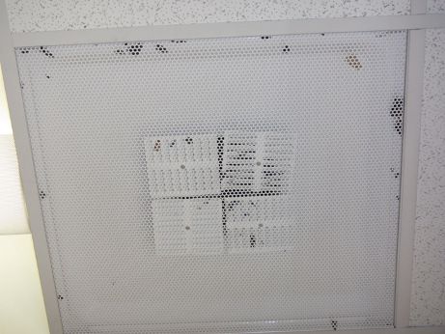

Ceiling-mounted supply air diffuser (note debris)

Picture

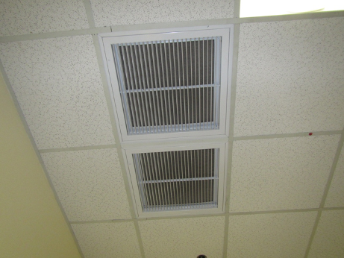

Return/exhaust vents
Picture

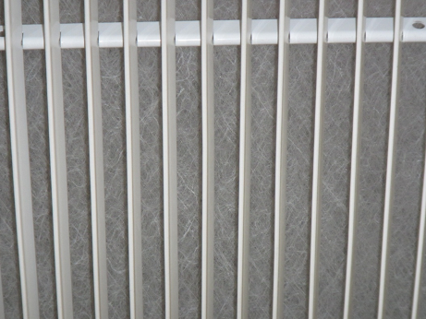

Return vent showing filter

Picture

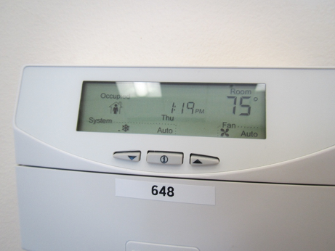

Thermostat showing fan setting of “auto” instead of preferred “on”
Picture

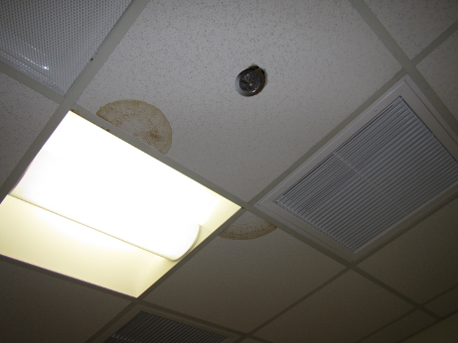

Water-damaged ceiling tiles

Picture

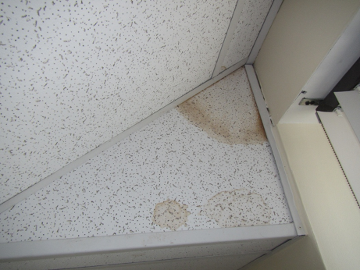

Water-damaged ceiling tiles
Picture

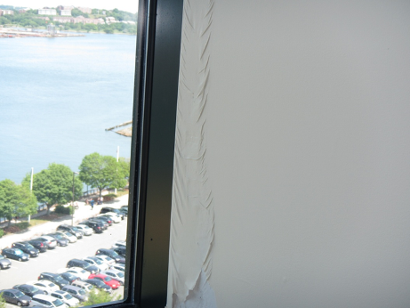

Water-damaged wall near window frame

Picture

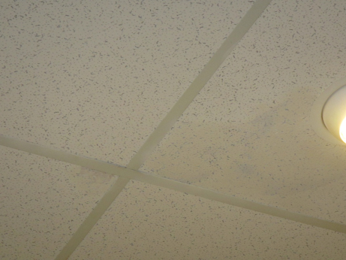

Water-damaged ceiling tile with what looks like paint over it
Picture

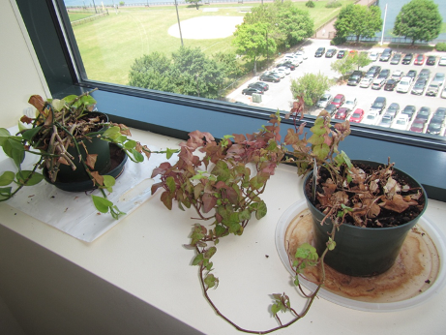

Plants in office area

Picture

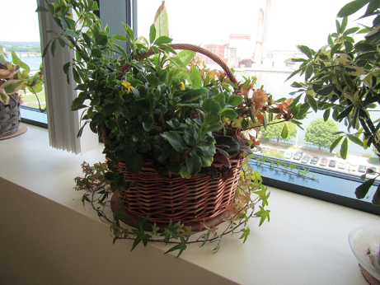

Plants in office area
Picture 11

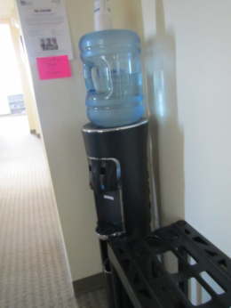

Water cooler on carpeting

Picture 12

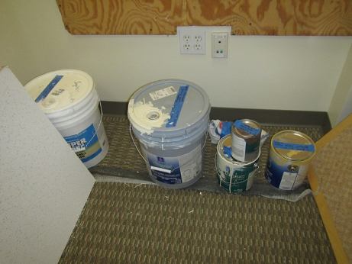

Paints stored in room 701
Picture 13

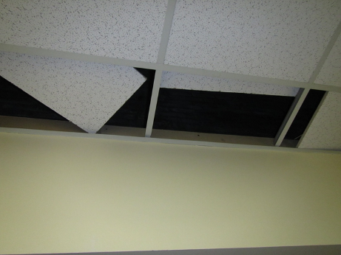

Missing ceiling tiles in room 701

Location | Carbon  Dioxide  (ppm) | Carbon Monoxide  (ppm) | Temp  (°F) | Relative  Humidity  (%) | VOCs  (ppm) | PM2.5  (µg/m³) | Occupants  in Room | Windows  Openable | Ventilation |  |  | Remarks
 |  |  |  |  |  |  |  |  | Intake | Exhaust
Background | 493 | 1.3 | 78 | 38 | ND | 18 |  |  |  |  |  | Sunny, slight haze, traffic
Reception | 507 | ND | 75 | 37 | ND | 5 | 1 | N | Y |  | Y | Musty odor, debris on supply diffuser
Conference room on floor 6 and a half | 645 | ND | 75 | 39 | ND | 1 | 0 | N | Y |  | N | Fan on auto
601 | 460 | ND | 73 | 35 | ND | 4 | 0 | N | Y |  | N | DO, DEM, stained items
605 | 509 | ND | 76 | 35 | ND | 11 | 1 | N | Y |  | N
606 | 538 | ND | 76 | 35 | ND | 1 | 1 | N | Y |  | N | DEM, HS
607 kitchen | 558 | ND | 76 | 35 | ND | 17 | 0 | N | Y |  | N | NC, backsplash open, fridges clean
608 | 563 | ND | 76 | 35 | ND | 4 | 1 | N | Y |  | N | AI, plants, DEM
609 | 610 | ND | 76 | 36 | ND | 7 | 1 | N | Y |  | N | DEM
610 | 615 | ND | 75 | 37 | ND | 1 | 0 | N | Y |  | N | DEM, fan auto, solar gain
612 | 600 | ND | 73 | 37 | ND | 1 | 1 | N | Y |  | N | DEM
614 cube | 610 | ND | 75 | 36 | ND | 1 | 0 | N | Y |  | Y
614 | 625 | ND | 73 | 37 | ND | 10 | 1 | N | Y |  | N | DO, low ceiling
615 cube | 595 | ND | 75 | 36 | ND | 1 | 0 | N | Y |  | Y | PF, HS
616 | 617 | ND | 76 | 36 | ND | 8 | 0 | N | Y |  | N | Flowers and plants, DEM
617 | 760 | ND | 76 | 36 | ND | 17 | 0 | N | Y |  | N | DO, plants, DEM
618 | 602 | ND | 76 | 36 | ND | 10 | 1 | N | Y |  | N
619 | 590 | ND | 77 | 35 | ND | 11 | 0 | N | Y |  | N | DEM
620 | 637 | ND | 77 | 39 | ND | 2 | 1 | N | Y |  | N | DO, plant
621 | 689 | ND | 76 | 39 | ND | 6 | 2 | N | Y |  | N | DEM, plants, may have two zones for thermostats
701 |  |  |  |  |  |  |  |  |  |  |  | Access to roof? Paint storage and other items, ajar and missing ceiling tiles.
706 cube | 417 | ND | 72 | 40 | ND | 12 | 0 | N | Y |  | Y
707 cube | 417 | ND | 72 | 40 | ND | 11 | 0 | N | Y |  | Y
708 conference | 473 | ND | 73 | 39 | ND | 5 | 0 | N | Y |  | Y | WD CT
709 | 474 | ND | 73 | 39 | ND | 4 | 0 | N | Y |  | N
710 | 502 | ND | 73 | 39 | ND | 4 | 0 | N | Y |  | N | 2 WD CT
712 half wall | 473 | ND | 74 | 39 | ND | 9 | 1 | N | Y |  | N | CP
713 half wall | 451 | ND | 73 | 39 | ND | 3 | 0 | N | Y |  | N
714 | 440 | ND | 74 | 40 | ND | 6 | 1 | N | Y |  | N | Plants
715 | 450 | ND | 74 | 40 | ND | 7 | 0 | N | Y |  | N | PF
716 | 412 | ND | 73 | 40 | ND | 7 | 1 | N | Y |  | N | DEM
718 | 396 | ND | 73 | 41 | ND | 7 | 0 | N | Y |  | N | Plant, DEM
719 | 419 | ND | 73 | 41 | ND | 10 | 0 | N | Y |  | N | WD paint, vacant office
720 |  |  |  |  |  |  |  |  |  |  |  | Empty storage closet

