**Commonwealth of Massachusetts**

**Executive Office of Health and Human Services**

**Update Virtual Gateway MyMassGov Account and/or Multi-Factor Authentication Reference Guide**



* This guide can be used by both MyMassGov Personal and Business tenants
* Commonwealth of MA staff with a Mass.gov email should **NOT** use this guide to make account updates

Log In to MyMassGov account 2

Update Account Information in a MyMassGov account 3

Update Multi-Factor Authentication in a MyMassGov account 5

To change your authenticator app: Update 6

To change your authenticator app: Remove 7

To change your primary phone (voice and text): Update 7

To change your primary phone (voice and text): Remove 8

To change your secondary phone (voice and mail) 8

View Update Profile in Virtual Gateway 8

Need Assistance 9

## Log In to MyMassGov account

1. Go to the Virtual Gateway page: <https://virtualgateway.mass.gov/VGPortal5>
2. Under ‘**Want to update MyMassGov account?**’, click the link labeled ‘**Update MyMassGov Account Settings**’.

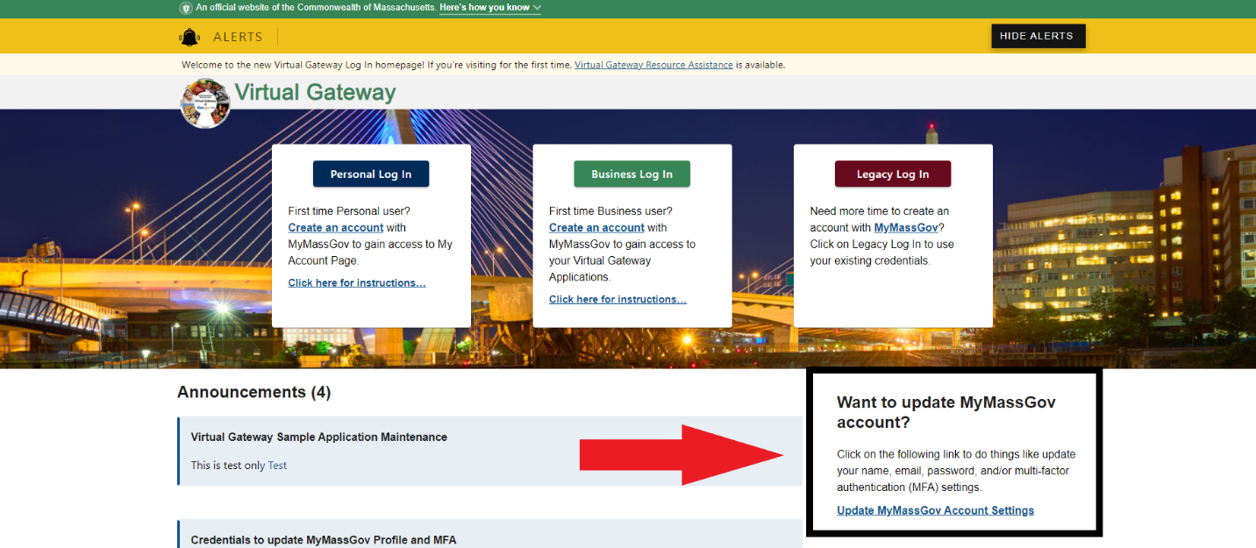

1. From the **Choose an account type** page, select **Personal** or **Business**, based on which option your MyMassGov account is under.
   * Click **Personal** if a MassHealth My Account Page (MAP) user.
   * Click **Business** if a Provider, DCF Mandated Reporter user.
2. Under **Already have an account?**, enter **Email** and **Password**. Click the **LOG IN** button. 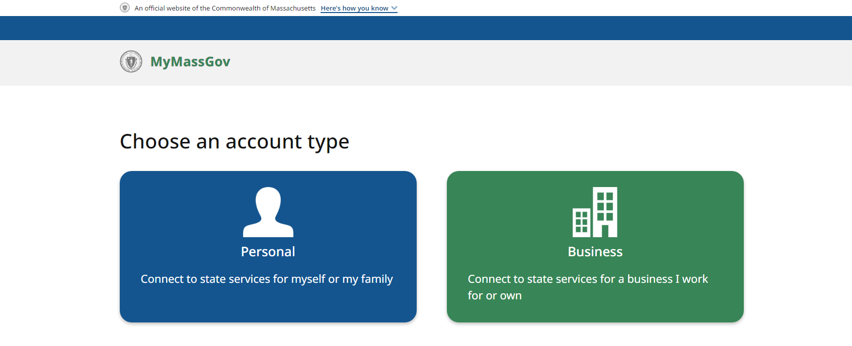
3. Click the Multifactor Authentication (MFA) method as presented on the screen. This will vary per user based on prior MFA setup.
4. Enter **Code**. Click the **VERIFY** button.

## Update Account Information in a MyMassGov account

User redirected to the **MyMassGov FOR BUSINESS Welcome** or **MyMassGov FOR PERSONAL Welcome** page.

1. Click the down arrow next to your user profile icon in the banner in the top right-hand corner of the screen.

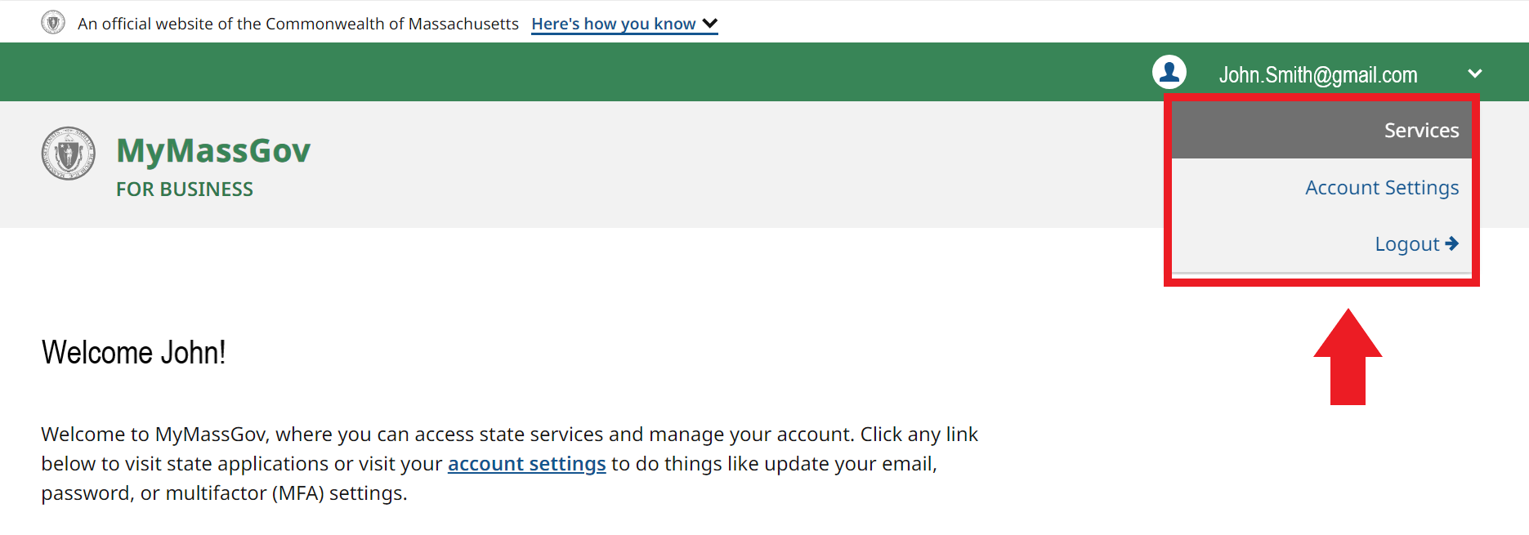

1. Click **Account Settings**.
   * On the left side of the Account settings page, you will see that you are currently viewing the **Account Information** view. You can also update Personal Information, and Multi-Factor Authentication.
   * On the right-hand side of the **Account Information** page, click the **Edit** button next to the option you want to update. You will be asked to verify your account based off your MFA methods previously setup.
     1. **Name**: If updating first or last name, enter new first and /or last name.
     2. **\* Email**: If updating email, enter new email.

**\*Note**: This applies only to new emails that have not been registered with MyMassGov.

* + 1. **Password**: If updating password, enter new password.

1. Click the **SAVE** button.

Image of Account settings:
You can update Name by clicking Edit button.
You can update Email by clicking Edit button.
You can update Password by clicking Edit button.

Once completed, you’ll be brought back to the **ACCOUNT SETTINGS** screen, where you’ll see a success message confirming the update.

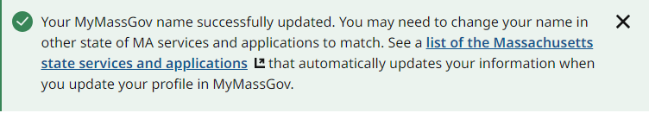

You’ll also receive an email message from the Commonwealth of Massachusetts, confirming that the name, email or password associated to your account was updated.

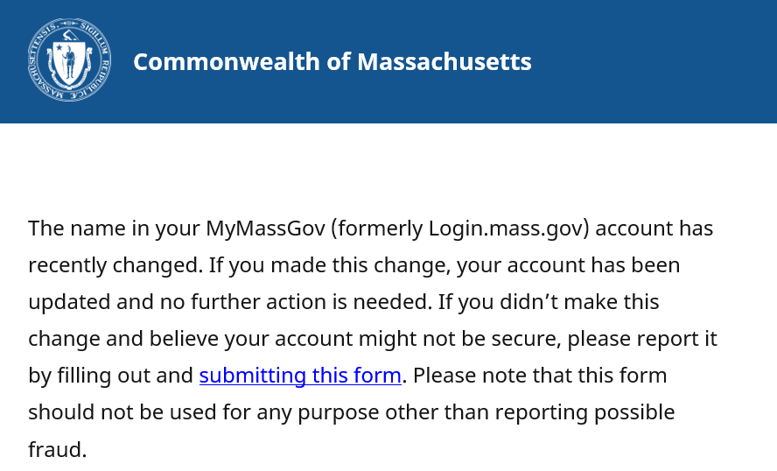

## Update Multi-Factor Authentication in a MyMassGov account

Follow these steps to log in to MyMassGov and change the MFA settings in your personal or business account.

*Note: You need to have at least 1 MFA method setup to make modifications to existing MFA methods or to setup additional MFA methods. If you only setup 1 MFA Method and you no longer have access to that MFA method, you will need to contact Virtual Gateway Customer Service at 800-421-0938 to request an MFA Reset.*

1. Go to the Virtual Gateway page: <https://virtualgateway.mass.gov/VGPortal5>
2. Under ‘**Want to update MyMassGov account?**’, click the link labeled ‘**Update MyMassGov Account Settings**’.



1. From the Choose an account type page, select **Personal** or **Business**, based on which option your MyMassGov account is under.
   * Click **Personal** if a MassHealth My Account Page (MAP) user.
   * Click **Business** if a Provider, DCF Mandated Reporter user.
2. Under **Already have an account?**, enter **Email** and **Password**. Click the **LOG IN** button.
3. Click the Multifactor Authentication (MFA) method as presented on the screen. This will vary per user based on prior MFA setup.
4. Enter **Code**. Click the **VERIFY** button.

User redirected to the MyMassGov FOR BUSINESS Welcome or MyMassGov FOR PERSONAL page.

1. Click the down arrow next to your user profile icon in the banner in the top right-hand corner of the screen.
2. Click **Account Settings**.
   * On the left side of the Account settings page, click **Multi-Factor Authentication**.

Image of Multi-Factor Authentication (MFA) Methods::
You can add or update Phone.
You can add or update Authenticator App.
You can add or update Secondary Phone.

1. Select **Multi-Factor Authentication** on the left-hand side of the account settings page
   * Note that any MFA methods that are already set up are indicated by a green circle next to them.
2. On the right-hand side of the “Multi-Factor Authentication (MFA) Methods” page, click on **Update MFA Methods**.
3. You’ll be brought to a “Change your MFA settings” screen to choose the MFA setting you’d like to change
   * Note that SECONDARY PHONE (VOICE & TEXT MESSAGE) will only appear here if you already have a primary PHONE (VOICE & TEXT MESSAGE) option set up

### To change your authenticator app: Update

1. Click on ‘**Authenticator app’\***
2. If you already have an authenticator app set up, you will see two options:
   1. Update authenticator app
   2. Remove authenticator app
3. Click on ‘**Update authenticator app’**
4. Open your authenticator app
5. Scan the QR code with your phone
6. Enter the code you receive in the ‘**Verification code’** field
7. Click ‘**Continue’**.

[**(See directions for setting up an authenticator app if you need help)**](https://www.mass.gov/info-details/set-up-multifactor-authentication-mfa-for-mymassgov).

  8.  When your change has been successfully completed, you will see a confirmation page.

  9.  Click ‘**Yes, I’d like to make more changes**’ to change another MFA method or ‘**No, I’m done**’ if you’re finished.

**\*NOTE:** If an authenticator app has not been set up, you will be taken to a page to complete the process.

### To change your authenticator app: Remove

1. Click on ‘**Authenticator app**’
2. If you already have an authenticator app set up, you will see two options:
   1. Update authenticator app
   2. Remove authenticator app
3. Click on ‘**Remove authenticator app**’
4. At the next screen, either confirm you would like to remove your authenticator app by clicking ‘**Yes, remove this method**’ or ‘**No, keep this method**’ to cancel out of the change process
5. When your change has been successfully completed, you’ll see a confirmation page
6. Click ‘**Yes, I’d like to make more changes**’ to change another MFA method or ‘**No, I’m done**’ if you are finished

### To change your primary phone (voice and text): Update

1. Click ‘**Primary phone number (voice and text)\***’
2. If you have a Primary phone number (voice and text) set up, you will see two options:
   1. Update phone number
   2. Remove phone number
3. Click on ‘**Update phone number**’
4. At the next screen, enter the updated phone number you’d like to link to your account
5. Click either ‘**Text Me’ or ‘Call Me**’
6. Enter the code you receive in the ‘**Verification code**’ field

[**(See directions for setting up Phone (voice and text) authentication if you need help).**](https://www.mass.gov/info-details/set-up-multifactor-authentication-mfa-for-mymassgov)

1. When your change has been successfully completed, you’ll see a confirmation page
2. Click ‘**Yes, I’d like to make more changes**’ to change another MFA method or ‘**No, I’m done**’ if you are finished.

**\*NOTE:** If a Primary phone (voice and mail) has not been set up, you will be taken to a page to do so.

### To change your primary phone (voice and text): Remove

1. Click ‘**Primary phone number (voice and text)\***’
2. If you have a Primary phone number (voice and text) set up, you will see two options:
   1. Update phone number
   2. Remove phone number
3. Click ‘**Remove phone number**’
4. At the next screen, either confirm you would like to remove your primary number by clicking ‘**Yes, remove this method**’ or ‘**No, keep this method**’ to cancel out of the change process
5. When your change has been successfully completed, you will see a confirmation page
6. Click on ‘**Yes, I’d like to make more changes**’ to change another MFA method or ‘**No, I’m done**’ if you are finished

**NOTE:** If you remove your primary phone number as a method and you have a secondary phone number set up, the secondary phone number will become the primary phone number.

### To change your secondary phone (voice and mail)

1. Click ‘**Secondary phone (voice and text)**’**\***
2. Follow the same process as updating or removing Primary phone (voice and text)

**\*NOTE:** A secondary phone number will only show if the primary phone number has already been set up as a method.

After completing your updates, click the **Logout** link to close your session.

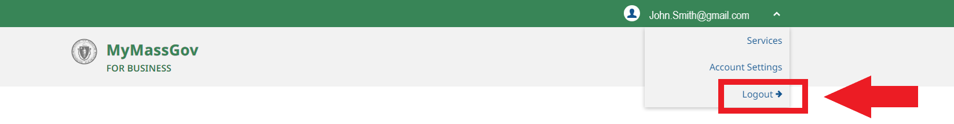

## View Update Profile in Virtual Gateway

After making updates to First/Last Name or Email, the next time you log into your Virtual Gateway account this information will automatically update your Virtual Gateway profile. You can view the updates on the Applications page under Manage My Account > Update Profile.

1. Log into Virtual Gateway account
2. Go to **Application** page
3. Click **Manage My Account**

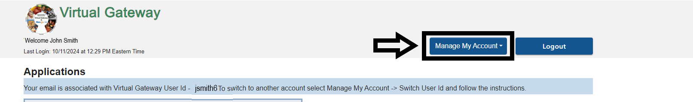

1. Click **Update** **Profile**

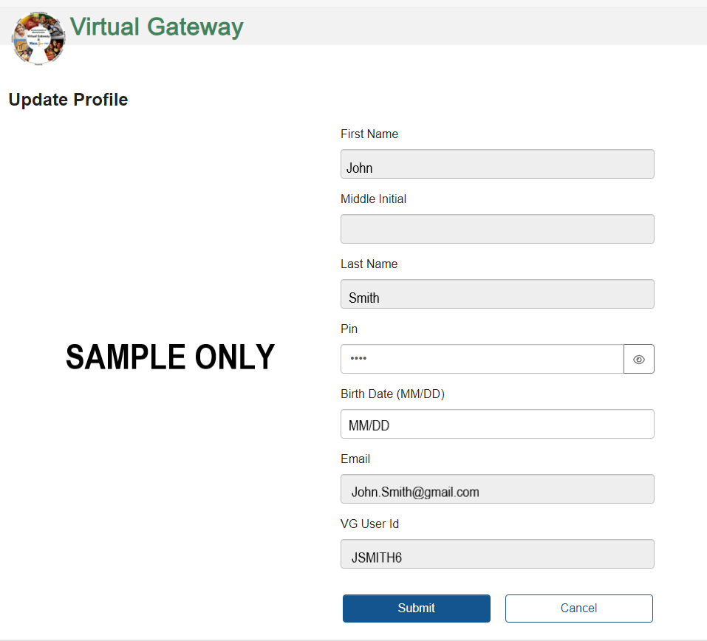

Only PIN and Birth Date (MM/DD) can be updated on this page. All other fields are view only.

1. Click **Submit** if updating PIN or Birth Date (MM/DD) or **Cancel**, if not making any updates.

## Need Assistance

Contact Virtual Gateway Customer Service at 800-421-0938.

TTY for the deaf and hard of hearing: Call Virtual Gateway, TTY at (617) 847-6578

Monday-Friday: 8:30 am - 5:00 pm