Commonwealth of Massachusetts
Executive Office of Health and Human Services
Update Virtual Gateway MyMassGov Business Account and/or Multi-Factor Authentication Reference Guide

Business Log In: Updating MyMassGov Account Settings
Business Log In: Updating MyMassGov Account Settings 1
Log In to MyMassGov account 1
Update Account Information in a MyMassGov account 3
Update Multi-Factor Authentication in a MyMassGov account 5
To change your authenticator app: Update 6
To change your authenticator app: Remove 7
To change your primary phone (voice and text): Update 7
To change your primary phone (voice and text): Remove 7
To change your secondary phone (voice and mail) 8

Log In to MyMassGov account
- Go to the Virtual Gateway page: https://virtualgateway.mass.gov/VGPortal5
- Under the Business Log In option click the link labeled ‘Click here to make changes to existing MyMassGov/MFA account’
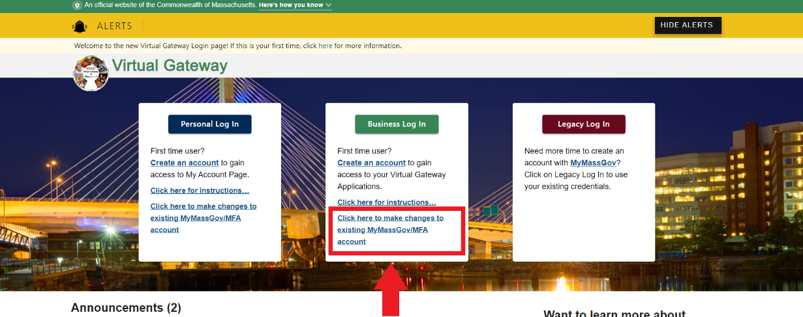
- Enter Email and Password. Click the LOG IN button.
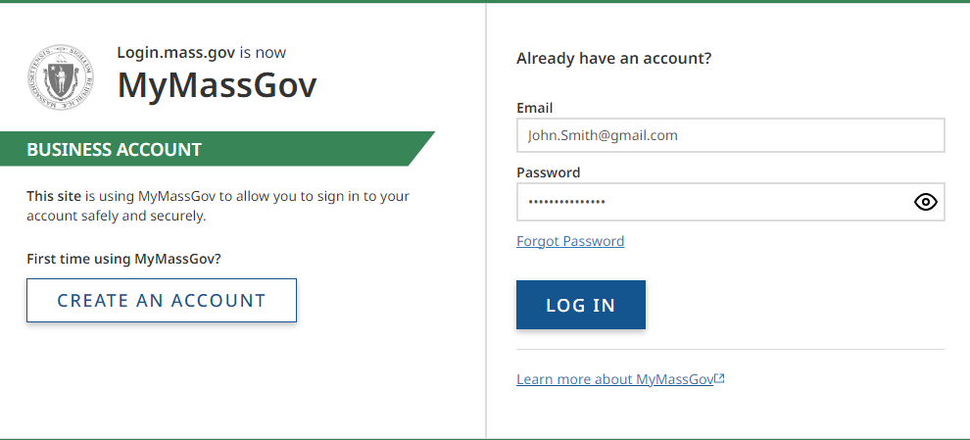
- Click the Multifactor Authentication (MFA) method as presented on the screen. This will vary per user based on prior MFA setup.
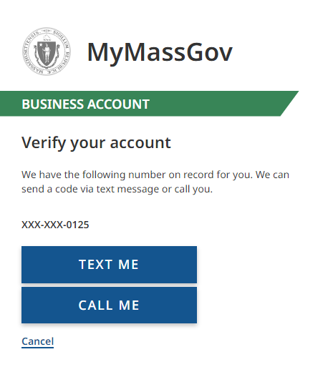
- Enter Code. Click the VERIFY button.
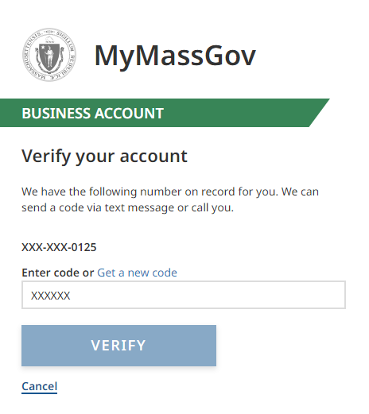

Update Account Information in a MyMassGov account
User redirected to the MyMassGov FOR BUSINESS Welcome page.
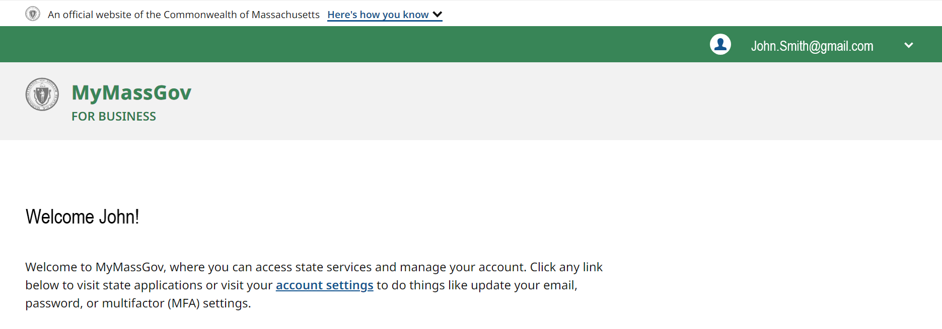
- Click the down arrow next to your user profile icon in the banner in the top right-hand corner of the screen.
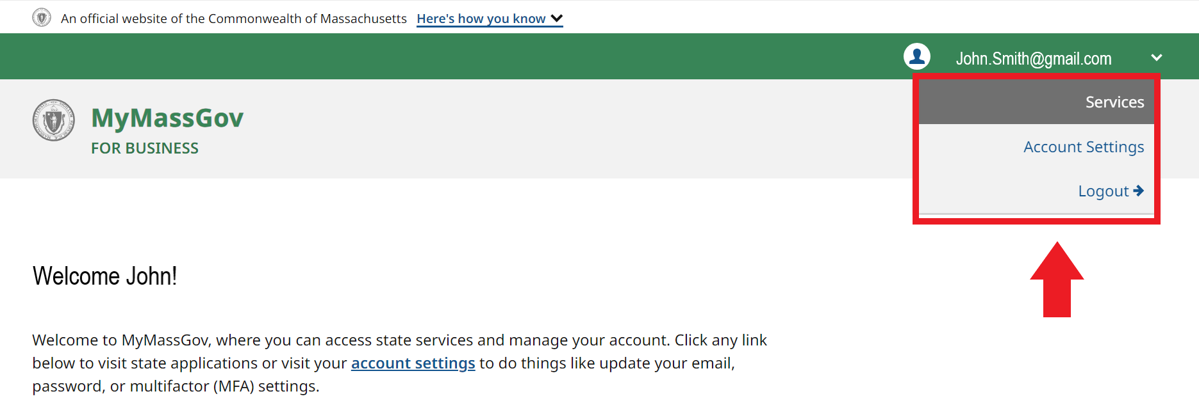
- Click Account Settings.
  - On the left side of the Account settings page, you will see that you are currently viewing the Account Information view. You can also update Multi-Factor Authentication (to switch, click on Multi-Factor Authentication).
  - On the right-hand side of the Account Information page, click the Edit button next to the option you want to update. You will be asked to Verify your account based off your MFA methods previously setup.
    - Name: Enter the first and last names you’d like to update your account with
    - Email: Enter the email address you’d like to update your account with
    - Password: Enter new password
- Click the SAVE button.
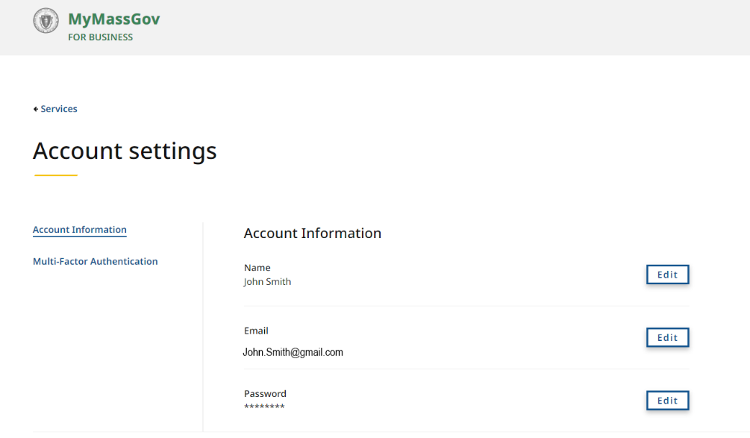
Once completed, you’ll be brought back to the ACCOUNT SETTINGS screen, where you’ll see a success message confirming the update.
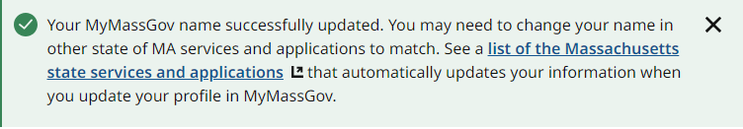
You’ll also receive an email message from the Commonwealth of Massachusetts, confirming that the name, email or password associated to your account was updated.
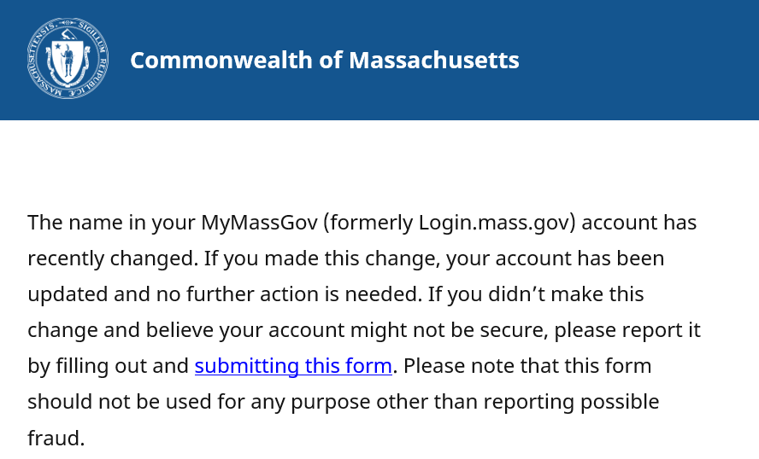

Update Multi-Factor Authentication in a MyMassGov account
Follow these steps to log in to MyMassGov and change the MFA settings in your personal or business account.
Follow these instructions to change or remove the MFA settings in your Business MyMassGov account.
- Go to the Virtual Gateway page: https://virtualgateway.mass.gov/VGPortal5
- Under the Business Log In option, Click here to make changes to existing MyMassGov/MFA account
- Enter Email and Password. Click the LOG IN button.
- Click the Multifactor Authentication (MFA) method as presented on the screen. This will vary per user based on prior MFA setup.
- Enter Code. Click Verify.
- Click on Account Settings
- Select Multi-Factor Authentication on the left-hand side of the account settings page
  - Note that any MFA methods that are already set up are indicated by a green circle next to them
- On the right-hand side of the “Multi-Factor Authentication (MFA) Methods” page, click on Update MFA Methods
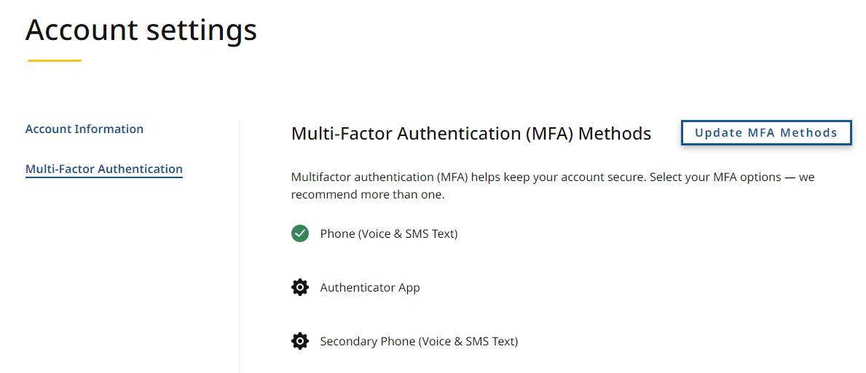
- You’ll be brought to a “Change your MFA settings” screen to choose the MFA setting you’d like to change
  - Note that SECONDARY PHONE (VOICE & TEXT MESSAGE) will only appear here if you already have a primary PHONE (VOICE & TEXT MESSAGE) option set up

To change your authenticator app: Update
- Click on ‘Authenticator app’*
- If you already have an authenticator app set up, you will see two options:
  - Update authenticator app
  - Remove authenticator app
- Click on ‘Update authenticator app’
- Open your authenticator app
- Scan the QR code with your phone
- Enter the code you receive in the ‘Verification code’ field
- Click ‘Continue’
(See directions for setting up an authenticator app if you need help).
8. When your change has been successfully completed, you will see a confirmation page
9. Click ‘Yes, I’d like to make more changes’ to change another MFA method or ‘No, I’m done’ if you’re finished
*NOTE: If an authenticator app has not been set up, you will be taken to a page to complete the process.

To change your authenticator app: Remove
- Click on ‘Authenticator app’
- If you already have an authenticator app set up, you will see two options:
  - Update authenticator app
  - Remove authenticator app
- Click on ‘Remove authenticator app’
- At the next screen, either confirm you would like to remove your authenticator app by clicking ‘Yes, remove this method’ or ‘No, keep this method’ to cancel out of the change process
- When your change has been successfully completed, you’ll see a confirmation page
- Click ‘Yes, I’d like to make more changes’ to change another MFA method or ‘No, I’m done’ if you are finished

To change your primary phone (voice and text): Update
- Click ‘Primary phone number (voice and text)*
- If you have a Primary phone number (voice and text) set up, you will see two options:
  - Update phone number
  - Remove phone number
- Click on ‘Update phone number’
- At the next screen, enter the updated phone number you’d like to link to your account
- Click either ‘Text Me’ or ‘Call Me’
- Enter the code you receive in the ‘Verification code’ field
(See directions for setting up Phone (voice and text) authentication if you need help).
- When your change has been successfully completed, you’ll see a confirmation page
- Click ‘Yes, I’d like to make more changes’ to change another MFA method or ‘No, I’m done’ if you are finished.
*NOTE: If a Primary phone (voice and mail) has not been set up, you will be taken to a page to do so.

To change your primary phone (voice and text): Remove
- Click ‘Primary phone number (voice and text)*
- If you have a Primary phone number (voice and text) set up, you will see two options:
  - Update phone number
  - Remove phone number
- Click ‘Remove phone number’
- At the next screen, either confirm you would like to remove your primary number by clicking ‘Yes, remove this method’ or ‘No, keep this method’ to cancel out of the change process
- When your change has been successfully completed, you will see a confirmation page
- Click on ‘Yes, I’d like to make more changes’ to change another MFA method or ‘No, I’m done’ if you are finished
NOTE: If you remove your primary phone number as a method and you have a secondary phone number set up, the secondary phone number will become the primary phone number.

To change your secondary phone (voice and mail)
- Click ‘Secondary phone (voice and text)’*
- Follow the same process as updating or removing Primary phone (voice and text)
*NOTE: A secondary phone number will only show if the primary phone number has already been set up as a method.
After completing your updates, click the Logout link to close your session.
