Massachusetts Department of Public Health | Bureau of Environmental Health

Updated Cancer Incidence Evaluation in Response to Community Concerns about PCB Contamination in the Housatonic River Area: Scope of Work

BACKGROUND

Since the early 1900s, General Electric (GE) operated a large-scale industrial facility in Pittsfield. Electrical transformers containing polychlorinated biphenyls (PCBs) were manufactured and serviced from 1932 to 1977. Years of PCB and industrial chemical use, and improper disposal led to extensive contamination of surface water, sediments, and floodplain soils around Pittsfield and along the Housatonic River. Since 1977, fishing and consumption of fish from areas of the Housatonic River have been banned. Remediation and restoration of the GE site and the Housatonic River is ongoing and being performed pursuant to a court-ordered consent decree issued in 2000.

A location of particular concern in Pittsfield is the Allendale Elementary School, which was built on fill consisting of soil removed from the GE site. PCBs were detected in soil on the school property in 1990 prompting some soils to be removed and a cap to be installed over much of the playground area. Subsequently, in 1999 and 2007/2008, a total of approximately 43,000 cubic yards of soil were removed and disposed. Restoration activities included backfilling with clean soil and installation of ball fields. Some soils were stockpiled at the nearby Hill 78 On-Plant Consolidation Area (OPCA). Since 2000, there have been no restrictions on the use of the school property. Since 2005, the U.S. Environmental Protection Agency (EPA) has conducted periodic air and groundwater sampling for PCBs at the Allendale School property and has found no detections of PCBs.

WHY IS THE MASSACHUSETTS DEPARTMENT OF PUBLIC HEALTH (DPH) EVALUATING HEALTH INFORMATION?

DPH routinely conducts health data reviews across the state to respond to questions from residents and local health departments. At the request of the Pittsfield Health Director, DPH attended meetings of the Pittsfield Public Health and Safety Committee in October 2020 and January 2021. DPH provided an overview of how cancer incidence is evaluated and a summary of past evaluations.

In 2002, DPH evaluated the incidence of 6 cancer types among residents of Pittsfield, Great Barrington, Lenox, Lee, and Stockbridge during 1982-1994 in response to concerns expressed by residents about possible exposures to PCB contamination associated with the GE site and the potential association with cancer incidence. Overall, the pattern of cancer did not suggest a relationship to PCB exposure or that a common environmental exposure pathway played a role.

In response to a request from the Pittsfield Public Health and Safety Committee for an evaluation of updated cancer incidence data, DPH will conduct a screening-level review of relevant health data collected by DPH.

WHAT TYPE OF HEALTH INFORMATION WILL DPH REVIEW?

DPH routinely collects health data across the state to monitor health and disease patterns in our communities. DPH will use data collected by the Massachusetts Cancer Registry to evaluate the pattern of selected cancer types in the Housatonic River area over a 25-year period.

The following 10 cancer types were selected based on having some evidence of possible association with PCB exposure in scientific studies:
▪ Breast ▪ Liver/intrahepatic bile duct
▪ Colon/rectum ▪ Gallbladder
▪ Melanoma ▪ Biliary tract
▪ Prostate ▪ Stomach
▪ Non-Hodgkin lymphoma
▪ Childhood acute lymphocytic leukemia

Bladder cancer will also be reviewed in Pittsfield and its 11 census tracts to follow up on statistical elevations previously identified during 1982-1994.

WHERE IS THE DPH EVALUATION AREA?

For health data reviews, DPH uses community boundaries and U.S. Census Bureau census tracts. Census tracts are small areas for which reliable disease rates can be calculated. DPH will focus on the 5 communities of Pittsfield, Great Barrington, Lee, Lenox, and Stockbridge as well as the 11 census tracts within Pittsfield. See the map below.

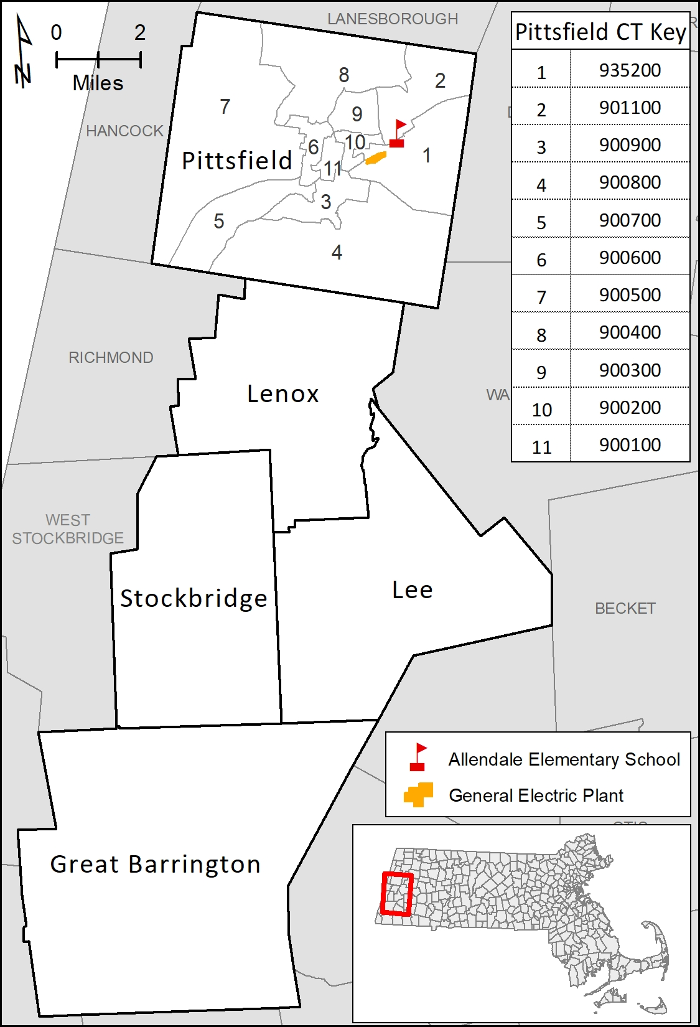

WHAT WILL THE RESULTS TELL US?

Diseases occur in the general population at a certain frequency and with certain characteristics. DPH will look to see if the patterns of these cancer types appear unusual at the community and census tract level.
If the pattern appears unusual, DPH will provide additional support to residents and work with EPA on any follow-up actions.

It is not an investigation to determine the cause of cancer in any individual. It also will not evaluate cancer incidence among students and staff of the Allendale School, which cannot readily be calculated given available data.

View our information sheet about cancer in Massachusetts for additional background and to learn about the type of information DPH considers during routine screening-level reviews.

HOW WILL THE RESULTS BE SHARED?

DPH will share the findings in writing with local health officials in the communities of Pittsfield, Great Barrington, Lee, Lenox, and Stockbridge. The findings will also be available to the public on the DPH website. DPH staff will be available to answer questions from residents.

No personal health information will be shared, only summary information for the 5 communities and 11 census tracts in this screening-level review.

WHERE CAN I GET MORE INFORMATION?
For questions about health concerns or this review of health data:
Massachusetts Department of Public Health
Bureau of Environmental Health
Phone: 617-624-5757
www.mass.gov/dph/environmental_health

If you are experiencing symptoms or have medical care questions, DPH always recommends consulting with your health care provider.
For questions about the ongoing remediation at the GE-Pittsfield/Housatonic River site:
U.S. Environmental Protection Agency
Community Involvement Coordinator
Kelsey Dumville
Phone: 613-918-1003

Massachusetts Department of Public Health
Bureau of Environmental Health
250 Washington Street
Boston, MA 02108
Phone: 617-624-5757 | Fax: 617-624-5777 | TTY: 617-624-5286
www.mass.gov/dph/environmental_health

April 2023

