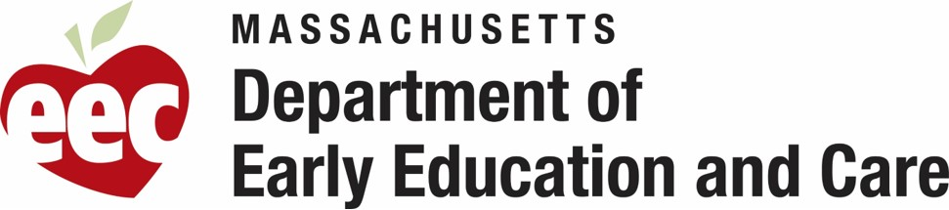
Direct care staff and supervisors at programs licensed and/or funded by the Department of Early Education and Care (EEC) are now eligible for the MA Repay Program, a student loan repayment program. This includes staff who work in center-based child care, out-of-school time (OST), and family child care (FCC) programs, including educators and assistants, as well as staff who work in residential programs.
Below you will find draft an outreach email that you can use to share awareness on the recent student loan forgiveness program that includes Early Childhood staff.
You can find more details here.

Material/ Support Language Access
- The application is available in English, Spanish, Portuguese, and Simplified Chinese.
- Phone support is available in English and Spanish.
Contents
Material/ Support Language Access 1
English 1
Spanish 2
Portuguese 2
Simplified Chinese 3

English
Early Education and Care Educators and Programs/ Residential Programs,
We are pleased to share that direct care staff and their supervisors at programs licensed and/or funded by the Department of Early Education and Care (EEC) are now eligible for the MA Repay Program, a student loan repayment program. This includes staff who work in center-based child care, out-of-school time (OST), and family child care (FCC) programs, including educators and assistants. This includes staff who work in residential programs.
Educators may qualify for between $3,000-$30,000 in student loan debt repayment.
The application closes 3/13/2024 or once the award amounts requested by applicants reaches approximately twice the available award funding for this program as determined by the Executive Office of Health and Human Services, whichever comes first.
Learn more and find out if you qualify at https://www.marepay.org/.

Spanish
Educadores y Programas de Educación y Cuidado Temprano/ Programas Residenciales,
Nos complace compartir que el personal de atención directa y sus supervisores en los programas autorizados y / o financiados por el Departamento de Educación Temprana y Cuidado (EEC) son ahora elegibles para el Programa de MA Repay, un programa de reembolso de préstamos estudiantiles. Esto incluye al personal que trabaja en centros de cuidado de niños, fuera del horario escolar (OST), y los programas de cuidado infantil familiar (FCC), incluidos los educadores y asistentes. Esto incluye también al personal que trabaja en programas residenciales.
Los educadores pueden calificar para recibir entre 3.000 y 30.000 dólares de reembolso de la deuda de préstamos estudiantiles.
La solicitud se cierra el 13/3/2024 o una vez que los importes de adjudicación solicitados por los solicitantes alcancen aproximadamente el doble de los fondos de adjudicación disponibles para este programa, conforme lo determine la Oficina Ejecutiva de Salud y Servicios Humanos, lo que ocurra primero.
Obtenga más información y averigüe si cumple con los requisitos en https://www.marepay.org/.

Portuguese
Educadores e Programas de educação e cuidados infantis/programas residenciais,
Temos a satisfação de compartilhar que a equipe de cuidados diretos e os supervisores de programas licenciados e/ou financiados pelo Departamento de Educação e Assistência Infantil (EEC) são agora elegíveis para participar do Programa de reembolso de Massachusetts, um programa de reembolso de empréstimos estudantis. Isso inclui funcionários que trabalham em programas de cuidados infantis baseados em centros, fora do horário escolar (OST) e cuidados infantis familiares (FCC), incluindo educadores e assistentes. Isso também inclui funcionários que trabalham em programas residenciais.
Os educadores podem se qualificar para receber de $3.000 a $30.000 em reembolso de dívidas de empréstimos estudantis.
As inscrições se encerram em 13/03/2024 ou quando as quantias solicitadas pelos candidatos atingirem aproximadamente o dobro do financiamento disponível para este programa, conforme determinado pelo Gabinete Executivo de Saúde e Serviços Humanos, o que ocorrer primeiro.
Saiba mais e descubra se você se qualifica no site: https://www.marepay.org/.

Simplified Chinese
致各早期教育和护理教育者和计划/住宿计划，
我们很高兴地与大家分享，由早期教育和护理部 （EEC） 所颁发执照和/或资助的项目的直接护理人员及其主管现在有资格参加 MA Repay Program，此计划是一项学生贷款还款计划。它涵括了在中心托儿所、校外时间 （OST） 和家庭托儿所 （FCC） 计划中工作的工作人员，包括教育工作者和助理。在住宿项目中工作的员工也包括在内。
教育工作者可能有资格获得 3,000 至 30,000 美元的学生贷款债务偿还。
申请截止日期为 2024 年 3 月 13 日，或者一旦申请人要求的获批免偿还金额达到卫生与公众服务执行办公室确定的该计划可用获批资金的大约两倍为止，看两个条件哪一个先达到。
如想了解更多信息，并了解您是否符合资格，请登录网址： https://www.marepay.org/.

