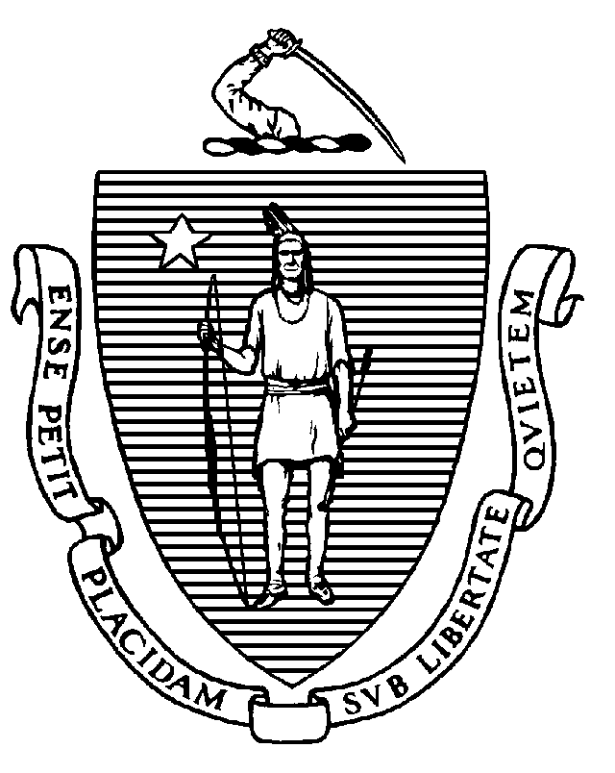
The Commonwealth of Massachusetts
Executive Office of Health and Human Services
Department of Public Health
Bureau of Health Care Safety and Quality
67 Forest Street, Marlborough, MA 01752

CHARLES D. BAKER
Governor
KARYN E. POLITO
Lieutenant Governor

MARYLOU SUDDERS
Secretary
MARGRET R. COOKE
Commissioner

Tel: 617-624-6000
www.mass.gov/dph

Memorandum

TO: Long-Term Care Facilities
FROM: Elizabeth Kelley, MBA, MPH, Director, Bureau of Health Care Safety and Quality
SUBJECT: Long-term Care Facility COVID-19 Personnel Vaccination Requirement
DATE: November 2, 2022

The Massachusetts Department of Public Health (DPH) continues to work with state, federal and local partners on the Coronavirus Disease 2019 (COVID-19) pandemic, and we continue to appreciate the essential role you have in responding to this evolving situation. This guidance replaces guidance issued on September 28, 2022; this update clarifies vaccination requirements for personnel in long-term care facilities (LTCFs) and how DPH will enforce the COVID-19 personnel vaccination requirement in LTCFs.

COVID-19 Vaccination Requirement:

Pursuant to the long-term care regulations (105 CMR 150.002(D)(11)), nursing homes and rest homes must ensure that all personnel have completed the full required regimen of vaccine doses against COVID-19 unless such administration is medically contraindicated, which means administration of COVID-19 vaccine is likely to be detrimental to the individual’s health, provided that the individual provides supporting documentation, or the individual objects to vaccination on the basis of a sincerely held religious belief. If the individual seeks an exemption for either medical or religious reasons, the individual must be able to perform their essential job functions with a reasonable accommodation that is not an undue burden on the nursing home or rest home. Personnel may not otherwise decline the vaccine. Nursing homes and rest homes shall ensure that all new personnel have completed their primary series of COVID-19 vaccine or qualify for an exemption from the requirement as described herein prior to being hired or otherwise affiliated with the facility.

Nursing homes and rest homes must ensure that all eligible personnel have completed the primary series of COVID-19 vaccine in accordance with the Centers for Medicare and Medicaid Services (CMS) requirements. While not required, all LTCF personnel are strongly encouraged to stay up to date with COVID-19 vaccines, which means an individual has received all doses in the primary series and received the most recent booster dose recommended for the individual by the CDC. In accordance with the LTC Surveillance Testing Guidance, personnel who are not yet up-to-date with COVID-19 vaccines should continue to test twice per week to reduce the risk of transmitting COVID-19 to residents or other personnel.

Any individual who has been granted a reasonable accommodation by their employer based on medical contraindication or a sincerely held religious belief is exempt from the requirement to receive the primary series. Nursing homes and rest homes must ensure that personnel who have not yet received their primary series and who have not been granted a reasonable accommodation receive the primary series as soon as possible. All new personnel must have received the primary series at the time of hiring.

Facility Documentation:

Nursing homes and rest homes shall require and maintain for each individual proof of current vaccination against COVID-19 or the individual’s declination statement and must have a central system to track the vaccination status of all personnel. The proof of current vaccination and central system must be made available to DPH upon request. Individual proof of current vaccination may include but is not limited to:
- Copy of CDC Vaccination Card
- Copy of MA Immunization Information System (MIIS) Vaccination Record
- Copy of vaccination from their electronic health record
- COVID-19 SmartHealthcard from the Commonwealth’s MyVaxRecords public portal

Declination statements from personnel must include but are not limited to: each individual who declines vaccination due to medical contraindication or a sincerely held religious belief signing a statement certifying he or she received information about the risks and benefits of COVID-19 vaccine. Appropriate documentation of a medical exemption must be issued by a licensed independent practitioner who has a practitioner/patient relationship with the individual and the documentation must support the finding that the COVID-19 vaccine is medically contraindicated, which means that the vaccine would likely be detrimental to the person’s health.

For every individual who has submitted a request for exemption, the nursing home or rest home must document that it has engaged in an appropriate individualized determination that the exemption is valid and that the nursing home or rest home has determined that the individual is able to perform their essential job functions with a reasonable accommodation that is not an undue burden on the employer. DPH recommends that facilities work with their legal counsel to ensure they conduct an appropriate process. As part of this individualized determination, nursing homes and rest homes should incorporate clinical considerations beyond standard infection control requirements (e.g., testing frequency). For example:
- requiring additional testing that goes above currently required DPH surveillance or outbreak testing guidance; and
- avoiding direct care for residents who are confirmed or suspected to be infected with COVID-19, are immunocompromised or who have not completed their primary series; and
- refraining from working after a close contact or exposure.

DPH supports staff using personal protective equipment as outlined in the Comprehensive PPE Guidance and does not endorse clinical considerations that deviate from this guidance. For example, while N95 respirators should be worn when caring for a patient with confirmed or suspected COVID-19, the available evidence does not support using N95 respirators as daily PPE as a substitute for direct care staff being vaccinated against COVID-19.

Nursing Home Reporting:

Nursing homes must use the CDC’s National Healthcare Safety Network (NHSN) to report cumulative weekly COVID-19 vaccination for residents and personnel through the Long-Term Care Facility Component. DPH will use data submitted through the weekly COVID-19 vaccination modules to provide consistent reporting and comparable data across facilities. NHSN data can be used to monitor COVID-19 vaccination trends over time, identify facilities with lower resident and/or personnel vaccination rates, and inform planning and implementation decisions regarding vaccine supply and distribution.

Training, data collection forms, and instructions can be found on the following NHSN website under ‘HCP & Resident COVID-19 Vaccination’: https://www.cdc.gov/nhsn/ltc/weekly-covid-vac/index.html

Facilities can access the COVID-19 vaccination modules by logging into NHSN (via Secure Access Management Service) as they would for any of the other NHSN reporting (cdc.gov). On the NHSN Home page, select the ‘COVID-19’option on the left-hand navigation bar. Personnel and resident data should be entered by selecting ‘COVID-19 Vaccination-HCW’ and ‘COVID-19 Vaccination-Residents’ respectively. This reporting is separate from the ‘Daily Entry’ where facilities enter weekly case counts and supply data. For reference, please see the image below:

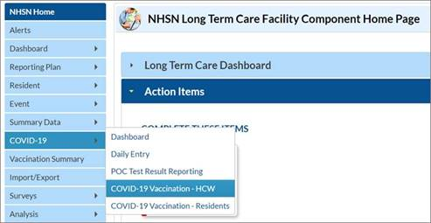

Nursing homes must complete the two vaccination modules each week, no later than Sunday at 11:59 PM, in alignment with the CMS weekly deadline.

Rest Home Reporting:

Rest homes must use DPH’s Health Care Facility Reporting System (HCFRS) to report cumulative monthly COVID-19 vaccination for residents and personnel through the COVID-19 Vaccination Module.

Facilities can access the HCFRS COVID-19 vaccination modules by logging into the Virtual Gateway as they would for any of the other required reporting or find more information at the following link: https://www.mass.gov/guides/how-to-set-up-initial-access-to-the-hcfrs

Rest homes must complete the vaccination module by the last day of each month, no later than 11:59 PM. Details about the specific information required to be reported and format may be found in Appendix A.

The Bureau may revise, change, update, or rescind this memorandum at any time.

DPH strongly encourages all nursing and rest homes in Massachusetts to monitor the Centers for Disease Control and Prevention (CDC) website for up-to-date information and resources:
- CDC Infection Control website: https://www.cdc.gov/coronavirus/2019-ncov/hcp/infection-control-recommendations.html
- CDC healthcare personnel exposure guidance may be found here: https://www.cdc.gov/coronavirus/2019-ncov/hcp/guidance-risk-assesment-hcp.html

Additionally, please visit DPH’s website that provides up-to-date information on COVID-19 in Massachusetts: https://www.mass.gov/2019coronavirus.

QSO-22-07 ALL Long-Term Care and Skilled Nursing Facility (cms.gov)
https://www.mass.gov/doc/updates-to-long-term-care-surveillance-testing-6-10-2021/download

