This job aid includes steps to update Category 1 Line Item information with or without creating a Personnel Summary. You should refer to your Agency Contract Manager to determine if you are required to complete a Personnel Summary to update Category 1 information before using this job aid.
Updating Category 1 Line Item Information: Creating a Personnel Summary in EIM
If you are required to complete a Personnel Summary:  - Access the Invoice Summary page.  - Select Personnel Summary from the navigation bar.  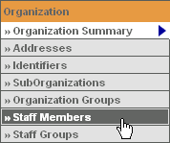  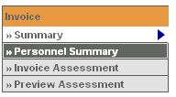  The Personnel Summary Information page appears.  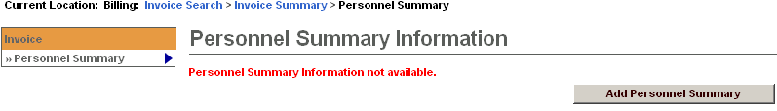  - Click .  The Personnel Summary page expands.  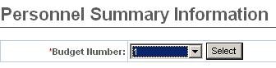  - Select a Budget Number.  - Click .  The Personnel Summary Add page appears. | 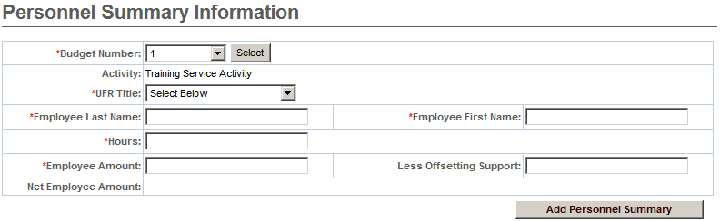  - Enter data in the required fields: Budget Number, UFR Title, Employee Last Name, Employee First Name, Hours, Employee Amount  Tip: The Employee Amount field should be the total of all wages paid to the employee during the billing period.  - Click.  The Personnel Summary page reappears with newly-entered information.  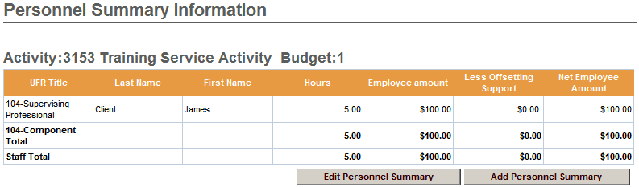  Note: When you add multiple Personnel Summary records (staff names) to the same Program Component UFR, the updated amount is reflected in the Invoice Summary for individual staff members as well as shown as a component total.

Updating Category 1 Information Without Creating a Personnel Summary
If you are not required to complete a Personnel Summary to update Category 1 Line items:  - Access the Invoice Summary page.  - Click .  The Invoice Summary page appears in “edit” mode:  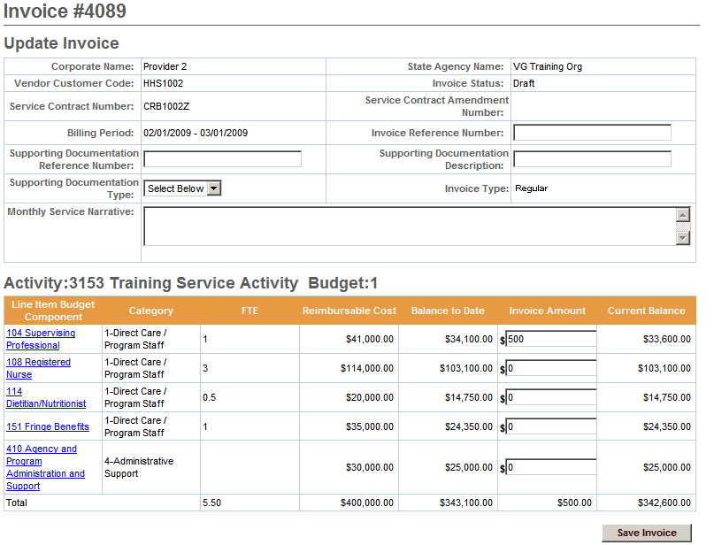  - Enter new Invoice Amount(s), as needed.  - Click . | The Invoice Summary page appears in “read only” mode with the new Invoice Amount(s) and Current Balance:  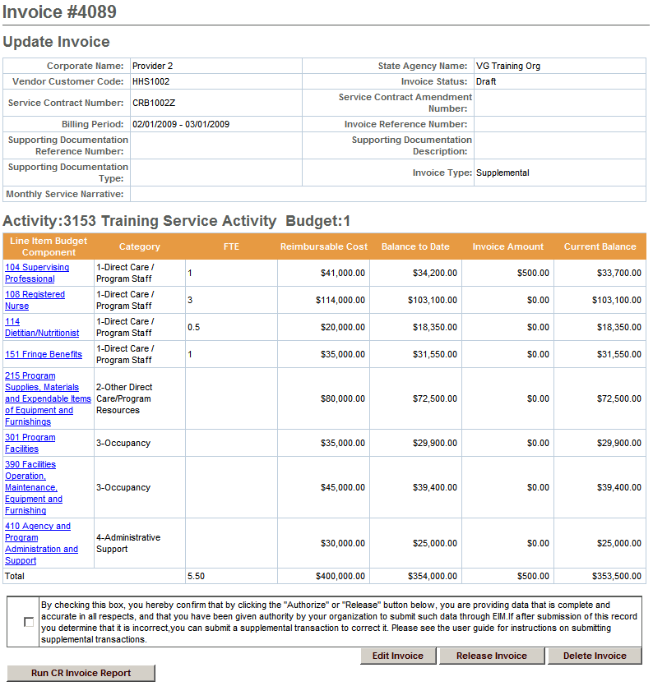
Questions or need assistance?
Call Virtual Gateway Customer Service
1-800-421-0938
(617-847-6578 - TTY for the deaf and hard of hearing)
8:30 am to 5:00 pm Monday through Friday

