WATER DAMAGE ASSESSMENT

Upton Library
2 Main Street
Upton, MA

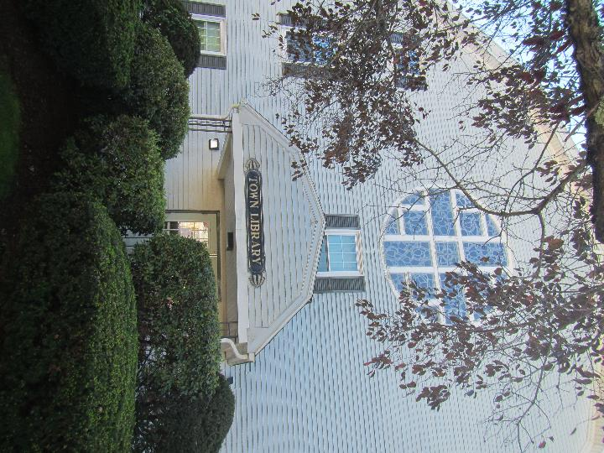

Prepared by:
Massachusetts Department of Public Health
Bureau of Environmental Health
Indoor Air Quality Program
October 2021

BACKGROUND
Building: | Upton Town Library
Address: | 2 Main Street, Upton, MA
Assessment Requested by: | Derek Brindisi, Town Manager, Town of Upton
Reason for Request: | Concerns regarding water damage and general indoor air quality (IAQ)
Date of Assessment: | September 29, 2021
Massachusetts Department of Public Health/Bureau of Environmental Health (MDPH/BEH) Staff Conducting Assessment: | Ruth Alfasso Environmental Engineer/Inspector, Indoor Air Quality Program
Building Description: | The library is a two-story wood frame building with a fieldstone foundation originally built as a church. It was renovated to become town offices and the library in the 1970s. In 2013, efforts were made to improve drainage around the building and decrease water infiltration. Some water damage remediation and cosmetic upgrades including paint and new carpet were also performed at that time.
Windows: | Openable

METHODS
DPH staff conducted testing for carbon dioxide, carbon monoxide, temperature, and relative humidity with a TSI, Q-Trak, IAQ Monitor 7565. Surface temperature was measured using a laser thermometer. Moisture testing of flooring and other materials was determined using a moisture meter, and a visual assessment of water-damaged materials was also conducted. Air tests for airborne particle matter with a diameter less than 2.5 micrometers were taken with the TSI, DUSTTRAK™ Aerosol Monitor Model 8520. Please refer to the IAQ Manual for methods, sampling procedures, and interpretation of results (MDPH, 2015).
Note that this building was visited previously by the IAQ program in 2000.

RESULTS AND DISCUSSION
The following is a summary of indoor air testing results (Table 1):
- Carbon dioxide levels were below the MDPH recommended level of 800 parts per million (ppm) in all areas surveyed.
- Temperature was within the MDPH recommended range of 70°F to 78°F in areas tested.
- Relative humidity was slightly above the MDPH recommended range of 40 to 60% in one occupied area (64%) and in the basement mechanical area (71%).
- Carbon monoxide levels were non-detectable (ND) in all areas tested.
- Particulate matter (PM2.5) concentrations measured were below the National Ambient Air Quality (NAAQS) level of 35 μg/m³ in all areas tested

Ventilation
A heating, ventilating and air conditioning (HVAC) system has several functions. First it provides heating and, if equipped, cooling. Second, it is a source of fresh air. Finally, an HVAC system will dilute and remove normally occurring indoor environmental pollutants by not only introducing fresh air, but by filtering the airstream and ejecting stale air to the outdoors via exhaust ventilation. Even if an HVAC system is operating as designed, point sources of respiratory irritation may exist and cause symptoms in sensitive individuals.
There are supply vents located in a few places in the library. It is believed these are connected to air handling units (AHU) in the ceiling, which could not be examined at the time of the visit. These vents supply cooled air during the summer. No vents on the exterior of the building were identified, so it is unclear if these AHU can supply fresh air. Windows in most of the library are openable and these appear to be the primary source of fresh air. Heating is also supplied by hot-water radiators along the outside edge of the building.
Exhaust vents have been installed in the main level restrooms (Picture 1). These are tied to the light switch and so only operate when the lights are on. Restroom vents are necessary to remove moisture and odors from the use of the restroom; tying the operation of vents to the light may reduce the utility of the vents.
In order to increase ventilation on the main library floor, some of the windows have been equipped with fans (Picture 2). These fans have the ability to blow either in or out of the window. At the time of the visit, all fans were set to blow air out of the building. Operating in this manner may depressurize the main area of the library. If this depressurization is significant enough, it may draw air from unintentional places, such as through gaps in the building envelope, and from unconditioned spaces such as the basement. It may be helpful to use these fans to either draw air in on all sides, which may help to pressurize the main area of the library, or to provide a measure of cross-ventilation, by drawing air in on one side of the building and exhausting it on the other. During very wet or very cold weather, this method may not be advisable due to moisture and temperature concerns.
The library has also purchased a few large air purifying units (Picture 3). According to manufacturer’s literature on these units, they contain a Minimum Efficiency Reporting Value (MERV) 7 pre-filter and a high-efficiency particulate arrestance (HEPA) filter, which can effectively remove particulates. HEPA filters, however, do not remove gases such as carbon dioxide, and are not able to remove odors that aren’t associated with particulates or aerosols. Therefore, some introduction of fresh air is required for optimal air quality, and source control of odors is also necessary.
A window air conditioner was also noted in one of the upstairs rooms (Picture 4). These units can supply some fresh air when operated in non-recirculating mode. They have filters that need to be cleaned periodically.
To maximize air exchange, the MDPH recommends that both supply and exhaust ventilation operate continuously during periods of occupancy. In order to have proper ventilation with a mechanical supply and exhaust system, the systems must be balanced to provide an adequate amount of fresh air to the interior of a room while removing stale air from the room. It is recommended that HVAC systems be re-balanced every five years to ensure adequate air systems function (SMACNA, 1994). It is not clear if the systems at the Upton Library can be balanced.

Microbial Concerns
The reasons for this visit to the Upton Library were concerns regarding odors and water damage in the building. When this building was visited in 2000, several recommendations were made to improve drainage and reduce the potential for odors to enter occupied areas from the dirt-floor basement. In 2013, several improvements were made to the building including:
- improved exterior drainage,
- covering the dirt floor in the basement with plastic,
- sealing breaches between the basement and the main level including those around radiator pipes,
- removal and replacement of water-damaged building materials inside the building next to the walls, and
- replacement of most carpeting in the building.
While these activities have reportedly decreased issues with odors and dampness in the building, concerns remain. In part, this is related to the very high amount of rain and days of high humidity that have been experienced in Massachusetts over the summer of 2021. In the experience of the IAQ program, many buildings are struggling to reduce humidity and control mold growth and odors.

Basement-related issues
The basement area of the building was examined. The door separating the basement from the main area was equipped with weather-stripping at the bottom, which is helpful to keep basement air out of unoccupied areas. The basement had a mild musty odor, which is reported to be markedly decreased from the condition before the plastic had been used to cover the dirt floor. One area of the basement has a concrete slab on which the hot water heaters for the radiators and domestic hot water are located. This slab is equipped with a sump and pump (Picture 5). This sump needs a cover to reduce odors from the stagnant water.
The basement also has a bulkhead door to the outside (Picture 6). This door has a hole for a hose to be drawn through. A cover or plug for this hole would reduce the potential for water and pests to enter the basement when the hose is not in use.
If the basement continues to be a source of odors to the main level of the building, systematic depressurization of the basement area may be a potential solution. Installation of fans which can draw air from the basement and eject it outside, such as through pipes, can reduce the potential for air from the basement to migrate to the upper level.

Other water damage issues
Other signs of water damage and potential sources of odors were identified in the building during the visit. Water-damaged ceiling tiles were noted in the restrooms on the main level (Picture 1). These are reportedly due to historic leaks from the plumbing system. While the water-damaged ceiling tiles were dry at the time of the assessment and did not appear to be colonized with mold, frequent moistening of porous materials such as ceiling tiles can lead to mold growth. Stained ceiling tiles should be replaced when the source of water has been identified and repaired. Water leaks in restrooms can also moisten other materials such as wood underflooring beneath tiles or laminate, which can also become colonized with mold.
Although most of the carpeting in the Upton Library was replaced in 2013 and is in good condition, the carpeting in the entryway area appears to be much older. This carpeting is also covered by a large walk-off mat. Moisture testing of the mat and the carpeting showed both were wet on the day of the assessment, likely from foot traffic during heavy rain earlier in the week. A musty odor was detectible from this carpeting. Carpeting that is chronically moistened may become colonized with mold and create odors. The DPH IAQ program does not recommend the use of carpeting in areas which are likely to be subject to moisture.

Other Conditions
Odors in a library can also be due to stored materials. Books which are returned or donated to the library should be monitored for water damage, mold and pests and cleaned where possible or discarded.
Carpets should be cleaned annually (or semi-annually in soiled/high traffic areas) in accordance with Institute of Inspection, Cleaning and Restoration Certification (IICRC) recommendations, (IICRC, 2012). Regular cleaning with a high efficiency particulate air (HEPA) filtered vacuum in combination with an annual cleaning will help to reduce accumulation and potential aerosolization of debris from carpeting.

CONCLUSIONS AND RECOMMENDATIONS
In view of the findings at the time of the visit, the following recommendations are made:

Ventilation Recommendations
- Assess whether the HVAC system brings in fresh air. If it does not, consider if future upgrades can be made to supply fresh air through the HVAC system.
- Operate the HVAC system to provide for continuous ventilation during occupied hours.
- Ensure all exhaust vents are drawing air during occupied periods to remove stale air, odors, moisture, and irritants.
- Use openable windows to supplement fresh air during temperate weather where possible. Ensure all windows are closed tightly at the end of each day.
- When operating window-mounted fans, consider using them to either pressurize the main floor of the library (all operating inward) or to provide cross ventilation (inward and outward on opposing sides) rather than in exhaust only mode.
- Change filters in HVAC units at least twice a year. Use MERV 8 or higher filters to the greatest extent that the equipment can handle.
- Maintain the air purifying units in accordance with manufacturer’s instructions including cleaning and filter changes.
- Clean window air conditioner filters periodically.
- If applicable, consider adopting a balancing schedule of every 5 years for all mechanical ventilation systems, as recommended by ventilation industrial standards (SMACNA, 1994).

Water Damage Recommendations
- Continue to monitor the basement for odors. If basement-related odors are detected on the main level, continue to seal any breaches between the basement and the main level.
- Remove the water-damaged carpeting in the entryway and replace with non-porous flooring. Ensure any walk-off mats are kept clean.
- Replace water-damaged ceiling tiles and examine the spaces above the tiles for any additional water-damaged materials.
- Examine other materials in restrooms such as underflooring that may have gotten wet for any water stains or odors and replace as needed.
- All water-damaged material should be removed in a manner consistent with recommendations listed in the US EPA’s “Mold Remediation in Schools and Commercial Buildings” (US EPA, 2008). This work should be performed when the building is unoccupied.
- Install a tight-fitting cover on the sump in the basement. Periodically check the pump to make sure it is working.
- Seal the hose hole in the bulkhead door with a plug or cap when it is not in use to deter pests and reduce moisture infiltration.
- Trim any plants within 5 feet of the building exterior, including overhanging trees.
- Ensure all materials brought into the library are inspected for odors and pests and cleaned or discarded when necessary.
- During humid weather, consider using dehumidifiers in the main library area to reduce the potential for condensation. Limit the use of open windows during elevated relative humidity (i.e., >70% outdoors). Do not operate dehumidifiers if windows are open.

Other Recommendations
- Clean supply/exhaust vents and personal fans regularly to remove accumulated dust/debris.
- Clean carpeting regularly in accordance with IICRC recommendations.
- Refer to the resource manual and other related indoor air quality documents located on the MDPH’s website for further building-wide evaluations and advice on maintaining public buildings. These documents are available at http://mass.gov/dph/iaq.

REFERENCES
MDPH. 2015. Massachusetts Department of Public Health. Indoor Air Quality Manual: Chapters I-III. Available at: https://www.mass.gov/lists/indoor-air-quality-manual-and-appendices
IICRC. 2012. Institute of Inspection, Cleaning and Restoration Certification. Carpet Cleaning: FAQ. Retrieved from https://www.iicrc.org/page/IICRCStandards.
SMACNA. 1994. HVAC Systems Commissioning Manual. 1st ed. Sheet Metal and Air Conditioning Contractors’ National Association, Inc., Chantilly, VA.
US EPA. 2008. “Mold Remediation in Schools and Commercial Buildings”. Office of Air and Radiation, Indoor Environments Division, Washington, DC. EPA 402-K-01-001. September 2008. Available at: http://www.epa.gov/mold/mold-remediation-schools-and-commercial-buildings-guide

Picture 1

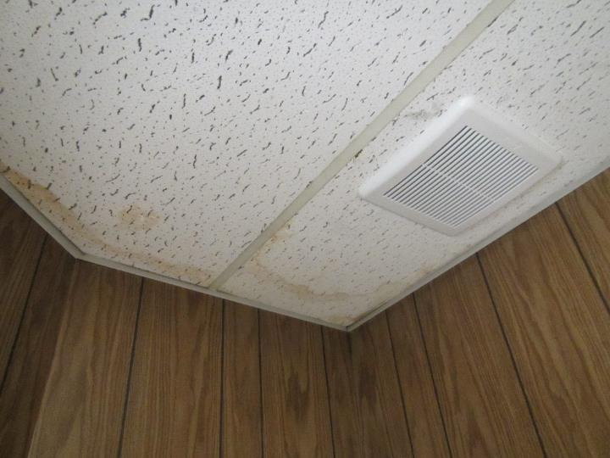
Restroom exhaust vent, note water-damaged ceiling tiles
Picture 2
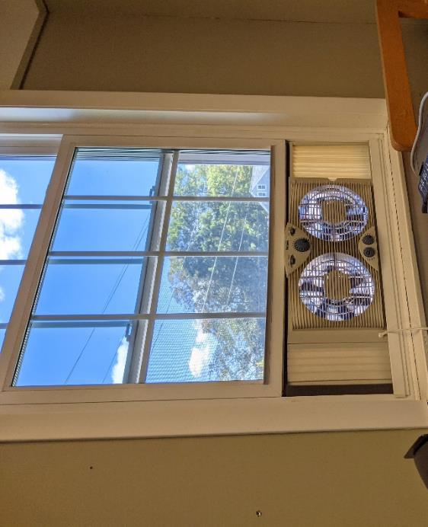
Reversible fan in window
Picture 3
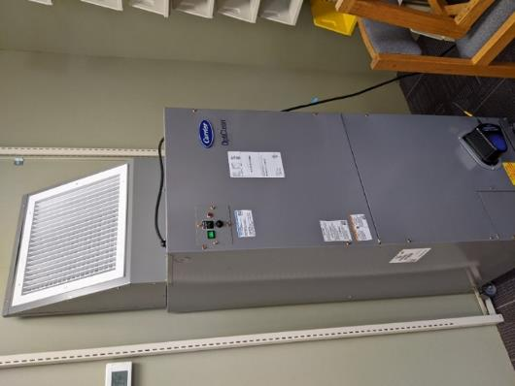
Air scrubber unit
Picture 4
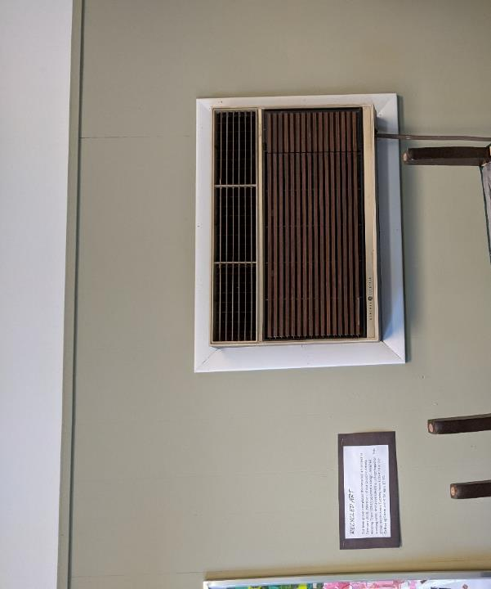
Window air conditioner built into a wall on the second floor
Picture 5
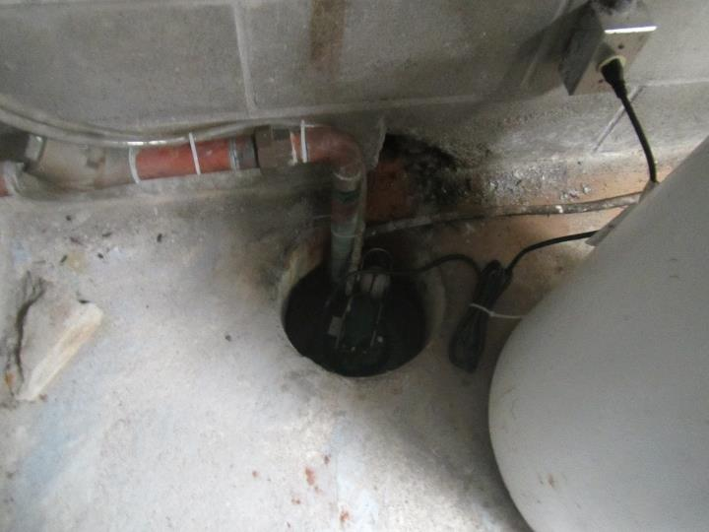
Sump hole in cement part of basement floor

Picture 6
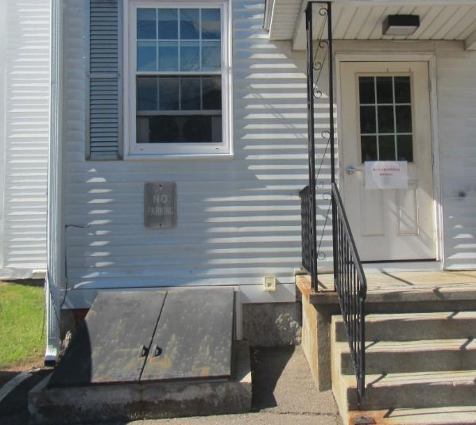
Basement bulkhead doors
Location | Carbon Dioxide  (ppm) | Carbon Monoxide (ppm) | Temp  (°F) | Relative  Humidity  (%) | PM2.5  (µg/m³) | Occupants | Window  Openable | Ventilation |  | Remarks
 |  |  |  |  |  |  |  | Supply | Exhaust
Background (outside) | 370 | 0.8 | 74 | 31 | 1 |  |  |  |  | Sunny and breezy
Vestibule | 422 | ND | 71 | 45 | 1 | 0 | N (door) | N | N | Carpet measures as wet, especially under the entryway mat. Carpet in this area may be original to the use of the building as a library.
Museum (upstairs) | 395 | ND | 70 | 50 | 3 | 0 | N | N | N
Cable TV (upstairs) | 407 | ND | 70 | 53 | 1 | 0 | N | N | N
2nd floor storage area | 476 | ND | 71 | 53 | 2 | 0 | Y | N | N | Window air conditioner
2nd floor restroom |  |  |  |  |  |  | Y | N | N
1st floor Stacks for kids books | 466 | ND | 71 | 55 | 1 | 2 | Y | Y | N | Opticlean air treatment unit
Kids storytime area | 440 | ND | 71 | 56 | ND | 0 | Y open with fan | Y | N
1st floor restrooms |  |  |  |  |  |  |  | N | Y | WD CT
Gathering room | 534 | ND | 71 | 64 | 6 | 0 | Y open | N | N
Study | 456 | ND | 71 | 58 | 1 | 1 | Y | N | N
YA stacks | 456 | ND | 72 | 56 | ND | 0 | Y | Y | N | Opticlean air treatment
DVD stacks | 455 | ND | 71 | 55 | ND | 0 | Y | Y | N | Sink, pumpkins
Office | 448 | ND | 71 | 52 | ND | 0 | Y open with fan | Y | N
Open work area | 482 | ND | 70 | 60 | 3 | 3 | Y | Y | N
Basement mechanical room | 686 | ND | 71 | 71 | 6 | 0 | N | N | N | Noted hole in bulkhead fitting (used for hose, needs pest-proof plug), sump pump needs cover. Basement soil is covered with plastic and ballast. Wood beams currently dry.

