Instructions for completing and submitting Agency Executive Order 504 Self Assessment Questionnaire (SAQ)
Revision: 2.00
Date: October 1, 2013

The ITD EO504 Compliance Application is accessible only from inside the MAGNet Wide-Area Network.

Using your browser, navigate to the ITD EO504 Compliance Application, the URL is EO504 Application Note: Simultaneous access is not recommended by agency users with editing rights. This is to prevent possible accidental overwriting of data.

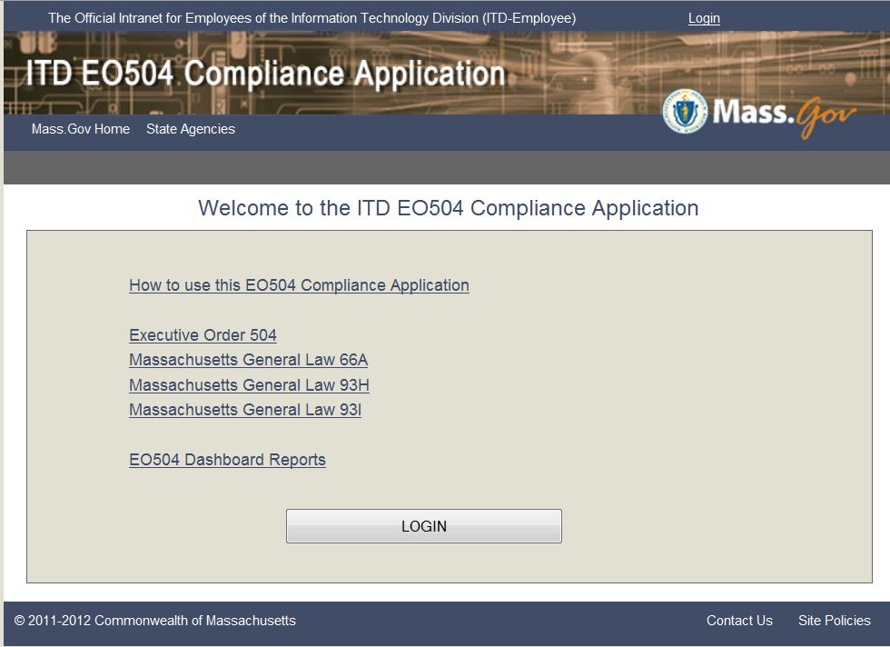

By clicking on How to use this EO504 Compliance Application you will be linked to the Adminstration and Finance (ANF) EO504 Support page.

Also from this screen, you are able to review Executive Order 504 and pertinent Massachusetts General Laws concerning the protections of Personal Information (PI).

To logon to the application, you will need the following information:

- Your application User Name (normally, your MassMail email address)
- Your User Password (the initial default password must be changed at first successful logon)
- Your agency EO504 Code (normally, your agency’s MMARS code) if you have access rights for multiple agencies

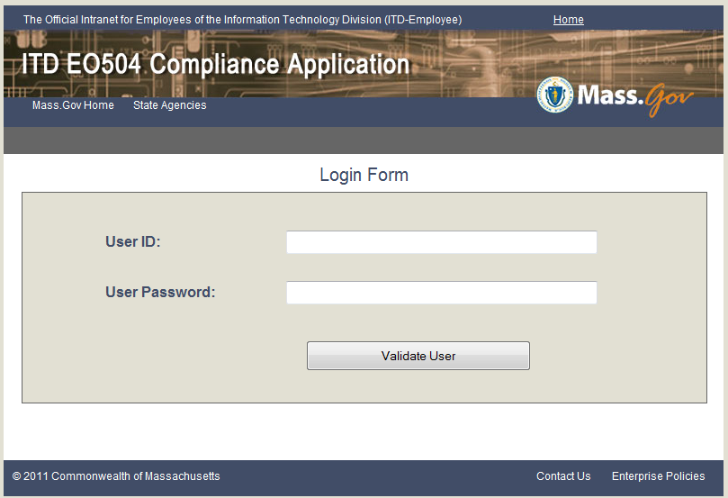

Enter your EO504 User ID and User Password. Then click Validate User. If you are a first time user, you will be required to change your password, see next page. If a repeat user, the main menu screen will display.

First time user password change screen

After you change your password you will be returned to the main login screen. Also note that in the future if you needed to or wanted to change your password, you will be able to change your password by selecting Tools on the navigation bar at the top of the page.

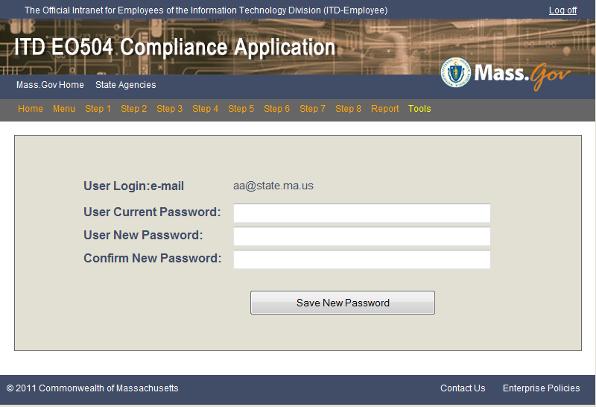

EO504 Compliance Application Main Menu

NOTE: It is not necessary to perform the steps in sequence.

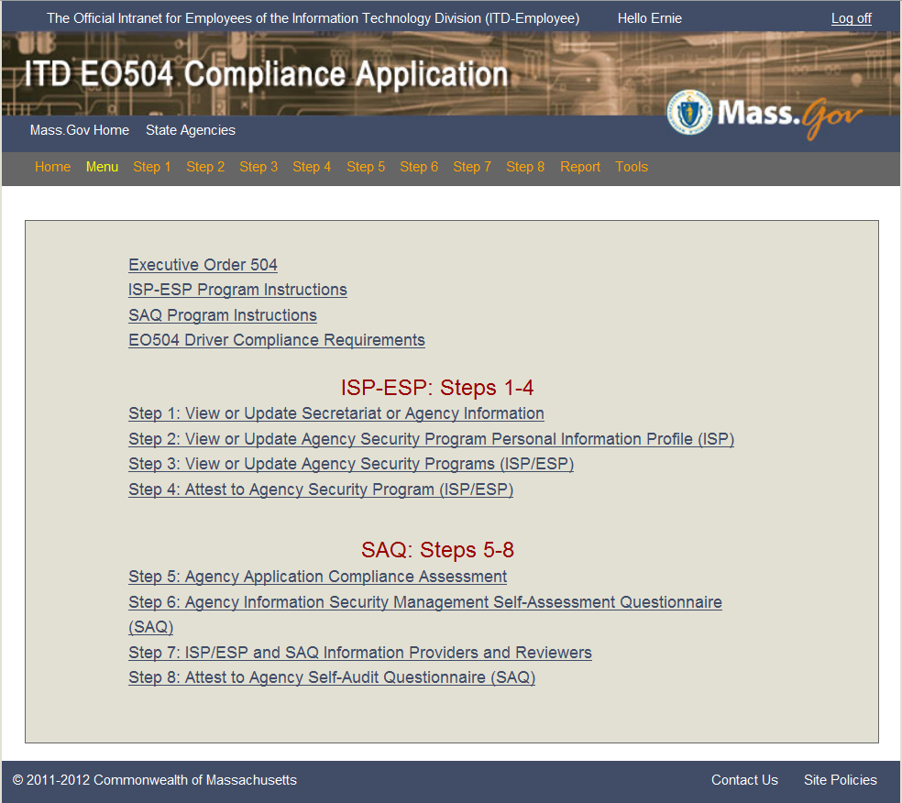

Completing Agency Self-Assessment Questionnaire (SAQ)
Step 5

From the main menu, click on the Step 5: Agency Application Compliance Assessment or select Step 5 on the navigation bar. The Agency Application Compliance Assessment page is displayed, listing Agency Applications entered during step 3.

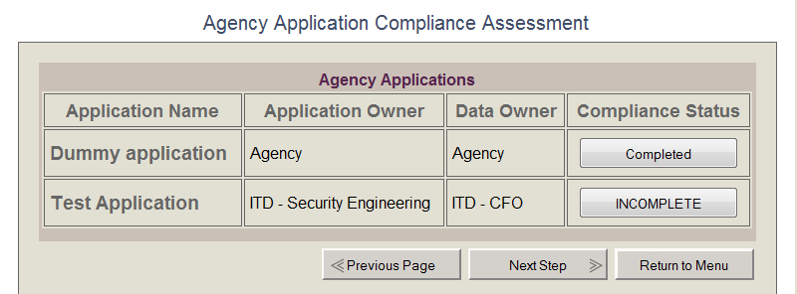

This will display the compliance status (Completed or INCOMPLETE) Click on the INCOMPLETE button to continue to compliance page for the selected application.

The Application Compliance Assessment screen will display with the drivers that you selected and entered previously in Step 3. For each driver, you must report the degree of compliance, how you determined compliance, and deficiencies (if any). Below is a guide to help you determine how to report your compliance. Clicking the Save Compliance button will save your responses and return you to the application list. You will need to do this for each agency application.

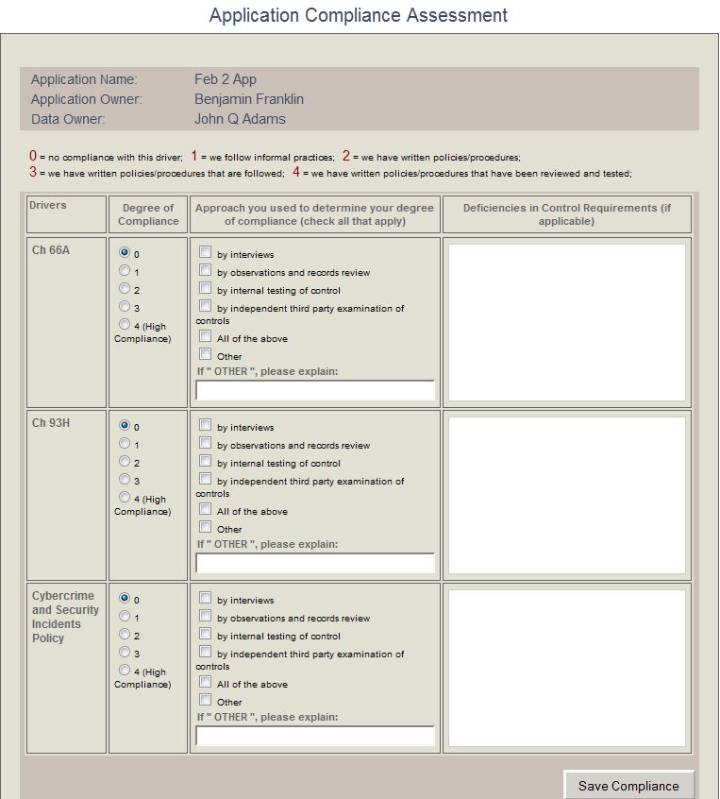

Completing Agency Self-Assessment Questionnaire (SAQ)
Step 6

From the main menu, click on the Step 6: Agency Information Security Management Self-Assessment Questionnaire or select Step 6 on the navigation bar. The Agency Information Security Management Self-Assessment Questionnaire (SAQ) page is displayed as shown below. Each of the listed categories has one or more questions. Nearly all of the questions have Yes, No, and NA response choices and a Comment field for providing additional free-form text information. After answering the questions in a section, click the Save Information button to save your responses. You will need to repeat this process for each of the 12 categories of the SAQ.

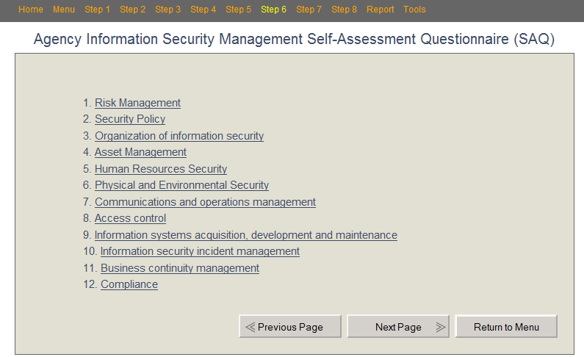

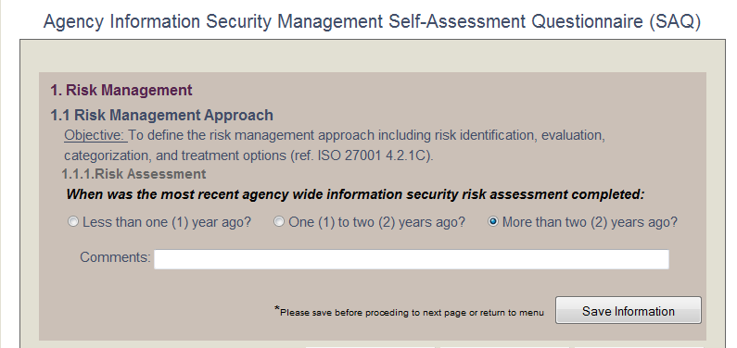

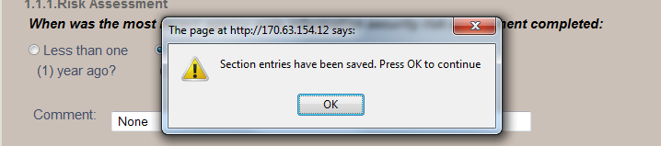

Click on the OK button to return to the section screen. To continue to the next sequencial section click on Next Page button.

When all sections are complete continue to Step 7: ISP/ESP and SAQ Information Providers and Reviewers or select Step 7 on the navigation bar.

Completing Agency Self-Assessment Questionnaire (SAQ)
Step 7

From the main menu, click on the Step 7: ISP/ESP and SAQ Information Providers and Reviewers or select Step 7 on the navigation bar. The ISP/ESP and SAQ Information Providers and Reviewers page will display as shown below. Here, you enter the names of individuals from your agency that provided information or direct responses to the completion of the ISP/ESP and the SAQ compliance questions or reviewed the ISP/ESP or SAQ before final submission. Enter the requested information for each person and then click the Save button to save your responses. When complete, click the Next Step or Return to Menu button to return to the main menu page.

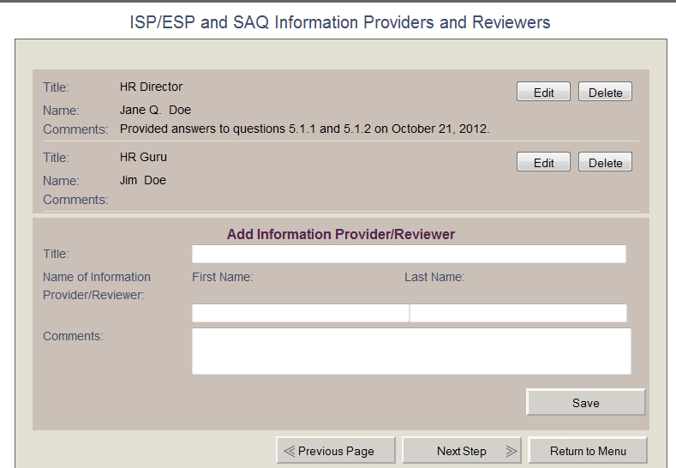

Completing Agency Self-Assessment Questionnaire (SAQ)
Step 8

From the main menu, click on the Step 8: Attest to Agency Self-Audit Questionnaire (SAQ) or select Step 8 on the navigation bar. The Agency SAQ Attestation screen is displayed, as shown below. Per Executive Order 504, the agency head and the agency Information Security Officer must sign/attest to the submissions. These two individuals are the only individuals who can sign the attestations for their agency. To electronically “sign” the attestation, click the Signed radio button in the appropriate section. Next, click on the Save Head Signature or the Save ISO Signature button, respectively. When both individuals have separately signed the attestation, either signer may submit the attestation by clicking the Submit Attestation button at the bottom of the screen.

The submitting of the Agency SAQ Attestation completes the process of preparing the agency’s SAQ.

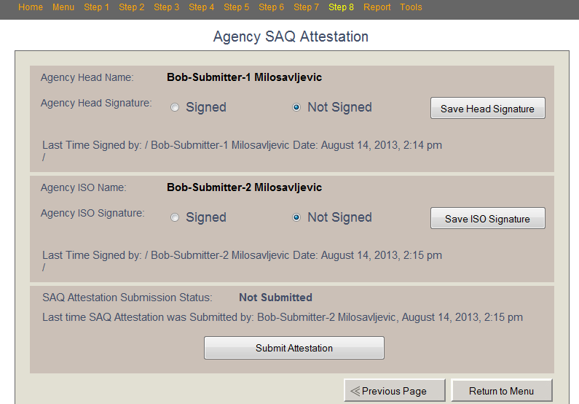

Completing Agency Self-Assessment Questionnaire (SAQ)
Report Step

To obtain a report of your agency’s submitted ISP/ESP and/or SAQ select Report on the navigation bar. A pdf formatted report will be displayed. You can print this report in order to have a hard copy for your agency’s record. You also can save the pdf report by clicking on the save icon and entering an appropriate file name and file location.

Terminating Agency Self-Assessment Questionnaire (SAQ)

To terminate the application at any time, click on Log Off at the upper right-hand corner of any screen. The confirmation/thank you screen shown below will display.

