Virtual Gateway’s My Account Page (MAP) for Direct Verification Summary
Massachusetts requires all LEAs to conduct their annual direct verifications using the Executive Office of Health and Human Services (EOHHS) Virtual Gateway’s My Account Page (MAP). The Virtual Gateway’s MAP is used by Local Educational Agencies (LEAs) for the Direct Verification process. MAP gives users the option to check for direct verification eligibility by either (1) manually entering student names or (2) uploading student names into a predefined enrollment template.
On an annual basis, each LEA must verify eligibility of children from a sample of household applications approved for free and reduced price meal benefits for that school year. Direct Verification uses records from public agencies to verify household income for program participation. The Verification Summary Report must be submitted to Department of Elementary and Secondary Education by the established annual due date.
This job aid provides users with the guidance needed to successfully upload and save a direct verification report.
Table of Contents
Logon to Virtual Gateway 1
Using File Upload Direct Verification 1
Using the Manual Direct Verification 7
Searching and Viewing Match History Results 9
Saving Match History Results 11
Additional Learning Opportunities 12
Questions or Need Assistance when logged into the Virtual Gateway? 13
Questions or Need Assistance with Training for the School Nutrition Program? 13
Key to Understanding Direct Certification and Direct Verification Match History Results 14
Key to Understanding Direct Certification and Direct Verification Error Messages 16

Logon to Virtual Gateway
In order to use the Virtual Gateway’s My Account Page (MAP), users must log on to the Virtual Gateway (www.mass.gov/vg), from the Virtual Gateway’s website, click the link Logon to Virtual Gateway, after logging on to the Virtual Gateway, and select the My Account Page (MAP) business service.
Note: See the Logon Assistance Job Aid for more information on accessing the Virtual Gateway.

Using File Upload Direct Verification
The File Upload Direct Certification provides functionality to (1) download a predefined Enrollment Template, (2) enter data into the Enrollment Template, (3) locate your saved enrollment template, and (4) upload your district’s student records to see which student’s are directly certified for free meals.
After the student enrollment records are uploaded, MAP performs a match process using data from public agencies to verify household income for program participation. The Match Report provides you with a listing of students who have been identified as either directly verified as an exact match or partial match. It also indicates students who are not matched and who need to be verified through the paper process. Any records not directly verified from the sample verification pool of approved applications require follow-up with individual households by the LEAs.
- From the Virtual Gateway Business Service page, click the [My Account Page] link.
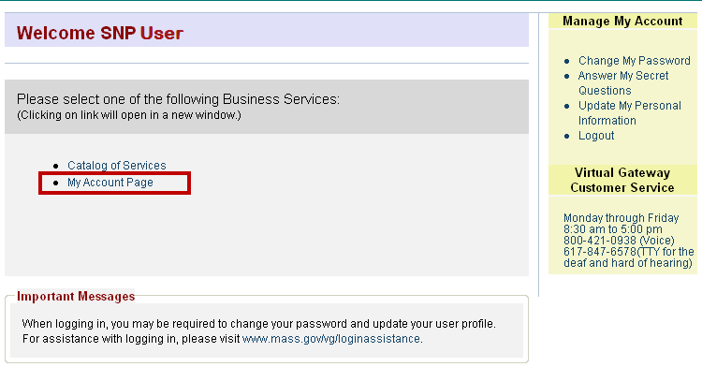

This takes you to the Online Direct Certification and Direct Verification Screen.
- Click the [File Upload Direct Verification] tab.
Step 1: Download a Predefined Blank Enrollment Template
To begin the upload process, you must first download a blank Enrollment Template.
- Click on the [Download Enrollment Template] link.
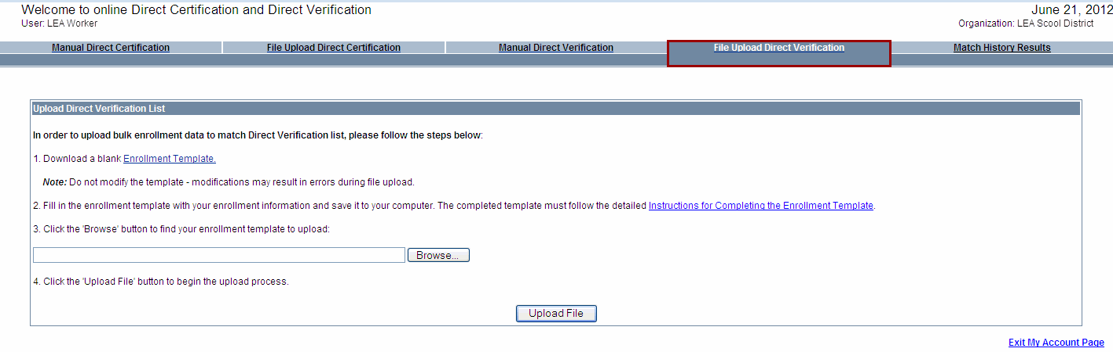
The File Download box appears
- Click [Save] from the File Download dialog box.
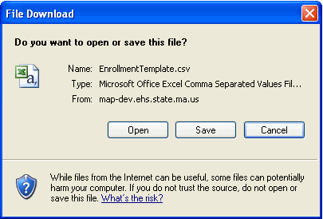
The Save As box appears.
- Within the Save As box, use the Save In drop down menu to navigate to the location where you want to save the Enrollment Template. Next, type in a filename remembering to use the .csv file extension*.
* The File Upload feature will only accept the .CSV file extension. If you save with the .XLS extension, the file will reject when uploading.
Suggested naming conventions:
  - mmddyyyy.csv
  - mmddyyyyelementaryschool.csv
  - mmddyyyya_h.csv
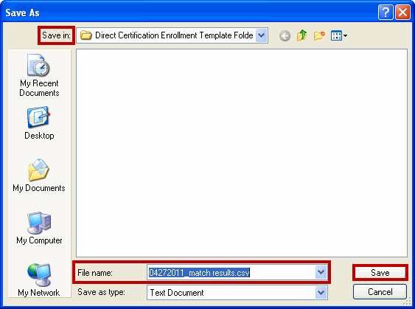
- Once the Save in, File name, and Save as Type are complete, click the [Save] button.
The Download Complete box appears.
- Click the [Open] button.
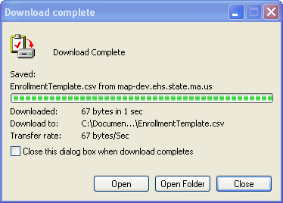
The Enrollment Template opens ready for data entry.
Step 2: Enter Data into the Enrollment Template
Once a blank Enrollment Template has been downloaded, student enrollment data* must be loaded. Enrollment data can either be typed directly into the blank template or you can use the copy/paste functionality from a file saved within an LEA’s internal computer system.
*Districts will need to supply student data to input into the enrollment template.
For assistance in completing the Enrollment Template select the link in Step 2 Instructions for Completing Enrollment Template.
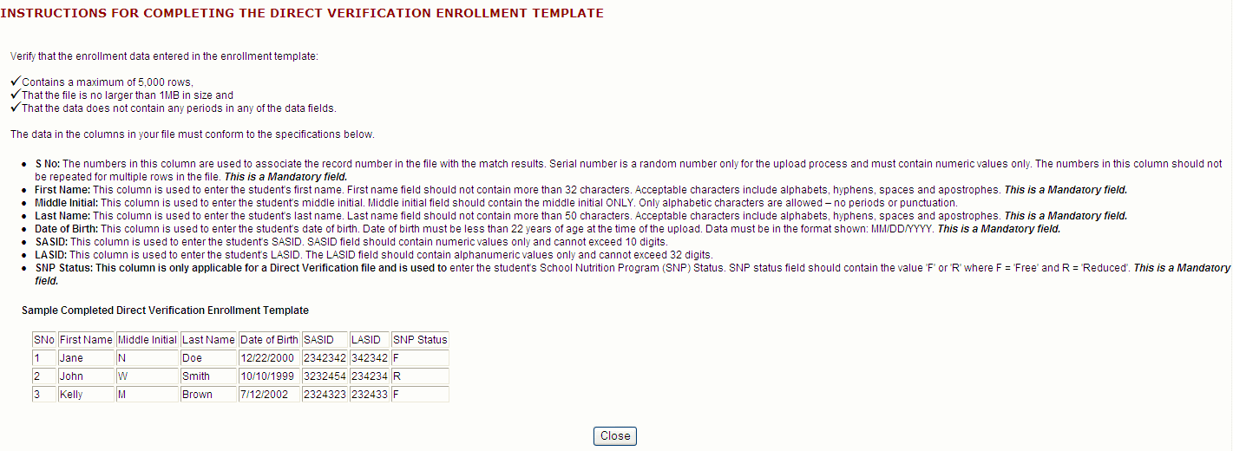
- From within the blank Enrollment Template, fill in student enrollment data by typing or using copy/paste functions from within the school’s business software (i.e. Microsoft Excel).
- * SNo (Serial Number: 1, 2, 3, etc …)
- * First Name
- Middle Initial (Optional)
- * Last Name
- * Date of Birth (Note: Must in the following format: mm/dd/yyyy)
- SASID (Optional – Not part of SNAP/TAFDC/Medicaid match process)
- LASID (Optional – Not part of SNAP/TAFDC/Medicaid match process)
- * SNP Status (Note: Must be in the following format: F for Free or R for Reduced)
For the purpose of this reference guide, we have indicated the required fields with an asterisk symbol (*). Fields not denoted with an asterisk are optional fields.
Here is a sample of the Enrollment Template filled in with data:
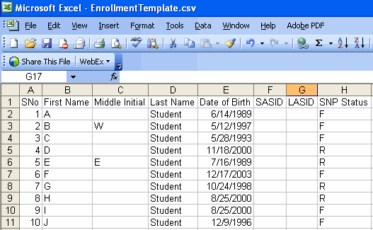
Important Reminders:
- You cannot change the names of the column headings or add additional fields on the enrollment template. This will cause the file to reject during the upload process.
- Please note that the maximum allowable file size is 1 MB and the maximum allowable row count is 5000 per file upload.
- Once the data is entered into the Enrollment Template, save the file. Remember that a completed enrollment template must be saved in the .csv file format in order to be successfully uploaded into MAP.
The following dialog box will appear since you are saving the file in .csv format. Select [Yes] to retain the .csv file format.
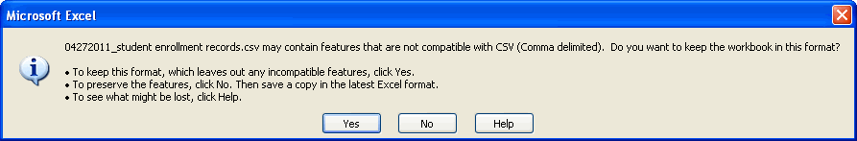
- Follow Step 2: A-B as outlined above for each template that you need to create. Based on the size of your school district, you may have more than one file to create and upload.
Please note that you will need to return to MAP and select the File Upload Direct Verification tab to begin the upload the process.
Step 3: Browse to Locate Your Completed Enrollment Template
- Click the click [Browse] button and locate your completed enrollment template that needs to be uploaded.
Step 4: Upload the Enrollment Data
- Click [Upload File] to begin the match process.

The following message will appear once the file has been uploaded and the Match Process started:
“Success! Your file has now been uploaded and the matching is in process. Your Match ID number is xxxx. You can use this number to come back and check the “Match History Results” tab at a later time to view the results. Please note this could take a few hours depending on the size of the file that was uploaded.”
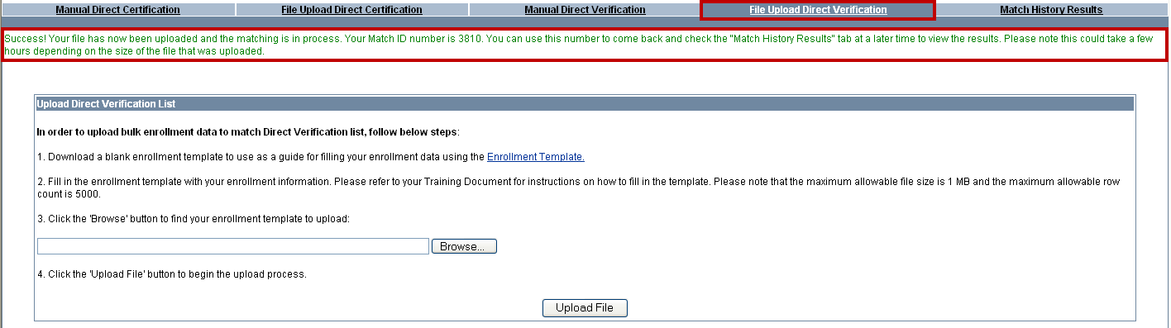
Repeat the Steps 3 and 4 for each enrollment template that you need to upload.
Refer to Key to Understanding Direct Certification and Direct Verification Error Messages and Known System Issues for VG SNP Manual Direct Certification and Direct Verification reference guides for guidance on understanding error messages when uploading a file.

Using the Manual Direct Verification
From the Welcome to Online Direct Certification and Direct Verification page,
- Click the [Manual Direct Verification] tab.
This is the Manual Direct Verification page. It is here that you can directly data enter your district’s sample verification pool of approved applications to run the annual direct verification process. You can check the eligibility of up to ten (10) students at time on the Manual Direct Verification page. After the student data are data entered, MAP performs a match process using data from public agencies to verify household income for continued program participation. Once the Match Report is complete, you can view the results under the Match History Results tab. The Match Report provides you with a listing of students which have been identified as directly verified for free or reduced priced meals. The Match Report will display Exact Matches, Partial Matches and No Matches.
This takes you to the Search Direct Verification List screen where you can directly enter your district’s student enrollment data to determine which student’s are directly verified for free meals. You can check the eligibility of up to ten (10) students at time.
The column headings are the same as you saw when using the File Upload Direct Verification Enrollment Template. Note that the required fields on the Manual Direct Verification page are denoted with an asterisk (*) symbol.
- Row # (Note that 10 is the maximum per page)
- First Name*
- Middle Initial (Optional)
- Last Name*
- Date of Birth* (Note: Must in the following format: mm/dd/yyyy)
- School Nutrition Program Status* (Note: Must select Free or Reduced)
- SASID (Optional – Not part of SNAP/TAFDC/Medicaid match process)
- LASID (Optional – Not part of SNAP/TAFDC/Medicaid match process)

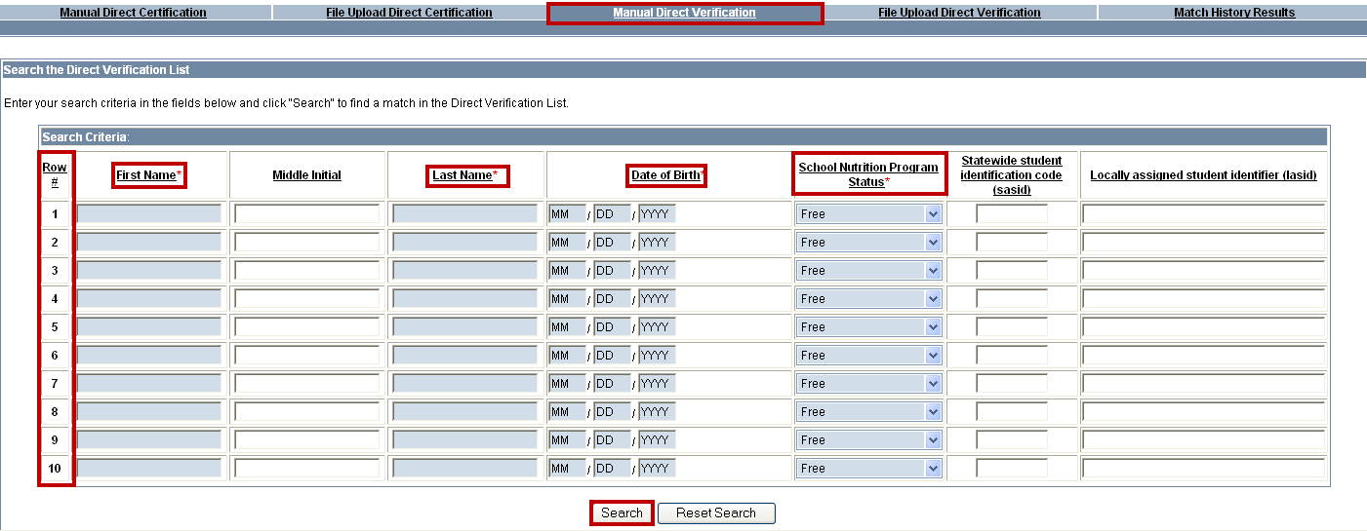
- Enter search criteria using student data. Use the following steps:
- Type [First Name].
- Type [Middle Initial], if provided.
- Type [Last Name].
- Type [Date of Birth]. (Using the following format: mm/dd/yyyy)

- Select [Free or Reduced] from menu options.
- Type [Statewide Student Identification Code (SASID)], if provided.
- Type [Locally Assisted Student Identifier (LASID)], if provided
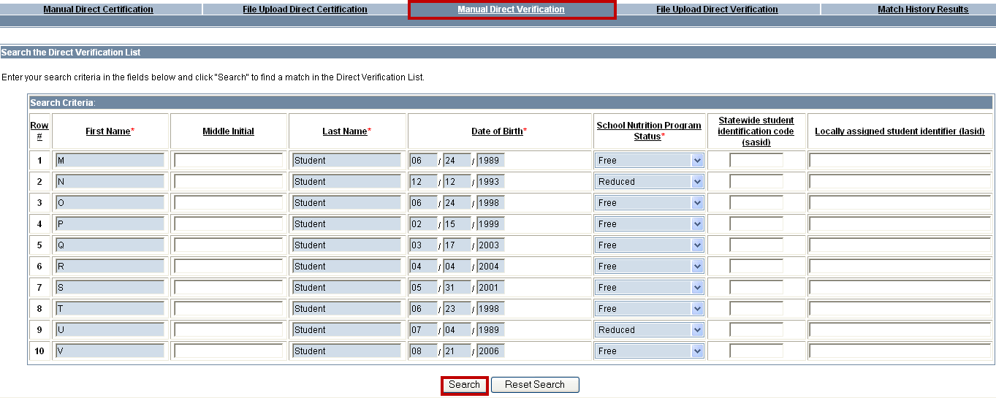
- Once all students are entered, click [Search]
Important: There will be times when you receive error messages surrounding the data that you input.
Here is an example of an error message that you may encounter.
“Error Message: M0317: Error. Invalid entry for ‘Date of Birth’ in rows (3,5). Date of Birth entered must be within the past 22 years.”
In this example, the student names and data associated with rows 3 and 5 have a date of birth that makes the student older than 22 and not eligible for the School Nutrition Program.
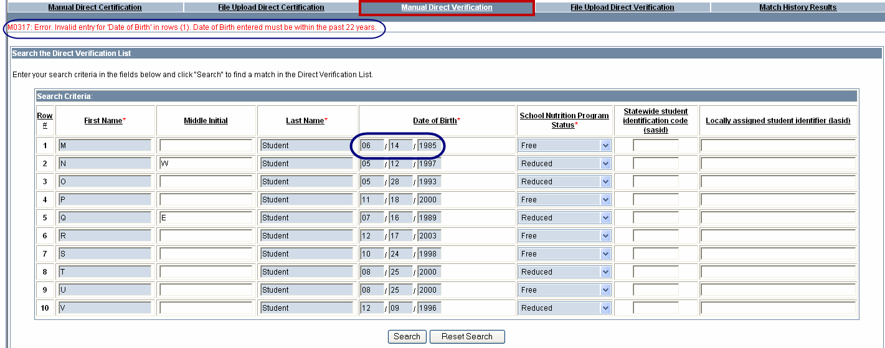
To correct this error and allow the Match Processing to continue, verify the data entered on those rows and correct the date of birth, if entered incorrectly, or remove if the date of birth was entered correctly since those students are no longer eligible to participate in this program.

Refer to Key to Understanding Direct Certification and Direct Verification Error Messages in this reference guide for guidance on understanding error messages when uploading a file.

Once the corrections are made, click [Search] to start the match process again.

Once a Manual Direct Verification is completed, the Match Results will display at the bottom of the page. Below is a sample of what the Match Results look like when running a Manual Direct Verification.

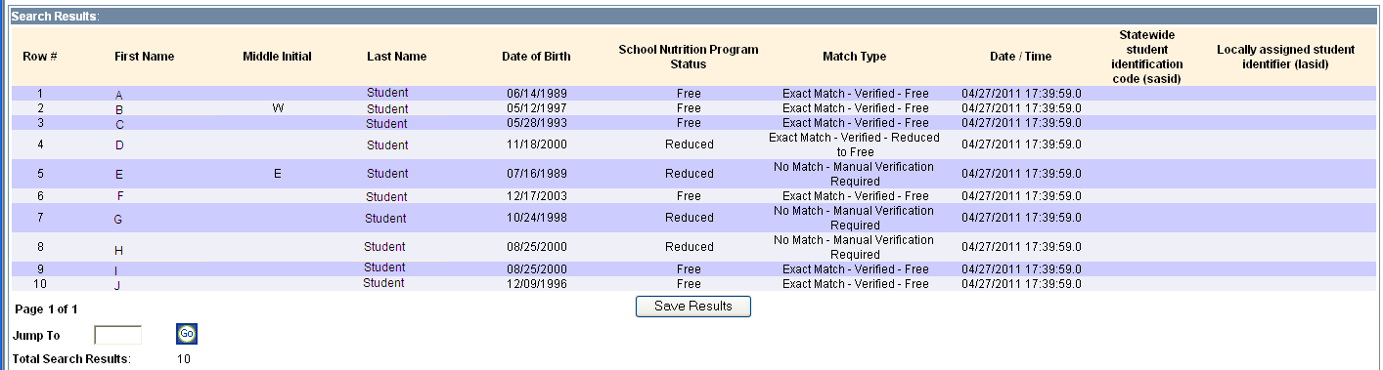
Refer to Key to Understanding Direct Certification and Direct Verification Error Messages and Known System Issues for VG SNP Manual Direct Certification and Direct Verification reference guides for guidance on understanding error messages when uploading a file.

Searching and Viewing Match History Results
The Match History Results tab allows you to search for and view both manually entered and uploaded enrollment data for both Direct Certification and Direct Verification.
The results remain under this tab for 18 months and are then archived. It is recommended that you save the results to your local computer for review and audit purposes. If you need to retrieve Match History Results greater than 18 months, contact your ESES Reviewer at the Department of Elementary and Secondary Education for assistance.
From the Welcome to Online Direct Certification and Direct Verification page:
Conducting a Search
- Click the [Match History Results] tab.

The Search Criteria screen appears.

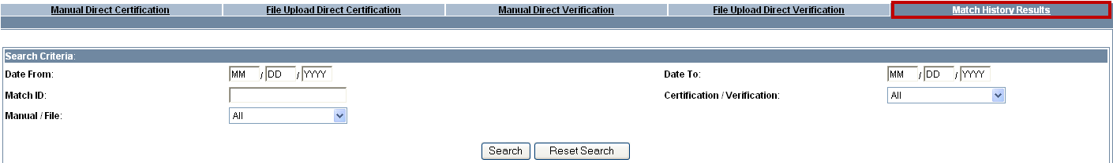
The Search Criteria Screen allows you to search for results using any combination of the following fields:
- Date From (format: mm/dd/yyyy)
- Date To (format: mm/dd/yyyy)
- Match ID (ID is listed on the Manual Direct Certification, File Upload Direct Certification, Manual Direct Verification, and File Upload Direct Verification pages after successful submission of data.)
- Manual/File (Indicates how data was submitted)
- Certification/Verification (Indicates which type of results you wish to view)
Note: The search, viewing and saving processes on the Match History Results page works the same for both Direct Certification and Direct Verification results.

- Enter Search Criteria
Example One: Search by a Submitted Date Range
- Click in the [From:] field
  - Type in [Month] (format MM) field
  - Type in [Day] (format DD) field
  - Type in [Year] (format YYYY) field
- Click in the [To:] field
  - Type in [Month] (format MM) field
  - Type in [Day] (format DD) field
  - Type in [Year] (format YYYY) field
- Select [Manual or File] from menu options
- Select [Certification or Verification] from menu options
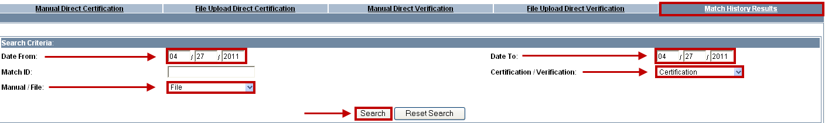
Example Two: To search by a Match ID
- Type in [Match ID].
- Complete search criteria and click [Search].
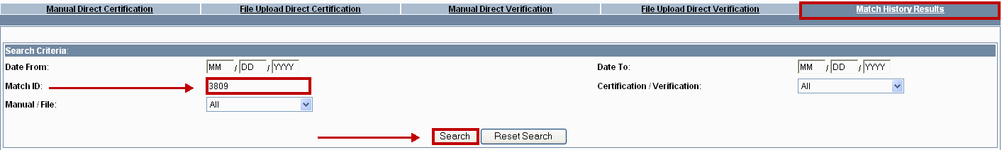
Viewing Search Results
Once the search is complete, the results are viewed using the following steps:
- From the Match Results screen, select the radio button under Match Results
- Click [View Results]
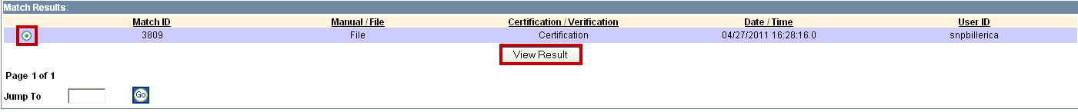
The Search Results will displays.
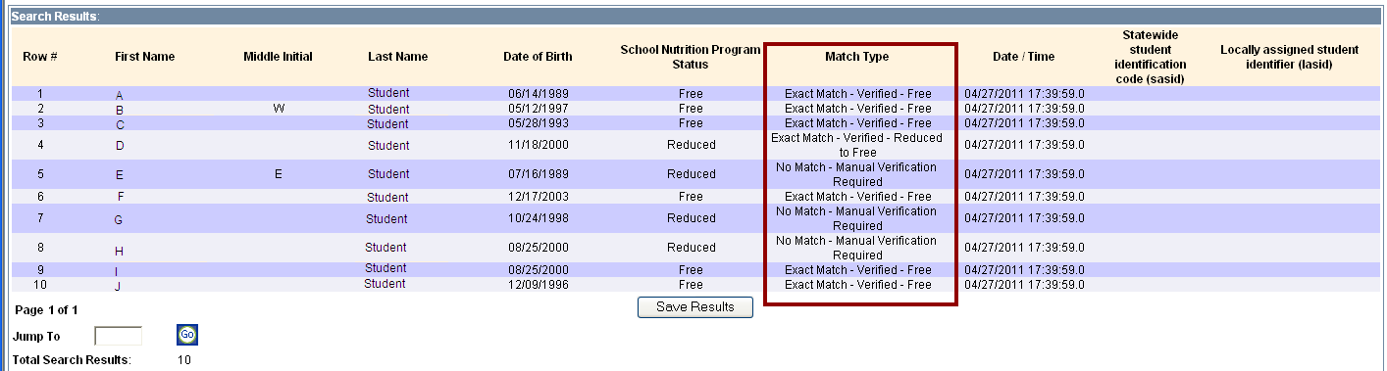
Refer to Key to Understanding Direct Certification and Direct Verification Match History Results in this job aid for guidance on understanding the Match Type results.

Saving Match History Results
The results remain under this tab for 18 months and are then archived. It is recommended that you save the results to your local computer for review and audit purposes. If you need to retrieve Match History Results greater than 18 months, contact your ESE Reviewer at the Department of Elementary and Secondary Education and they will assist you with this process.
To save the results to your local computer/network:
- From the Search Results screen, click [Save Results]
- Click [Save] from the File Download box.
- Within the Save As dialog box, use the Save In drop down menu to navigate to the location where you want to save the results. Next, type in a filename (remembering to use the .csv file extension).
- Click [Save].
Here is a sample of a saved Match Results file:
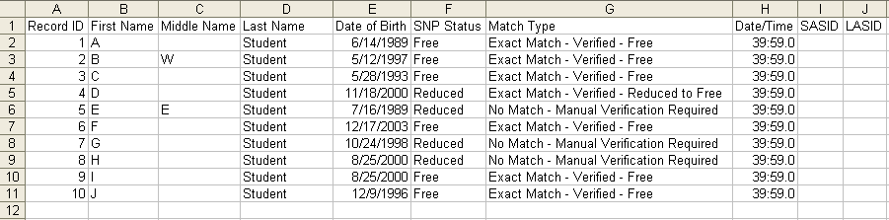
Once the results are in Excel you can sort, filter and format just as you would any other spreadsheet. A suggestion is turn on the Auto Filter functionality from within Excel in order to filter the results. The filtered results can be saved as separate files for later use.
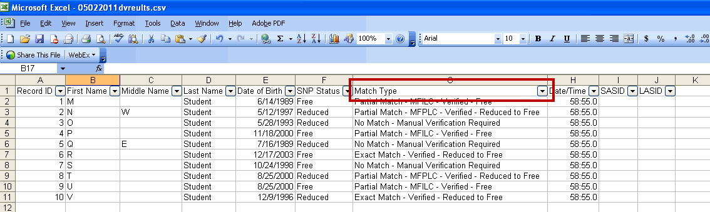

Additional Learning Opportunities
- 403 Using My Account Page (MAP) for Direct Certification and Direct Verification CBT – To take online course, log into PACE.
- Bookmark our Site: www.mass.gov/vg/snp for a complete listing of Virtual Gateway School Nutrition Reference Guides.

Questions or Need Assistance when logged into the Virtual Gateway?
Call Virtual Gateway Customer Service
1-800-421-0938 (617-984-6578 - TTY for the deaf and hard of hearing)
8:30 am to 5:00 pm Monday through Friday

Questions or Need Assistance with Training for the School Nutrition Program?
Call Department of Elementary and Secondary Education PACE Site Administrator
1-781-338-6113 or 1-781-338-6110

8:30 am to 4:00 pm Monday through Friday

Key to Understanding Direct Certification and Direct Verification Match History Results

** Direct Verification Outcomes (SNAP / TAFDC Match)
# | SNP Status  in the Input | Possible Outcomes
1 | F | Exact Match - Verified - Free
2 | F | Partial Match - MFILC - Verified - Free
3 | F | Partial Match - MFLPD - Verified - Free
4 | F | Partial Match - MFPLC - Verified - Free
5 | R | Exact Match - Verified - Reduced to Free
6 | R | Partial Match - MFILC - Verified - Reduced to Free
7 | R | Partial Match - MFLPD - Verified - Reduced to Free
8 | R | Partial Match - MFPLC - Verified - Reduced to Free
9 | F | No Match*

** Direct Verification Outcomes (SNAP / TAFDC Match)  SNP Status School Nutrition Program  F Free Meals  R Reduced Meals | *** Direct Verification Outcomes (Medicaid Match)  SNP School Nutrition Program  F Free Meals  R Reduced Meals  FPL Federal Poverty Limit

Possible Outcomes:
- Exact Match: Exact match on all data provided
- MFILC condition: Match on First Initial, Last Name and DOB
- MFLPD condition: Match on First Name, Last Name and Partial DOB
(2 out of 3 Date fields should match)
- MFPLC condition: Match on First Name, Partial Last Name (first 4 letters) and DOB
- No Match: No match found based on data provided
NOTE: If a duplicate match was found for Direct Certification or as part of the SNAP / TAFDC match during Direct Verification, then we will follow the normal process for matching (as if they weren't a duplicate) and display the Match Type accordingly from the values above.

*** Direct Verification Outcomes (Medicaid Match)
# | SNP Status in the Input | Household FPL | Possible Outcomes
1 | F | < = 133% | Exact Match - Verified - Free
2 | F | < = 133% | Partial Match - MFILC - Verified - Free
3 | F | < = 133% | Partial Match - MFLPD - Verified - Free
4 | F | < = 133% | Partial Match - MFPLC - Verified - Free
5 | F | 133% < x < = 185% | Exact Match - Verified - Free to Reduced
6 | F | 133% < x < = 185% | Partial Match - MFILC - Verified - Free to Reduced
7 | F | 133% < x < = 185% | Partial Match - MFLPD - Verified - Free to Reduced
8 | F | 133% < x < = 185% | Partial Match - MFPLC - Verified - Free to Reduced
9 | F | > 185% | Exact Match - Verified - Free to Paid
10 | F | > 185% | Partial Match - MFILC - Verified - Free to Paid
11 | F | > 185% | Partial Match - MFLPD - Verified - Free to Paid
12 | F | > 185% | Partial Match - MFPLC - Verified - Free to Paid
13 | R | < = 133% | Exact Match - Verified - Reduced to Free
14 | R | < = 133% | Partial Match - MFILC - Verified - Reduced to Free
15 | R | < = 133% | Partial Match - MFLPD - Verified - Reduced to Free
16 | R | < = 133% | Partial Match - MFPLC - Verified - Reduced to Free
17 | R | 133% < x < = 185% | Exact Match - Verified - Reduced
18 | R | 133% < x < = 185% | Partial Match - MFILC - Verified - Reduced
19 | R | 133% < x < = 185% | Partial Match - MFLPD - Verified - Reduced
20 | R | 133% < x < = 185% | Partial Match - MFPLC - Verified - Reduced
21 | R | > 185% | Exact Match - Verified - Reduced to Paid
22 | R | > 185% | Partial Match - MFILC - Verified - Reduced to Paid
23 | R | > 185% | Partial Match - MFLPD - Verified - Reduced to Paid
24 | R | > 185% | Partial Match - MFPLC - Verified - Reduced to Paid
25 | F | Any FPL | No Match - Manual Verification Required
26 | R | Any FPL | No Match - Manual Verification Required
27 | F | Any FPL | Duplicate Match - Not Verified
28 | R | Any FPL | Duplicate Match - Not Verified
Possible Outcomes:
- Exact Match: Exact match on all data provided
- MFILC condition: Match on First Initial, Last Name and DOB
- MFLPD condition: Match on First Name, Last Name and Partial DOB
(2 out of 3 Date fields should match)
- MFPLC condition: Match on First Name, Partial Last Name (first 4 letters) and DOB
- No Match: No match found based on data provided
NOTE: If a duplicate match was found for Direct Certification or as part of the SNAP / TAFDC match during Direct Verification, then we will follow the normal process for matching (as if they weren't a duplicate) and display the Match Type accordingly from the values above.

Key to Understanding Direct Certification and Direct Verification Error Messages

Functionality | Scenario | Expected Error Message
Manual Direct Certification  Manual Direct Verification | When 'Search' button is clicked under 'Manual Direct Certification' or 'Manual Direct Verification' tab without entering any information on the page. | M0330: Error. Please enter First Name, Last Name and Date of Birth for at least 1 row in order to proceed.
Manual Direct Certification  Manual Direct Verification | When invalid data (eg. alphabetic character) is entered for 'Statewide student identification code (sasid)' OR 'Locally assigned student identifier (lasid)' under 'Manual Direct Certification' or 'Manual Direct Verification'. | M0315: Error. Invalid entry for '~' in rows (~). Please enter a numeric value.
Manual Direct Certification  Manual Direct Verification | When invalid data (eg. numeric character) is entered for 'Middle Initial' under 'Manual Direct Certification' or 'Manual Direct Verification'. | M0316: Error. Invalid entry for '~' in rows (~, ~, ~). Please enter alphabetic characters only.
Manual Direct Certification  Manual Direct Verification | When DOB > 22 years is enter under 'Manual Direct Certification' or 'Manual Direct Verification'. | M0317: Error. Invalid entry for '~' in rows (~, ~, ~). Date of Birth entered must be within the past 22 years.
Manual Direct Certification  Manual Direct Verification | When invalid data is entered in the mandatory fields (such as First Name, Last Name etc.) under 'Manual Direct Certification' or 'Manual Direct Verification'. | M0314: Error. The following rows have incomplete or incorrect data (~, ~). Please remember each row must contain a First Name, Last Name and Date of Birth. Names can only contain letters and the following characters (hyphen, space, apostrophe). Date of Birth should be in the format MM/DD/YYYY.
File Upload Direct Certification  File Upload Direct Verification | When the 'Upload File' button is clicked under 'File Upload Direct Certification' or 'File Upload Direct Verification' without choosing the file to upload. | M0318: Error. Please select a file for upload by clicking the 'Browse' button.
File Upload Direct Certification | When a Direct Certification file containing errors in the mandatory fields (such as First Name, Last Name etc.) is uploaded, this error message indicates the row numbers with the incorrect data. | M0331: Error. An error occurred while processing your file. The following rows in the file have incomplete or incorrect data (~). Please remember each row must contain a Serial Number, First Name, Last Name and Date of Birth. Names can only contain letters and the following characters (hyphen, space, apostrophe). Date of Birth should be in the format MM/DD/YYYY and should be in the past 22 years.
File Upload Direct Certification  File Upload Direct Verification | When a Direct Certification or Direct Verification file containing errors in the non-mandatory fields (such as Middle Initial, Statewide student identification code (sasid) etc.) is uploaded, this error message indicates the row numbers with the incorrect data. | M0334: Error. An error occurred while processing your file. The following rows in the file have incomplete or incorrect data (~, ~). Middle Initial can only contain alphabetic character. Lasid and Sasid can only contain numeric values. Sasid should not exceed 10 digits and Lasid should not exceed 32 digits.
File Upload Direct Verification | When a Direct Verification file containing errors in the mandatory fields (such as First Name, Last Name etc.) is uploaded, this error message indicates the row numbers with the incorrect data. | M0329: Error. An error occurred while processing your file. The following rows in the file have incomplete or incorrect data (~). Please remember each row must contain a Serial number, First Name, Last Name, Date of Birth and Program Status. Names can only contain letters and the following characters (hyphen, space, apostrophe). Date of Birth should be in the format MM/DD/YYYY and should be in the past 22 years. Program status should be either 'F' for free or 'R' for reduced.
File Upload Direct Certification | When the Direct Certification file being uploaded is not in the expected format. | M0333: Please upload a file in CSV format using the Enrollment Template for filling your enrollment data. Please ensure that the file size does not exceed 3 MB and the row count does not exceed 15000 rows.
File Upload Direct Verification | When the Direct Verification file being uploaded is not in the expected format. | M0333: Please upload a file in CSV format using the Enrollment Template for filling your enrollment data. Please ensure that the file size does not exceed 1 MB and the row count does not exceed 5000 rows.
Match History Results | When 'View Results' button under 'Match Results' section is clicked without choosing a record. | M0319: Error. Please choose the record you want to view the results for.
Match History Results | When invalid data (eg. alphabetic character) is entered for 'Match ID' under 'Search Criteria' section. | M0009: Error. Invalid entry for 'Match ID'. Please enter a numeric value.
Match History Results | When invalid data (eg. alphabetic character) is entered for Date fields under 'Search Criteria' section. | M0013: Error. Invalid entry for '~'. Please enter a numeric date in the following format: MM/DD/YYYY.
Match History Results | When invalid data (e.g. alphabetic character) is entered for Date fields under 'Search Criteria' section. | M0013: Error. Invalid entry for '~'. Please enter a numeric date in the following format: MM/DD/YYYY.
Match History Results | When only one of the dates are entered under 'Search Criteria' section. | M0226: Error. ‘Date To’ is a required field if ‘Date From’ value is entered.
Match History Results | When the page number mentioned in the ‘Jump To’ box is more than the last page value. This is applicable to the ‘Jump to’ field under both ‘Match Results’ and ‘Search Results’ sections.  Eg. Page 1 to 5 is returned, but Jump To = Page 7, then on clicking ‘Go’ button, this error message is shown. | M0337: Error. Please enter a numeric value for the page number which should be less than or equal to the highest page number.

