Using the MassGIS DataViewer Toolbar

The DataViewer uses a dBase file (themeinv.dbf, aka the “theme inventory table”) provided with your data to populate the data layer choices in the Toolbar menus. This table is what makes the DataViewer work, as it stores all of the relationships between the menus that appear when you click the A, Search, or Z Buttons, the LYR files, and the actual Shapefile or File Geodatabase data sources. The table is in the 'ArcGIS' folder that came with your data set from MassGIS.

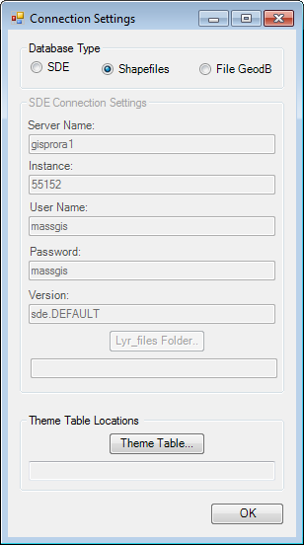
Set-up for use in ArcMap 10.0
1
The first time you use the DataViewer Toolbar (by clicking on any of its buttons) in ArcMap 10 you will be presented with the ‘Connections Settings’ dialog. In order to use the Toolbar, you must do the following:

- Select Shapefiles or File Geodatabase as your 'Database Type', depending on what format of data you received and previously copied as specified in the document “Installing the MassGIS DataViewer Toolbar”.
- Click on the Theme Table button to navigate to the themeinv.dbf table you have in your ArcGIS folder (for example, C:\MassGIS_DV\ArcGIS\themeinv.dbf).
1
- Click OK.

A small text file called ConnectionSettings.txt gets created and you will not be prompted to set your connection settings again. A message box will appear informing you of the location of this file:
2

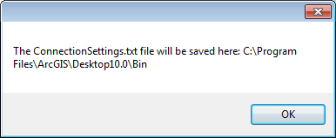
3
Click OK to dismiss this message box

The ConnectionSettings.txt file stores the settings you just chose in the Connection Settings dialog. When you click on the ‘A’ button the Viewer will read from that file in order to find the proper data files to load into ArcMap.

Note: Currently, the location of this text file may vary from user to user or machine to machine, as it is set to be saved in Environment.CurrentDirectory, which means “the directory from which this process starts.” If in the future you open or save map documents (MXDs) in other folders, in later ArcMap sessions when you hit the ‘A’ button for the first time you may be prompted to enter information into the Connection Settings dialog again, and another ConnectionSettings.txt file will be created in that location.

If in the future, if you change the location of the DataViewer files, you should delete this text file (note there may be many on your PC). You will then be prompted for the new Theme Table location when you use the DataViewer toolbar next, and a new ConnectionSettings.txt file will be created.

Using the DataViewer Toolbar in ArcMap 9.x does not require the above set-up steps.

Overview of the Toolbar’s Buttons
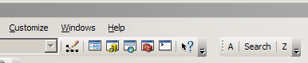
The MassGIS DataViewer Toolbar has three buttons:

A -- Add data to the map. Clicking this button displays the Browse window which allows you to view the data choices in a menu system, using categories and subcategories of data.

Search – Clicking this button displays the Search window, allowing you to enter keywords to locate and add data to your map.

Z -- Zoom to different geographic extents and specific locations in Massachusetts.

“A” Button

MassGIS has designed a menu system which allows locating data based on categories and subcategories.

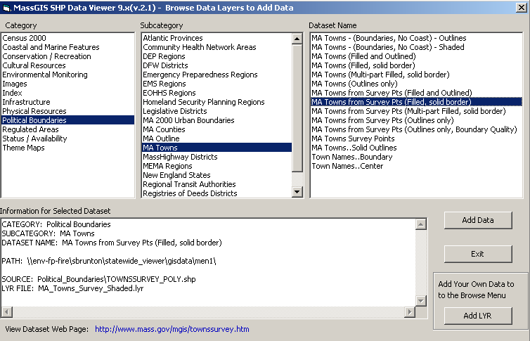
Click on choices in each menu box
Click ‘Add Data’
Click link to view metadata
Adding your own data is discussed on page 5.

Adding MassGIS Data

To load a data layer to your map, click through the A button menus, following the Category -> Subcategory -> Dataset Name windows. Once you choose a layer from the last menu item (Dataset Name), the text box titled “Information for Selected Dataset” will be populated with details about the selected Dataset, including the menu choices to the dataset, the path to the shapefile and the name of the lyr file the DataViewer uses for that datalayer selection.

To add this dataset to your map, click the ‘Add Data’ button.

(Note: When you add data layers to the map they will be turned off (unchecked) when they first appear in ArcMap’s table of contents.)

Viewing Metadata

You can also view the associated web page on the MassGIS web site describing the dataset, if you have an Internet connection, by clicking on the link next to ‘View Dataset Web Page’ at the bottom of the Browse dialog.

“Search” Button

Under the search tab you can search through the data to find all data layers that match certain keywords. In the Search Keywords field as you type, any layer that has matching keywords will appear in the Search Results list.

An example of searching for all data layers associated with trains:

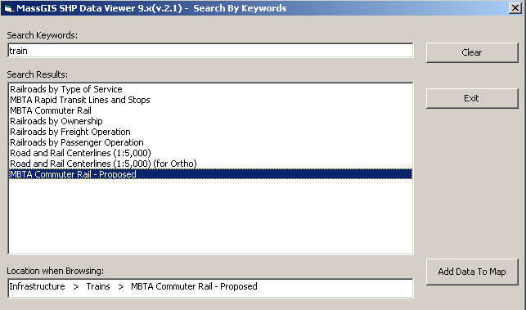

Select a data layer you want to add in the search results list and click the ‘Add Data to Map’ button to view the data layer in ArcMap.

When a layer is selected in the Search Results, the ‘Location when Browsing’ box will display where that data layer is found in the ‘A’ button menus; this will help you avoid having to search for that data again.

“Z” Button

Like the ‘A’ button, the ‘Z’ button has three menu selections. These are Category -> Subcategory -> Extent:

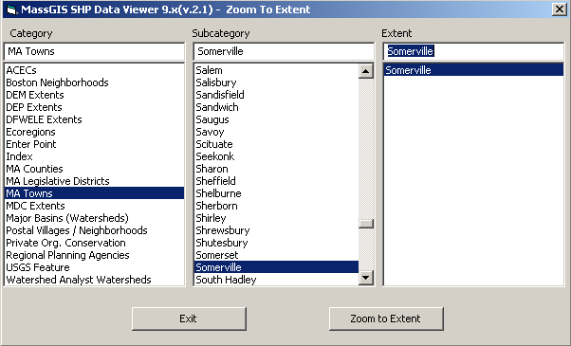
“Type-ahead” fields

At the top of each list you can use the type-ahead field instead of scrolling through the data. The example here displays all the matching Massachusetts Town values that begin with “S”. The ‘Zoom to Extent’ button is disabled until you make a selection in the third (Extent) box. After you select the extent, you can zoom into the area by either double-clicking an extent or by selecting an extent and clicking the ‘Zoom to Extent’ button.
Enter Point

In the Zoom menu, one Category option is ‘Enter Point’. By selecting this option, a new screen will appear:

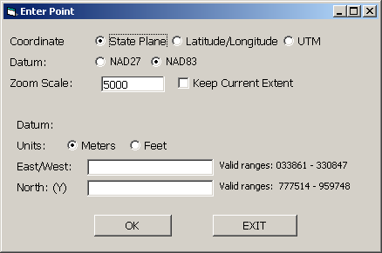

The Enter Point dialog will allow you to enter coordinates in order to zoom to a point on the map. MassGIS data is projected as NAD83 State Plane Mainland meters. Since your coordinates may come from different coordinate systems, datums, zones and units, they will be converted to NAD83 State Plane Mainland meters in order to zoom to the point on the map.

Enter Point accepted coordinates are:

NAD83 State Plane meters
NAD83 State Plane feet
NAD27 State Plane feet
UTM NAD83 State Plane meters, Zone 18
UTM NAD83 State Plane meters, Zone 19
Latitude/Longitude in Degrees Minutes, Seconds
Latitude/Longitude in Decimal Degrees

Example -- Entering a Coordinate in UTM, NAD83, meters, Zone19:

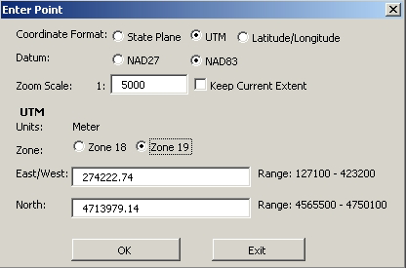

When you enter the Coordinates to zoom to, you can control the scale to which you zoom in. As shown above, the default zoom scale is 1:5000. You can change the zoom scale or click the checkbox next to ‘Keep Current Extent’ to avoid zooming to the point.

When you click OK, a red X will appear at your coordinates, either (1) zoomed in based on the scale or (2) drawn at the current extent:
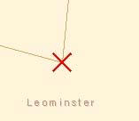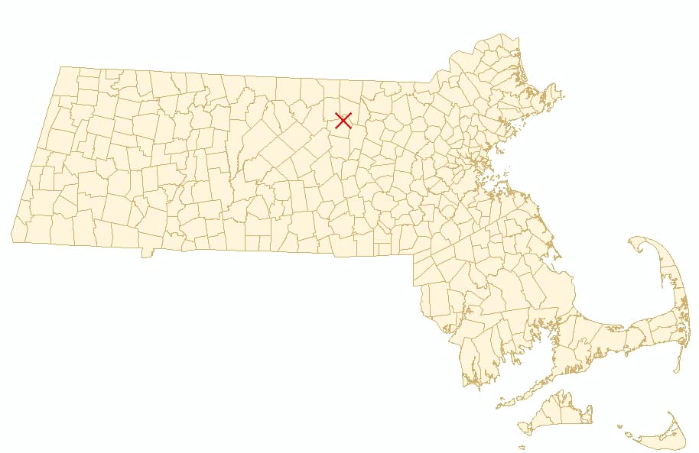
2
1

Adding Your Own Data to the ‘A’ button
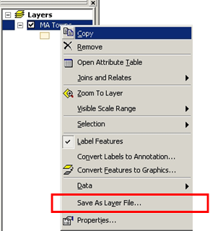
In addition to being able to browse through different categories of MassGIS data using the ‘A’ button, you can add menu choices for your own spatial data to the DataViewer’s ‘A’ button. This allows easy access to and consistent symbolization of your data. Your spatial data can be in a variety of formats, including Shapefiles, SDE layers and File and Personal Geodatabase feature classes. If you can create a .lyr file from your data, you can add it to the DataViewer.

Before you add your data to the Data Viewer, you need to figure out how you want to display it. Load your original data into ArcMap with the standard ‘Add Data’ button and set the properties, such as symbolization, labeling, and any joins/relates. When you are happy with the results, right click on the data layer in the table of contents and select ‘Save as Layer File’.

Save the .lyr file in an area accessible to the Data Viewer, giving it a name that you understand. NOTE: You will need to remember the locations and names of the original data and the .lyr file.

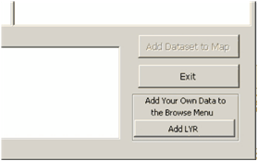
In the add data (‘A’ button) menu, on the bottom right is the option to ‘Add LYR’. By clicking this button, you will bring up a window where you will need to input information about the data you want to add to the Data Viewer:

STEP 1: Choose Menu options when Browsing Data

When you use the ‘A’ button of the DataViewer, you are selecting the Category, Subcategory and Dataset. In order to add your own data, you will have to choose the location of your datasets within that structure in order to be able to navigate to your data using the ‘A’ button.

The following window will appear when you click ‘Add LYR’:

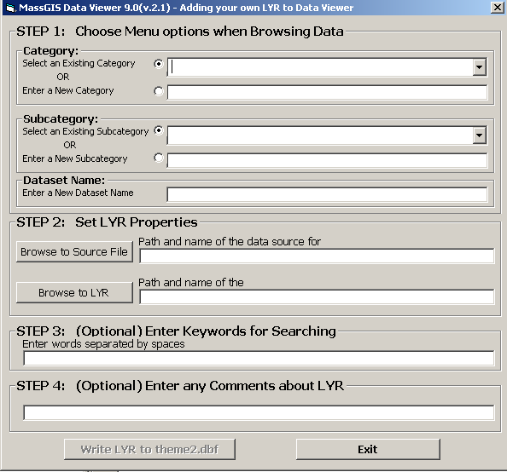

Category

Start by specifying the Category, which is the first option that appears under the ‘Adding your own data to Data Viewer’ window. You may select one of the existing categories in the dropdown list. This list includes all Categories from the MassGIS DataViewer ‘A’ button and any Categories you may have already added.

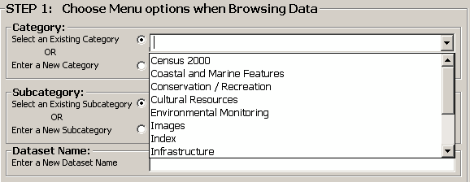
Choose from Category dropdown list

If you would rather start a new main category, then click the circle next to ‘Enter a New Category’. This will activate the text box allowing you to enter a new category name:

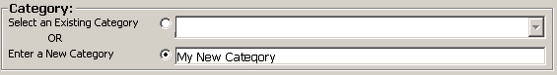
Or type new Category name

Subcategory

If you select an existing Category, the pull down list of all of associated Subcategories for that Category is populated. Again, you can choose an existing option, or enter a new Subcategory.

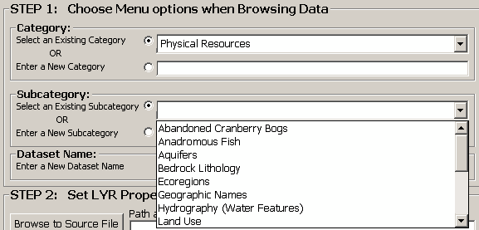
Choose from Subcategory dropdown list

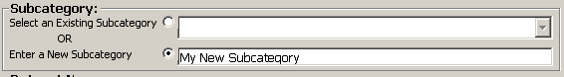
Or type new Subcategory name

Dataset

Since the Dataset Name describes the layer, each name must be unique.

Type new Dataset name

STEP 2: Set LYR Properties

This is where you will add the location information for your data so the Data Viewer can find the data source and the .lyr file (The path and the name of the data source must be included):

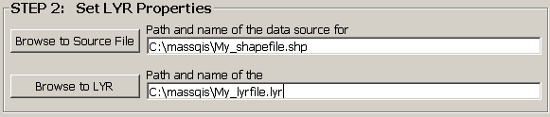

First, either type in the path to the data source, or browse to it with the ’Browse to Source File’ button:

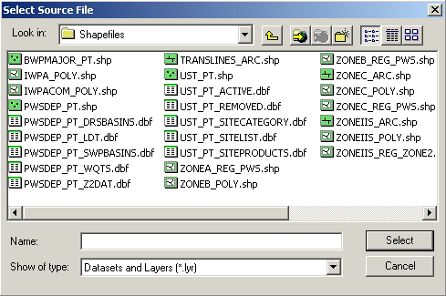

Then do the same thing again for the .lyr file, either typing in the path to the .lyr file or browsing to it with the ’Browse to LYR’ button:

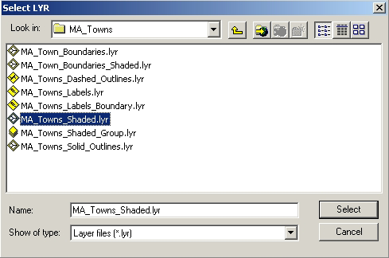

STEP 3: Keywords

This is an optional step: you can enter words to be used in the Search feature. These words should be related to the data layer, to make it easier to locate the data. This feature can be helpful when sharing the data with others or when adding many datasets.

STEP 4: Comments

This is another optional step: you can enter comments or a description about the dataset you are adding to the DataViewer, such as the date of the data, who collected the data, general description, etc. The comments will appear in the information box of the ‘A’ button screen:

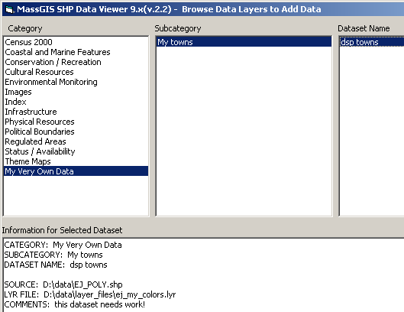

When you have finished filling in the appropriate fields, you can then write this information to the database. Clicking the ‘Write to Theme2.dbf’ button will fill the values into the database, and alert you to any missing information that is required. When the data is successfully written to the database, a message box will appear confirming the completion.

The theme2.dbf table is supplied with the viewer. Initially it is an empty table, containing only the required fields. You can populate this table through the Data Viewer, with the method described above.

After you click OK, you can either enter another .lyr file to the database or click the ‘Exit’ button to leave the ‘Adding your own LYR to Data Viewer’ screen. When you exit, the program will refresh the DataViewer’s ‘A’ button menus to incorporate the new data that you added.

MassGIS
May 23, 2012
http://www.mass.gov/mgis

