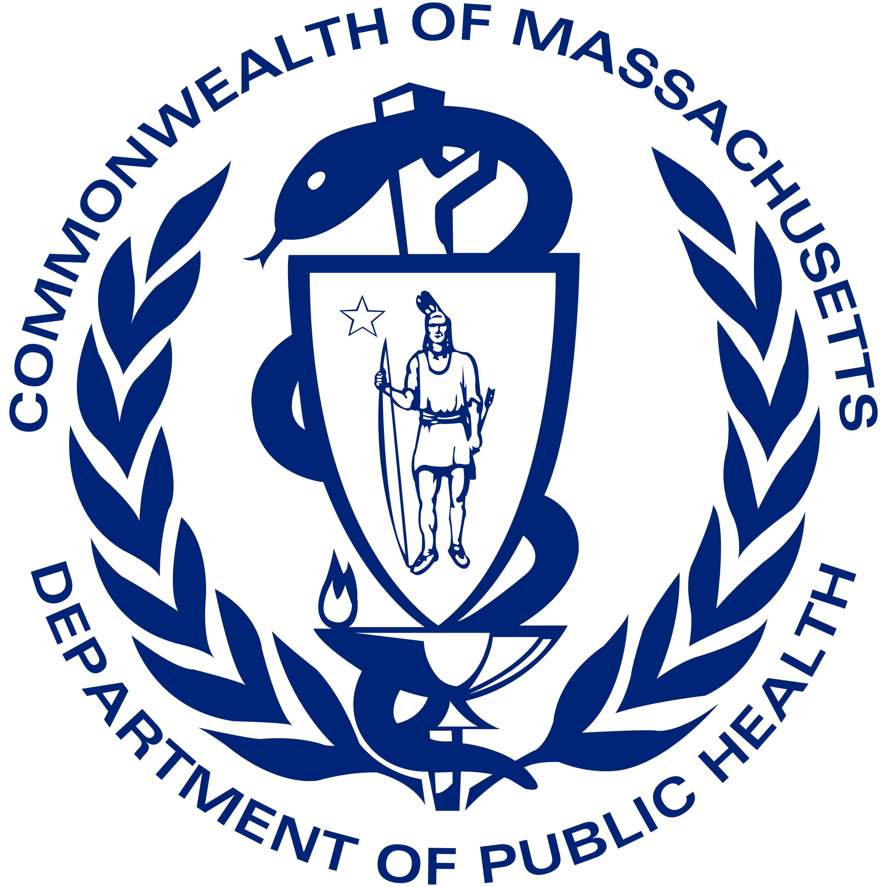
Vaccine Equity Initiative
Focused Grassroots Outreach: Menu of Offerings

DPH is implementing a community-based and driven system, designed around needs and assets for each individual community. This approach is centered on equity, a core pillar of our vaccine distribution. Our goal is to work in collaboration with our local communities, to meet people where they are, and to reduce barriers – both physical and otherwise – to getting the COVID-19 vaccine.

The Vaccine Equity Initiative will focus on 20 cities and towns with the greatest COVID-19 case burden, taking into account social determinants of health and the disproportionate impact of COVID-19 on BIPOC. These communities are Boston, Brockton, Chelsea, Everett, Fall River, Fitchburg, Framingham, Haverhill, Holyoke, Lawrence, Leominster, Lowell, Lynn, Malden, Methuen, New Bedford, Randolph, Revere, Springfield, and Worcester.

There are several resources available to support and strengthen your community’s vaccination efforts. Together, we will work with you to leverage and coordinate state resources and customize support based on your community’s needs. The menu below is part of a larger portfolio of resources, provided in collaboration with Archipelago Strategies Group (ASG) and Health Care for All (HCFA). ASG and HCFA will work with DPH to leverage both the Trust the Facts. Get the Vax. campaign materials/messaging provided by MORE advertising and new messaging and materials for a bi-directional community engagement dissemination strategy. Unless otherwise noted, these services will be provided by either ASG or HCFA depending on the community being served. To access these resources, please contact your Community Liaison or ASG/HCFA representative.

Events & Services

- Offer Assistance in Community-Wide Online Town Halls
- Work in partnership with community leaders and city officials and offer assistance in preparation materials and presentation tools
- Support as needed and coordinate, schedule, produce, and promote townhall events
- Manage simultaneous broadcasting of townhalls in multiple languages
- Work with all local media and ethnic broadcast channels for streaming and/or dissemination in target languages

- Recruit Local Influencers to Participate in Messaging Outreach and Media Interviews
- Connect with leaders of community organizations, health centers, social service agencies, faith-based groups and others to endorse vaccine messaging and uptake
- Work with leaders to record and disseminate short 1-minute videos on vaccine safety and trust
- Pitch one local story per week to local media and work to set up local cable TV, radio interviews, and other earned media opportunities, e.g., op-eds and letters to the editor and work with local leaders and influencers to participate.

- Coordinate, Conduct, and Staff Hyper-Local Public Events
- Work with local businesses and organizations to set up and staff information booths in high-traffic locations like supermarkets, downtowns, parks and recreational areas, and places of worship. The booth staff would answer questions, distribute information in multiple languages, and give out care kits to include PPE and vaccine education materials.
- Organize and conduct group walks of neighborhood commercial strips, posting of signs and distribution of PPE and information.

- Door-to-Door Canvassing
- Conduct bilingual, bi-cultural canvassing with community members to knock on doors, answer questions about vaccine safety and potentially register residents for appointments.

- Virtual Phone Banking
- Bilingual, bi-cultural workers from the communities will staff virtual phone banks for outbound calls to hundreds of residents. Callers would also register and remind people of appointments.

- SMS (Text Messaging)
- Manage a texting schedule of messages to go to individuals who have consented to receive messages who fit our criteria. Messages would help guide recipients to their appointment or remind them of key dates.

Tailored Communications

- Place Paid Ads in Local Media or Boost Digital Town Halls on Social Media
- In coordination with MORE Advertising, provide linguistically and culturally appropriate messages through community-specific and hyper targeted channels.

- Develop Multi Language Adaptations of Assets of the “Trust the Facts. Get the Vax.” Campaign
- Develop linguistically and culturally appropriate messages, built on data-driven and research-based campaign messages.

