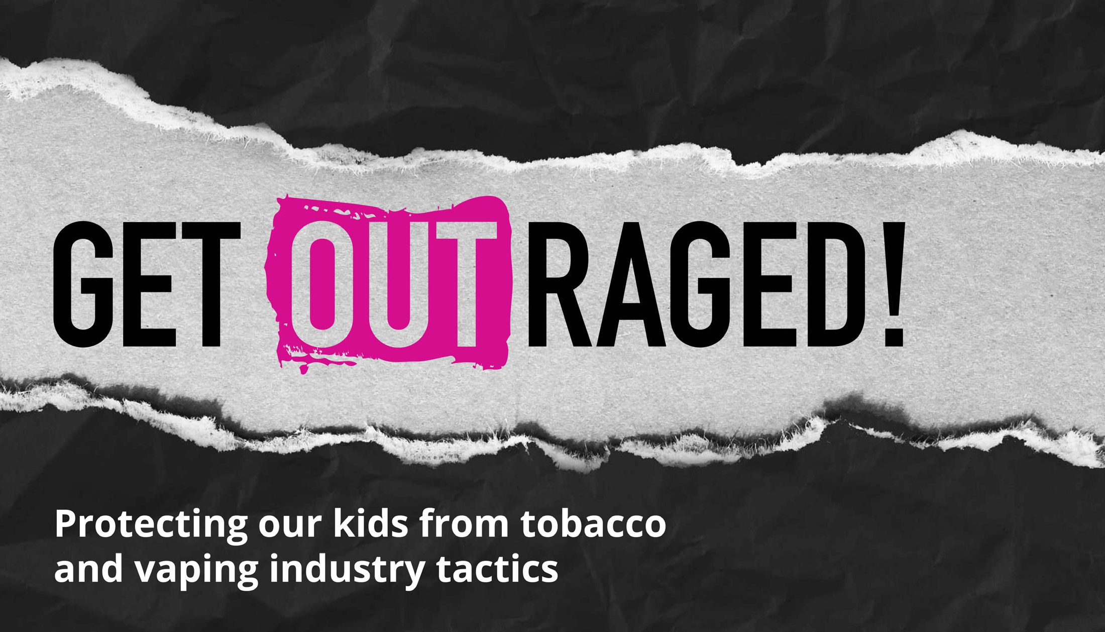

**Note for presenter**:

Throughout the slides, notes for presentation are titled “Note for presenter” and talking points or a script for the slide are titled “Script”

If you would like assistance with giving this presentation, please connect with your local Tobacco‐Free Community Partnership Program. You’ll find contact information at the end of this presentation.



Introduction

Insert Name, Job Title

Insert program name, school, organization, etc.

**Note for presenter:**

Introduction slide for the presenter.

Especially for a parent‐focused presentation, please introduce yourself and your role. You can also indicate that you will provide your contact information at the end of the presentation.

Agenda

1. Vaping Overview
2. Industry Tactics



1. Helping Youth Quit
2. School and Local Policies
3. Resources

**Note for presenter:**

You can adjust the agenda according to your needs. Feel free to add additional sections or take away sections that may not be relevant for your meeting.

If your time is limited, think about the goal for the presentation and adjust your time to focus on those sections.

**Script:**

This is what we will cover today. As a note, when the slides reference youth, teens, or young adults, in general youth/teens refer to ages 12‐17 and young adults refers to 18‐ 24 year olds.



**Note for presenter:**

If you don’t have internet access, start with the next slide and encourage people to watch the videos and learn more at GetOutraged.org

ht[tps://www.youtube.com/watch?v=1yceI03MWJY&list=PL54knlBH64ACEFZN4nHWKg5vCa](http://www.youtube.com/watch?v=1yceI03MWJY&list=PL54knlBH64ACEFZN4nHWKg5vCa) rdpBbOi&index=3

# Script:

To help us start thinking about vaping, let’s watch this short video from the Massachusetts Department of Public Health.

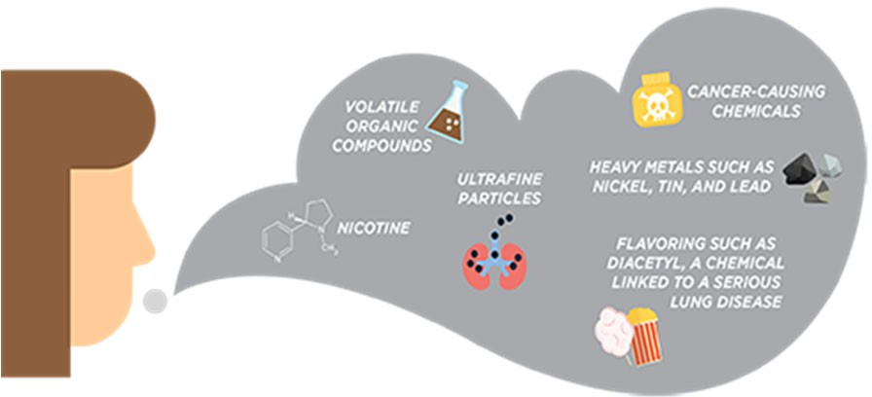

What is vaping?

Vaping is the act of inhaling and exhaling the aerosol (often called vapor) produced by an e‐cigarette or similar battery‐ powered device.

# Script:

According to the Centers for Disease Control and Prevention, 10% of high school students reported current use (past 30 day use) of e‐cigarettes in 2023.

(Massachusetts data is from 2021 and showed current e‐ cigarette use among high school students at 17.2%)

E‐cigarettes are also known as e‐cigs, vapes, vape pens, e‐ hookahs, e‐pipes, tanks, mods, electronic nicotine delivery systems, or ENDS, and more.

Some people refer to vaping devices by their brand name such as Elf Bar, Esco Bar, Vuse, Juul, Mr. Frog, SMOK, and others.

E‐cigarettes contain pre‐filled pods or e‐liquids/e‐juices

the user adds to the device. E‐liquids generally consist of nicotine, propylene glycol, glycerin, flavorings, and other chemicals. Many of these pods and e‐liquids come in fruit and candy flavors that appeal to youth.

E‐cigarettes produce an aerosol, which users inhale from the device and exhale. The aerosol can contain harmful and potentially harmful substances, including:

* Nicotine
* Ultrafine particles that can be inhaled deep into the lungs
* Flavoring such as diacetyl, a chemical linked to a serious lung disease
* Volatile organic compounds
* Cancer‐causing chemicals
* Heavy metals such as nickel, tin, and lead

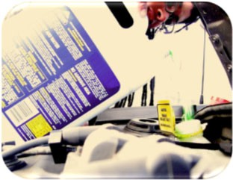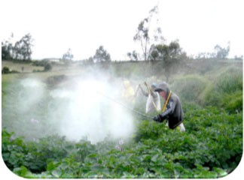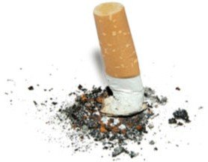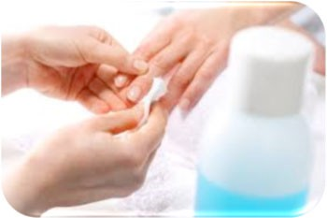

Where else can you find chemicals commonly found in vape aerosol?

**Propylene glycol** → **Antifreeze Acetone** → **Nail Polish Remover Ethylbenzene**

→ **Paints, Pesticides**

**Formaldehyde** → **Embalming**

**Nicotine** → **Cigarettes**

**Rubidium** → **Fireworks**

# Note for presenter:

If you don’t want to go through the entire list (maybe just 2 or 3 examples), nicotine should be on the list. It can be last for emphasis, but it should be noted regardless of how many examples are given.

# Script:

* + Although the chemicals that have been found in e‐cig aerosols might seem unrecognizable, you are familiar with other places some of those same chemicals can be found.
  + (*click)* For example, Propylene glycol can be found in antifreeze products or also used to winterize plumbing systems
* (*click)* Acetone is commonly found in nail polish remover and as a paint thinner
* (*click)* Ethylbenzene is often used to make other chemicals. It’s also found in other products, including pesticides, synthetic rubber, varnishes paints, and inks
* (*click)* Formaldehyde based solutions are also used in embalming to disinfect and temporarily preserve human and animal remains
* (*click)* Maybe the most important ingredient here is nicotine. Nicotine is a drug that's highly addictive in moderate doses and is the reason why smokers smoke even after they start getting sick. Of course, in high doses, it's a poison.
* (*click)* Rubidium is a chemical that can be used to give fireworks their bright colors

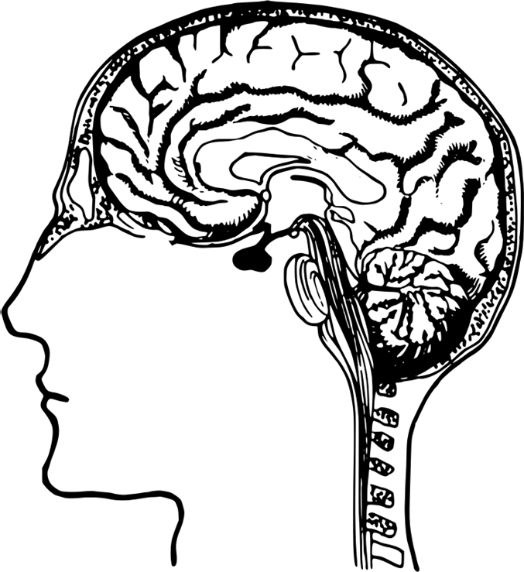

How does nicotine harm teens?

* People who start smoking or using tobacco products in adolescence, smoke more and have a harder time quitting than people who start as adults1
* Youth who use e‐cigarettes are more likely to become combustible cigarette smokers2

# Script:

According to the Surgeon General, because the brain isn’t fully developed until the mid‐20s, youth and young adults are uniquely at risk for long‐term, long‐lasting effects of exposing their developing brains to nicotine.

These risks include nicotine addiction, mood disorders, and permanent lowering of impulse control. Nicotine also changes the way synapses are formed, which can harm the parts of the brain that control attention and learning. Teens can get addicted more easily than adults. The nicotine in e‐cigarettes and other tobacco products can also prime the adolescent brain for addiction to other drugs.

E‐cigarette use among youth and young adults is strongly linked to the use of other tobacco products, such as regular cigarettes, cigars, hookah, and smokeless tobacco.

**Citations:**

1. Many published studies have shown this, including: Abreu‐Villaca, Y. et al (2003). Short‐term adolescent nicotine exposure has immediate and persistent effects on cholinergic systems: Critical periods, patterns of exposure, dose thresholds. Neuropsychopharmocology, 28 pp. 1935‐1949.
2. U.S. Department of Health and Human Services. E‐Cigarette Use Among Youth and Young Adults: A Report of the Surgeon General—Executive Summary. Atlanta, GA:

U.S. Department of Health and Human Services, Centers for Disease Control and Prevention, National Center for Chronic Disease Prevention and Health Promotion, Office on Smoking and Health, 2016.

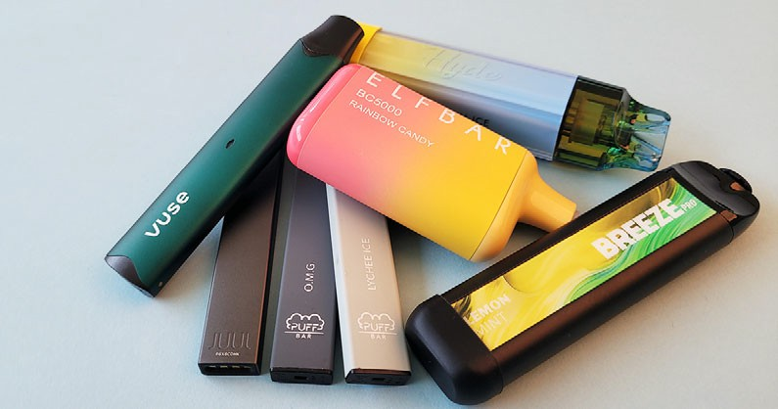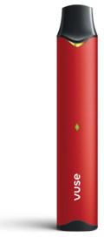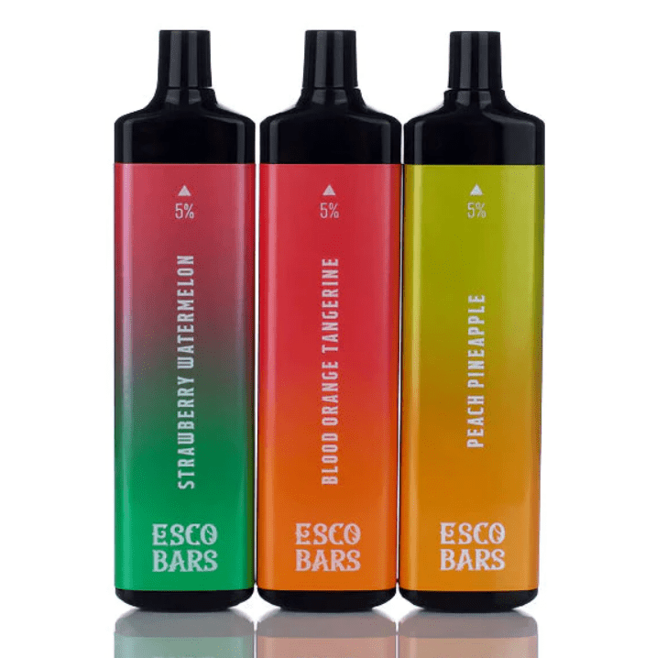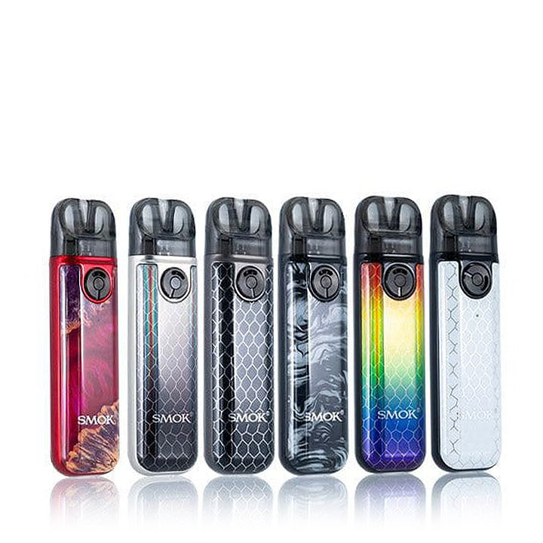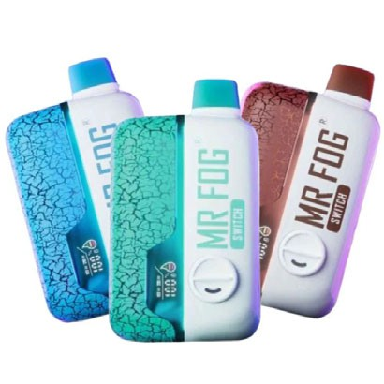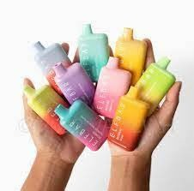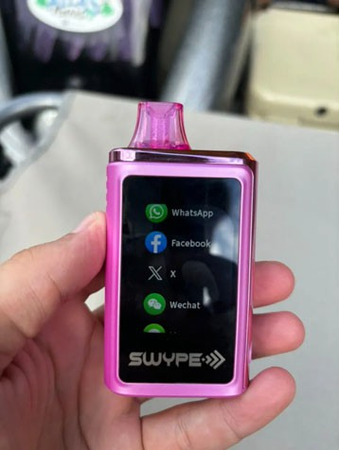

What do newer vaping products look like?

**Script:**

Some e‐cigarettes are made to look like regular cigarettes, cigars, or pipes. Some resemble pens, small electronic devices such as USB sticks, and other everyday items. The products that are designed to resemble small electronic devices are often compact and allow for discreet carrying and use – at home, in school hallways and bathrooms, and even in classrooms.

Tobacco and vaping companies appear to be introducing many new types of vaping devices that are sleek, concealable, and modern. Some still closely resemble the design features of JUUL. Major tobacco companies as well as independent companies are producing these types of vapes.

Although the FDA (Food and Drug Administration) has only approved 34 e‐cigarettes (3 brands) (as of August 2024) for sale in the United States, thousands more are in stores illegally

Companies are also now introducing pre‐charged, completely disposable vaping devices. (From Campaign for Tobacco‐Free Kids)

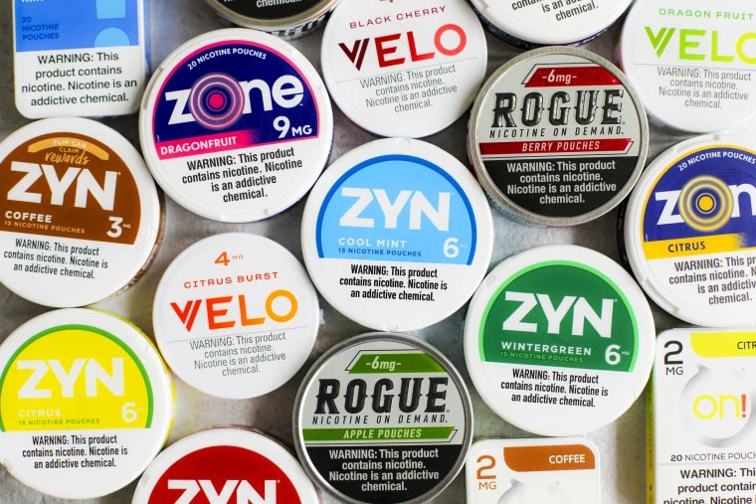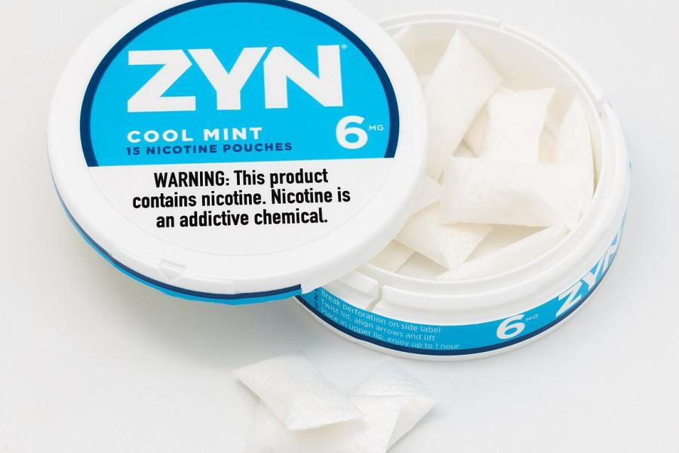

Other emerging nicotine products

**Script:**

And even though this presentation focuses on vaping, we want to mention that smokeless tobacco products are being used increasingly by youth. Smokeless tobacco is any tobacco that isn’t burned or inhaled by the user. One type, oral nicotine pouches, like Zyn and Velo, have become popular with youth recently. They contain nicotine powder that dissolves in the user’s mouth. They are “spitless.” Nicotine pouches are small and discrete, making their use easy to hide.



How do we know if teens are vaping?

* Might be a flavored e- juice for a vaping device
* If you come across unusual pens or USB drives or

an unfamiliar battery or battery charging device, they could be associated with vaping

* Youth leaving room frequently (to vape) and symptoms of nicotine withdrawal
  + Difficulty concentrating
  + Feeling anxious, irritable, restless, angry

Signs of Nicotine Addiction

Unfamiliar Products

Unexplained Sweet Scent

# Script:

You might observe signs of nicotine addiction, which could include leaving the class frequently (students feeling a need to use nicotine) and symptoms of withdrawal when they have gone long periods without vaping such as anxiety, irritability, restlessness, difficulty concentrating, depressed mood, frustration, and anger (source: Mayo Clinic))



# Note to presenter:

If you don’t have internet access, go to the next slide and encourage people to watch the videos and learn more at GetOutraged.org

http[s://www.youtube.com/watch?v=61qY4ooWWvE&list](http://www.youtube.com/watch?v=61qY4ooWWvE&list)

=PL54knlBH64ACEFZN4nHWKg5vCardpBbOi

# Script:

Before we move on to talk about how the tobacco and vaping industries targeted youth, how the Commonwealth of Massachusetts has responded and how you can support teens who vape, let’s watch this video from the Department of Public Health.



How has Massachusetts responded to tobacco industry tactics?

**Massachusetts took action with a statewide law to reduce the influence of the tobacco and vaping industries.**

* **SWEET – FLAVOR RESTRICTION:** ALL flavored tobacco and e‐cigarette products, including menthol, are restricted to adult‐only smoking bars for onsite consumption only.
* **CHEAP – TAXING E‐CIGS:** E‐cigarettes and other electronic nicotine delivery systems are now taxed, bringing them in line with the cost of cigarettes and other tobacco products and making them less attractive for

impulse buys.

* **EASY to GET:** Massachusetts laws make e‐cigarettes and all other flavored tobacco products harder

to get. But this doesn’t mean that youth will stop seeing tobacco products or advertisements in your community

# Script:

The tobacco industry has a history of targeting groups of people to make them new customers.

The tobacco and vaping industries target youth with products that are sweet, cheap, and easy to get. These e‐cigarettes and flavored tobacco products are undermining the nation’s efforts to reduce youth tobacco use‐ and they’re putting a new generation of young at risk of nicotine addiction and negative health effects.

**Sweet**: Vapes and e‐cigarettes come in thousands of different flavors that appeal to youth.

**Cheap**: Products are priced to encourage impulse buys by young people. Coupons are often offered, making products less expensive.

**Easy to Get**: These products were at gas stations, corner stores, mini‐marts, and many more types of stores. Youth see advertisements online.

**Other ways the industry targets teens**: Making their products appear like tech gadgets, making them discreet, and advertising on platforms that are popular with youth.

Massachusetts updated its tobacco laws to improve health in the communities that have been historically and unjustly targeted by the tobacco and vaping industries.

These industries have targeted the Black community, the LGBTQ+ community and the Latinx community, among others

The Legislature passed and Governor Charlie Baker signed into law An Act Modernizing Tobacco Control in 2019, which provided the Massachusetts Department of Public Health with additional authority to regulate access to tobacco and electronic nicotine delivery systems, including vapes.

Just like other tobacco and nicotine products, youth may get e‐cigarettes from friends who vape or from local or online stores that do not abide by Massachusetts

restrictions on sales. If you wish to report one of these sales violations, call 1‐800‐992‐1895 or contact your local Board of Health. According to the 2023 Massachusetts Youth Health Survey, most youth who use tobacco products get them from friends or family members.

For more information about Massachusetts’ laws about tobacco, visit [www.mass.gov/dph/mtcp](http://www.mass.gov/dph/mtcp)

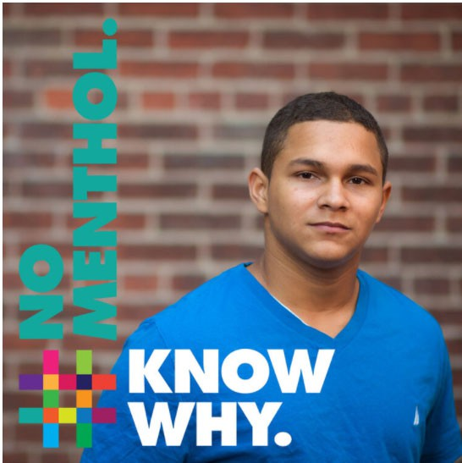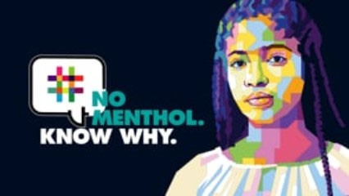

Massachusetts’ Tobacco Law of 2019

Massachusetts updated its tobacco laws to improve health in the communities that have been unjustly targeted by the tobacco and vaping industries.

NoMentholKnowWhy.org

# Script:

A main component of the 2019 Tobacco Law was restricting the sale of flavored tobacco products in Massachusetts. Prior to this law, many cities and towns had flavor restrictions in place. These flavor restrictions DID NOT include mentholated products (or mint and wintergreen). While meant to protect people, without including menthol, these flavor restrictions overlooked African Americans and other groups historically targeted by the tobacco industry with menthol products.

The inclusion of menthol in a statewide flavor restriction aims to create justice around this issue –protecting ALL Massachusetts residents from these products.

The flavor restriction:

* Restricts the sale of ALL tobacco products, including menthol cigarettes to licensed smoking bars for onsite consumption only. These smoking bars are adult‐only establishments
* Restricts the sale of non‐flavored e‐cigarettes with a high nicotine content to adult‐only tobacco retail stores and adult‐only smoking bars.
* Essentially leaves only non‐flavored cigarettes, cigars, and e‐cigarettes with lower nicotine content in corner stores where youth are exposed to them.

Now that we know a little about how teens are targeted and how the Commonwealth has responded, what does the latest data tell us?

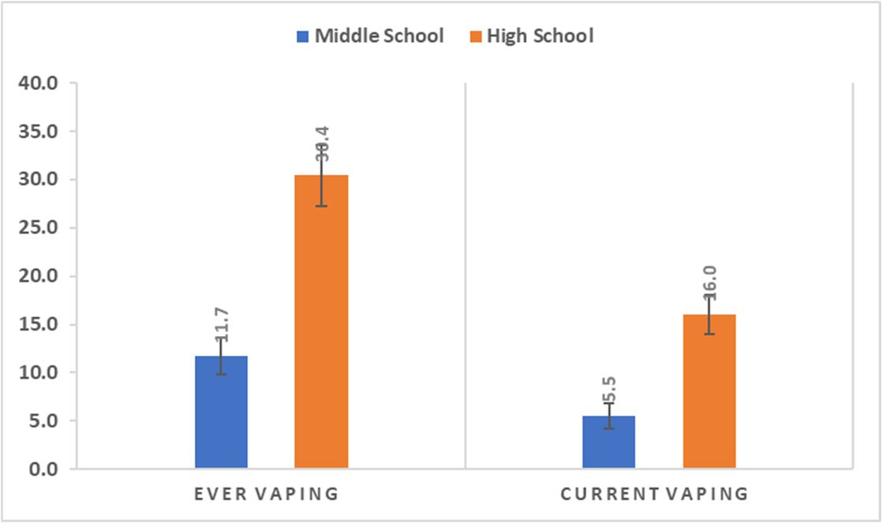

Middle and High School Vaping - 2023

**Note to presenter:**

Any local or organizational data you have can be added to this slide or used to replace the statewide data on the slide.

**Script:**

Current use is defined as use within the past 30 days.

In 2023, 16% of high school youth and 5.5% of middle school youth reported currently using e‐cigarettes.

2023 data also show that 30% of high school students reported ever using e‐cigarettes and nearly 12% of middle school students reported ever‐using them.

Source: 2023 MA YHS

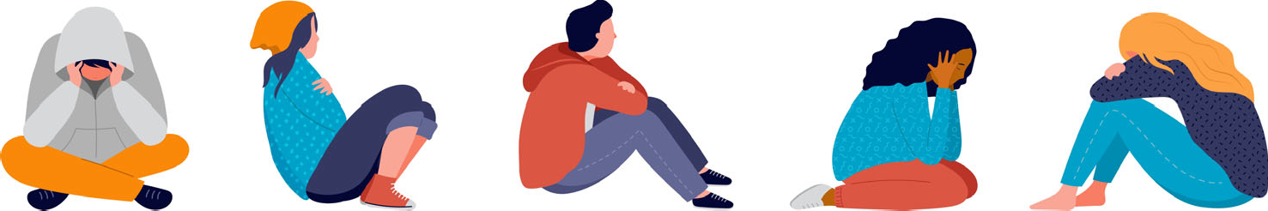

How can we tell if a teen is hooked?

**Nicotine is an addictive substance that impacts the brain and body.**

If teens experience one or more of the following, they likely are hooked:

* Having strong cravings to vape or use tobacco
* Feeling nervous or anxious when they can’t vape or use tobacco
* Vaping in places they aren’t supposed to (going out of their way to vape or use tobacco)
* Having trouble concentrating
* Feeling like they need to vape or use tobacco to feel better
* Feeling angry, irritable or restless when they haven’t vaped or used tobacco in a while.

# Script:

Some young people may not realize they are addicted to nicotine. If you think a young person is hooked, try to have a positive conversation with them about it. Offer them help and support and, if it’s appropriate, tell them you’re concerned about them and suggest they try to stop. If they are willing to seek help tell them about mass.gov/vaping and all the free resources designed to help teens quit.



What can we do to help our young people?

Educate

* Adults who work with youth
* Youth and parents
* Review disciplinary policies around vaping and consider alternatives to suspension
* Have tobacco policies in place and let youth know about them
* Safely dispose of found or confiscated vaping products
* Create an environment that promotes healthy ways to deal with stress.

# Script:

What can our school/organization do to help young people who are addicted to nicotine?

We can educate youth and the adults around them about the dangers of vaping, how to know if a young person is addicted and how to help a teen who wants to quit. We can review our disciplinary policies and consider supportive alternatives for youth who vape. And we can assure that we safely dispose of vaping products—e‐ cigarette are considered hazardous waste products because of batteries, nicotine and other chemicals.

And, most importantly, we can create a school culture that teaches and promotes healthy ways to deal with stress so more students don’t start to vape

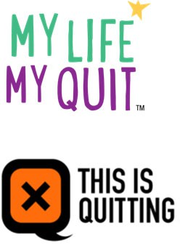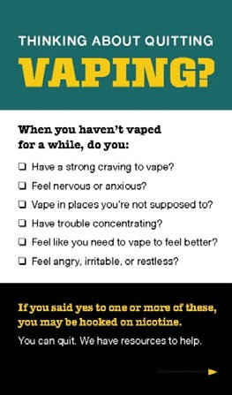

**Quitting vapes or other tobacco products can be hard.** Here are some ways to help young people get the support they need:

* **My Life, My Quit TM** has youth coach specialists trained to help young people by phone or text. Call 855‐891‐9989 or text *Start My Quit* to 36072 for **free and confidential** help. For more information or to sign up online,

visit mylifemyquit.com.

* **This is Quitting** powered by truth® is a free and confidential texting program for young people who vape. Young people can text *VapeFreeMass* to 88709 to get started.

What resources are available to help teens quit?

**Script:**

What resources are available to help teens quit? On the slide, you’ll see information about two services designed for teens to help them quit—MyLife, My Quit and This is Quitting.

In addition,

* There’s Smokefree Teen (teen.smokefree.gov), part of the National Cancer Institute’s (NCI) Smokefree.gov Initiative. Services offered include text messaging and a quitSTART app that provides strategies for tackling cravings, bad moods, and other situations.
* Young people can ask for help from their school nurse or counselor, athletic coach, doctor, parent or another trusted adult.
* For more information, young people can visit mass.gov/vaping.
* A “Thinking About Quitting Vaping” resource card is available to order free of charge from the Massachusetts Health Promotion Clearinghouse. The front of the card is pictured here and the back includes the resources mentioned on this slide.



Where can I get more information about youth vaping?

[www.GetOutraged.org](http://www.GetOutraged.org/)

•Facts

* For parents (tips on talking with your kids)
* For schools and youth-serving organizations
  + Toolkit divided into information for administrators, teachers, school health services, healthcare providers
* Resources to help youth quit

[www.mass.gov/vaping](http://www.mass.gov/vaping)

* Simple information and videos on vaping and quitting resources for youth

Massachusetts Health Promotion Clearinghouse

* Print materials

**Note for Presenter:** You can download and print or order the materials from the MA Health Promotion Clearinghouse in advance of the presentation and bring them with you to show.

# Script:

Visit the Massachusetts Department of Public Health’s website focused on vaping at [www.GetOutraged.org.](http://www.GetOutraged.org/) You can get the facts on vaping and other tobacco products, as well as information for parents and for schools! There is a toolkit for schools and organizations to use to help address this issue, including this PowerPoint.

* The toolkit also includes information on free vaping

prevention curricula as well as information on alternatives to suspension for youth who violate school tobacco policies.

There is also the Massachusetts Health Promotion Clearinghouse found at [www.mass.gov/maclearinghouse.](http://www.mass.gov/maclearinghouse) This site has free printed materials to download or order to help spread the word. Much of the content on the GetOutraged.org website is available in print form at the Clearinghouse.

Available materials for a youth audience include: Quitting Vaping: Information for Youth Brochure; Youth Vaping Handout; Thinking About Quitting Vaping Card

Available materials for schools or organizations include: Vaping Cessation –A Guide for School Nurses and Counselors; Youth Vaping Poster

And there are many materials available for parents as well, including a flyer titled Want to Help Your Teen Quit Vaping or Using Tobacco?

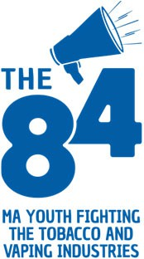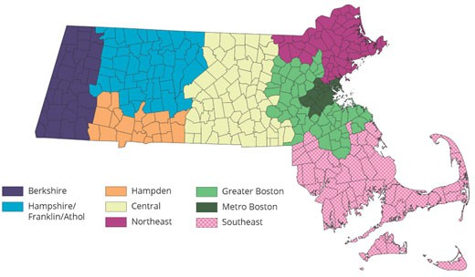

Find your local Tobacco-Free Community Partnership contact: <http://makesmokinghistory.org/my-> community/community-partnerships/

Meet The 84 Movement youth leaders and adult advisors in your region by contacting Carly Caminiti at [ccaminiti@hria.org.](mailto:ccaminiti@hria.org)

Are there local people I can speak with for more information?

# Script:

The Tobacco‐Free Community Partnerships around the state prioritizes racial justice and community health over tobacco and vaping industry profits. They work with local partners to fight the industry’s historic & unjust targeting of specific groups.

The 84 Movement is a statewide youth racial justice and tobacco prevention program that promotes youth leadership to improve public health. Specifically, The 84 supports young people in middle and high school to fight the influence of the tobacco and vaping industries in their communities. Chapters of The 84 educate peers and adults about the deceptive marketing practices and racial inequities perpetuated by these industries.



Our school’s vaping policies

# Note to presenter:

This slide is optional –Information about your organization’s vaping policy can be inserted here on what you are doing to address vaping. This slide is at the end, so it doesn’t distract from the other information.



Are there local people I can speak with for more information?

**Note for Presenter:**

You can insert your contact information or other school/organization contact information here