INDOOR AIR QUALITY ASSESSMENT

Varnum Brook Elementary School
10 Hollis Street
Pepperell, Massachusetts

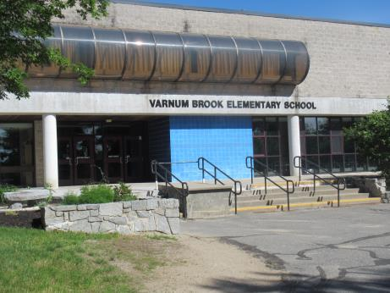

Prepared by:
Massachusetts Department of Public Health
Bureau of Environmental Health
Indoor Air Quality Program
June 2017

Background
Building: | Varnum Brook Elementary School
Address: | 10 Hollis St, Pepperell, MA
Assessment Requested by: | Oscar Hills, Building and Grounds Supervisor, North Middlesex Regional School District
Reason for Request: | General indoor air quality (IAQ) concerns and concerns about water damage and health in the library.
Date of Assessment: | June 14, 2017
Massachusetts Department of Public Health/Bureau of Environmental Health (MDPH/BEH) Staff Conducting Assessment: | Ruth Alfasso, Environmental Engineer/Inspector, IAQ Program
Building Description: | Two-story concrete block school building originally constructed in 1979 with an addition in the 1990s.
Windows: | Exterior windows are mostly openable.

Methods
Please refer to the IAQ Manual and appendices for methods, sampling procedures, and interpretation of results (MDPH, 2015).

Results and Discussion
The following is a summary of indoor air testing results (Table 1).
- Carbon dioxide measurements were below the MDPH recommended level of 800 parts per million (ppm) in most areas surveyed indicating adequate fresh air in most areas of the building.
- Temperature was above the MDPH recommended range of 70°F to 78°F in most areas surveyed at the time of assessment, which reflects heat wave conditions that occurred for several days before the visit.
- Relative humidity was within or close to the lower end of the MDPH recommended range of 40 to 60% in all areas tested.
- Carbon monoxide levels were non-detectable in all areas tested.
- Particulate matter (PM2.5) concentrations measured were below the National Ambient Air Quality (NAAQS) level of 35 μg/m³ in all areas tested.

Ventilation
A heating, ventilating and air-conditioning (HVAC) system has several functions. First it provides heating and, if equipped, cooling. Second, it is a source of fresh air. Finally, an HVAC system will dilute and remove normally occurring indoor environmental pollutants by not only introducing fresh air, but also filtering the airstream and ejecting stale air to the outdoors via exhaust ventilation.
Fresh air is provided by a combination of unit ventilators (univents) located in individual classrooms (Picture 1) and air handing units (AHUs), which serve central areas such as the gym, library and office areas. The unit ventilators draw fresh air through a vent on the exterior wall (Picture 2). Air is mixed with return air from the room, filtered, heated (if needed) and delivered back to the room (Figure 1). In a few classrooms, univents were blocked with furniture and items (Table 1; Picture 3) which can prevent proper functioning.
Air from the AHUs is filtered, heated or cooled as needed, and delivered to rooms via ducted supply vents (Picture 4). While areas served by the AHU have some air conditioning (cooling), areas served only by univents do not. In a few classrooms, window air conditioners (WAC) were installed and operating (Picture 5). Classrooms where these WAC were installed had carbon dioxide levels higher than the preferred level of 800 ppm (Table 1). The univents in these classrooms were turned off so that hot outside air was not being brought in. WAC units can be configured to provide some outside air and it appeared that these were not configured in this manner at the time of the visit.
Air is exhausted from ceiling-mounted exhaust vents. In some cases exhaust vents are located near classroom doors, so when classroom doors are open, exhaust vents will tend to pull hallway air into the classroom instead of removing stale air/pollutants from the room and out the building. Also, exhaust vents in some classrooms were found to be off/nonfunctional at the time of the assessment (Table 1). It was reported that work was being performed on some of the rooftop fans as well as on one of the AHUs at the time of the assessment and that all units would be checked over the summer for proper function.
A kiln room is present next to one of the art classrooms. It could not be determined if this room is vented directly out of the building. Kilns produce waste heat and odors and should be vented directly out of the building and not into the general recirculation system.
At the time of the visit, indoor temperatures were mostly slightly higher than the recommended comfort level of 70°F to 78°F, which is reflective of a period of several days of hot weather that had occurred prior to the visit. Elevated temperatures indoors are common in schools during the warm weather that sometimes occurs at the beginning and end of the school year. An MDPH guidance regarding “Methods for Increasing Comfort in Non-Air-Conditioned Schools” is included as Appendix A.
It is important to note that relative humidity levels in the building would be expected to be lower during the winter months due to atmospheric conditions and heating. Low relative humidity can lead to common symptoms such as: dry skin, lips, and scalp; dry/scratchy throats and noses (nose bleeds); exacerbation of asthma, eczema, or allergies; dry/irritated eyes; and irritation of respiratory tract.
In order to have proper ventilation with a mechanical supply and exhaust system, these systems must be balanced to provide an adequate amount of fresh air while removing stale air from a room. It is recommended that existing ventilation systems be re-balanced every five years to ensure adequate air systems function (SMACNA, 1994). It is unknown the last time these systems were balanced.

Microbial/Moisture Concerns
Water-damaged ceiling tiles were observed in many areas on the second floor (Pictures 6 and 7). Note that the area above the ceiling is typically an open space containing no additional porous materials to hold water or become colonized with mold. Moistened ceiling tiles are likely to dry quickly in this situation, and not become mold-colonized. Many of the water-damaged tiles were caused by roof leaks. Although the roof has reportedly been repaired recently which has reduced the leaks, it is reported that the roof is beyond its service life and needs replacement to prevent future leaks. Other water-damaged tiles reportedly stem from leaks from the HVAC system. Water-damaged tiles should be replaced when they are discovered.
Plants were observed in a few areas (Picture 8; Table 1). Plants can be a source of pollen and mold, which can be respiratory irritants to some individuals. Plants should be properly maintained and equipped with drip pans and should be located away from air diffusers to prevent the aerosolization of dirt, pollen and mold. A few classrooms had aquariums and terrariums (Picture 9), which should be kept clean to prevent odors.
Sinks were observed in a number of classrooms, including science sinks in some classrooms that no longer served as science classrooms. Unused sinks may leak where it isn’t immediately detected, and the drain traps in them may dry out, which can allow sewer gases and odors into occupied spaces. Sinks that go unused should have the drains filled with water periodically to maintain the trap seal; if the sinks are no longer needed, they should be properly capped and removed. Many sinks examined also had items, including porous items, stored inside the sink cabinet, which is a moist environment (Pictures 8 and 10).
Note that the portion of the building that contains the gym is partially below grade (Picture 11) and the first floor is mainly on slab. Flooring that is directly in contact with the ground may be cooler than the surrounding air, and during hot, humid weather, moisture may condense on the floor and moisten carpeting and items that are on the floor. Picture 11 also shows that the land adjacent to the gymnasium slopes towards the building. It was reported that drainage had been improved to reduce water impinging on the building, but that these drainage systems need maintenance.
The exterior of the building was examined for potential breaches in the building envelope and other conditions. Pictures 12-14 show some of the impacts of water on the exterior of the building, including water stains on the concrete, especially on the shaded side of the building, moss growth in this area, and rusted trim/flashing along exterior overhangs and windows. It was reported that the roof drains are located higher than the lowest areas of the roof due to deterioration of the roof, which allows water to pool on the roof and lead to leaking inside. These conditions indicate that the exterior of the building is gradually deteriorating and may lead to water infiltration into the building.
Several exterior doors were observed to lack door sweeps, which can lead to infiltration of water and unconditioned air inside as well as pest entry. It was reported that door maintenance/replacement along with some window replacement is scheduled.

Other IAQ Evaluations

The Library
One of the main areas of concern in this building is the library, where staff have reported respiratory symptoms. The library is a two-story space which is served by the central AHU. It is also open to the adjacent common area hallways on both floors (Picture 15). Carbon dioxide readings in the lower level were slightly above the MDPH level of 800 ppm, indicating that it could be served by additional fresh air at ground level when fully occupied (Table 1). Several other conditions were observed that may be sources of respiratory irritation or allergic reactions in the space:
- The library is carpeted. Carpeting in this area is scheduled to be deep cleaned, which will help reduce dust and other potential irritants. Carpeting should be cleaned annually or semi-annually in soiled high traffic areas as per the recommendations of the Institute of Inspection, Cleaning and Restoration Certification (IICRC, 2012).
- Note that carpeting, ceiling tiles and draperies had been removed from two of the staff office areas in the library to help reduce the potential for irritants and allergens in this area.
- There is a “story time” area located along the windows in the back of the library, which has stairs that are carpeted to serve as seating (Picture 16). This area had a slight dusty odor. The shape of this carpeting makes it more difficult to thoroughly vacuum and clean, and it is in frequent contact with students.
- Dust was observed along windows in the story time area (Picture 17). This should be cleaned regularly.
- The exterior of the building in this area is subject to water penetration as discussed above; seams along the edge of the floor should be checked for any water infiltration during wet weather.
- In the library and adjacent office areas, large amounts of items including books, boxes, papers, decorative items, and craft supplies were stored on the floor and in open boxes (Picture 18 and 19) which can allow dusts to build up and may also provide harborage for pests.
- Books can be a source of musty odors and mold if they are stored under conditions where they may be exposed to high humidity. Books can also collect dust which can be difficult to clean, and may be exposed to other allergens such as pollen and pet hair when they are borrowed from the library. Books should be sorted and cleaned periodically, and stored in protective containers when they are not shelved for use.

Other Conditions
Exposure to low levels of total volatile organic compounds (TVOCs) may produce eye, nose, throat, and/or respiratory irritation in some sensitive individuals. To determine if VOCs were present, BEH/IAQ staff examined rooms for products containing VOCs. BEH/IAQ staff noted hand sanitizers, cleaners, and dry erase materials in use within the building (Picture 20). All of these products have the potential to be irritants to the eyes, nose, throat, and respiratory system of sensitive individuals.
It is recommended that AHUs be outfitted with pleated filters of a Minimum Efficiency Reporting Value (MERV) of 8, which are adequate in filtering out pollen and mold spores (ASHRAE, 2012). In addition, filters should be changed 2-4 times a year or in accordance with the manufacture’s recommendations.
In a number of areas, items were observed on the floor, windowsills, tabletops, counters, bookcases and desks (Pictures 21 and 22). The large number of items stored provides a source for dusts to accumulate. These items (e.g., papers, folders, boxes) make it difficult for custodial staff to clean. Items should be relocated and/or be cleaned periodically to avoid excessive dust build up. In addition, dusty materials can accumulate on flat surfaces (e.g., desktops, windowsills and carpets) in occupied areas and subsequently be re-aerosolized causing further irritation.
There is a maintenance/storage hallway that connects to the music room and building operations areas on the second floor along the outside edge of the building (Picture 23). There are many items, including porous items such as boxes and instrument cases, stored in an unorganized manner in this area, which is not supplied with ventilation. Storage areas, especially those without ventilation and not frequently visited, should be kept organized, with items off the floor, so that items may be moved quickly and any problems, such as leaks, condensation, or pest infiltration can be quickly discovered and repaired.
Some areas were carpeted and many rooms had area rugs. As mentioned above, carpeting is not recommended for below-grade areas because of the potential for becoming moistened by condensation. Carpets should be cleaned annually (or semi-annually in soiled/high traffic areas) in accordance with Institute of Inspection, Cleaning and Restoration Certification (IICRC) recommendations, (IICRC, 2012). Area rugs that are too worn or soiled to be effectively cleaned should be replaced.
Several rooms examined had upholstered items. In order to remove dust mites and other pollutants, frequent vacuuming of upholstered furniture is recommended (Berry, M.A., 1994). It is also recommended that upholstered furniture (if present in schools), be professionally cleaned on an annual basis. If outdoor conditions or indoor activities (e.g., renovations) create an excessively dusty environment, cleaning frequency should be increased (every six months) (IICRC, 2000).
A pet hamster and guinea pig were observed in classrooms (Picture 24). Pets can be a source of hair, dander and waste which can be allergenic and may lead to debris and odors. Pet cages should be kept clean, with food, water and bedding changed regularly, to prevent the build-up of odors and allergenic materials.
The staff kitchen had several cooking appliances. The room did not appear to have a direct-vented exhaust. Kitchen areas can produce particulates and odors that should be removed from the building. Kitchen equipment should be kept clean and free of crumbs and debris to avoid odors, smoke and pests.
Some classrooms were noted to have accumulations of chalk dust (Picture 25) or dry erase residue in the trays. Both of these may have irritant effects when aerosolized. Accumulated dust/debris was noted on vents and surrounding ceiling tiles (Picture 26), which should be cleaned periodically (e.g., after regular filter changes). Chalk dust was also observed on the outside of the building, indicating that erasers had been shaken off there; this activity should not take place close to univent intakes or windows.
Note that the Environmental Protection Agency (EPA) conducted a National School Radon Survey in which it discovered nearly one in five schools had “…at least one frequently occupied ground contact room with short-term radon levels above 4 [picocuries per liter] pCi/L” (US EPA 1992). The BEH/IAQ Program therefore recommends that every school be tested for radon, and that this testing be conducted during the heating season while school is in session in a manner consistent with USEPA radon testing guidelines. Radon measurement specialists and other information can be found at www.nrsb.org and http://aarst-nrpp.com/wp, with additional information at: http://www.mass.gov/eohhs/gov/departments/dph/programs/environmental-health/exposure-topics/iaq/radon.

Conclusions and Recommendations
In view of the findings at the time of the visit, the following recommendations are made:
- Repair and activate all AHUs on the roof and run continuously during occupied periods.
- Operate univents continuously during occupied periods.
- Ensure all exhaust vent fans are operating.
- Examine window air conditioners to see if they can be configured to provide some fresh air during use.
- Use openable windows to provide fresh air during temperate weather except in areas where air conditioning is operating. Ensure all windows are closed tightly at the end of the day.
- Change filters on rooftop AHUs and univents regularly (2 to 4 times a year). If not currently using them, consider upgrading to filters with a minimum efficiency of MERV 8.
- Remove all items/furniture blocking univents to ensure adequate airflow.
- Close classroom doors to maximize air exchange/improve exhaust capabilities.
- Ensure that direct exhaust ventilation is used every time the kiln is operated unit it cools.
- Consider adopting a balancing schedule of every 5 years for all mechanical ventilation systems, as recommended by ventilation industrial standards (SMACNA, 1994).
- Consult the guidance in Appendix A “Methods for Increasing Comfort in Non-Air-Conditioned Schools” to assist during hot weather in the non-air-conditioned parts of the school.
- For buildings in New England, periods of low relative humidity during the winter are often unavoidable. Therefore, scrupulous cleaning practices should be adopted to minimize common indoor air contaminants whose irritant effects can be enhanced when the relative humidity is low. To control for dusts, a high efficiency particulate arrestance (HEPA) filter-equipped vacuum cleaner in conjunction with wet wiping of all surfaces is recommended. Avoid the use of feather dusters. Drinking water during the day can help ease some symptoms associated with a dry environment (throat and sinus irritation).
- Continue with plans to repair or replace the roof, including improving roof drainage.
- Repair water leaks promptly and replace water-damaged ceiling tiles once a leak is repaired.
- Move plants away from any air streams in classrooms. Avoid over-watering or placing them on porous materials (e.g., cloth, paper) and examine drip pans periodically for mold growth.
- Properly maintain aquariums and terrariums to prevent odors.
- Determine whether unused plumbing fixtures such as those in the old science room are needed. Unused fixtures should have water poured into drains on a regular basis to avoid dry drain traps. Fixtures no longer needed should be removed and properly sealed/capped.
- Avoid storing porous items or large amounts of items underneath sinks.
- Consider removing carpeting from first floor areas.
- Monitor building exterior for breaches and water infiltration and make repairs as needed.
- Monitor exterior groundwater/stormwater drainage and make repairs if needed.
- Ensure exterior doors fit tightly with door sweeps to prevent infiltration of unconditioned air and pests.
- Continue with plans to deep clean library carpeting including the story time area seating. All carpeting should be cleaned annually or more often in high-traffic locations in accordance with IICRC recommendations (IICRC, 2012).
- Replace ceiling tiles where they had been removed in in the library office and install non-porous flooring where carpeting had been removed to improve the ability to clean these areas.
- Clean area rugs and upholstered items regularly and discard those that are worn out or too soiled to be cleaned.
- Examine books and other items in the library for signs of water damage, and allergens such as pet hair or pollen; clean or discard as needed.
- Reduce clutter building-wide, including storage areas.
- Increase dust control in the building, including cleaning supply/exhaust/return vents and personal fans regularly to prevent aerosolization of debris.
- Clean chalk dust and dry erase marker debris using wet wiping. Avoid shaking off erasers next to the building near air intakes or windows.
- Reduce use of products and equipment that create VOCs.
- Ensure that all pet cages and areas are kept clean.
- Ensure all cooking equipment is kept clean to prevent odors, smoke and pests. If no direct exhaust vent is present in the kitchen, consider installing one.
- Continue to adopt the US EPA (2000) document, “Tools for Schools”, as an instrument for maintaining a good IAQ environment in the building available at: http://www.epa.gov/iaq/schools/index.html.
- The school should be tested for radon by a certified radon measurement specialist during the heating season when school is in session. Radon measurement specialists and other information can be found at: www.nrsb.org, and http://aarst-nrpp.com/wp/.
- Refer to resource manual and other related IAQ documents located on the MDPH’s website for further building-wide evaluations and advice on maintaining public buildings. These documents are available at http://mass.gov/dph/iaq

REFERENCES
ASHRAE. 2012. American Society of Heating, Refrigeration and Air Conditioning Engineers (ASHRAE) Standard 52.2-2012 -- Method of Testing General Ventilation Air-Cleaning Devices for Removal Efficiency by Particle Size (ANSI Approved).
Berry, M.A. 1994. Protecting the Built Environment: Cleaning for Health, Michael A. Berry, Chapel Hill, NC.
IICRC. 2000. IICRC S001. Reference Guideline for Professional On-Location Cleaning of Textile Floor Covering Materials. Institute of Inspection, Cleaning and Restoration Certification. Institute of Inspection Cleaning and Restoration, Vancouver, WA.
IICRC. 2012. Institute of Inspection, Cleaning and Restoration Certification. Carpet Cleaning: FAQ. Retrieved from http://www.iicrc.org/consumers/care/carpet-cleaning.
MDPH. 2015. Massachusetts Department of Public Health (MDPH). 2015. Indoor Air Quality Manual: Chapters I-III. Available at: http://www.mass.gov/eohhs/gov/departments/dph/programs/environmental-health/exposure-topics/iaq/iaq-manual/.
SMACNA. 1994. HVAC Systems Commissioning Manual. 1st ed. Sheet Metal and Air Conditioning Contractors’ National Association, Inc., Chantilly, VA.
US EPA. 1992. Radon Measurement in Schools, Revised Edition. Office of Air and Radiation, Office of Radiation and Indoor Air, Indoor Environments Division (6609J). EPA 402-R-92-014. https://www.epa.gov/sites/production/files/2014-08/documents/radon_measurement_in_schools.pdf
US EPA. 2000. Tools for Schools. Office of Air and Radiation, Office of Radiation and Indoor Air, Indoor Environments Division (6609J). EPA 402-K-95-001, Second Edition. http://www.epa.gov/iaq/schools/index.html.
Picture 1
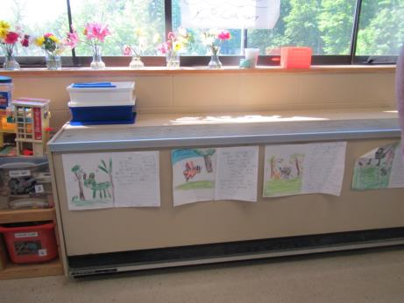
Unit ventilator (univent)
Picture 2
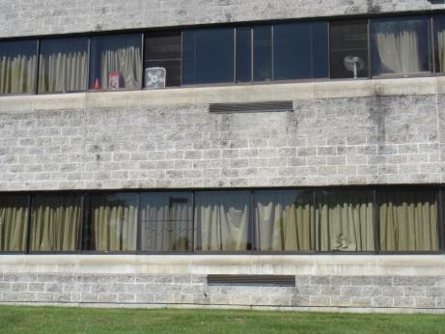
Univent fresh air intakes
Picture 3
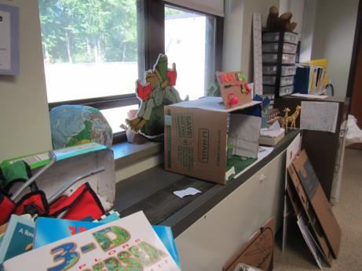
Univent blocked with items
Picture 4
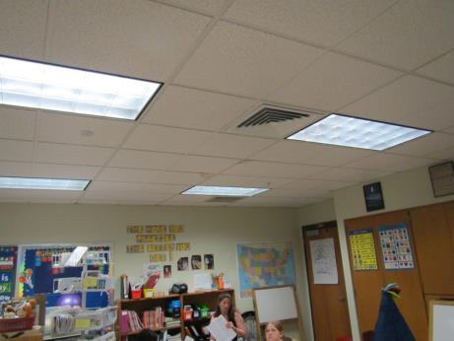
Supply vent in interior classroom (arrow)
Picture 5
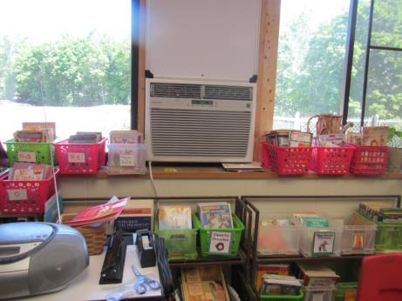
Window air conditioner in classroom
Picture 6
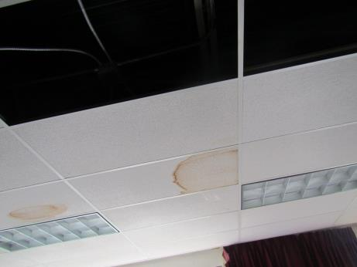
Water-damaged and missing ceiling tiles
Picture 7
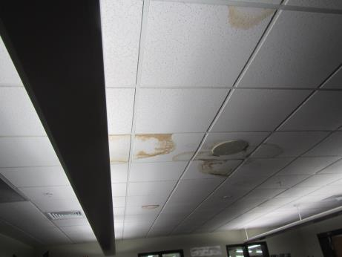
Water-damaged ceiling tiles
Picture 8
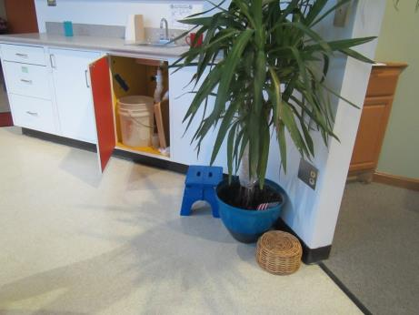
Plant in a common area, also note items under sink
Picture 9
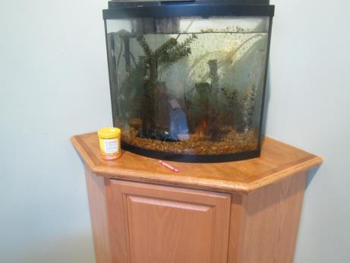
Aquarium
Picture 10
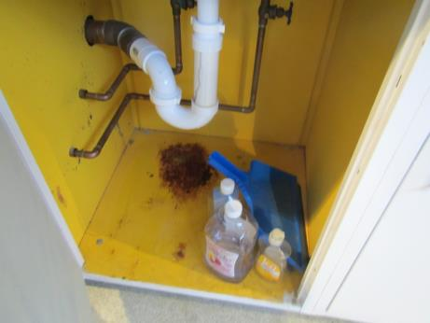
Rust stains in sink cabinet
Picture 11
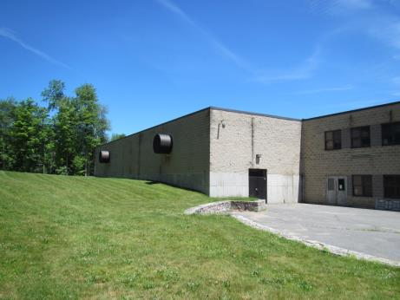
Side of building showing partial burial and drainage towards gymnasium area
Picture 12
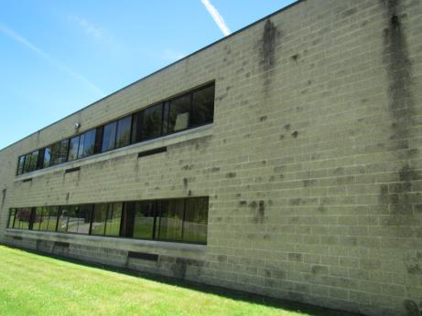
Water staining on the side of the building
Picture 13
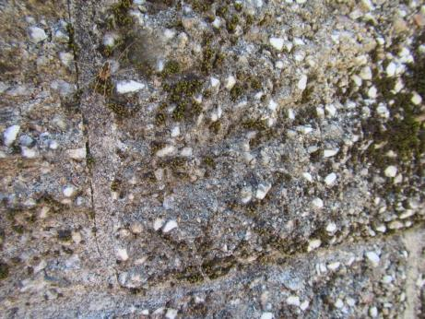
Moss growth on concrete blocks on the side of the building
Picture 14
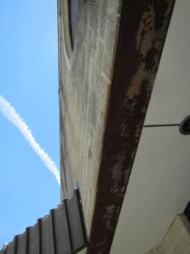
Rusty trim under an overhang for windows next to the library
Picture 15
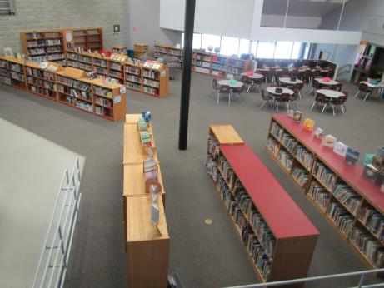
View of the library from the upper level open hallway
Picture 16
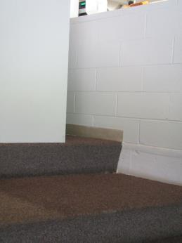
Carpeted seating in the story time area
Picture 17
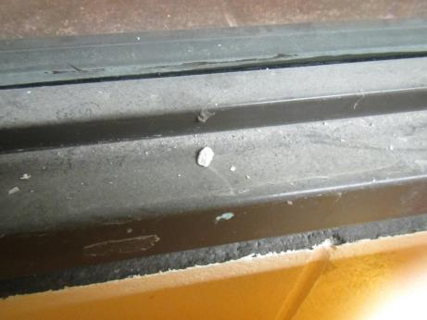
Dusty windowsill in the story time area
Picture 18
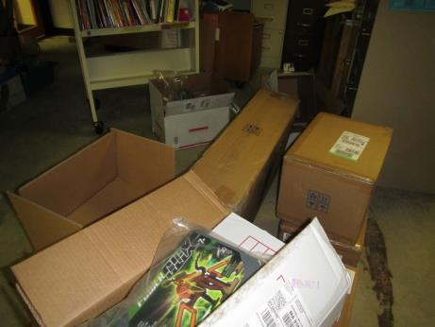
Items in one of the library offices, note boxes on floor
Picture 19
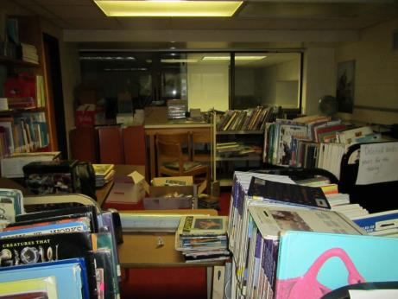
Items in a library office
Picture 20
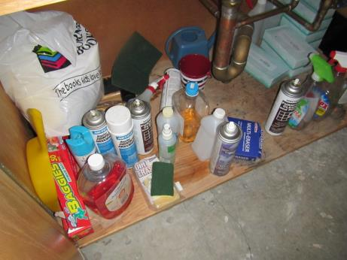
Cleaning products under a sink
Picture 21
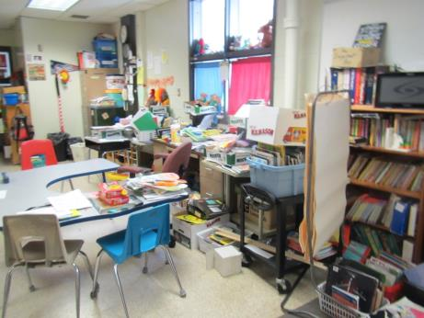
Accumulated items in a classroom
Picture 22
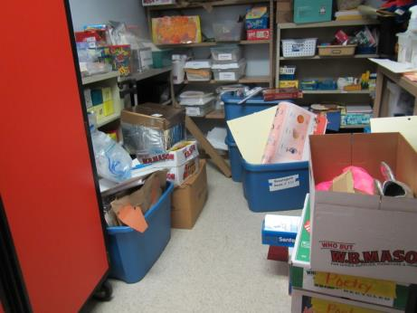
Items in a storage area
Picture 23
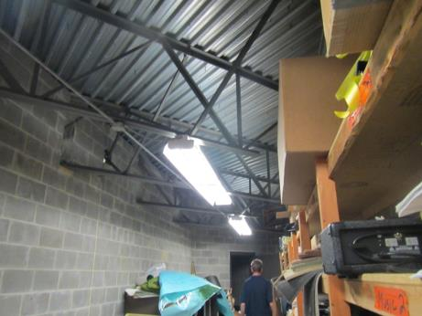
Maintenance/storage area hallway
Picture 24
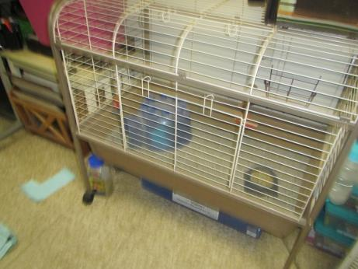
Pet cage
Picture 25
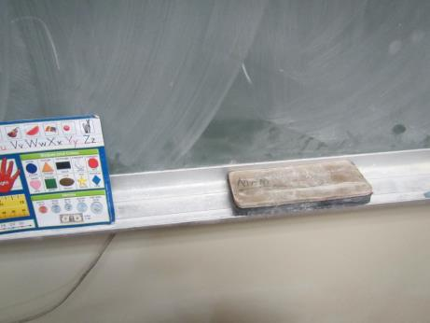
Chalk dust
Picture 26
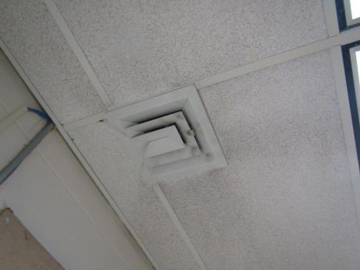
Dusty supply vent
Location | Carbon  Dioxide  (ppm) | Carbon Monoxide  (ppm) | Temp  (°F) | Relative  Humidity  (%) | PM2.5  (µg/m³) | Occupants  in Room | Windows  Openable | Ventilation |  |  | Remarks
 |  |  |  |  |  |  |  | Intake | Exhaust
Background | 346 | 0.6 | 76 | 36 | 7 | - | - | - |  | - | Sunny
Second Floor
206 | 594 | ND | 82 | 37 | 10 | 18 | Y open | Y UV off |  | Y off | WD CT, area rug
207 | 581 | ND | 83 | 33 | 3 | 18 | Y open | Y on |  | Y off | Area rugs, DEM, flowers
208 | 518 | ND | 83 | 31 | 3 | 0 | Y open | Y on |  | Y off | Fan in open window, plant, area rug, DEM
210 | 500 | ND | 84 | 33 | 3 | 4 | Y open | Y |  | Y off | PF on, area rug, bean bags
211 | 600 | ND | 85 | 36 | 3 | 5 | Y open | Y |  | Y | WD CT (5) and MT, PF on, area rug
212 instrument/storage |  |  |  |  |  |  | N | N |  | N | This inner/hidden hallway goes around half the building and contains mechanical spaces and storage, no vents
212 music | 705 | ND | 81 | 29 | 1 | 9 | Y | Y (both AHU and UV) |  | Y | Area rug and carpet, AHU in cooling mode, cylindrical window
214 computer lab | 627 | ND | 79 | 35 | 2 | 18 | N | Y |  | Y | 20 computers, DEM, WD CT (8), carpeted
215 computer lab | 650 | ND | 76 | 36 | 4 | 12 | N | Y |  | Y | AHU in cooling mode, WD CT (4), carpet, 20 computers
216 | 567 | ND | 80 | 39 | 3 | 4 | Y | Y |  | Y | PF on, aquarium, NC, area rug, HS
217 | 556 | ND | 80 | 39 | 4 | 0 | Y | Y obstr. UV |  | Y | Items on UV, area rug, sink, plants, DEM
218 | 771 | ND | 79 | 40 | 5 | 0 | N | Y |  | Y | NC, sink, area rug
219 | 600 | ND | 79 | 43 | 1 | 0 | N | Y |  | Y | NC, carpet, items, chalk dust
220 | 584 | ND | 80 | 39 | 6 | 6 | Y | Y off |  | Y | Area rug and pillows, sinks - items underneath, NC
221 | 562 | ND | 80 | 40 | 4 | 0 | Y | Y off |  | Y | NC
222 |  | ND | 80 | 39 | 4 | 0 | Y | Y |  | Y | Area rugs, AI, CD
223 | 612 | ND | 80 | 36 | 4 | 0 | Y | Y |  | Y | AI, WAC, HS, area rug, DO
224 | 596 | ND | 81 | 36 | 5 | 1 | Y | Y |  | Y | Occupational therapy room, WD CT (4), chalk, PF on
225 | 1335 | ND | 80 | 33 | 13 | 0 | Y | Y off |  | Y | WAC, area rug, DEM
226 | 677 | ND | 81 | 36 | 12 | 0 | Y | Y |  | Y | Area rug
227 | 460 | ND | 82 | 33 | 3 | 0 | Y open | Y |  | Y | Area rug, PF on, DEM
228 | 524 | ND | 82 | 37 | 4 | 0 | Y open | Y |  | Y | Pet guinea pig, PF, NC, area rug
229 | 463 | ND | 82 | 31 | 12 | 1 | Y open | Y |  | Y | NC, PF on, area rug
230 | 580 | ND | 81 | 35 | 3 | 1 | Y open | Y |  | Y | PF on, chalk dust, area rug, DEM
Auditorium upper level | 812 | ND | 78 | 43 | 3 | 0 (all in lower level) | N | Y |  | Y | Carpeted audience risers
Former darkroom (storage) |  |  |  |  |  |  | N | Y |  | Y | Items in old sinks
S1 | 670 | ND | 80 | 42 | 2 | 3 | N | Y |  | Y | Bean bags and area rug, PF, microwave and refrigerator
S2 | 613 | ND | 80 | 42 | 1 | 0 | N | Y |  | Y | WD CT, chalk dust, hamster, NC
S3 | 728 | ND | 79 | 49 | 6 | 0 | Y | Y off |  | N | AI, NC
Second floor open lounge area | 546 | ND | 81 | 41 | 4 | 0 | N | Y |  | Y | Plant, sink - backsplash open, fan
Staff 2 | 643 | ND | 79 | 43 | 5 | 4 | N | Y |  | Y | WD CT, sink, area rug, small side room
T1 | 601 | ND | 80 | 35 | 3 | 0 | N | Y |  | Y | DEM, carpet, tiny room
T10 | 587 | ND | 81 | 40 | 1 | 0 | N | Y |  | Y | Reportedly cold, vent partially blocked inside
T2 | 661 | ND | 79 | 37 | 1 | 0 | N | Y |  | Y | CD, carpet
T3 | 644 | ND | 79 | 40 | 4 | 4 | N | Y |  | Y | DEM, carpet
T4 | 557 | ND | 79 | 35 | 1 | 0 | N | Y |  | Y | Carpet, DEM, upholstered items
T5 | 555 | ND | 79 | 39 | 2 | 0 | N | Y |  | Y | Carpet, DEM
T6 | 581 | ND | 77 | 38 | 0 | 0 | N | Y |  | Y | PF on, NC, HS
T7 | 599 | ND | 79 | 39 | 2 | 0 | N | Y |  | Y | Carpet, sink and stove (stove not usable/in use)
T9 | 540 | ND | 81 | 37 | 3 | 0 | N | Y |  | Y | PF on, DEM, WD CT
Upper mezzanine over library | 600 | ND | 80 | 43 | 3 | 0 | N | Y |  | Y
First Floor
Office | 611 | ND | 78 | 41 | 6 | 0 | N |  |  | Y
Main office area | 577 | ND | 76 | 42 | 3 | 2 | Y | Y |  | Y
Cafeteria | 693 | ND | 77 | 47 | 7 | many | Y | Y |  | Y
Teacher’s lunch | 637 | ND | 76 | 42 | 5 | 3 | N | Y |  | Y | Fridge (clean)
MP1 | 714 | ND | 76 | 45 | 3 | 0 | N | Y |  | Y | Instruments
MP2 | 705 | ND | 76 | 46 | 3 | 0 | N | Y |  | Y | School store items, carpet
Gym | 619 | ND | 76 | 56 | 7 | 15 | N | Y |  | Y | AHU is off
Kiln |  | ND |  |  |  |  | N | Y |  | Y | Not sure if direct vented
Nurse | 716 | ND | 74 | 43 | 2 | 0 | N | Y |  | Y
C3 |  |  |  |  |  |  |  | Y |  | Y
Occupational therapy | 631 | ND | 77 | 44 | 7 | 0 | N | Y |  | Y
Library | 847 | ND | 78 | 42 | 2 | 12 | N | Y |  | Y | Reported leaks and some WD CT/materials, carpeted
Librarian’s office | 678 | ND | 79 | 40 | 7 | 0 | N | Y |  | Y | NC - carpeting removed, along with drapery, cleaning products, items
Story time nook | 670 | ND | 80 | 41 | 7 | 0 | N | Y |  | Y | Carpeted, dusty smell, reported issues
101 | 469 | ND | 79 | 31 | 2 | 0 | N | Y |  | Y | Area rug
102 | 391 | ND | 78 | 30 | 2 | 0 | N | Y |  | Y | Area rug, terrarium/reptile
112 | 538 | ND | 80 | 37 | 7 | 0 | Y | Y on |  | Y | PF on, area rugs, HS
113 | 541 | ND | 79 | 38 | 7 | 15 | Y open | Y |  | Y
114 | 966 | ND | 76 | 46 | 9 | 14 | Y | Y off |  | Y | WAC, area rugs, plant
115 | 1042 | ND | 75 | 47 | 7 | 0 | Y | Y off |  | Y | WAC, microwave
116 | 757 | ND | 74 | 35 | 6 | 12 | N | Y |  | Y | NC, area rug, WD CT, previous WD area now cleaned/replaced tiles, sink
118 | 706 | ND | 76 | 47 | 3 | 0 | N, but has door | Y |  | Y

