Contract User Guide

VEH123: Fuel and EV Charging Cards
Contract Overview
Category Manager Contact Information | Kelly Thompson Clark  617-720-3184
Contract Term | - Current Contract Term: 25 November 2025 to 29 June 2029  - Maximum End Date: 27 June 2033; this contract has no options for renewal.
Massachusetts Management Accounting System (MMARS) Master Agreement (MA) Number | VEH12300000000000000
Quote Requirements | Quotes are not required for purchasing.
Vendor List | Find Vendor List and Information for eligible vendors on this contract.
Updates | January 06, 2026 WEX card application available on Page 17 – Appendix A

Table of Contents
Contract summary 3
Benefits and cost savings 3
Contract exclusions and related statewide contracts 5
Who can use the contract 5
Pricing options 6
Purchase options 7
Setting up a commbuys account 7
Finding contract documents (including cug, rfr, specifications, and other attachments) 8
Finding vendor-specific documents 8
Supplier diversity program (sdp) requirements 9
Emergency services 9
Vendor performance 9
General procurement guidelines and best practices 10
Environmentally preferable products and services (epps) 10
Instructions for MMARS users 11
Vendor list and information 12
UNSPSC codes 13
Appendix A VEH123 fuel card services agreement 14
Appendix B how to pull invoices online 14
Appendix C EV charging services enrollment and eligibility 16

TIP: To return to the first page throughout this document, use Control Plus Home.

Contract Summary
VEH123: Fuel and EV Charging Cards: This is a Statewide Contract for Fuel and Electric Vehicle Charging Card Services. Users can acquire Fuel or EV Charging Cards from WEX Bank to use for vehicle fueling. WEX cards are accepted at over 95% of retail fueling and charging stations and can also be used with private fueling systems. Purchasers are billed monthly and have access to online reporting of transactions and more. OSD is participating in the Sourcewell Contract 030625-WEX that affects this Statewide Contract.

All eligible entities must complete a Fuel Card Services Agreement prior to accessing EV charging services. Only WEX-authorized charging station partners are included in this contract.
Vendor’s Master Blanket Purchase Order (MBPO) with Participating Agreement

Benefits and Cost Savings
Statewide contracts are an easy way to obtain benefits for your organization by:
- Leveraging the Commonwealth’s buying power
- Simplifying the solicitation process
- Enhancing vendor relationships through proactive management and oversight
- No set-up or monthly card fees or charges (beyond standard customer billing)
- No fees for replacement cards (does not include shipping fees)
- Improving the availability of environmentally preferable products
- Volume-based Rebates
- Gulf Oil Discounts
- Ability to use WEX cards at a variety of gas and EV charging stations
Monthly Volume Rebates
- This contract does not offer Prompt Pay Discounts or PPD. A monthly rebate will be paid starting in the second month in accordance with the below table:

Payment Timing Table
Bill Presentment | Payment Timing Options: Payment in full within the following calendar days of the billing date appearing on your invoice | Basis Points (Rebate Percentage)
Monthly | 0 | 20 basis points (0.20%)
Monthly | 1 | 19 basis points (0.19%)
Monthly | 2 | 18 basis points (0.18%)
Monthly | 3 | 17 basis points (0.17%)
Monthly | 4 | 16 basis points (0.16%)
Monthly | 5 | 15 basis points (0.15%)
Monthly | 6 | 14 basis points (0.14%)
Monthly | 7 | 13 basis points (0.13%)
Monthly | 8 | 12 basis points (0.12%)
Monthly | 9 | 11 basis points (0.11%)
Monthly | 10 | 10 basis points (0.10%)
Monthly | 11 | 9 basis points (0.09%)
Monthly | 12 | 8 basis points (0.08%)
Monthly | 13 | 7 basis points (0.07%)
Monthly | 14 | 6 basis points (0.06%)
Monthly | 15 | 5.5 basis points (0.055%)
Monthly | 16 | 5 basis points (0.05%)
Monthly | 17 | 4.5 basis points ( 0.045%)
Monthly | 18 | 4 basis points (0.04%)
Monthly | 19 | 3.5 basis points (0.035%)
Monthly | 20 | 3 basis points (0.03%)
Monthly | 21 | 2.5 basis points ( 0.025%)
Monthly | 22 | 2 basis points (03.02%)
Monthly | 23 | 1.5 basis points (0.015%)
Monthly | 24 | 1 basis points (0.01%)
Monthly | 25 | 0.5 basis points (0.005%)
Monthly | 26 | 0 basis points (0.00%)
Rebates will be off all Monthly Retail Transactions charged to Eligible Entity’s accounts.
Volume rebates are only credited to accounts that are paid within 45 days of invoice.
Gulf Oil Discounts
Gulf Oil has agreed to provide Eligible Entities a discount on fuel purchased at Gulf and Cumberland Farm branded locations according to the schedule below:
- Monthly Gallons between 500 and 3,999 = $0.02 per gallon
- Monthly Gallons between 4,000 and 6,999 = $0.03 per gallon
- Monthly Gallons between 7,000-9,999 = $0.04 per gallon
- Monthly Gallons 10,000 and over = $0.05 per gallon
The discount will not appear on the posted pump price but will be applied to the billing statement.

Contract Exclusions and Related Statewide Contracts
This contract is not for the purchase of fuel for tanks that are managed by the eligible entity. Consult
ENE53 Ultra Low Sulfur Diesel and Biodiesel, ENE54 Gasoline to learn more about those products and services. This contract does not include Prompt Pay Discounts (PPD).

Who Can Use the Contract
The following is a complete list of the types of organizations generally allowed to use Operational Service Division’s (OSD's) Statewide Contracts (SWCs). Some SWCs may be open to additional organizations, and some are more restricted in usage.
- Cities, towns, districts, counties, and other political subdivisions
- Executive, Legislative, and Judicial Branches, including all departments and elected offices therein
- Independent public authorities, commissions, and quasi-public agencies
- Local public libraries, public school districts, and charter schools
- Public hospitals owned by the Commonwealth of Massachusetts
- Public institutions of higher education
- Public purchasing cooperatives
- Non-profit, UFR-certified organizations that are doing business with the Commonwealth
- Other states and territories and their cities, towns, districts, counties, other political subdivisions, and public institutions of higher education without prior approval from the State Purchasing Agent
- Other entities when designated in writing by the State Purchasing Agent

Pricing Options
Fixed Pricing: Contract pricing has been negotiated, and no further negotiations may be made.
The pricing for Fuel Cards is the listed price at each fuel station less, applicable taxes if Tax Exemption paperwork has been processed with WEX as part of the user’s account set up.
Please note, your WEX bills must be paid in a timely manner. Continued non-payment, overdue bills, or continual delays in payment could result in your card not working when fueling or no permitted use of card.
Also, these credit cards are each agency’s responsibility and should be treated as such. Loss of cards and a consistent need for replacement cards will result in fees. If buyers want to attach their UPS or FedEx account information for replacement card mailings, please contact WEX to set that up.
Note: Product pricing may be found on the vendor information page, where links to the vendor’s MBPO are provided.

Purchase Options
- Document Items in COMMBUYS That Have Already Been Purchased: This contract enables buyers to retroactively record a previously made contract purchase within the COMMBUYS system. This is done through a Request for Payment Authorization (RPA) Release Requisition, which also allows MMARS users to easily keep track of spending.
For a description on how to complete this purchase in COMMBUYS, review the How To Record a Contract Purchase Previously Made (RPA Release) job aid.
Note: MMARS and COMMBUYS do not interface. Payment request and invoice must be reported in both MMARS and COMMBUYS.

Setting Up a COMMBUYS Account
COMMBUYS is the Commonwealth of Massachusetts' official e-procurement platform, serving as a central marketplace for state agencies to procure goods and services connecting government buyers and businesses. It aims to streamline the purchasing process, ensuring transparency, efficiency, and accessibility in the procurement process.
While COMMBUYS use is not mandated for Non-Executive Agencies, it is highly recommended to streamline the procurement process and make informed purchasing choices. Eligible entities should follow their internal guidelines for COMMBUYS use.
For Executive Agencies, COMMBUYS is required. Per 801 CMR 21.00, Executive Agencies must use established statewide contracts (SWCs) for the purchase of products and services. To set up a COMMBUYS buyer account or to update an existing agency account, the buyers must contact the COMMBUYS Help Desk at: 888-627-8283 or OSD Help Desk.

Finding Contract Documents (Including CUG, Master Agreement, Fuel Services Agreement and Other Attachments)
Buyers can view contract documents on COMMBUYS without requiring a COMMBUYS account or logging in.
To find contract documents in COMMBUYS, follow these steps:
- On the COMMBUYS home page, enter VEH123 in the search tool and select Blankets from the drop-down list.
- Access the Search icon. The related Vendor Master Blanket Purchase Orders (MBPOs) information opens in a table format.
- To view the associated contract documents, under the Blanket Number column, Access on the applicable Purchase Order (PO) link. MBPO opens for the selected PO and the attachments can be found in the Agency Attachments or Vendor Attachments section.
All contract documents and WEX documents and information are within the Vendor Master Contract Record. Access them directly by Accessing this link: Vendor Master Blanket Purchase Order (MBPO)

Finding Vendor-Specific Documents
To find vendor-specific documents, review the links to the individual vendor MBPOs on the Vendor Information page, and follow these steps:
- On the Vendor Information page, under the Vendor Master Blanket Purchase Order Number Column, Access on the applicable Purchase Order (PO) link. The Master Blanket Purchase Order (MBPO) opens for the selected PO.
- On the MBPO, scroll down to the Vendor Attachments section to find the vendor-specific documents.
- To view, Access on the desired document link.

Supplier Diversity Program (SDP) Requirements
Please review the following guidelines:
- Vendor SDP commitment percentages can be found on the vendor list table.
- Executive Departments should use diverse and small businesses to the extent possible based on contract terms, Supplier Diversity Office or SDO, and departmental policies, laws, and regulations.
- In cases where all other factors are equal, and particularly when adhering to a best value approach, the department will favor the vendor with a stronger SDP commitment
- Operational Services Division (OSD) provides a list of SDP businesses through the Statewide Contract Index. Review the Programs for SDO and SBPP tab on the index (scroll to view the tab).
- For more information, review Best Value Evaluation of SDP Plan Forms: A Guide for Strategic Sourcing Teams .

Emergency Services
Vendors on this contract may be required to provide products or services in cases of statewide emergencies. ML - 801 CMR 21 defines emergency for procurement purposes. Visit the Emergency Response Supplies, Services and Equipment Contact Information for Statewide Contracts list for emergency services related to this contract.

Vendor Performance
Vendor performance is measured by a number of factors to include:
- Provide actionable feedback on vendors for this contract to optimize performance. Access Procurated for input. On the Procurated website page, select an OSD contract, Access Select, and then Access Provide a Review for the applicable vendor listed.
- Buyers are encouraged to reach out to the Category Manager if vendors are not meeting their contractual obligations and buyers may be surveyed for vendor performance feedback.
- Vendor will be evaluated on their current performance and may be asked to work with the Commonwealth towards improvement.
  - If Vendor performance is unacceptable but can be corrected, the Contractor will be given the opportunity to develop and implement a corrective action plan, working collaboratively with OSD and the relevant purchasing entities.
  - If the Vendor’s performance is inadequate or breaches the RFR terms, including attachments and agreements, the OSD Category Manager may issue a warning, add vendors, implement a corrective action plan, or suspend or terminate the contract.
- Vendor must meet all contractual requirements throughout the life of the contract, including requirements for timely and accurate report submission, to remain in good standing under the contract.

General Procurement Guidelines and Best Practices
For general procurement guidelines and best practices, follow these recommendations:
- Buyers should inform vendor to reference Contract VEH123 on all their forms and invoices.
- No prepayment should be made for products not yet delivered or services not yet rendered.
- No sales tax should be applied to invoices.
- No fees or surcharges (including traveling, fuel, delivery) should be applied to invoices.
- Special order fees must be agreed upon by both parties upfront.
- Payments for products or services provided must be paid within 45 days per Massachusetts Bill Payment Policy, or sooner if applying Prompt Payment Discount.
- Buyers are not required to sign additional agreements with vendors that conflict with the Request for Response or RFR Terms and Conditions. Contact the Category Manager for further guidance.

Environmentally Preferable Products and Services (EPPs)
This contract is considered all-EPP. It provides Fuel Cards for fleet vehicle users, enabling online billing review and downloads for streamlined management. The vendor provides a mobile app that helps drivers locate the lowest fuel prices nearby, including options for alternative fuel locations. Additionally, the vendor supports the integration of electric fueling transactions through select EV charging station providers. Review Appendix C: EV Charging Services Enrollment and Eligibility for more information about adding EV charging to the card.
Learn More: Explore the Environmentally Preferable Products (EPP) Procurement Program and discover detailed guidance in the EPP Products and Services Guide.

Instructions for MMARS Users
When placing orders with a contractor, MMARS users must reference the contract ID number VEH12300000000000000 in the applicable field in MMARS. For MMARS technical support and job aids, contact the Comptroller Help and Support Desk at 617-973-2468 or Comptroller Help Desk.

Vendor List and Information

Vendor | Master Blanket  Purchase Order Number | Contact Person | Phone Number | Email | Discounts | Supplier Diversity Program (SDP) Percentage
Master Blanket Purchase Order (MBPO and all contract documents) | PO-26-1080-OSD03-SRC3-37880 | Kelly Thompson Clark | 617-720-3184 | kelly.thompsonclark@mass.gov | Not Applicable | Not Applicable
WEX Bank | PO-26-1080-OSD03-OSD03-37708 | Ryan Paul | 207-523-6227 | Ryan.paul@wexinc.com | Volume-based Rebates and Gulf Oil Discounts | 1.0%
Note that COMMBUYS is the official system of record for vendor contact information.
The Master Blanket Purchase Order is the central repository for all common contract files.

UNSPSC Codes
- 93–15–00 Public administration and finance services
- 25–17–24 Fuel tanks and systems

Appendix A: VEH123 Fuel Card Services Agreement
Please access the Fuel Card Services Agreement to apply for WEX products and services. This application must be completed by any agency, organization or municipality that wants to have access to contracted WEX products and services.
This Agreement is subject to Sourcewell Contract Number 030625 and Massachusetts Statewide Contract VEH123
WEX Bank complies with Section 326 of the USA PATRIOT Act which requires all financial institutions to obtain, verify, and record information that identifies each company or person who opens an account. What this means for you, when you open an account, we will ask for your name, address, date of birth, and other information that will allow us to identify you. We may also ask you to review your driver’s license or other identifying documents for your business.

Appendix B: How to Pull Invoices Online
- Go to Gulf WEX Online
- Log in using your username and password
  - If you do not have a username and password, please contact your fleet manager to request access
- Once you log in Access on the Home button
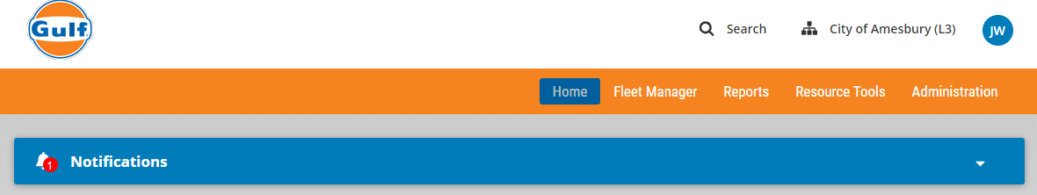
- Select View Invoice
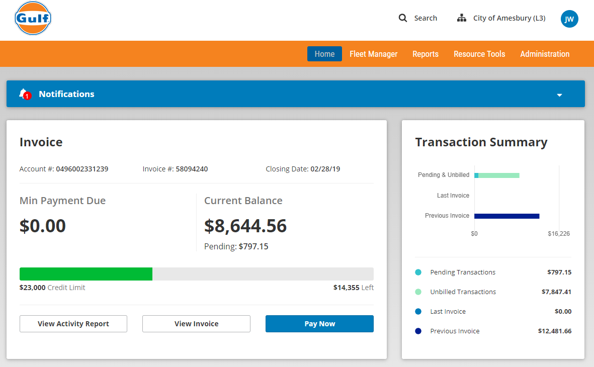
- The invoice will open in new window, and you can save it as PDF.
Appendix C: EV Charging Services Enrollment and Eligibility
All eligible entities, agencies, departments and municipalities will need to complete an EV Charging En Route Solution Enrollment Form to add charging station service billing to your WEX card. Each agency is responsible for their own users and there are no exceptions or waiving of fees. If you are an existing customer of the Office of Vehicle Management (OVM), please contact Cheryl Cushman to enroll your fleet drivers. If you are a new or existing WEX cardholder, or have questions about the program, please contact the Category Manager for more information.

