Vaccine Equity Initiative:
Interactive Dashboard User Guide

Description of Dashboard

- A customized community data report provides access to weekly vaccination and COVID-19 incidence rates compared to the overall statewide rates. These data serve as benchmarks for the 20 prioritized communities in the Vaccine Equity Initiative (VEI).
- These data can help the 20 VEI communities to direct resources toward identified gaps to achieve the equity benchmarks in each community overall and for population subgroups defined by race/ethnicity, sex, and age. The data report, posted on Fridays, highlights rates that meet or exceed the statewide vaccination average to help the 20 VEI communities prioritize additional outreach/vaccines.
- Progress towards equity can be demonstrated when there is an increase in:
  - The number of 20 VEI communities that received a First Dose or have been Fully Vaccinated – overall and within different race, sex and age groups – that meet or exceed the statewide rate.
  - The decrease in COVID-19 Incidence rates in the 20 VEI communities as listed on the weekly COVID-19 statewide public health report.

Overview Page
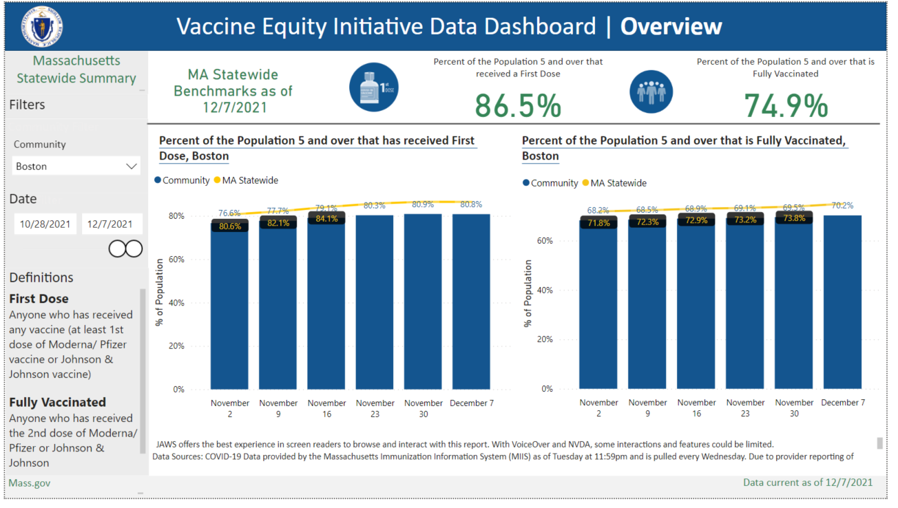
Interactive Features
- Community Filter – Select any of the 20 VEI communities using the Community Filter
  - When Community filter is on “ALL”, or no community is selected then the data presented will be statewide rates for MA
- Trends Over Time – Toggle the date to see data from beginning of initiative (3/17/2021) to current/selected date
Metrics
- Percent of Population 5 and over that received a First Dose
  - Community and MA statewide counts can be found if yo u hover over visual
- Percent of Population 5 and over that is Fully Vaccinated
  - Community and MA statewide counts can be found if you hover over visual
Definitions
- Vaccination definitions for First Dose and Fully Vaccinated
Demographic Page: Race/Ethnicity
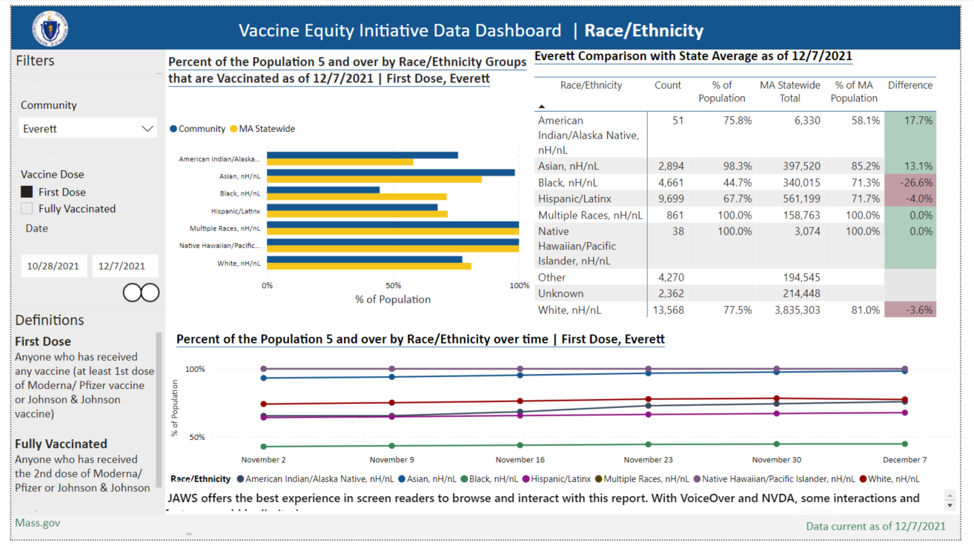
Interactive Features
- Community Filter – Select any of the 20 VEI communities using the Community Filter
    - When Community filter is on “ALL”, or no community is selected then the data presented will be statewide rates for MA
- Vaccine Dose – select first dose or fully vaccinated
- Trends Over Time – Toggle the date to see data from beginning of initiative (3/17/2021) to current/selected date
Metrics
- Percent of Population 5 and over by Race/Ethnicity Group that received a First Dose
    - Community and MA statewide counts can be found if you hover over visual
- Percent of Population by Race/Ethnicity that is Fully Vaccinated
    - Community and MA statewide counts can be found if you hover over visual
Definitions
- Vaccination definitions for First Dose and Fully Vaccinated
Demographic Page: Sex
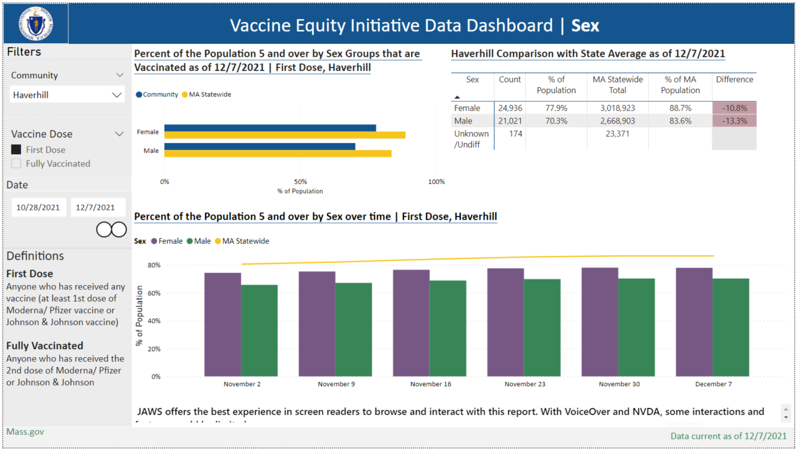
Interactive Features
- Community Filter – Select any of the 20 VEI communities using the Community Filter
  - When Community filter is on “ALL”, or no community is selected then the data presented will be statewide rates for MA
- Vaccine Dose – select first dose or fully vaccinated
- Trends Over Time – Toggle the date to see data from beginning of initiative (3/17/2021) to current/selected date
Metrics
- Percent of Population 5 and over by Sex Group that received a First Dose
  - Community and MA statewide counts can be found if you hover over visual
- Percent of Population 5 and over by Sex that is Fully Vaccinated
  - Community and MA statewide counts can be found if you hover over visual
Definitions
- Vaccination definitions for First Dose and Fully Vaccinated
Demographic Page: Age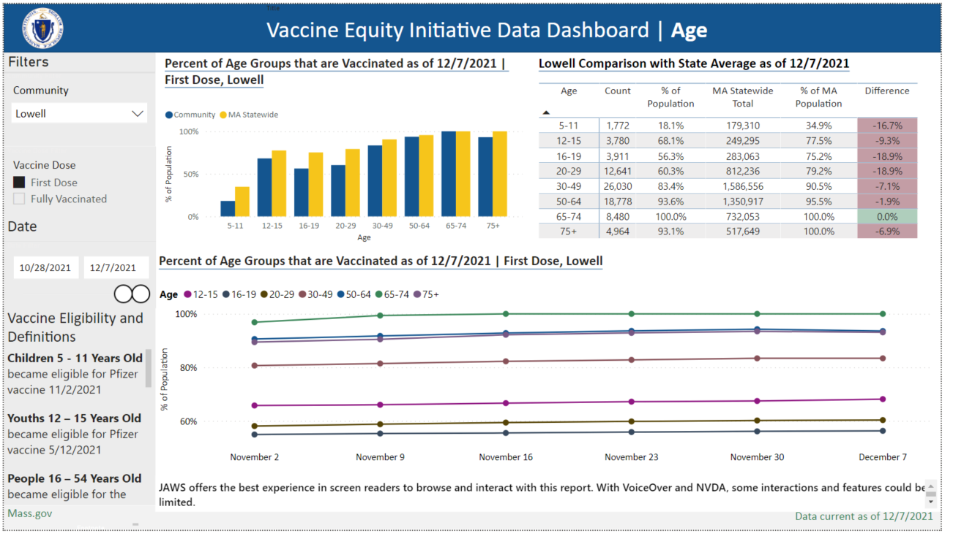
Interactive Features
- Community Filter – Select any of the 20 VEI communities using the Community Filter
  - When Community filter is on “ALL”, or no community is selected then the data presented will be statewide rates for MA
- Vaccine Dose – select first dose or fully vaccinated
- Trends Over Time – Toggle the date to see data from beginning of initiative (3/17/2021) to current/selected date
Metrics
- Percent of Population by Age Group that received a First Dose
  - Community and MA statewide counts can be found if you hover over visual
- Percent of Population by Age Group that is Fully Vaccinated
  - Community and MA statewide counts can be found if you hover over visual
- A more granular age breakdown
  - 5-11 years old, 12 – 15 years old, 16 – 19 years old, 20 – 29 years old, 30 – 49 years old, 50 – 64 years old, 65 – 74 years old, 75+ years old
Vaccine Eligibility and Definitions
- A breakdown of when each age group became eligible for the vaccine
- Vaccination definitions for First Dose and Fully Vaccinated
Community Summary Page
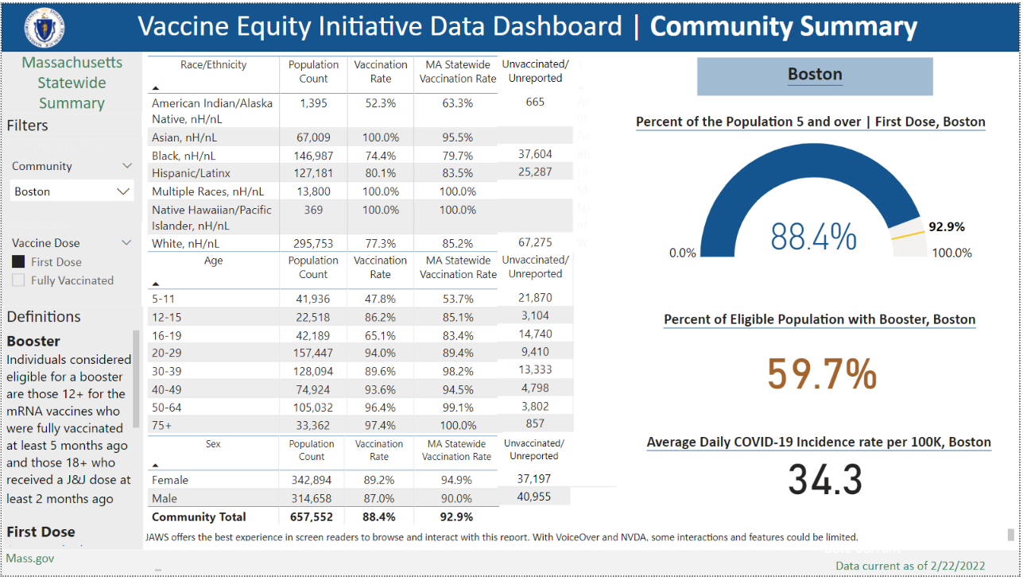

Interactive Features
- Community Filter – able to select any of the 20 VEI communities using the Community Filter
  - When no community is selected the data presented will be MA State
- Vaccine Dose – select first dose or fully vaccinated
Metrics
- Percent of Population 5 and over by Race/Ethnicity, Age and Sex that received a First Dose
- Percent of Population 5 and over by Race/Ethnicity, Age and Sex that is Fully Vaccinated
- Percent of the Eligible population with a booster for community
- Average Daily COVID-19 Incidence rate per 100k for community
- Gauge visual – allows community to see how they compare to moving statewide rate
Vaccine Eligibility and Definitions
- Vaccination definitions for First Dose, Fully Vaccinated and Booster

Background Page
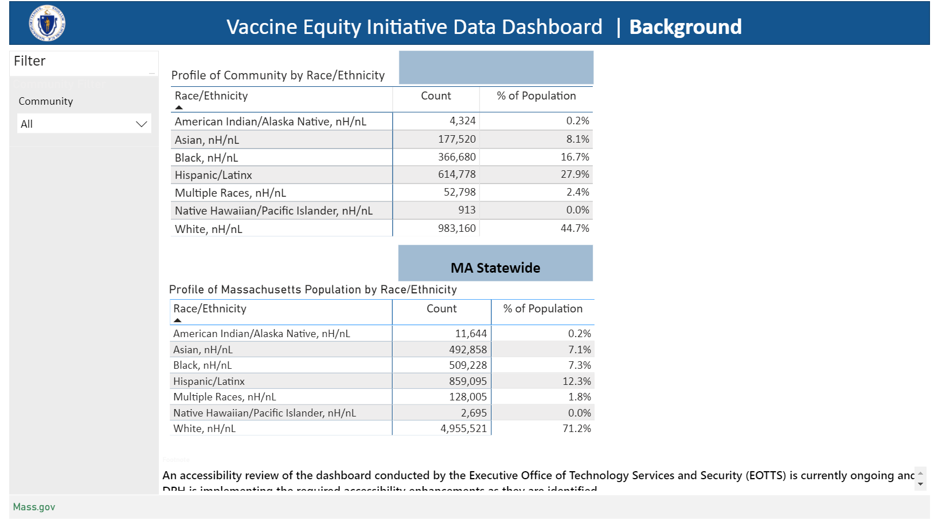

Interactive Features
- Community Filter – able to select any of the 20 VEI communities using the Community Filter

Background
- Population estimates by Race/Ethnicity

COVID-19 Case Counts & Rates Page
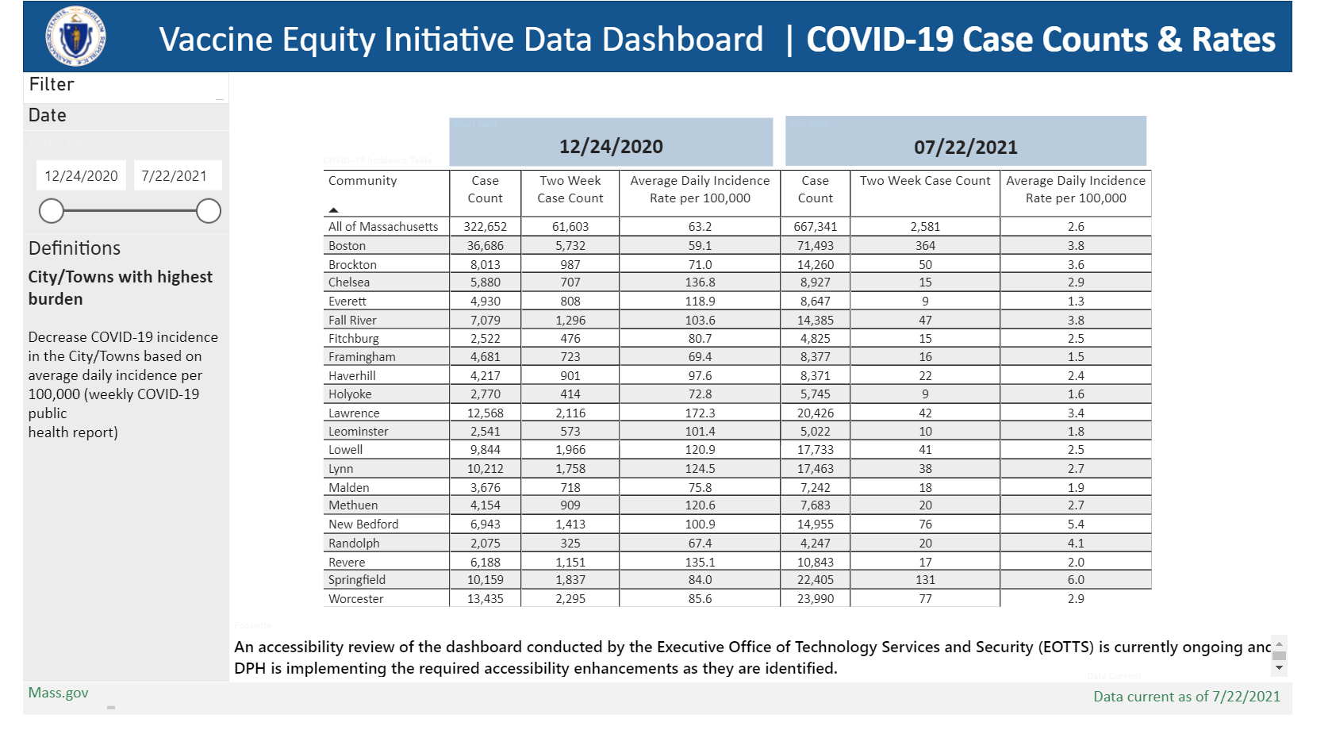

Interactive Features
- Date Filter – able to toggle the date to see data from 12/24/2020 to current/selected date

Metrics
- COVID-19 Incidence

Dashboard Features

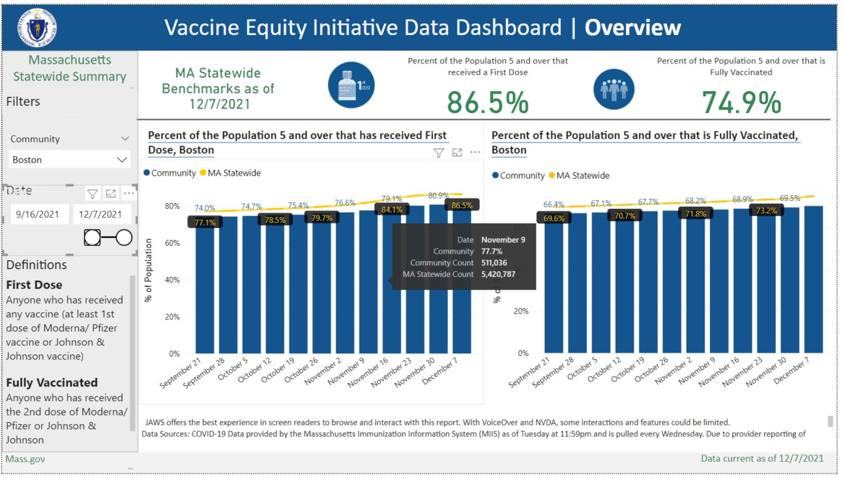
Hover Function
Other informative data such as counts and date can be found if you hover over a visual

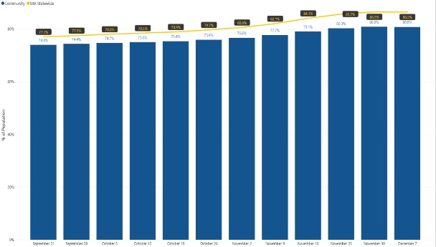
To zoom in on a visual select the arrow button on the top right of the visual and it will enlarge the visual for you

Focus Function
Benchmark Page
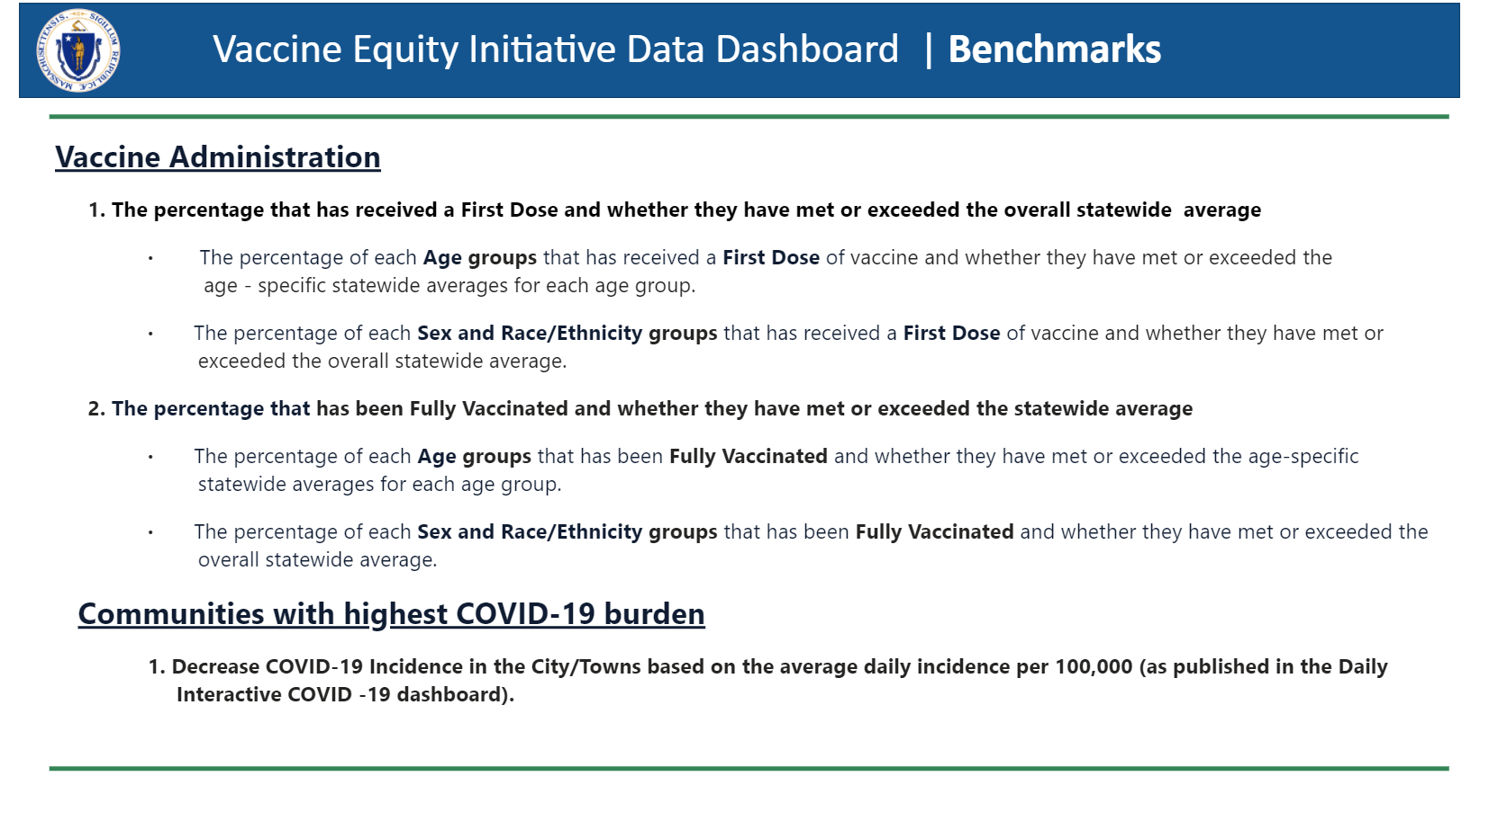
Benchmarks
- Defines the benchmarks that are used in the report

Resources Page

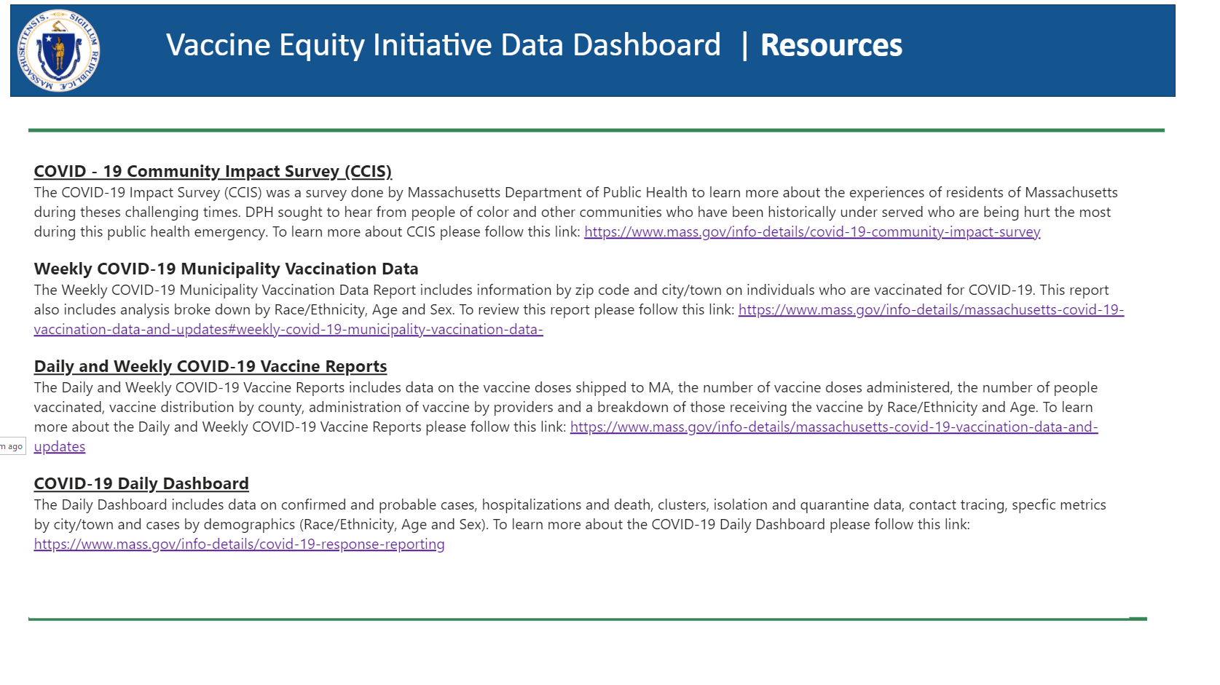
What’s New?
- Resources - provides links to other COVID-19 work that is being done throughout the department

Footnote Page

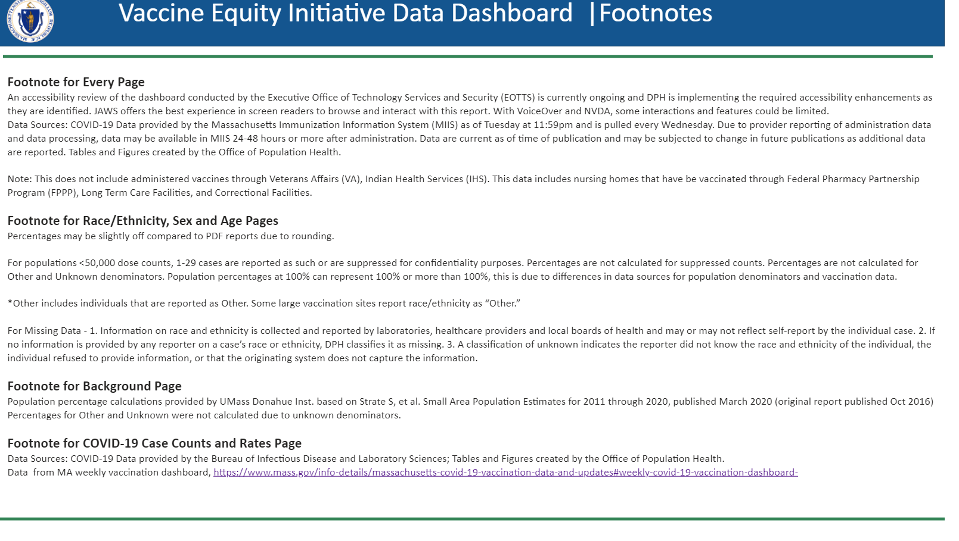

What’s New?
- Footnotes – easy access to the footnotes that are throughout the dashboard

