INDOOR AIR QUALITY ASSESSMENT

Ventress Memorial Library
Library Plaza
Marshfield, Massachusetts



Prepared by:
Massachusetts Department of Public Health
Bureau of Environmental Health
Indoor Air Quality Program
June 2008

Background/Introduction
At the request of Peter J. Falabella, Director of the Marshfield Board of Health (MBOH), the Massachusetts Department of Public Health’s (MDPH), Bureau of Environmental Health (BEH) provided assistance and consultation regarding indoor air quality concerns at the Ventress Memorial Library (VML), located at Library Plaza in Marshfield, MA. The assessment was prompted by occupant symptoms (e.g., headaches, eye, skin and respiratory irritation) as well as concerns of possible exposure to microbial growth and water-damaged materials due to both current and chronic roof leaks.
On March 24, 2008, a visit to conduct an assessment of the VML was made by Cory Holmes, an Indoor Air Inspector in BEH’s Indoor Air Quality (IAQ) Program. Mr. Holmes was accompanied by Ellen P. Riboldi, Director, VML and Laurel Thorne, Assistant Director, MBOH, during the assessment.
The VML was originally constructed as a supermarket in the late 1960s. In the early 1980s the building was converted to a library. Renovations to the building include replacement of a skylight in 1996, laying of new carpeting in 2000 and installation of a new heating, ventilation and air conditioning system in 2005. It was reported that prior to this assessment, Service Master Inc., a professional flooding and restoration firm was contracted to conduct large scale drying and remediation operations at the VML. This contract included removal of water damaged building materials (e.g., insulation, ceiling tiles) and cleaning/drying of carpeting. At the time of the assessment, Service Master had completed operations in all but one area, a small interior office (the administrative assistant office) that remained unoccupied.

Methods
BEH staff performed a visual inspection of building materials for water damage and/or microbial growth. Moisture content of porous building materials was measured with a Delmhorst, BD-2000 Model, Moisture Detector equipped with a Delmhorst Standard Probe. Air tests for carbon dioxide, carbon monoxide, temperature and relative humidity were conducted with the TSI, Q-TRAK™ IAQ Monitor, Model 8551. Air tests for airborne particulate matter with a diameter less than 2.5 micrometers were taken with the TSI, DUSTTRAK™ Aerosol Monitor Model 8520.

Results
The VML houses approximately 25 staff members and can be visited by hundreds of residents daily. Tests were taken during normal operations and results appear in Table 1.

Discussion

Ventilation
It can be seen from Table 1 that carbon dioxide levels were below 800 parts per million (ppm) in all areas surveyed, indicating adequate air exchange at the time of the assessment. Mechanical ventilation is provided by air handling units (AHUs) located on the roof (Picture 1). Outside air is heated or cooled and distributed to occupied areas via ceiling-mounted air diffusers (Picture 2); the supply vent in the meeting room was missing its diffuser (Picture 3). Return air is drawn into ceiling-mounted vents and ducted back to the AHUs (Picture 4). Thermostats control each AHU, which were set to the fan “auto” setting which deactivates the HVAC system at a preset temperature. Therefore, no mechanical ventilation is provided until the thermostat re-activates the system.
To maximize air exchange, the MDPH recommends that both supply and exhaust ventilation operate continuously during periods of occupancy. In order to have proper ventilation with a mechanical supply and exhaust system, the systems must be balanced to provide an adequate amount of fresh air to the interior of a room while removing stale air from the room. It is recommended that existing ventilation systems be re-balanced every five years to ensure adequate air systems function (SMACNA, 1994). The date of the last balancing of these systems should have occurred after installation in 2005.
The Massachusetts Building Code requires a minimum ventilation rate of 15 cubic feet per minute (cfm) per occupant of fresh outside air or have openable windows in each room (SBBRS, 1997; BOCA, 1993). The ventilation must be on at all times that the room is occupied. Providing adequate fresh air ventilation with open windows and maintaining the temperature in the comfort range during the cold weather season is impractical. Mechanical ventilation is usually required to provide adequate fresh air ventilation.
Carbon dioxide is not a problem in and of itself. It is used as an indicator of the adequacy of the fresh air ventilation. As carbon dioxide levels rise, it indicates that the ventilating system is malfunctioning or the design occupancy of the room is being exceeded. When this happens a buildup of common indoor air pollutants can occur, leading to discomfort or health complaints. The Occupational Safety and Health Administration (OSHA) standard for carbon dioxide is 5,000 parts per million parts of air (ppm). Workers may be exposed to this level for 40 hours/week based on a time weighted average (OSHA, 1997).
The MDPH uses a guideline of 800 ppm for publicly occupied buildings. A guideline of 600 ppm or less is preferred in schools due to the fact that the majority of occupants are young and considered to be a more sensitive population in the evaluation of environmental health status. Inadequate ventilation and/or elevated temperatures are major causes of complaints such as respiratory, eye, nose and throat irritation, lethargy and headaches. For more information concerning carbon dioxide, please see Appendix A.
Temperature measurements ranged from 71º F to 77º F, which were within the MDPH recommended comfort guidelines on the day of the assessment (Table 1). The MDPH recommends that indoor air temperatures be maintained in a range of 70 º F to 78 º F in order to provide for the comfort of building occupants. Temperature control complaints (excessive heat) were reported in the conference room. In many cases concerning indoor air quality, fluctuations of temperature in occupied spaces are typically experienced, even in a building with an adequate fresh air supply. In an effort to seal drafts in the attic, insulation boards were installed over large passive vents that served to ventilate the former supermarket (Pictures 5 and 6). However several of the insulation boards have subsequently fallen off, allowing the uncontrolled introduction of un-tempered outside air.
The relative humidity ranged from 13 to 17 percent, which was below the MDPH recommended comfort range during the assessment (Table 1). The MDPH recommends a comfort range of 40 to 60 percent for indoor air relative humidity. Relative humidity levels in the building would be expected to drop during the winter months due to heating. The sensation of dryness and irritation is common in a low relative humidity environment. Low relative humidity is a very common problem during the heating season in the northeast part of the United States.

Microbial/Moisture Concerns
As previously discussed, the VML has a history of chronic roof leaks. Ms. Riboldi, reported that the town of Marshfield was currently accepting bids to have the roof replaced, with work was tentatively scheduled for the end of April 2008. In the interim, attempts reportedly continue to be made to temporarily repair the roof by patching (Pictures 7 through 9). MDPH staff examined the roof and found the roof surface to be rippled and bulging in various areas. These defects can eventually result in further damage to the roof membrane and create breaches in the building envelope enhancing water penetration into the building. Note: Ms. Riboldi reported that the administrative office has had no further leaks since roof repairs were implemented.
In an effort to ascertain moisture content of water-damaged porous materials, moisture content was measured with a Delmhorst Moisture Detector equipped with a Delmhorst Standard Probe. Elevated moisture readings were measured on carpeting in the administrative assistant’s office; however, in subsequent correspondence with Ms. Riboldi, she reported that this area was remediated shortly after the BEH assessment and that the office was now reoccupied. All other materials tested during the assessment had low (i.e., normal) moisture measurements. Please note that moisture content of materials measured is a real-time measurement of the conditions present at the time of the assessment.
Repeated water damage to porous building materials (e.g., GW, ceiling tiles, and carpeting) can result in microbial growth. The US Environmental Protection Agency (US EPA) and the American Conference of Governmental Industrial Hygienists (ACGIH) recommend that porous materials be dried with fans and heating within 24 to 48 hours of becoming wet (US EPA, 2001; ACGIH, 1989). If not dried within this time frame, mold growth may occur. Once mold has colonized porous materials, they are difficult to clean and should be removed/discarded.
Of note was water damaged plaster and efflorescence along the window in the history room (Pictures 10 and 11) and meeting room (Pictures 12 through 14). Efflorescence is a characteristic sign of water damage, but it is not mold growth. As moisture penetrates and works its way through porous building materials (e.g., brick, plaster, cement), water-soluble compounds in the material dissolves, creating a solution. As this solution moves to the surface of the material, the water evaporates, leaving behind white, powdery mineral deposits. This condition indicates that moisture is penetrating through the building envelope in this area, most likely through the exterior wall around window frames.
Water stained carpeting and gypsum wallboard (GW) was observed beneath and adjacent to the water fountain in the restroom hallway (Picture 15). Carpeting and GW are porous materials that can provide a medium for mold growth if wetted repeatedly.
BEH staff examined the exterior of the building to identify breaches in the building envelope that could provide a source of water penetration. Several potential sources were identified:
- Spaces around a utility hole along the front of the building (Picture 16);
- Damaged/corroded metal frames around exterior doors and missing sealant around door frames (Picture 17);
- Failing/damaged caulking around windows (Pictures 18 and 19);
- Missing/damaged sealant between expansion joints (Pictures 20 and 21);
- Lack of gutters/downspouts, which causes the sloped roof to direct water against the base of the building causing staining and moss growth (Pictures 22 and 23). Moss growth is a sign of heavy/continuous water exposure, which can result in damage to the structural integrity the building.
The conditions listed above can undermine the integrity of the building envelope and create/provide a means of water entry by capillary action into the building through exterior walls, foundation concrete and masonry (Lstiburek & Brennan, 2001). The freezing and thawing action of water during the winter months can create cracks and fissures in the foundation. In addition, they can serve as pathways for insects, rodents and other pests into the building.

Other IAQ Evaluations
Indoor air quality can be negatively influenced by the presence of respiratory irritants, such as products of combustion. The process of combustion produces a number of pollutants. Common combustion emissions include carbon monoxide, carbon dioxide, water vapor and smoke (fine airborne particle material). Of these materials, exposure to carbon monoxide and particulate matter with a diameter of 2.5 micrometers (μm) or less (PM2.5) can produce immediate, acute health effects upon exposure. To determine whether combustion products were present in the school environment, BEH staff obtained measurements for carbon monoxide and PM2.5.
Carbon monoxide is a by-product of incomplete combustion of organic matter (e.g., gasoline, wood and tobacco). Exposure to carbon monoxide can produce immediate and acute health affects. Several air quality standards have been established to address carbon monoxide and prevent symptoms from exposure to these substances. The MDPH established a corrective action level concerning carbon monoxide in ice skating rinks that use fossil-fueled ice resurfacing equipment. If an operator of an indoor ice rink measures a carbon monoxide level over 30 ppm, taken 20 minutes after resurfacing within a rink, that operator must take actions to reduce carbon monoxide levels (MDPH, 1997).
The American Society of Heating Refrigeration and Air-Conditioning Engineers (ASHRAE) has adopted the National Ambient Air Quality Standards (NAAQS) as one set of criteria for assessing indoor air quality and monitoring of fresh air introduced by HVAC systems (ASHRAE, 1989). The NAAQS are standards established by the US EPA to protect the public health from six criteria pollutants, including carbon monoxide and particulate matter (US EPA, 2006). As recommended by ASHRAE, pollutant levels of fresh air introduced to a building should not exceed the NAAQS levels (ASHRAE, 1989). The NAAQS were adopted by reference in the Building Officials & Code Administrators (BOCA) National Mechanical Code of 1993 (BOCA, 1993), which is now an HVAC standard included in the Massachusetts State Building Code (SBBRS, 1997). According to the NAAQS, carbon monoxide levels in outdoor air should not exceed 9 ppm in an eight-hour average (US EPA, 2006).
Carbon monoxide should not be present in a typical, indoor environment. If it is present, indoor carbon monoxide levels should be less than or equal to outdoor levels. On the day of assessment, outdoor carbon monoxide concentrations were non-detect (ND) (Table 1). Carbon monoxide levels measured in the building were also ND (Table 1).
The US EPA has established NAAQS limits for exposure to particulate matter. Particulate matter is airborne solids that can be irritating to the eyes, nose and throat. The NAAQS originally established exposure limits to particulate matter with a diameter of 10 μm or less (PM10). According to the NAAQS, PM10 levels should not exceed 150 microgram per cubic meter (μg/m³) in a 24-hour average (US EPA, 2006). These standards were adopted by both ASHRAE and BOCA. Since the issuance of the ASHRAE standard and BOCA Code, US EPA established a more protective standard for fine airborne particles. This more stringent PM2.5 standard requires outdoor air particle levels be maintained below 35 μg/m³ over a 24-hour average (US EPA, 2006). Although both the ASHRAE standard and BOCA Code adopted the PM10 standard for evaluating air quality, MDPH uses the more protective PM2.5 standard for evaluating airborne particulate matter concentrations in the indoor environment.
Outdoor PM2.5 concentrations were measured at 4 μg/m³ (Table 1). PM2.5 levels within the building ranged from 3 to 7 μg/m³, which were below the NAAQS of 35 μg/m³ (Table 1). Frequently, indoor air levels of particulates can be at higher levels than those measured outdoors. A number of mechanical devices and/or activities that occur in buildings can generate particulates during normal operation. Sources of indoor airborne particulate may include but are not limited to particles generated during the operation of fan belts in the HVAC system, cooking in the cafeteria stoves and microwave ovens; use of photocopiers, fax machines and computer printing devices, operating an ordinary vacuum cleaner and heavy foot traffic indoors.
Finally, a number of supply diffusers, return vents and adjacent ceiling tiles were observed to have accumulated dust/debris (Pictures 2, 4, & 24). Dusts can provide a source of eye and respiratory irritation and provide a source of mold growth, especially if moistened repeatedly.

Conclusions/Recommendations
It appears that temporary attempts to repair the source of leaks (i.e., patching of roof) and the prompt drying/replacement of water damaged materials was successful in preventing mold growth. However, having the roof replaced will provide a more long-term solution to preventing further water penetration. For further reference, we are including MDPH guidance on mold (Appendix B) and renovations (Appendix C), due to the pending roof replacement. The MDPH has prepared these guidance documents in order to reduce or minimize exposure to mold in buildings, and to prevent/reduce the migration of renovation-generated pollutants into occupied areas, respectively.
In view of the findings at the time of the assessment, the following recommendations are made:
- Continue with plans for roof replacement.
- Operate the HVAC system continuously in the fan “on” mode during periods of occupancy to maximize air exchange.
- Consult the buildings’ heating, ventilation and air conditioning (HVAC) vendor concerning temperature control issues in the conference room.
- Replace missing supply diffuser in meeting room.
- Reseal passive attic vents to prevent drafts, water penetration and pest entry.
- Consider adopting a balancing schedule of every 5 years for all mechanical ventilation systems, as recommended by ventilation industrial standards (SMACNA, 1994).
- For buildings in New England, periods of low relative humidity during the winter are often unavoidable. Therefore, scrupulous cleaning practices should be adopted to minimize common indoor air contaminants whose irritant effects can be enhanced when the relative humidity is low. To control for dusts, a high efficiency particulate arrestance (HEPA) filter equipped vacuum cleaner in conjunction with wet wiping of all surfaces is recommended. Avoid the use of feather dusters. Drinking water during the day can help ease some symptoms associated with a dry environment (throat and sinus irritations).
- Make repairs to failing/damaged caulking around windows particularly in the history and meeting rooms.
- Once repairs are made, repair water damaged plaster in history and meeting room.
- Place tile or rubber matting underneath water fountains in carpeted areas to prevent water damage/mold growth to carpeting. Inspect carpeted area below water cooler for mold and remove if colonized. Repair water damaged wallboard.
- Make repairs to failing/damaged sealant around exterior door frames.
- Repair or replace corroded/damaged exterior doors as necessary.
- Make repairs to failing/damaged sealant in expansion joints/wall panels.
- Consider installing drainage system (e.g., gutters/downspouts) to prevent the impact of back-splashing rainwater on the exterior of the building.
- Seal any breaches around exterior utility holes and spaces under/around exterior doors to prevent water penetration, drafts and pest entry.
- Clean carpeting annually (or semi-annually in soiled high traffic areas) as per recommendations of the Institute of Inspection, Cleaning and Restoration Certification (IICRC). Copies of the IICRC fact sheet can be downloaded at: http://www.cleancareseminars.com/carpet_cleaning_faq4.htm (IICRC, 2005)
- Clean air diffusers, exhaust, return vents and adjacent ceiling tiles periodically of accumulated dust. If soiled ceiling tiles cannot be cleaned, replace.
- Consider installing openable windows to facilitate the introduction of outside air. This could either be done as a major renovation or one or two at a time over a designated period.
- For further information on mold/remediation consult “Mold Remediation in Schools and Commercial Buildings” published by the US Environmental Protection Agency (US EPA, 2001). This document can be downloaded from the US EPA website at: http://www.epa.gov/iaq/molds/mold_remediation.html.
- Refer to resource manual and other related indoor air quality documents located on the MDPH’s website for further building-wide evaluations and advice on maintaining public buildings. These documents are available at: http://mass.gov/dph/indoor_air.

References
ACGIH. 1989. Guidelines for the Assessment of Bioaerosols in the Indoor Environment. American Conference of Governmental Industrial Hygienists, Cincinnati, OH.

ASHRAE. 1989. Ventilation for Acceptable Indoor Air Quality. American Society of Heating, Refrigeration and Air Conditioning Engineers. ANSI/ASHRAE 62-1989
BOCA. 1993. The BOCA National Mechanical Code/1993. 8th ed. Building Officials & Code Administrators International, Inc., Country Club Hills, IL.

IICRC. 2005. Carpet Cleaning FAQ 4 Institute of Inspection, Cleaning and Restoration Certification. Institute of Inspection Cleaning and Restoration, Vancouver, WA.

Lstiburek, J. & Brennan, T. 2001. Read This Before You Design, Build or Renovate. Building Science Corporation, Westford, MA. U.S. Department of Housing and Urban Development, Region I, Boston, MA
MDPH. 1997. Requirements to Maintain Air Quality in Indoor Skating Rinks (State Sanitary Code, Chapter XI). 105 CMR 675.000. Massachusetts Department of Public Health, Boston, MA.
OSHA. 1997. Limits for Air Contaminants. Occupational Safety and Health Administration. Code of Federal Regulations. 29 C.F.R 1910.1000 Table Z-1-A.

SBBRS. 1997. Mechanical Ventilation. State Board of Building Regulations and Standards. Code of Massachusetts Regulations. 780 CMR 1209.0

SMACNA. 1994. HVAC Systems Commissioning Manual. 1st ed. Sheet Metal and Air Conditioning Contractors’ National Association, Inc., Chantilly, VA.

US EPA. 2001. “Mold Remediation in Schools and Commercial Buildings”. Office of Air and Radiation, Indoor Environments Division, Washington, DC. EPA 402-K-01-001. March 2001. Available at: http://www.epa.gov/iaq/molds/mold_remediation.html

US EPA. 2006. National Ambient Air Quality Standards (NAAQS). US Environmental Protection Agency, Office of Air Quality Planning and Standards, Washington, DC. http://www.epa.gov/air/criteria.html.
Picture 1

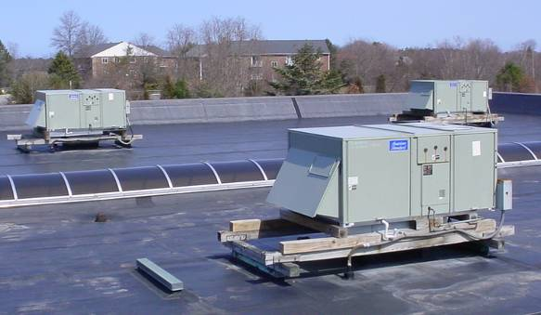

Rooftop AHUs

Picture 2

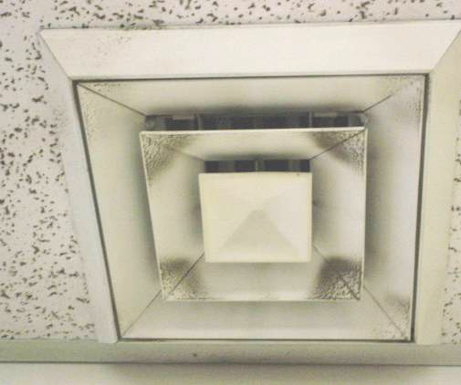

Supply Diffuser, Note Dust/Debris Accumulation on Surface of Louvers

Picture 3

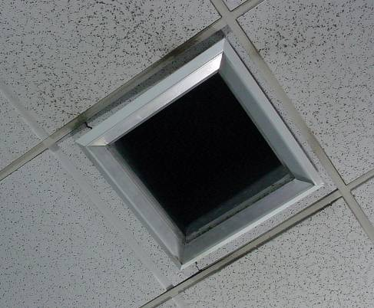

Supply Vent Missing Diffuser in Meeting Room

Picture 4

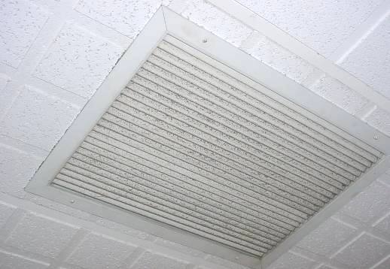

Return Vent, Note Dust/Debris Accumulation on Surface of Louvers
Picture 5

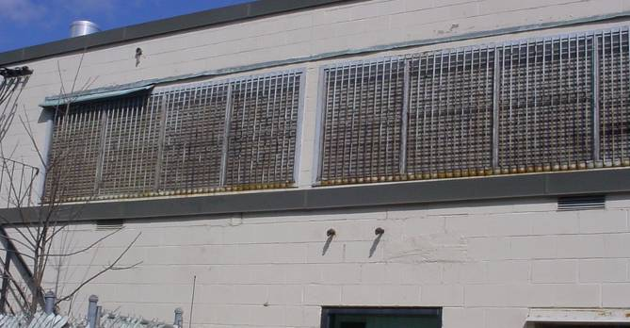

Passive Attic Vents

Picture 6

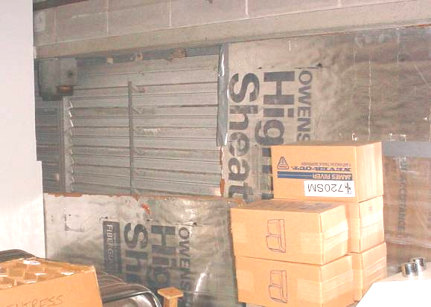

Passive Attic Vents Sealed with Insulation Boards, Note Missing Board Top/Left
Picture 7

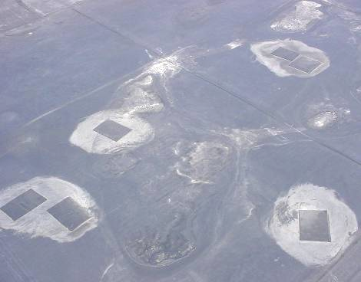

Numerous Patches Observed on Roof

Picture 8

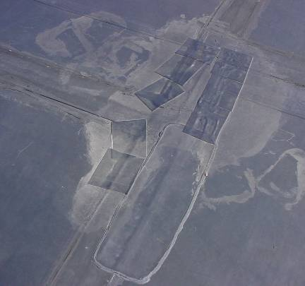

Numerous Patches Observed on Roof
Picture 9

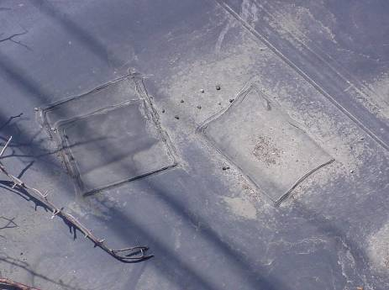

Patches Observed on Roof

Picture 10

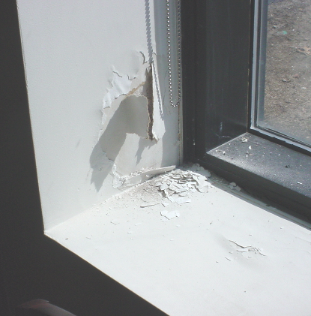

Water Damaged Wall Plaster around Window Frame in the History Room
Picture 11

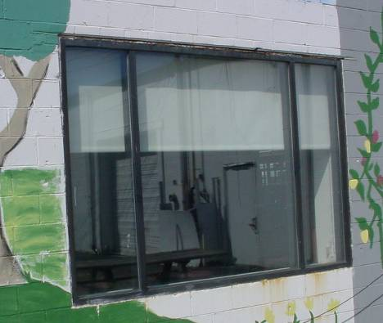

Exterior View of History Room Window System

Picture 12

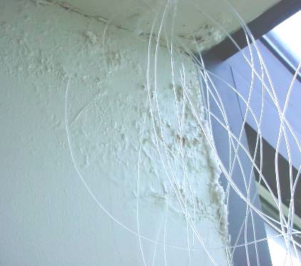

Water Damaged Wall Plaster/Efflorescence around Window Frame in the Meeting Room
Picture 13

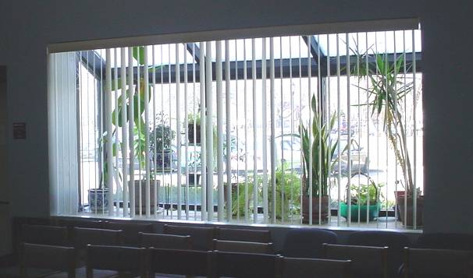

Interior View of Window System in Meeting Room

Picture 14

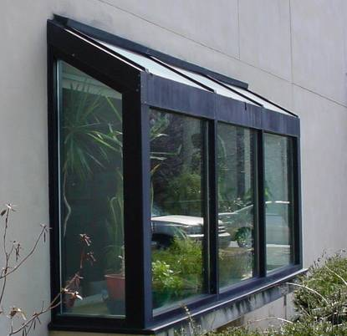

Exterior View of Window System in Meeting Room

Picture 15

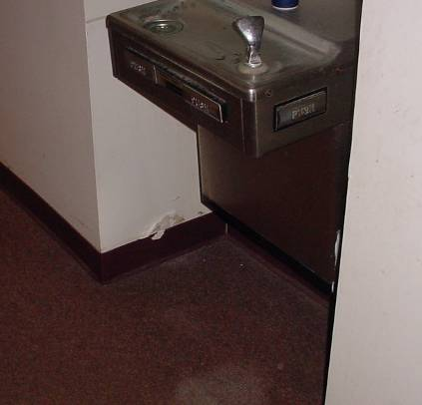

Water Stained Carpeting and GW beneath/adjacent to Water Fountain

Picture 16

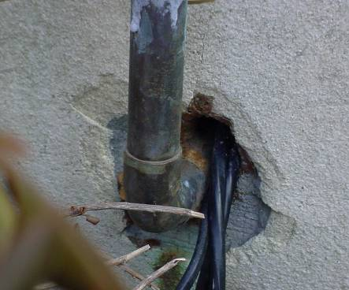

Spaces around Utility at near Front Entrance of Building
Picture 17

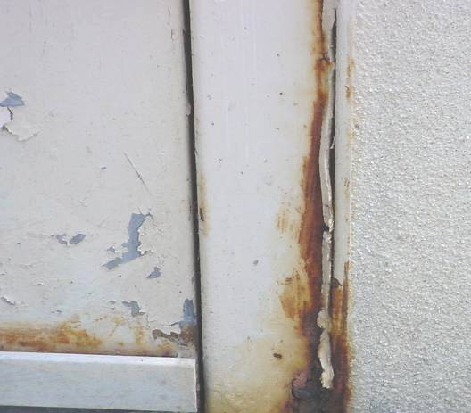

Damaged/Corroded Metal Frame around Door, Noted Missing/Damaged Sealant
along Right Side of Frame

Picture 18

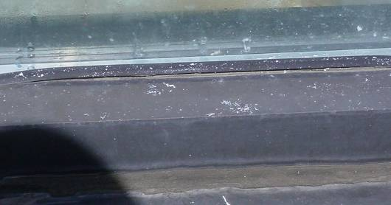

Failing Strip Caulking along Meting Room Window

Picture 19

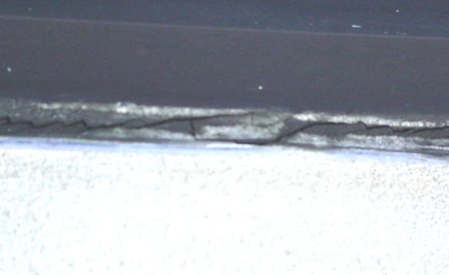

Cracked/Damaged Caulking along Meting Room Window

Picture 20

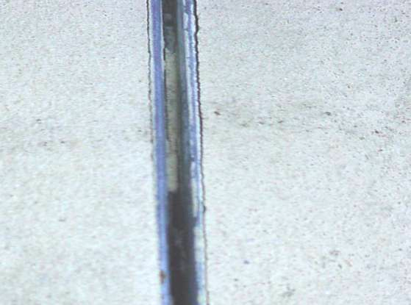

Missing/Damaged Sealant along Expansion Joint/Exterior Wall Panels
Picture 21

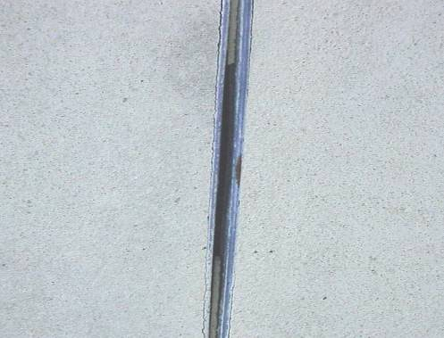

Missing/Damaged Sealant along Expansion Joint/Exterior Wall Panels

Picture 22

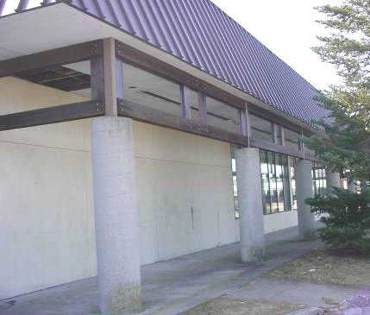

Lack of Gutters/Downspouts, Note Staining/Moss Growth on Apron/Columns
Due to Water Accumulation and Splashback
Picture 23

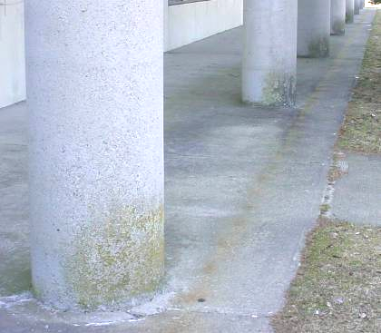

Close-Up of Staining/Moss Growth on Apron/Columns
Due to Water Accumulation and Splashback

Picture 24

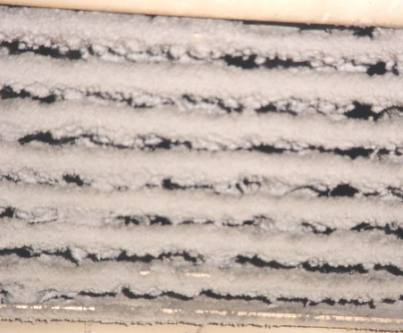

Close-Up of Accumulated Dust/Debris on Exhaust Vent in Restroom

Location/ Room | Occupants  in Room | Temp  (°F) | Relative  Humidity  (%) | Carbon  Dioxide  (ppm) | Carbon Monoxide  (ppm) | PM2.5  (µg/m³) | Windows  Openable | Ventilation |  | Remarks
 |  |  |  |  |  |  |  | Supply | Exhaust | Remarks
background |  | 44 | 41 | 320 | ND | 4 |  |  |  | Sunny, cool
History Room | 3 | 77 | 14 | 543 | ND | 3 | N | Y | Y | WD plaster windows-low (i.e., normal) moisture measurements, dust/debris accumulation on vents
Director’s Office | 0 | 73 | 13 | 437 | ND | 7 | N | Y | Y | WD CT-1
Admin Assistant Office | 0 | 73 | 13 | 428 | ND | 4 | N | Y | Y | WD/MTs, area of roof leaks, WD carpet/walls, insulation, unoccupied, elevated moisture measurement-carpet, low moisture measurement-walls, scheduled for remediation by Service Master
Cataloging Office | 1 | 74 | 17 | 634 | ND | 4 | N | Y | Y | Dust/debris on vents
Staff Restroom |  |  |  |  |  |  | N | Y | Y | Dust/debris on vents
Storage |  |  |  |  |  |  |  |  |  | 2 WD CTs
Lounge | 0 | 75 | 16 | 540 | ND | 4 | N | Y | Y | Dust/debris on vents, 2 WD CTs
Men’s Restroom |  |  |  |  |  |  | N | Y | Y | 1 of 2 exhaust vents drawing air, 2 WD CTs, floor drain
Restroom Hallway |  |  |  |  |  |  |  |  |  | WD GW near water fountain-low moisture, stained carpeting under fountain-low moisture
Children’s Library | 4 | 72 | 17 | 553 | ND | 6 | N | Y | Y | WD CT-low moisture, previous leak-fixed
Meeting Room | 0 | 71 | 16 | 414 | ND | 4 | N | Y | Y | Missing supply diffuser, dust/debris on vents, WD wall plaster/efflorescence-window area-low moisture
Main Entrance |  |  |  |  |  |  |  | Y |  | Dislodged/missing CTs, dust/debris on vents
Library Center | 0 | 71 | 17 | 466 | ND | 4 | N | Y | Y | MT, dust/debris on vents
Reference | 2 | 71 | 17 | 471 | ND | 5 | N | Y | Y | Dust/debris on vents
Art & Music | 4 | 72 | 17 | 435 | ND | 5 | N | Y | Y
Conference Room | 0 | 72 | 17 | 431 | ND | 4 | N | Y | Y | Temperature control issues
Computer Lab | 0 | 72 | 16 | 463 | ND | 6 | N | Y | Y | Dust/debris on vents

