INDOOR AIR QUALITY ASSESSMENT

Bourne Veteran's Memorial Community Center
239 Main St, Buzzards Bay

May 2026

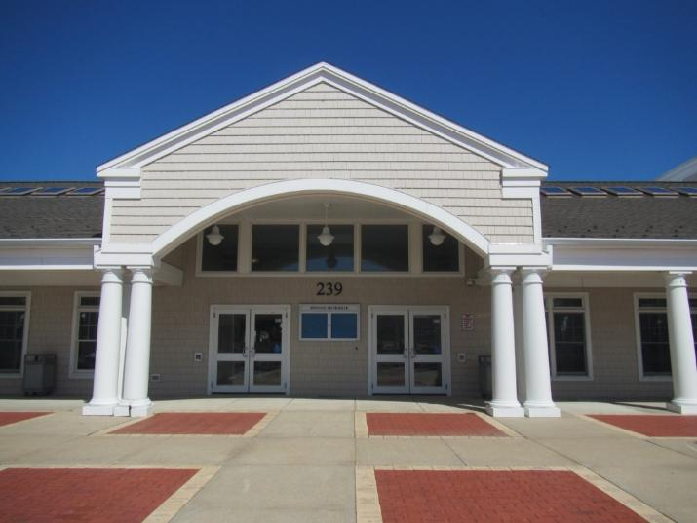

Prepared by:
Massachusetts Department of Public Health
Bureau of Climate and Environmental Health
Division of Environmental Health Regulations and Standards

Contents

EXECUTIVE SUMMARY 3
BACKGROUND 4
RESULTS AND DISCUSSION 5
Ventilation and HVAC System Maintenance 5
Water Damage and Moisture Concerns 6
Sources of Respiratory Irritants/Possible Asthma Triggers 8
CONCLUSIONS AND RECOMMENDATIONS 9
REFERENCES 12
FIGURES 13
PICTURES 15
Table 1 23
Table 2A 25
Table 2B 26
Table 2C 27
Table 3 28
Table 4 30

EXECUTIVE SUMMARY
The Massachusetts Department of Public Health’s Division of Environmental Health Regulations and Standards (MDPH/EHRS) conducted an indoor air quality (IAQ) assessment of the Bourne Veteran’s Memorial Community Center (VMCC) at 239 Main St, Buzzards Bay. This assessment was coordinated through the Department of Labor Standards (DLS) for the purpose of addressing staff complaints about mold and other issues. DLS and the EHRS IAQ Unit often coordinate a response to a complaint when concerns include general IAQ or mold, as these are not included in any regulatory citations that are covered by DLS, but are among the issues the IAQ Unit addresses.
Any building can have IAQ issues. These issues can worsen through conditions common to marginalized communities (Environmental Justice communities or EJ) such as inequitable exposure to outdoor air pollution and a greater likelihood of poor building conditions leading to deterioration of IAQ, resulting in higher asthma rates. The town of Bourne contains a number of EJ communities (This data was obtained from https://www.mass.gov/info-details/massgis-data-2020-environmental-justice-populations). While the pediatric asthma rate for the town of Bourne is 6.8%, which is statistically significantly lower than the statewide pediatric asthma prevalence rate of 9.6% (MAEPHT, 2026), building conditions can contribute to asthma symptoms in sensitive people.
The assessment was conducted by evaluating several key elements within the building; a visual inspection of the heating, cooling, and ventilating (HVAC) systems, water/microbial damage, cleanliness, point sources of respiratory irritants such as chemicals, and electronic measurement of carbon dioxide (CO₂), carbon monoxide (CO), temperature, relative humidity (RH), and small particulate matter (PM2.5) all taken with a Qtrak XP monitor. Data is collected in this manner to identify potential asthma triggers, allergens, and other environmental factors that can cause indoor air quality symptoms. Please refer to the Indoor Air Quality Manual on the MDPH website for methods, sampling procedures, and interpretation of results.
As a result of this walkthrough, there are several findings: at less than 25 years old, this building is generally in excellent condition. As building systems age, appropriate preventive and regular maintenance will help to keep mechanical systems operating well and the building envelope weathertight. Note that some water-stained ceilings were found, and there are occupant-induced issues including storage/clutter.
Based on the results of the assessment, the following primary recommendations are made:
- Replace water-damaged ceiling tiles and check for reoccurring leaks,
- Consider more permanent methods of removing unneeded water service from the locker room, and
- Take steps to ensure the building envelope remains weathertight including monitoring flashing where roof surfaces meet.
(Conclusions and Recommendations)

BACKGROUND

Building: | Bourne Veteran’s Memorial Community Center (VMCC)
Address: | 239 Main St, Buzzards Bay
Assessment Requested by: | Department of Labor Standards (DLS) received a complaint from an employee about chemical safety issues and indoor air quality (IAQ) in the building.
Reason for Request: | Mold and general indoor air quality
Date of Assessment: | April 23, 2026
Massachusetts Department of Public Health/Bureau of Climate and Environmental Health/Division of Environmental Health Regulations and Standards (MDPH/BCEH/EHRS) Staff Conducting Assessment: | Ruth Alfasso, Environmental Engineer, Indoor Air Quality Outreach and Education Unit
Building Description: | The VMCC was completed in 2003. It is a single-story building with a roof with both peaked and flat areas. It contains offices, activity rooms, a cafeteria, and a gym. This building is used for both senior center activities and recreation center activities.
Windows: | Windows in the building are openable.

RESULTS AND DISCUSSION
The following is a summary of indoor air testing results (Table 1)
- Carbon dioxide (CO₂) | a measure of the adequacy of ventilation | Levels were below the MDPH guideline of 800 parts per million (ppm) in all of areas surveyed indicating that most areas have sufficient fresh air for the occupancy at the time of the visit. Note that occupancy can be higher in the building than it was during the visit.
- Temperature | a measure of comfort | Was within or very close to the MDPH recommended range of 70°F to 78°F in all areas tested.
- Relative humidity | a measure of comfort and, when in excess for an extended period, a way to reflect the potential for mold and fungal growth | Was within or close to the MDPH recommended range of 40 to 60% in all areas tested, which is common during the heating season.
- Carbon monoxide  (CO) | a product of combustion that can result in acute and long term cardiovascular, respiratory, and neurological symptoms | Levels were non-detectible in all areas assessed.
- Particulate matter (PM2.5) | a way to measure inhalable particle distribution in the air | Concentrations were below the National Ambient Air Quality Standard (NAAQS) of 35 micrograms per cubic meter (μg/m³) in all areas tested.

Ventilation and HVAC System Maintenance
Ventilation refers to both the supply of fresh air and the removal of stale air from a room. The introduction of fresh air into an occupied space will dilute normally occurring pollutants that are generated by occupancy and other activities. In addition, a heating, ventilation, and air conditioning (HVAC) system will remove pollutants from a building if operating appropriately.

The building is equipped with mechanical ventilation. Air handling units bring in fresh air which is distributed through ceiling-mounted vents (Picture 1). Return or exhaust vents are present on interior walls or ceilings of most rooms (Picture 1 and 2). Fan coil units in the ceilings heat and cool the air and recirculate it. A fan coil unit does not have a fresh air supply itself, but contains a fan and filters to filter and circulate the air in the room (Figure 1). Some rooms are equipped with unit ventilators (univents, Picture 3). Univents draw air in from a vent in the exterior of the building, heat or cool it, filter it and deliver it through a vent on the top, air from the room is drawn into a vent at the bottom and mixed with the fresh air (Figure 2). Univents work best if the top and front of them are free of obstructions.
Some of the univents in the building were broken, due to previously frozen pipes. These units had insulation inserted underneath them to block drafts from outside (Picture 4). The material used appeared to be fiberglass, which can emit irritating fibers if disturbed.
Some rooms were found to have no supply or no return ventilation (Table 1). Without a supply of fresh air and removal of stale air, the air can feel stuffy and common indoor pollutants can build up. Some exhaust vents in the building were tested for air draw, and all were found to be working.
Building mechanical systems are controlled through a building management system which can be accessed by a computer or tablet. Systems should be set to allow for continuous fresh air and air circulation during all occupied periods. If other parameters such as carbon dioxide or humidity are measured by the system and fed into the building management system, these measurements can be used to ensure sufficient fresh air is being supplied for occupancy. Humidity measurements can be used to assess whether there is the potential for condensation during hot humid weather.
Ventilation equipment including air handling units, univents, and fan coil units are all equipped with filters. Filters used in this system have a minimum efficiency reporting value (MERV rating) of 8 (Picture 5). Filters are reportedly changed every 180 days, which is twice a year. The EHRS IAQ unit recommends that filters be changed a minimum of twice a year, and more often if filters are found to be heavily dusty, or if recommended by the equipment manufacturer. Note that filters are stored in the mechanical room, and some were stored on the floor or outside of boxes (Picture 6). Clean filters should be protected from dust, moisture, and other contaminants before use.
To have proper ventilation with a mechanical ventilation system, the systems must be balanced after installation to provide an adequate amount of fresh air to the interior of a room while removing stale air from the room. It is recommended that HVAC systems be re-balanced every five years to ensure adequate air systems function (SMACNA, 1994).
The various types of ventilation components as well as devices that can move/redirect airflow are listed in Table 2A, Table 2B and Table 2C.

Water Damage and Moisture Concerns
Molds are found naturally in our environment both indoors and outdoors. Inside, mold growth may occur when items, particularly porous products such as paper or gypsum wallboard, are exposed to moisture. Typical water sources include leaks, floods, and condensation. To avoid mold growth, dry all water-damaged items and affected areas within 24-48 hours and reduce indoor humidity. Some people with chronic respiratory conditions, such as asthma, are more likely to experience health symptoms associated with molds, including allergic reactions and respiratory irritation. Controlling moisture is the key to preventing mold growth and potential health symptoms.

Hot, humid summers are becoming more frequent due to climate change. Massachusetts has experienced hot, humid, and rainy summers in 2018, 2021, and 2023. July of 2021 was the wettest ever recorded in Massachusetts, and the three-month period from June through August, known as the meteorological summer, was the fourth wettest on record, according to the National Oceanic and Atmospheric Administration’s (NOAA) Centers for Environmental Information (NOAA, 2021). The summer of 2023 was also hot, and wet, being measured as the second rainiest on record (WBUR, 2023). The summers of 2024 and 2025 also had significant stretches of hot, humid weather.

During these hot and wet summers, extended periods of outdoor relative humidity above 70% occurred. Under these weather periods, public buildings experienced extended periods of water vapor exposure from high relative humidity. When exposed to these conditions, porous materials such as gypsum wallboard, cardboard, and other materials may become prone to developing mold colonization, particularly if located in areas that are prone to developing condensation on floors and walls (e.g., below grade space).
Please note that the IAQ Outreach and Education Unit does not recommend conducting mold testing in a typical water damage remediation. For details, please consult Guidance Regarding Testing for Mold in Water-Damaged Public Buildings | Mass.gov
The application of a mildewcide to moldy porous materials is not recommended.

Water Damage Issues
(see Water Damage and Moisture Concerns Pictures)
Mold Growth
Porous materials (e.g., gypsum wallboard, ceiling tiles and carpeting) can be dried with fans and heating within 24 to 48 hours of becoming wet (US EPA, 2008).
If porous materials are not dried within this time frame, mold growth may occur.

- Water damage from leaks and condensation was observed in the form of water-damaged tiles and water-damaged ceiling material in various areas (Table 1; Pictures 7 and 8). Some of these are believed to be due to water infiltration during wind-driven rain. Water-damaged ceiling tiles should be removed and replaced. If they reoccur, the source of the water should be repaired.
- Plants were noted in a few areas (Table 1; Picture 9). Plants, soil, and drip pans can serve as sources of mold/bacterial growth. Plants should be properly maintained, over-watering of plants should be avoided, and drip pans should be inspected periodically for mold growth and cleaned/replaced as needed.
- Water dispensers were located in carpeted areas (Picture 10). Spills or leaks from these appliances can moisten carpeting leading to odors or mold growth.
- The building contains a locker room that is currently used for storage (Pictures 11 and 12). Unused fixtures may leak if they are still connected to water service. Unused drains may dry out and lead to infiltration of sewer gases into the building. Facility staff reported that drains are maintained periodically, and may be equipped with trap primers, which will help prevent dry drain traps. If this locker room is not planned to be returned to service, a more permanent method of draining and/or sealing plumbing should be considered to prevent accidental leaks or flooding.
- Note that while refrigerators examined in this building are not covered by the food code, it is good practice to have a thermometer in each refrigerator that is visible to ensure refrigerated food temperatures are kept at 5ºC (41ºF) or less (US FDA, 2022).

An exterior evaluation was also conducted to identify potential pathways for water penetration and pest entry:
- Light was visible beneath the exterior doors in the gym (Picture 13). These gaps can allow moisture and pests into the building.
- A piece of siding was missing from an exterior wall (Picture 14). This should be repaired to improve the weather-tightness of the building.
- While the building is fairly new, the complicated shape of the roof, which includes peaks, a courtyard, and skylights, may lead to leaking where one section meets another, including due to roof dams or freezing of water in roof valleys. Flashing on the building should be inspected periodically to ensure that drainage surfaces are intact and continuous.
See Table 3 for a list of water damage conditions

Sources of Respiratory Irritants/Possible Asthma Triggers
Asthma is a lung disease that can make breathing difficult. Without careful management of asthma, some people can have symptoms, like a tight feeling in the chest, shortness of breath, coughing, or wheezing. Although there is no cure for asthma, people with asthma can live healthy, active lives. A safe and healthy environment helps to reduce asthma symptoms. The below advice was developed for schools, but similar conditions exist in other public buildings.

Comparison of Local and State-wide Asthma Rates (2024-2025 school year/MAEPHT, 2026)
9.6% of children
have asthma
Massachusetts
6.8% of children
have asthma
Town of Bourne

Note that these rates are based on asthma data for children from kindergarten to 8th grade. Possible asthma triggers and/or airborne pollutants exist in the building. These are described below as well as listed in (Table 4).
(see Sources of Respiratory Irritant Pictures)

- Personal products, particularly those with volatile organic compounds (VOCs) including scents, can also be a source of respiratory irritation. VOCs are carbon-containing substances that have the ability to evaporate at room temperature. Frequent exposure to low levels of total VOCs (TVOCs) may produce eye, nose, throat and/or respiratory irritation in some sensitive individuals. Products noted were sanitizers and cleaning products, (Table 1; Picture 15). Consult “Clean Air Is Odor Free” for more information on fragrances in public buildings.
- As noted above, fiberglass was used to insulate the broken univents. Fiberglass is a good insulator, but creates irritating fibers if disturbed. A different insulating material, preferably one that is water resistant, should be used for this purpose.

CONCLUSIONS AND RECOMMENDATIONS
HVAC System
Helpful links
Ensure the mechanical ventilation is on and supplying fresh air during occupied periods.
Ensure building control systems are set to deliver comfortable temperatures during occupied periods. Night setbacks can be used to save energy.
Have the HVAC system balanced every 5 years in accordance with SMACNA guidance.
Continue using MERV 8 filters in HVAC systems. Filters should be changed at least twice a year, and more often if they are heavily soiled at filter change time. Clean dust and debris out of HVAC unit cabinets during each filter change.
Store unused filters in a clean, dry area off the floor.
Remove dust from vents, fans, and radiators periodically during the year.
When possible, repair univents. Until that time, insulate the univents using a material that is water-resistant and does not produce irritating fibers. Closing off the units at the exterior vent may be helpful.

Water Damage Sources
 | Replace water-damaged ceiling tiles. Repeated water damage to ceiling tiles indicates leaks from the roof, building envelope, or plumbing/HVAC system. | http://www.epa.gov/mold/mold-remediation-schools-and-commercial-buildings-guide
 | Keep plants in good condition, avoid overwatering, and keep them away from the airstream of ventilation equipment.
 | Place a waterproof mat underneath water dispensers to protect the carpet from leaks.
 | Routinely clean food/liquid stains from the refrigerator, food residues from microwaves, crumbs from toaster oven, and any other appliances used to prepare or heat food.
 | Ensure all food and food packets are stored in pest-proof containers and clean up food waste and crumbs promptly to deter rodents.
 | Consider decommissioning fixtures in the locker room to prevent leaks, excess humidity, and the potential for dry drain traps. Depending on the potential for using it as a locker room later, temporary or more permanent actions (e.g., cutting, capping, and removing all fixtures) can be taken.
 | If the building management system measures humidity, this information can be used to help improve comfort and prevent condensation during hot weather. | https://www.mass.gov/info-details/preventing-mold-growth-in-massachusetts-schools-during-hot-humid-weather
 | Make sure all doors to the exterior are tight-fitting using weatherstripping to prevent water, moisture, odor, fumes, exhaust, drafts, and pest access.
 | Repair siding shown in Picture 14.
 | Use proactive/preventative maintenance to address potential issues due to the complicated shape of the roof of the building, including inspecting flashing and addressing ice damming to prevent leaks.
Respiratory Irritants/Possible Asthma Triggers
 | To control for dusts, use a HEPA filter-equipped vacuum cleaner and wet wiping on all surfaces on a regular basis.
 | Use VOC-containing products in areas with good ventilation and keep tightly closed when not in use. Avoid products with strong scents and avoid mixing incompatible products. | Clean Air Is Odor Free
 | Clean carpeting in accordance with IICRC recommendations (IICRC, 2012); annually (or semi-annually in soiled/high traffic areas).
 | For buildings in New England, periods of low relative humidity during the winter are often unavoidable. Therefore, scrupulous cleaning practices should be adopted to minimize common indoor air contaminants whose irritant effects can be enhanced when the relative humidity is low. To control dust, HEPA filter equipped vacuum cleaner in conjunction with wet wiping of all surfaces is recommended. Avoid the use of feather dusters. Drinking water during the day can help ease some symptoms associated with a dry environment (throat and sinus irritations).
 | Follow any additional recommendations from the Department of Labor Standards based on their inspection.
 | Refer to resource manual and other related IAQ documents located on the MDPH’s website for further building-wide evaluations and advice on maintaining public buildings. These documents are available at: Indoor Air Quality | Mass.gov

REFERENCES
ASHRAE. 1991. ASHRAE Applications Handbook, Chapter 33 “Owning and Operating Costs”. American Society of Heating, Refrigeration and Air Conditioning Engineers, Atlanta, GA.
IICRC. 2012. Institute of Inspection, Cleaning and Restoration Certification. Carpet Cleaning: FAQ.
MAEPHT. 2025. Massachusetts Environmental Public Health Tracking. Massachusetts Department of Public Health – Bureau of Climate and Environmental Health. https://matracking.ehs.state.ma.us/
MDPH. 2015. Massachusetts Department of Public Health. Indoor Air Quality Manual: Chapters I-III. Available at: Indoor Air Quality Manual.
NOAA. 2021. Summer 2021 neck and neck with Dust Bowl summer for hottest on record. National Oceanic and Atmospheric Administration, 1401 Constitution Avenue NW, Room 5128, Washington, DC 20230 https://www.noaa.gov/news/summer-2021-neck-and-neck-with-dust-bowl-summer-for-hottest-on-record.
SMACNA. 1994. HVAC Systems Commissioning Manual. 1st ed. Sheet Metal and Air Conditioning Contractors’ National Association, Inc., Chantilly, VA.
US EPA. 2008. Mold Remediation in Schools and Commercial Buildings. US Environmental Protection Agency, Office of Air and Radiation, Indoor Environments Division, Washington, D.C. EPA 402-K-01-001. http://www.epa.gov/mold/mold-remediation-schools-and-commercial-buildings-guide.
US FDA. 2022. 2022 Food Code. U.S. Department of Health and Human Services. U.S. Food and Drug Administration. College Park, MD January 18, 2023 Version. https://www.fda.gov/media/164194/download
WBUR. 2023. “It's been a summer of rain and flooding misery in Mass.” WBUR local news. September 12, 2023. https://www.wbur.org/news/2023/09/12/summer-flooding-rain-massachusetts.

FIGURES
Figure 1
Fan Coil Unit (FCU)

Air Diffuser

Outdoors Indoors

Fan

Heating/Cooling Coil

Air Mixing Plenum

Filter

Return
Air

Figure 2
Unit Ventilator (Univent)

Mixed Air

Air Diffuser

Outdoors Indoors

Fan

Heating/Cooling Coil

Air Mixing Plenum

Filter

Outdoor Return
Air Air

Air
Flow
Control
Louvers

Air Flow

= Fresh Air/Return Air

= Mixed Air

PICTURES
(Click to link back to report)
HVAC pictures
Picture 1
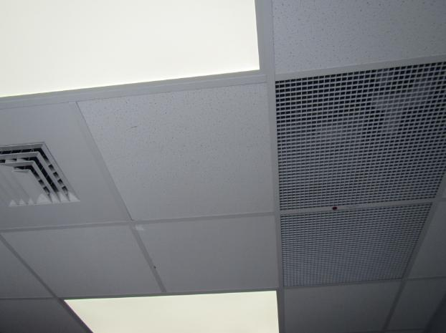
Supply vent (left) and return vent (right)
Picture 2
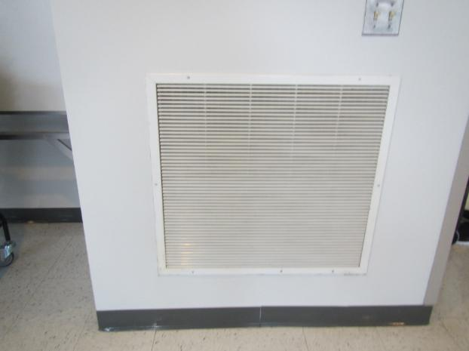
Wall-mounted return/exhaust vent
Picture 3
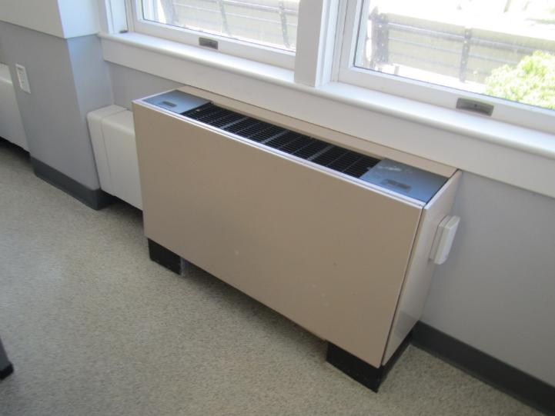
Unit ventilator
Picture 4
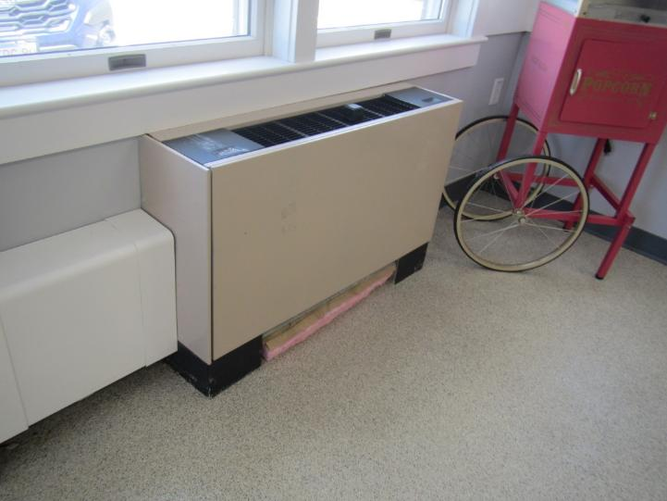
Broken unit ventilator with fiberglass insulation in the bottom
Picture 5
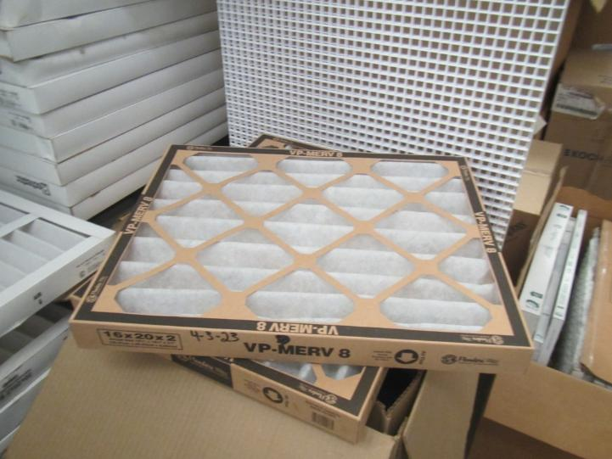
MERV 8 filter
Picture 6
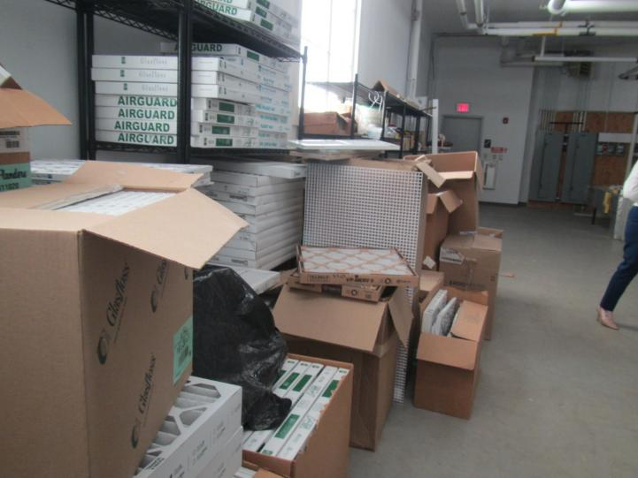
Storage of filters on the floor and in open boxes in the boiler room
Water Damage and Moisture Concern Pictures
(click to link back to report)
Picture 7
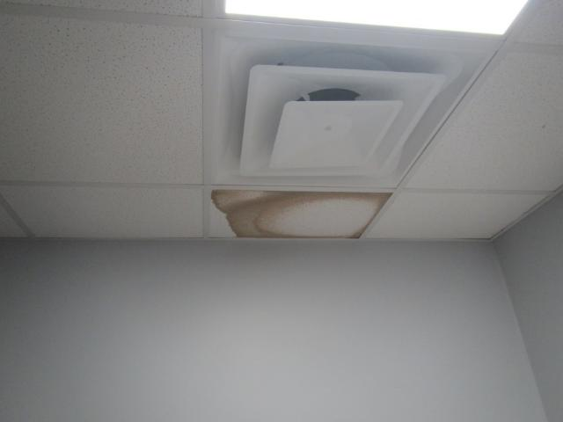
Water-damaged ceiling tile
Picture 8
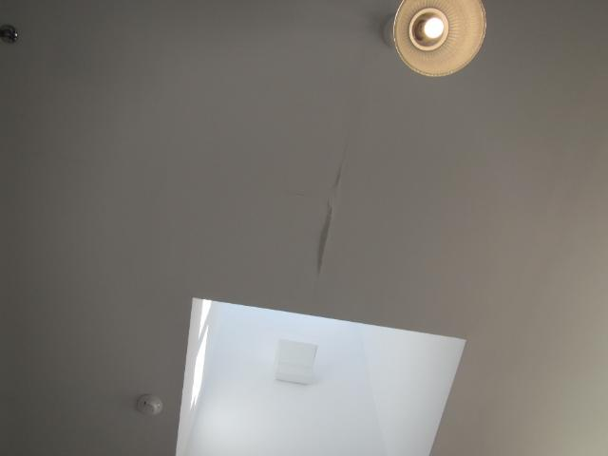
Damage to ceiling, likely due to water infiltration
Picture 9

Plants on a desk
Picture 10
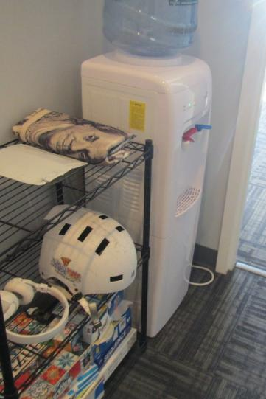
Water cooler on carpet
Picture 11
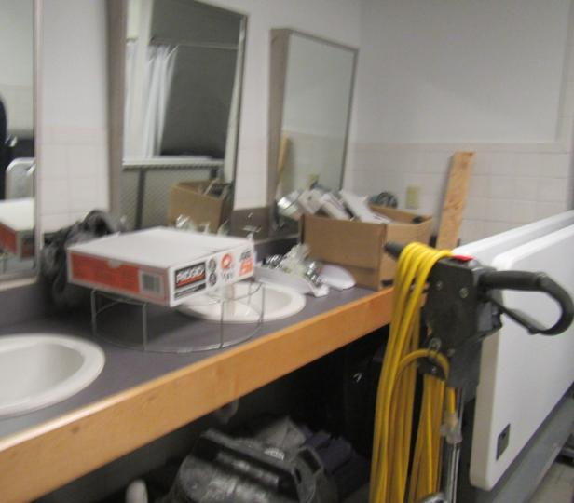
Locker room used for storage
Picture 12
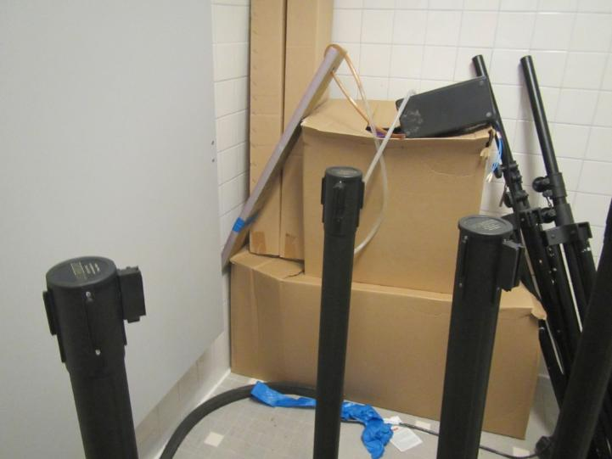
Locker room used for storage
Picture 13
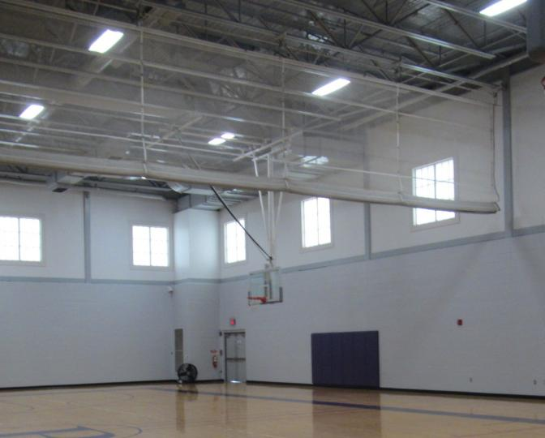
Light visible beneath door in the gym
Picture 14
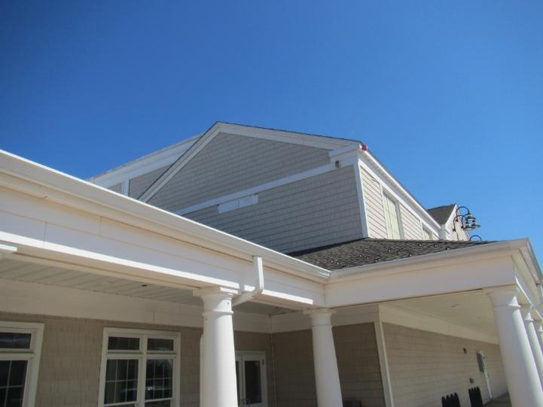
Patch of missing siding (arrow)
Sources of Respiratory Irritant Pictures
(Click to link back to report)
Picture 15
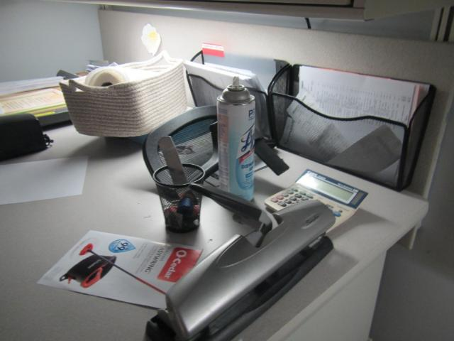
Cleaning/sanitizing product
Table 1 Location | Carbon  Dioxide  (ppm) | Carbon Monoxide  (ppm) | Temp  (°F) | Relative  Humidity  (%) | PM2.5  (µg/m³) | Occupants  in Room | Windows  Openable | Ventilation |  | Remarks
 |  |  |  |  |  |  |  | Supply | Exhaust | Remarks
Background | 431 | ND | 61 | 53 | 7 |  |  |  |  | Parking lot between park and busy road. Sunny and clear.
Meeting room 2 | 451 | ND | 75 | 35 | 2 | 0 | Y | Y | Y | NC
Women’s restroom |  |  |  |  |  |  | N | N | Y | WD CT
Meeting room 1 | 486 | ND | 72 | 38 | 2 | 1 | Y | Y | Y | NC
Rec center offices | 636 | ND | 71 | 39 | 4 | 1 | Y | Y | Y | Plush furniture, carpet, WD CT, water cooler on carpet
Custodian storage/office | 571 | ND | 72 | 39 | 2 | 1 | N | N | Y | Fridge and microwave, NC
Main open room | 555 | ND | 72 | 39 | 3 | 5 | Y | Y | Y | Mostly not carpeted
Cafeteria | 522 | ND | 71 | 39 | 3 | 12 | Y and door | Y | Y
COA hallway | 553 | ND | 71 | 39 | 0 | 0 | N | Y | Y | 2 WD CT
COA admin office | 592 | ND | 71 | 40 | 2 | 3 | N | Y | Y | NC, sanitizers
Medical storage |  |  |  |  |  |  |  |  |  | 1 WD CT, fridge and microwave, NC, plant
COA coordinator | 577 | ND | 71 | 39 | 1 | 1 | Y | Y | Y | Heater, area rug
Director’s office | 576 | ND | 71 | 38 | 1 | 0 | Y | Y | Y
Employee entrance hall | 531 | ND | 72 | 38 | 1 | 0 | Door | Y | Y
TV room | 608 | ND | 71 | 41 | 2 | 8 | Y | Y | Y | Kitchen equipment including fridge, microwave, sink. Univents in room, some broken (frozen pipes), one univent filled with fiberglass insulation. Two restrooms attached to room
Office next to TV room | 538 | ND | 69 | 44 | 3 | 0 | Y | Y | Y | Univents
Relaxation room | 536 | ND | 69 | 43 | 2 | 0 | N | N | Y | Yoga equipment
Gym | 475 | ND | 69 | 40 | 1 | 0 | Door | Y | Y | Light visible under doors
Locker room |  |  |  |  |  |  |  |  |  | Not used as locker room, used for storage.
Meeting room 3 | 495 | ND | 69 | 40 | 3 | 3 | Y | Y | Y

(Click to link back to report)

Table 2A
Equipment Present in Building  (X = Yes) | Type of Heating/Cooling Ventilation  Equipment | Fresh  Air  Supply  (X = Yes) | Type of Location(s) | Air Filters Installed  MERV Rating  (1-15, U*)  (X = Yes) | Comments
y | Univents | y |  | 8
 | Rooftop Air Handling Units
 | Outdoor, Ground-Installed Air Handling Units
 | Attic/Crawlspace Air Handling Units
y | Ceiling-Mounted Air Handling Units (including inside plenum) | n |  | 8
 | Basement/Crawlspace-Installed Air Handling Units
 | Mechanical Room-installed Air Handling Units
y | Fan Coil Units | n |  | 8
 | Window-Mounted Air Conditioners
 | Wall Louver-Controlled Gravity Air Supply
X | Windows | X
 | Fan in window (blowing in)
 | Built in wall fan (switched)
 | Heat recovery ventilator unit
 | Energy recovery ventilator unit
 | Chilled Beam
 | Passive combustion supply vent in basement/boiler room

*U = Filter Rating underdetermined due to inaccessibility during building visit

(Click to link back to report)

Table 2B
Equipment Present in Building  (X = Yes) | Type of Exhaust Ventilation  Equipment | Ducted  To Outdoors  (X = Yes) | Type of Location(s) | Comments
y | Rooftop Motors/Fans
 | Unit Exhaust
y | Ceiling Return Vent
 | Ceiling Return Vent, Plenum
 | Wall Return Vent
 | Kitchen Stove Hood
 | Restroom Exhaust Vent
 | Photocopier Exhaust Vent
 | Garage
 | Chemical Hood(s)
y | Locker Rooms
 | Showers
 | Lock up Cells
 | Clothes Dryers
 | Gas Water Heaters
 | Furnace-Flue to Chimney
 | Furnace/Boiler direct vent or power vent (no combustion air supply)
 | Kiln, Pottery
 | Dark Room
 | Generator Room
 | Wood Shop Dust Collector
 | Spray Paint Booths
 | Fan in window (blowing out)

Table 2C
Equipment Present in Building  (X = Yes) | Type of Equipment | Type of Location(s) | Comments
 | Floor Fans, pedestal
X | Portable fans | Various areas | Some dirty and dusty
 | Air Purifier (HEPA, other)
 | Floor heaters, portable
X | Refrigerators, Cold Beverage Vending Machines | Break rooms and some offices | Clean food/liquid spills
 | Radiator, wall-mounted
 | Radiator, floor-mounted
 | Passive vents (Wall/Door)

(Click to link back to report)

Table 3
Found in Building  X = Yes | Water-Damaged Materials, Building Components or Stored Materials | Location | Visible Microbial Growth?  X = Yes | Musty odor detected?  X = Yes | Comments
 | Books-other bound materials
 | Brick walls – broken, missing mortar
 | Brick walls – blocked weep holes
 | Cardboard boxes
 | Carpet tiles
 | Carpet - Area rugs
 | Carpet wall-to-wall
 | Ceiling tiles - affixed directly to ceiling surface
 | Ceiling tiles - bowing-in suspended ceiling
 | Ceiling tiles - water-stained in splined ceiling
X | Ceiling tiles - water-stained in suspended ceiling | Various | X
 | Chairs - laminated
 | Cloth
 | Countertops (around sinks)
 | Curtains
 | Dust/debris within AHU, uninvent, HVAC, chilled beam units, etc. (WD through condensation, humidity, or leaks)
 | Efflorescence (i.e., mineral deposits)
 | Engineered woods - particleboard, plywood, Masonite
 | Flooring – loosened tiles
 | Flooring - wooden
 | Furniture - laminated
 | Furniture - upholstered
 | Gypsum wallboard - ceiling
 | Gypsum wallboard - restroom wall
 | Gypsum wallboard - interior wall
 | Gypsum wallboard – located on exterior wall
 | HVAC drain pan – lack of draining
 | HVAC filters
 | Insulation- attic (paper-backed)
 | Insulation - inside air handling unit
 | Insulation - on pipe(s) fiberglass
 | Insulation - on pipe(s) other/plaster-like material
 | Insulation - wall cavity
 | Insulation – ceiling plenum
 | Modular furniture – walls/cloth partitions
 | Musical instrument cases
 | Plaster ceilings
 | Plaster walls
 | Records/files
 | Refrigerator - door gasket
 | Refrigerator - drip pan
 | Refrigerator - Interior surfaces
 | Room divider - ceiling-mounted, sliding
 | Sink backsplash
 | Tables – laminated
 | Wallpaper
 | Wood - attic/roof materials
 | Wood - floor joists in basement ceiling
 | Wood - wall framing
 | Wood - window sills
 | Wood - window-mounted air conditioner framing
 | OTHER: Wooden baseboard

WHAT ARE ENVIRONMENTAL ASTHMA TRIGGERS?
Asthma triggers are any chemical, pollutant, or allergen that can make your asthma worse. Asthma triggers can also be strong chemical smells, dust, or pets. Your asthma triggers may be different from those of other people. Not all asthma triggers affect people the same way. Environmental asthma triggers are found both indoors and outdoors. DPH link: Asthma and Your Environment (mass.gov)

(click to link back to report)

Table 4
Condition Present  X = Yes | Possible asthma symptom-inducing environmental pollutant | Recommendation to reduce or eliminate the pollutant
X | Water Damage and/or Mold  (allergen) | Identify water source and repair to eliminate.  Clean non-porous materials.  Remove and replace porous materials susceptible to mold growth.  Perform regular water damage assessments as a tool to ensure timely mitigation as needed.  Use NIOSH water damage assessment protocol as a guide: NIOSH water damage assessment guideline.
X | Moistening of building components during hot, humid weather (>2 days in length) (mold, allergen) | Remove materials not dried in <2 days in a manner consistent with US EPA Mold Removal in Commercial Buildings guideline.  Use dehumidification in occupied basement areas and other areas with chronic dampness.
 | Vegetation against exterior of building (water damage-mold) | Remove all vegetation preventing building exterior drying.  Remove all vegetation capable of falling onto a building or depositing debris onto the roof.
 | Personal humidifiers (lack of proper maintenance)  (pollutant and allergen) | Clean and maintain properly.  Use distilled water to eliminate metal and water treatment odors.  Maintain hydration by increasing water consumption.
X | Drains: Floor drains, Sink drains (abandoned use)  Water bubblers (abandoned use) | If in use, pour water into drain at least twice a week.  If not in use, seal the drain with an appropriate material in accordance with Massachusetts Plumbing Code (248 CMR 10.00).
 | Live Animals (turtles, gerbils, birds, rabbits, etc.) | Ensure cleanliness or remove animals from the location.
 | Improperly maintained aquariums and terrariums (allergen) | Maintain such equipment properly to eliminate odor.  Discontinue use.
X | Plants and flowers  (allergen and mold) | Keep indoor plants well maintained and not overwatered. Monitor for signs of mold and pests.  Ensure water for cut flowers does not become stagnant.  Ensure dried plant material is free of odors, mold, and pests and handled carefully  If asthma risks are high, eliminate plants and flowers.
 | HVAC system moisture issues  (mold, allergen) | Consult ASHRAE’s minimum standards for HVAC maintenance and inspection of commercial HVAC systems (https://www.ashrae.org/technical-resources/bookstore/standards-180-and-211).
 | HVAC system contaminant issues (allergen) | Consult ASHRAE’s minimum standards for HVAC maintenance and inspection of commercial HVAC systems (https://www.ashrae.org/technical-resources/bookstore/standards-180-and-211).
 | Indoor swimming pool odors outside of swimming pool (mold, chemical) | Maintain and operate pool HVAC systems to vent odors from building.  Ensure locker room exhaust vents are operating during building hours.  All doors leading to pool should be rendered airtight and be closed.
X | Pollen (allergen) | Recommend installation of MERV 8 or better filters if HVAC engineer confirms HVAC system can be so equipped without adversely affecting function.  Cut grass after hours.  Cut grass in a pattern to direct clippings away from exterior wall.  Remove trees and shrubs from in front of windows and air intakes.
X | Dry air | Maintain hydration.  Avoid overheating of air.
 | Dust mites  (allergen) | Recommendation to remove non-official upholstered furniture, area rugs, pillows, cushions, etc.  Cleaning with use of HEPA-filtered vacuum cleaner.  Eliminating clutter, storing items in dust and moisture-proof containers, and regularly removing dust through wet wiping.
 | Pests, including rodents and cockroaches  (allergen) | Use of integrated pest management guidelines, including:  - Proper disposal of food containers  - Proper storage of food products in airtight containers  - Elimination of use of food as art projects  - Remove pest harborages/clutter  - Regular monitoring for pests  EPA IPM guideline link
 | Latex-containing materials | Remove tennis balls from furniture legs.
X | Fragrances  (chemical) | Eliminate point sources, such as:  - Plug-in air fresheners  - Aroma/oil reed diffusers  - Scented sprays  - Discontinue use of other scented materials  - Consult DPH fragrance guideline: Clean air is odor-free
 | Strong smells from /use of Chemicals (such as cleaning products)  (chemical) | Use building-issued cleaning products.  Use products in accordance with manufacturer’s instructions including dilution, application, and ventilation.  Avoid using products that are stronger than needed for the situation.
 | Strong odors from new building materials (carpeting/furniture)  (chemical) | Use low VOC-emitting materials.  Air out materials (outside or in unoccupied area) prior to installation.
 | Tobacco smoke  Secondhand Smoke  (pollutant) | Eliminate tobacco smoking.  Seal all shared wall penetrations.
X | Products with a strong odor such as paint, perfume, hairspray, air fresheners, bug-spray, laminators, candles, wax melters, dry erase markers and other VOC-containing products  (chemical) | If essential:  - Provide proper exhaust ventilation to eject aerosolized product directly outdoors.  - Avoid/reduce use during occupied hours.  If not necessary, remove and eliminate.
X | Vehicle exhaust  (pollutant) | Enforce anti-idling regulations and post signs to give notice.  Relocate vehicles away from fresh air intakes.  Require vehicles to park face-in at building walls.  Close doors to prevent vehicle exhaust from entering occupied spaces. idling-faq
 | Vapors and or fumes from gas, oil, or kerosene stoves  (pollutant) | Operate stove hood when stove in use.  Install stove hood if not present.  Ensure equipment is in good working order.
 | Ozone (pollutant) | Eliminate use of ozone generating equipment.
 | Window Air Conditioners (if not properly maintained) (allergen) | Equip with proper filter and clean periodically.  Clean drip pans.  Install in window with weathertight, non-mold-growth sustaining material.
 | Pottery (pollutant) | Do not operate kiln during occupied hours.  Operate kiln with exhaust system activated.  Seal all seams and holes in kiln vent.  Ensure kiln exhaust discharge terminates outdoors.
X | Carpeting (allergen) | Clean carpeting in a manner consistent with IICRC standards, including regular vacuuming with a high efficiency particulate air (HEPA) filtered vacuum in combination with annual cleaning or semi-annual cleaning in soiled high traffic areas.
 | Sweeping/dusting vs HEPA vacuuming/wet wiping  (allergen or pollutant) | Refrain from using feather dusters or brooms.  Utilize HEPA vacuums and wet wiping to minimize aerosolizing particulate matter.
 | Lack of adequate air exchange/mechanical ventilation | Make repairs as necessary and ensure all HVAC system components are operating continuously when building is occupied.
 | Lack of local exhaust at source of pollution (vocational shop activities, kitchen exhaust hood) (all) | Recommend installation of exhaust ventilation to direct pollutants directly outdoors.
 | Renovating buildings while occupied  (chemical) | Use all SMACNA guidelines for Renovation While Buildings Are Occupied. For information, visit https://www.mass.gov/service-details/construction-and-renovation-generated-pollutants-in-occupied-buildings.
 | Chemistry program chemical storage  (chemical) | Repair (if needed) and operate chemical storeroom vents appropriately.  Reduce or eliminate unneeded or overstocked chemicals.  Store all chemicals in a manner to separate incompatible chemicals.  Keep chemical storerooms clean.
X | Photocopiers/duplicating machines | All machines should have dedicated exhaust vents or be used in a well-ventilated area.

