INDOOR AIR QUALITY ASSESSMENT

Veterans Memorial School
10 Webster Street
Gloucester, MA 01930



Prepared by:
Massachusetts Department of Public Health
Bureau for Environmental Health
Emergency Response/Indoor Air Quality Program
June 2007

Background/Introduction
At the request of Mr. Jack Vondras, Director, Gloucester Health Department (GHD), the Massachusetts Department of Public Health (MDPH), Bureau of Environmental Health (BEH) conducted an indoor air quality assessment at the Veteran’s Memorial School (VMS), 138 Cherry Street, Gloucester, Massachusetts. On February 2, 2007, a visit to conduct an indoor air quality assessment was made to the VMS by Sharon Lee, an Environmental Analyst in BEH’s Emergency Response/Indoor Air Quality (ER/IAQ) Program. The request was prompted primarily by concerns related to transient fish odors entrained from the outdoors, dry drain odors in the gym office, musty odors in two classrooms and chemical odors in the hallway shared by the nurse’s office and storage/copier room.
The VMS is a single-story building constructed in 1956. An addition was constructed in 1993. Concurrent to the construction of the addition, classroom carpets were installed and the library was subdivided. The school consists of classrooms, a gymnasium, a computer room and offices. Windows throughout the school are openable.
As previously indicated, the assessment was prompted by odor concerns. The VMS is located within a quarter mile of the inner harbor fishing pier. A number of fish processing plants are also in close proximity to the VMS. The school reportedly experiences occasional fish odors throughout the year, depending on wind direction. During the early fall of 2006, a neighboring fish processing company contacted the school to report a malfunction in the company’s odor scrubbing equipment. As a result of the malfunction, odors were released into air. These odors were then entrained into the school’s ventilation equipment and distributed throughout the building. The processing company reportedly repaired the scrubber within 24-hours of the release, and no further odors were reportedly experienced in the school the following day. According to school officials, this was an isolated event.

Methods
Air tests for carbon monoxide, carbon dioxide, temperature and relative humidity were conducted with the TSI, Q-Trak, IAQ Monitor, Model 8551. Air tests for airborne particle matter with a diameter less than 2.5 micrometers were taken with the TSI, DUSTTRAK™ Aerosol Monitor Model 8520. Screening for total volatile organic compounds (TVOCs) was conducted using a Thermo Environmental Instruments Inc., Model 580 Series Photo Ionization Detector (PID). BEH staff performed a visual inspection of building materials for water damage and/or microbial growth.

Results
The school houses approximately 225 students in pre-kindergarten through eighth grade and approximately 30 staff members. Tests were taken during normal operations at the school and results appear in Table 1.

Discussion

Ventilation
It can be seen from Table 1 that carbon dioxide levels were above 800 parts per million (ppm) in 11 of 28 areas surveyed, indicating less than optimal ventilation at the time of assessment. It is important to note that several areas were empty or sparsely populated at the time of assessment. Low occupancy can greatly reduce carbon dioxide levels. With increased occupancy, carbon dioxide levels would be expected to rise.
Fresh air in classrooms is supplied by unit ventilator (univent) systems (Picture 1). A univent is designed to draw air from outdoors through a fresh air intake located on the exterior wall of the building (Picture 2) and return air through an air intake located at the base of the unit (Figure 1). Fresh and return air are mixed, filtered, heated and provided to classrooms through an air diffuser located in the top of the unit. Many univents were operating weakly or found to be off at the time of assessment. Obstructions to airflow, such as papers and books stored on univents and bookcases and carts and desks located in front of univent returns, were seen in a few classrooms. In some cases, univents were used to dry art projects (Pictures 3 and 4, Table 1). In order for univents to provide fresh air as designed, units must be allowed to operate and remain free of obstructions.
Exhaust ventilation in classrooms is provided by ducted and grated closet, wall or ceiling vents (Pictures 5 and 6) powered by rooftop motors. Classroom exhaust was operating at the time of assessment. A number of wall exhaust vents were also obstructed by desks, bookcases and other items (Picture 7). As with the univents, in order to function properly, exhaust vents must be activated and remain free of obstructions. Some areas did not have mechanical supply and/or exhaust. Without mechanical ventilation, normally occurring pollutants can accumulate.
Mechanical ventilation to common areas and offices is provided by rooftop air handling units (AHUs). Fresh air is distributed via ductwork connected to ceiling-mounted air diffusers. Air is returned to the AHUs through ceiling-mounted return vents (Picture 8).
Some retrofitted offices (e.g. gym office) lack fresh air supply. Consideration should be given to undercutting office doors to create a space at least 1 inch high to provide a source of ventilation to the office when the door is closed. The gym office has a mechanical exhaust; however, it did not appear to be functioning at the time of assessment.
To maximize air exchange, the MDPH recommends that both supply and exhaust ventilation operate continuously during periods of school occupancy. In order to have proper ventilation with a mechanical supply and exhaust system, the systems must be balanced to provide an adequate amount of fresh air to the interior of a room, while removing stale air from the room. It is recommended that HVAC systems be re-balanced every five years (SMACNA, 1994). The date of the last balancing was not available at the time of the assessment.
The Massachusetts Building Code requires that each room have a minimum ventilation rate of 15 cubic feet per minute (cfm) per occupant of fresh outside air or openable windows (SBBRS, 1997; BOCA, 1993). The ventilation must be on at all times the room is occupied. Providing adequate fresh air ventilation with open windows and maintaining the temperature in the comfort range during the cold weather season is impractical. Mechanical ventilation is usually required to provide adequate fresh air ventilation.
Carbon dioxide is not a problem in and of itself. It is used as an indicator of the adequacy of the fresh air ventilation. As carbon dioxide levels rise, it indicates that the ventilating system is malfunctioning or the design occupancy of the room is being exceeded. When this happens, a buildup of common indoor air pollutants can occur, leading to discomfort or health complaints. The Occupational Safety and Health Administration (OSHA) standard for carbon dioxide is 5,000 parts per million parts of air (ppm). Workers may be exposed to this level for 40 hours/week, based on a time-weighted average (OSHA, 1997).
The MDPH uses a guideline of 800 ppm for publicly occupied buildings. A guideline of 600 ppm or less is preferred in schools due to the fact that the majority of occupants are young and considered to be a more sensitive population in the evaluation of environmental health status. Inadequate ventilation and/or elevated temperatures are major causes of complaints such as respiratory, eye, nose and throat irritation, lethargy and headaches. For more information concerning carbon dioxide, please consult Appendix A.
Temperature measurements ranged from 68º F to 73º F, which were within or slightly below the MDPH recommended comfort guidelines in some areas. The MDPH recommends that indoor air temperatures be maintained in a range of 70 º F to 78 º F in order to provide for the comfort of building occupants. In many cases concerning indoor air quality, fluctuations of temperature in occupied spaces are typically experienced, even in a building with an adequate fresh air supply.
The relative humidity measurements in the building ranged from 20 to 37 percent, which were below the MDPH recommended comfort range. The MDPH recommends a comfort range of 40 to 60 percent for indoor air relative humidity. Relative humidity levels in the building would be expected to drop during the winter months due to heating. The sensation of dryness and irritation is common in a low relative humidity environment. Low relative humidity is a very common problem during the heating season in the northeast part of the United States.

Microbial/Moisture Concerns
As previously mentioned, musty odors were detected in classrooms 1 and 2, during early fall 2006. At the time that the odor was detected, Gloucester Public School’s (GPS) facility department examined these classrooms as well as neighboring areas for leaks and moisture. GPS staff reportedly shampooed the carpets, cleaned the classrooms, cleaned the ventilation equipment and changed filters for the univents. At the time of the assessment, BEH staff did not detect any odors or observe any moisture in this portion of the building.
While the source of the odors could not be determined, one potential source for moisture penetration in the 1993 portion of the building is the building’s exterior. It appears that the building’s exterior consists of engineered (i.e., strand board) wood (Picture 9), similar to that used for modular buildings. In some areas of the building, the exterior appears to show damage (Picture 10). Of note is the penetration of water into the building through the univent fresh air intake casing (Picture 2). As previously discussed, each univent has a fresh air intake located on the exterior of the building. Each fresh air intake is mounted directly onto the building exterior with screws. These screws appear to show signs of weathering (Picture 12). The top portion of the fresh air intake cases as well as each louver of the intake show staining. Since these cases are not flush/within the wall and do not have flashing installed over the top of the univent grates, the staining is an indication that water is being retained on the lip of the case/against the exterior wall.
It does not appear that a seal exists between the case and the wall. Without any sealant, water can penetrate through the breach and moisten insulation between the exterior and interior walls. Insulation can act as a wick, drawing moisture towards the interior of the building, potentially moistening the interior wall.
Since moisture may be penetrating through the breach between the fresh air univent intake case and the exterior wall, the exterior wallboard directly behind the intake case may also be water damaged. As with insulation, these materials may be prone to mold growth if not allowed to dry sufficiently. Due to proximity, odors produced by the moistened insulation and damaged exterior wall can be drawn into the fresh air intake, become entrained in the univent and be distributed throughout the classroom.
The US Environmental Protection Agency (US EPA) and the American Conference of Governmental Industrial Hygienists (ACGIH) recommends that porous materials be dried with fans and heating within 24 to 48 hours of becoming wet (US EPA, 2001; ACGIH, 1989). If porous materials are not dried within this time frame, mold growth may occur. Water-damaged porous materials cannot be adequately cleaned to remove mold growth. The application of a mildewcide to moldy porous materials is not recommended.
BEH staff examined the exterior wall and could not locate weep holes in one wall section. It also appears that weep holes were sealed/clogged in another wall section (Picture 12). Weep holes are designed to provide for water drainage. Exterior wall systems should be designed to prevent moisture penetration into the building interior. An exterior wall system should consist of an exterior curtain wall (Figure 2). Behind the curtain wall is an air space that allows for water to drain downward and for the exterior cladding system to dry. Opposite the exterior wall and across the air space is a continuous, water-resistant material adhered to the back up wall that forms the drainage plane.
The purpose of the drainage plane is to prevent moisture that crosses the air space from penetrating into interior building systems. The plane also directs moisture downwards toward the weep holes. The drainage plane can consist of a number of water-resistant materials, such as tarpaper or, in newer buildings, plastic wraps. The drainage plane should be continuous. Where breaks exist in the drainage plane (e.g., window systems, door systems and univent fresh air intakes), additional materials (e.g. copper flashing) are installed as transitional surfaces to direct water to weep holes. If the drainage plane is discontinuous, missing flashing or lacking air space, rainwater may accumulate inside the wall cavity and lead to moisture penetration into the building.
In order to allow water to drain from the exterior brick wall system, a series of weep holes is customarily installed at or near the foundation slab/exterior wall system junction (Figure 2). Weep holes allow for accumulated water to drain from a wall system (Dalzell, 1955). Failure to install weep holes in brickwork will allow water to accumulate within the base of walls, resulting in seepage and possible moistening of interior building components (Figure 3). As mentioned, the exterior wall of the VMS lacks weep holes. As a result, water is may be accumulating against the exterior brick wall. Overtime, moisture can erode brick and mortar.
In addition, plants were observed to be growing against the foundation walls (Picture 9). The growth of roots against exterior walls can bring moisture in contact with the foundation. Plant roots can eventually penetrate, leading to cracks and/or fissures in the sublevel foundation. Over time, this process can undermine the integrity of the building envelope, providing a means of water entry into the building via capillary action through foundation concrete and masonry (Lstiburek & Brennan, 2001).
While no mold growth was observed at the time of assessment, some potential sources for mold growth were observed. A few areas had water-damaged ceiling tiles, which can indicate leaks from the roof or plumbing system. Water-damaged ceiling tiles can provide a source for mold growth and should be replaced after a water leak is discovered and repaired. Tiles glued directly to the ceiling system are more difficult to remove. Appropriate precautions should be taken when removing and replacing these tiles.
Open seams between sink countertops and walls were observed in several rooms (Picture 13). If not watertight, water can penetrate through the seam, causing water damage. Improper drainage or sink overflow can lead to water penetration into the countertop, cabinet interior and areas behind cabinets. Water penetration and chronic exposure of porous and wood-based materials can cause these materials to swell and show signs of water damage. If these materials become wet repeatedly they can provide a medium for mold growth.
Plants were also observed in several classrooms. Some plants were observed on carpets (Picture 14). Plants, soil and drip pans can serve as sources of mold growth, thus should be properly maintained. Over-watering of plants should be avoided and drip pans should be inspected periodically for mold growth. Plants and related materials should also be located away from ventilation sources to prevent aerosolization of dirt, pollen, odors or mold.
A number of aquariums and terrariums were located in classrooms. Algal growth was observed in the tank of one aquarium. Aquariums should be properly maintained to prevent microbial/algae growth, which can emit unpleasant odors. Similarly, terrariums should be properly maintained to ensure soil does not become a source for mold growth.

Other Concerns
Indoor air quality can be negatively influenced by the presence of respiratory irritants, such as products of combustion. The process of combustion produces a number of pollutants. Common combustion emissions include carbon monoxide, carbon dioxide, water vapor and smoke (fine airborne particle material). Of these materials, exposure to carbon monoxide and particulate matter with a diameter of 2.5 micrometers (μm) or less (PM2.5) can produce immediate, acute health effects upon exposure. To determine whether combustion products were present in the school environment, BEH staff obtained measurements for carbon monoxide and PM2.5.
Carbon monoxide is a by-product of incomplete combustion of organic matter (e.g., gasoline, wood and tobacco). Exposure to carbon monoxide can produce immediate and acute health affects. Several air quality standards have been established to address carbon monoxide and prevent symptoms from exposure to these substances. The MDPH established a corrective action level concerning carbon monoxide in ice skating rinks that use fossil-fueled ice resurfacing equipment. If an operator of an indoor ice rink measures a carbon monoxide level over 30 ppm, taken 20 minutes after resurfacing within a rink, that operator must take actions to reduce carbon monoxide levels (MDPH, 1997).
The American Society of Heating Refrigeration and Air-Conditioning Engineers (ASHRAE) has adopted the National Ambient Air Quality Standards (NAAQS) as one set of criteria for assessing indoor air quality and monitoring of fresh air introduced by HVAC systems (ASHRAE, 1989). The NAAQS are standards established by the US EPA to protect the public health from six criteria pollutants, including carbon monoxide and particulate matter (US EPA, 2006). As recommended by ASHRAE, pollutant levels of fresh air introduced to a building should not exceed the NAAQS levels (ASHRAE, 1989). The NAAQS were adopted by reference in the Building Officials & Code Administrators (BOCA) National Mechanical Code of 1993 (BOCA, 1993), which is now an HVAC standard included in the Massachusetts State Building Code (SBBRS, 1997). According to the NAAQS, carbon monoxide levels in outdoor air should not exceed 9 ppm in an eight-hour average (US EPA, 2006).
Carbon monoxide should not be present in a typical, indoor environment. If it is present, indoor carbon monoxide levels should be less than or equal to outdoor levels. On the day of assessment, outdoor carbon monoxide concentrations were non-detect (ND) (Table 1). Carbon monoxide levels measured in the school were also ND, while carbon monoxide levels measured in the boiler room was 1 ppm.
The US EPA has established NAAQS limits for exposure to particulate matter. Particulate matter is airborne solids that can be irritating to the eyes, nose and throat. The NAAQS originally established exposure limits to particulate matter with a diameter of 10 μm or less (PM10). According to the NAAQS, PM10 levels should not exceed 150 microgram per cubic meter (μg/m³) in a 24-hour average (US EPA, 2006). These standards were adopted by both ASHRAE and BOCA. Since the issuance of the ASHRAE standard and BOCA Code, US EPA proposed a more protective standard for fine airborne particles. This more stringent PM2.5 standard requires outdoor air particle levels be maintained below 65 μg/m³ over a 24-hour average (US EPA, 2006). Although both the ASHRAE standard and BOCA Code adopted the PM10 standard for evaluating air quality, MDPH uses the more protective proposed PM2.5 standard for evaluating airborne particulate matter concentrations in the indoor environment.
Outdoor PM2.5 concentrations were measured at 41 μg/m³ (Table 1). PM2.5 levels measured in the school were between 22 to 33 μg/m³ (Table 1), which were below the NAAQS PM2.5 level of 35 μg/m³. Frequently, indoor air levels of particulates (including PM2.5) can be at higher levels than those measured outdoors. A number of mechanical devices and/or activities that occur in schools can generate particulate during normal operations. Sources of indoor airborne particulates may include but are not limited to particles generated during the operation of fan belts in the HVAC system, cooking in the cafeteria stoves and microwave ovens; use of photocopiers, fax machines and computer printing devices; operation of an ordinary vacuum cleaner and heavy foot traffic indoors.
Indoor air quality can also be negatively influenced by the presence of materials containing volatile organic compounds (VOCs). VOCs are carbon-containing substances that have the ability to evaporate at room temperature. Frequently, exposure to low levels of total VOCs (TVOCs) may produce eye, nose, throat and/or respiratory irritation in some sensitive individuals. For example, chemicals evaporating from a paint can stored at room temperature would most likely contain VOCs. In an effort to determine whether VOCs were present in the building, air monitoring for TVOCs was conducted. An outdoor air sample was taken for comparison. Outdoor TVOC concentrations were ND (Table 1). Indoor TVOC concentrations were also (Table 1).
Please note, TVOC air measurements are only reflective of the indoor air concentrations present at the time of sampling. Indoor air concentrations can be greatly impacted by the use of TVOC containing products. In an effort to identify materials that can potentially increase indoor TVOC concentrations, BEH staff examined classrooms for products containing these respiratory irritants. Several classrooms contained dry erase boards and dry erase board markers. Materials such as dry erase markers and dry erase board cleaners may contain VOCs, such as methyl isobutyl ketone, n-butyl acetate and butyl-cellusolve (Sanford, 1999), which can be irritating to the eyes, nose and throat.
One classroom contained a product known as “Artificial Snow” (Picture 15), which simulates frost on windows. This spray product contains the flammable materials heptane and xylene (CPC, 1998). Heptane and xylene are volatile organic compounds (VOCs) that are associated with irritation to the eyes, nose and throat.
Dry drain odors stemming from old drains in the gym office were voiced as a concern. At the time of assessment, all drains appeared to have been filled with cement (Picture 16). According to VMS staff, these drains were sealed in October 2006. No odors have been detected since this remediation. The potential for other odors to persist in this office exists. New athletic equipment is stored in the gym office. As previously mentioned, the gym office lacks mechanical fresh air supply and, at the time of assessment, the mechanical exhaust did not appear to be functioning. Storage of new equipment may result in accumulation of off-gassed materials from the equipment. Consideration should be given to storing athletic equipment in cabinets in the gym rather than in the office. Storage of such equipment outside of the office would prevent accumulation of odors and related materials.
In addition, breaches around pipes and utility holes were observed in the gym office (Pictures 17 and 18). These spaces can allow materials and odors from behind the wall to penetrate and accumulate in the gym office. Consideration should be given to sealing holes and breaches to prevent accumulation of odors and related materials.
As previously discussed, occupant expressed to BEH staff concerns regarding ‘chemical odors’ in the hallway shared by the nurse’s office and copy/storage room. As indicated by staff, the exhaust ventilation for the copy/storage room was sealed when the school was renovated. BEH staff did not locate any mechanical exhaust vent in the room. Although a portion of the ceiling was cut away (Picture 19), BEH staff did not observe any equipment that would indicate exhaust capabilities. Since there is no mechanical exhaust to remove odors and materials produced by the risograph and photocopiers, these materials can migrate into the hallway area.
Also of note was the amount of materials stored inside classrooms. In classrooms throughout the school, items were seen on windowsills, tabletops, counters, bookcases and desks. The amount of items stored provides a means for dusts, dirt and other potential respiratory irritants to accumulate. Many of the items (e.g. papers, folders, boxes) make it difficult for custodial staff to clean.
Dust accumulation was observed along the walls and floors of the gym (Pictures 20 to 21). The acoustical wall system in the gym makes cleaning difficult; however, removal of accumulated debris is recommended to prevent odor production (i.e. from old food particles). Consideration should be given to periodically vacuuming these areas with a high efficiency particle arrestance (HEPA) filtered vacuum cleaner.
A number of exhaust/return vents, univent supply vents and personal fans were observed to have accumulated dust (Pictures 5 and 8). If exhaust vents are not functioning, backdrafting can occur, which can re-aerosolize accumulated dust particles. Re-activated univents and fans can also aerosolize dust accumulated on vents/fan blades. As discussed, dust is a respiratory irritant.
Missing ceiling tiles were observed in some areas (Picture 22). Items were also observed suspended from the ceiling tile system. Missing/ajar ceiling tiles can provide a pathway for materials (e.g., odors, dust, particulates) to migrate into occupied areas. Ceiling tiles should be flush with ceiling system to prevent such movement. Similarly, occupants should refrain from hanging items from the ceiling tile systems to prevent potential pathways for materials into occupied areas.
Lastly, in an effort to reduce noise from sliding chairs, tennis balls had been spliced open and placed on chair legs (Picture 23). Tennis balls are made of a number of materials that are a source of respiratory irritants. Constant wearing of tennis balls can produce fibers and off gas VOCs. Tennis balls are made with a natural rubber latex bladder, which becomes abraded when used as a chair leg pad. Use of tennis balls in this manner may introduce latex dust into the school environment. Some individuals are highly allergic to latex (e.g., spina bifida patients) (SBAA, 2001). It is recommended that the use of materials containing latex be limited in buildings to reduce the likelihood of symptoms in sensitive individuals (NIOSH, 1997). A question and answer sheet concerning latex allergy is attached as Appendix B (NIOSH, 1998). Consideration should be given to using latex-free tennis balls or rubber booties.

Recommendations
In view of the findings at the time of the visit, the following recommendations are made:
- Operate both supply and exhaust ventilation continuously, independent of classroom thermostat control, during periods of school occupancy to maximize air exchange.
- Examine each univent for function. Survey classrooms for univent function to ascertain if an adequate air supply exists for each room. Operate univents while classrooms are occupied. Check fresh air intakes for repair and increase the percentage of fresh air intake if necessary.
- Remove all blockages from univents and exhaust vents to ensure adequate airflow. Clean univent and exhaust vents periodically to prevent excessive dust build-up.
- Use openable windows in conjunction with classroom univents and exhaust vents to increase air exchange. Care should be taken to ensure windows are properly closed at night and weekends to avoid the freezing of pipes and potential flooding.
- Consult a ventilation engineer concerning balancing of the ventilation systems. Ventilation industrial standards recommend that mechanical ventilation systems be balanced every five years (SMACNA, 1994).
- Consider undercutting doors by at least one inch in rooms lacking mechanical supply.
- Consider installing mechanical exhaust ventilation in the storage/copy room to facilitate removal of materials produced by photocopying equipment and off-gassing paper products.
- For buildings in New England, periods of low relative humidity during the winter are often unavoidable. Therefore, scrupulous cleaning practices should be adopted to minimize common indoor air contaminants whose irritant effects can be enhanced when the relative humidity is low. To control for dusts, a high efficiency particulate arrestance (HEPA) filter equipped vacuum cleaner in conjunction with wet wiping of all surfaces is recommended. Drinking water during the day can help ease some symptoms associated with a dry environment (throat and sinus irritations).
- Repair damage to exterior walls to 1993 building, and re-point the exterior brick wall of 1956 building to prevent water penetration to the building.
- Seal spaces between univent casing and exterior wall of 1993 building to prevent water penetration and subsequent damage to insulation and building. This may be accomplished by installing flashing in the seams.
- Remove plants from the wall/tarmac junction around the perimeter of the building. Seal the wall/tarmac junction with an appropriate sealer.
- Unclog weep holes to allow for proper drainage of water from the 1956 building.
- Seal breaches between the sink backsplash and counter top to prevent damage.
- Maintain plants to prevent growth and odors.
- Clean and maintain aquariums and terrariums to prevent mold growth and associated odors.
- Remove artificial snow canister and similar materials to prevent irritant symptoms.
- Seal utility holes and breaches to prevent movement of odors and materials to occupied areas.
- Consider vacuuming gym with a HEPA-filtered vacuum to remove dust and debris.
- Relocate or consider reducing the amount of materials stored in classrooms to allow for more thorough cleaning. Clean items regularly with a wet cloth or sponge to prevent excessive dust build-up.
- Clean accumulated dust from exhaust vents and blades of personal fans.
- Store cleaning products properly and out of reach of students.
- Replace latex-based tennis balls with latex-free tennis balls or rubber booties.
- Refrain from using strongly scented materials (e.g., air fresheners) in classrooms.
- Consider adopting the US EPA (2000) document, Tools for Schools, in order to provide self-assessment and maintain a good indoor air quality environment. The document can be downloaded from the Internet at http://www.epa.gov/iaq/schools/index.html.
- Refer to resource manuals and other related indoor air quality documents for further building-wide evaluations and advice on maintaining public buildings. Copies of these materials are located on the MDPH’s website: http://mass.gov/dph/indoor_air.

References
ACGIH. 1989. Guidelines for the Assessment of Bioaerosols in the Indoor Environment. American Conference of Governmental Industrial Hygienists, Cincinnati, OH.
ASHRAE. 1989. ASHRAE Standard: Ventilation for Acceptable Indoor Air Quality. Sections 5.11, 5.12. American Society of Heating, Refrigerating and Air-Conditioning Engineers, Inc. Atlanta, GA.
BOCA. 1993. The BOCA National Mechanical Code/1993. 8th ed. Building Officials and Code Administrators International, Inc., Country Club Hill, IL.
Dalzell, J.R. 1955. Simplified Masonry Planning and Building. McGraw-Hill Book Company, Inc. New York, NY.
Lstiburek, J. & Brennan, T. 2001. Read This Before You Design, Build or Renovate. Building Science Corporation, Westford, MA. U.S. Department of Housing and Urban Development, Region I, Boston, MA
MDPH. 1997. Requirements to Maintain Air Quality in Indoor Skating Rinks (State Sanitary Code, Chapter XI). 105 CMR 675.000. Massachusetts Department of Public Health, Boston, MA.
NIOSH. 1997. NIOSH Alert Preventing Allergic Reactions to Natural Rubber latex in the Workplace. National Institute for Occupational Safety and Health, Atlanta, GA.
NIOSH. 1998. Latex Allergy A Prevention. National Institute for Occupational Safety and Health, Atlanta, GA.
OSHA. 1997. Limits for Air Contaminants. Occupational Safety and Health Administration. Code of Federal Regulations. 29 C.F.R 1910.1000 Table Z-1-A.
Sanford. 1999. Material Safety Data Sheet (MSDS No: 198-17). Expo® Dry Erase Markers Bullet, Chisel, and Ultra Fine Tip. Sanford Corporation. Bellwood, IL.
SBAA. 2001. Latex In the Home And Community Updated Spring 2001. Spina Bifida Association of America, Washington, DC.
SBBRS. 1997. Mechanical Ventilation. State Board of Building Regulations and Standards. Code of Massachusetts Regulations. 780 CMR 1209.0.
SMACNA. 1994. HVAC Systems Commissioning Manual. 1st ed. Sheet Metal and Air Conditioning
US EPA. 1992. Indoor Biological Pollutants. US Environmental Protection Agency, Environmental Criteria and Assessment Office, Office of Health and Environmental Assessment, research Triangle Park, NC. EPA 600/8-91/202 January 1992.
US EPA. 2000. Tools for Schools. Office of Air and Radiation, Office of Radiation and Indoor Air, Indoor Environments Division (6609J). EPA 402-K-95-001, Second Edition. http://www.epa.gov/iaq/schools/tools4s2.html
US EPA. 2001. “Mold Remediation in Schools and Commercial Buildings”. Office of Air and Radiation, Indoor Environments Division, Washington, DC. EPA 402-K-01-001. March 2001. Available at: http://www.epa.gov/iaq/molds/mold_remediation.html
US EPA. 2006. National Ambient Air Quality Standards (NAAQS). . US Environmental Protection Agency, Office of Air Quality Planning and Standards, Washington, DC. http://www.epa.gov/air/criteria.html.
Picture 1

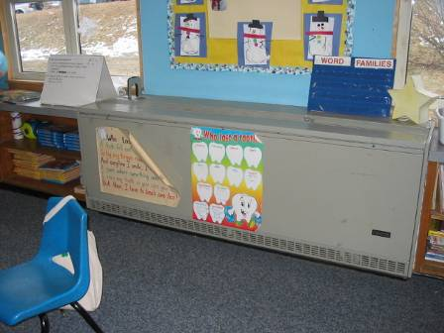

Classroom univent

Picture 2

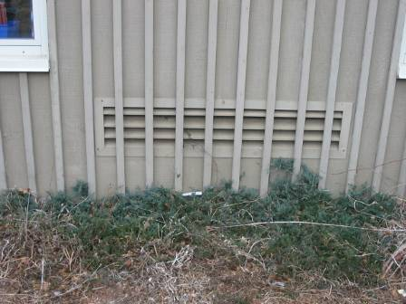

Univent fresh air intake

Picture 3



Paper project drying on univent

Picture 4

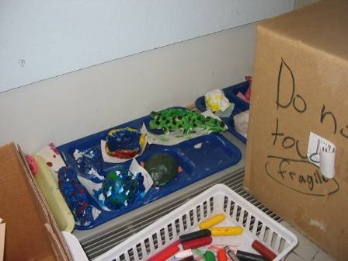

Items blocking univent diffuser

Picture 5

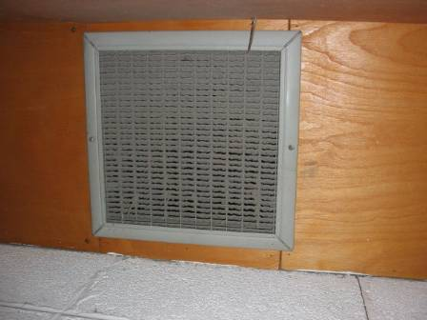

Exhaust vent in closet ceiling

Picture 6

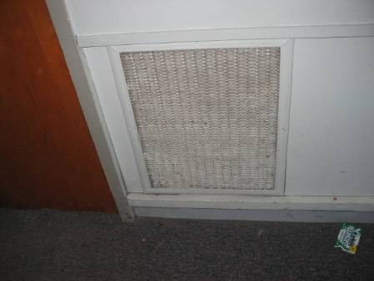

Wall-mounted exhaust vent

Picture 7

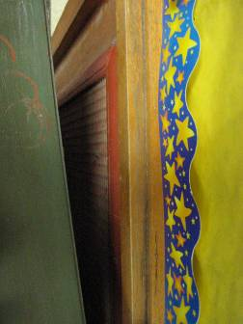

Wall-mounted exhaust vent blocked by bookcase

Picture 8

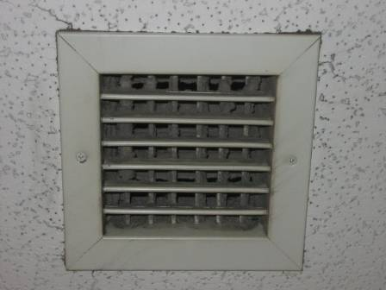

Ceiling-mounted exhaust vent

Picture 9

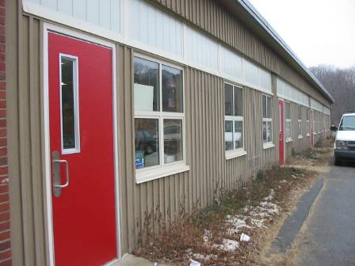

Exterior of 1993 building

Picture 10

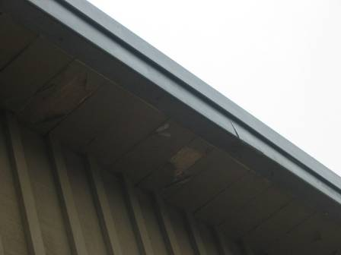

Damaged exterior on 1993 building

Picture 11
Discoloration on top of univent casing

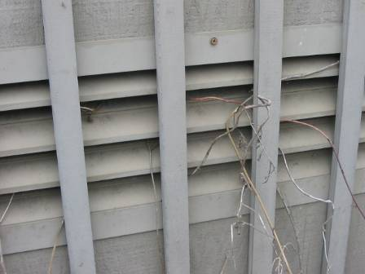
Oxidized nail

Univent casing

Picture 12

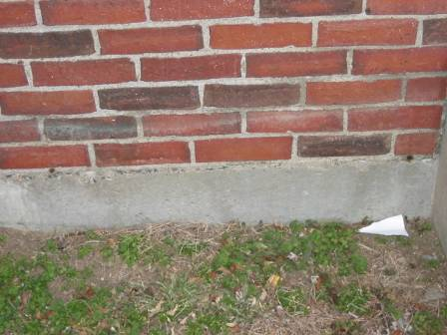

Clogged weep holes

Picture 13

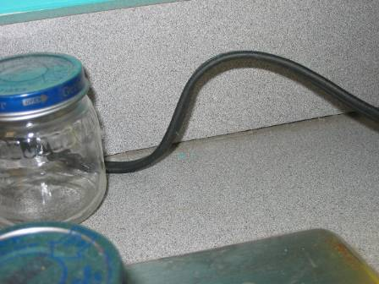

Breach between sink backsplash and counter top

Picture 14

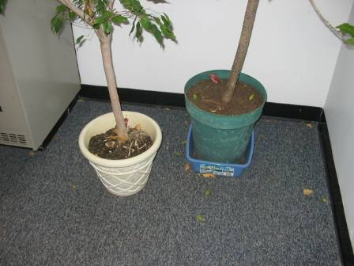

Plants on carpeting

Picture 15

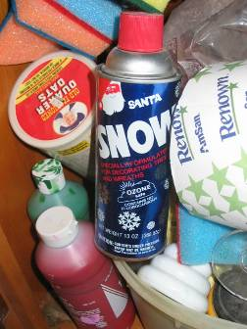

Artificial snow

Picture 16

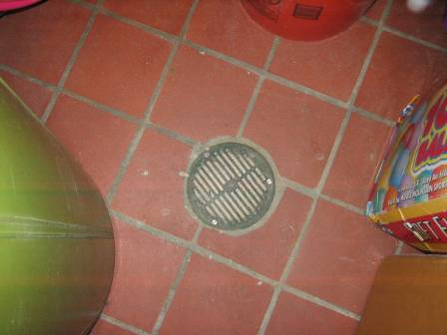

Cement filled drain

Picture 17

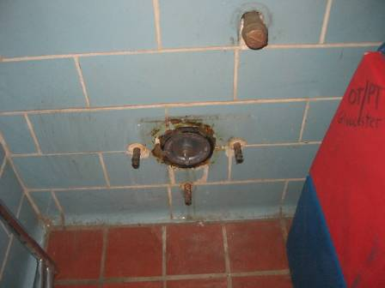

Spaces around shower accessories

Picture 18

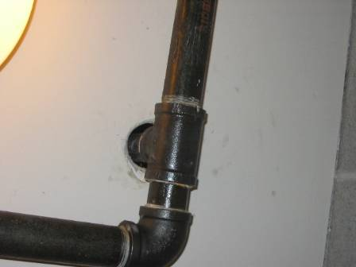

Breach around pipe

Picture 19

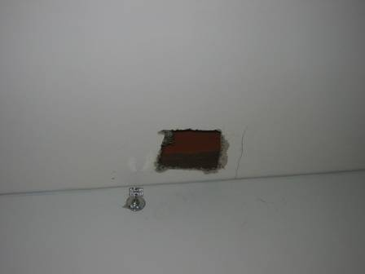

Cut out in ceiling of storage/copy room

Picture 20

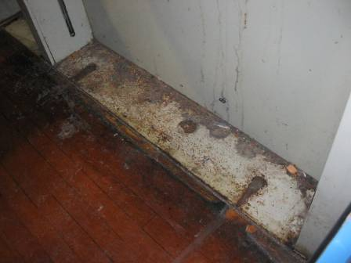

Wall in gymnasium, note dust and debris accumulation

Picture 21

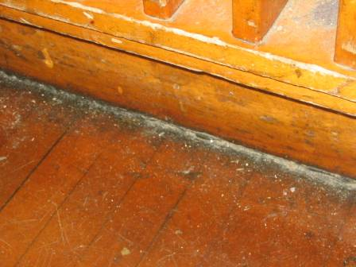

Dust accumulation on floor and between wood panels in wall

Picture 22

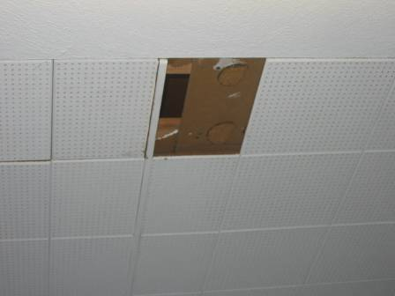

Missing ceiling tile

Picture 23

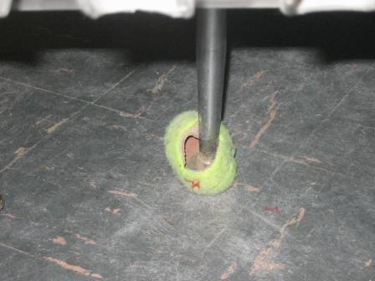

Tennis ball on chair leg

Location/ Room | Occupants  in Room | Temp  (°F) | Relative  Humidity  (%) | Carbon  Dioxide  (ppm) | Carbon Monoxide  (ppm) | TVOCs  (ppm) | PM2.5  (µg/m3) | Windows  Openable | Ventilation |  | Remarks
 |  |  |  |  |  |  |  |  | Supply | Exhaust | Remarks
background |  | 46 | 40 | 360 | ND | ND | 41 |  |  |  | overcast, slight wind
Health clinic | 3 | 68 | 37 | 712 | ND | ND | 23 | Y | Passive | N | Hallway DO
6A | 1 | 71 | 26 | 642 | ND | ND | 28 | N | N | Y  ceiling | Hallway DO
6B | 2 | 71 | 25 | 638 | ND | ND | 32 | Y | Y  univent | Y  ceiling | Hallway DO
6C | 0 | 72 | 24 | 472 | ND | ND | 30 | Y | Y  univent | Y  ceiling | Hallway DO, items
6D | 2 | 72 | 22 | 488 | ND | ND | 24 | N | Y  univent | Y  ceiling | 1 MT
5 | 15 | 72 | 23 | 648 | ND | ND | 22 | Y  # open: 0  # total: 6 | Y  univent  Boxes, items | Y  ceiling | DEM, TB, plants
4 | 20 | 71 | 27 | 997 | ND | ND | 27 | Y  # open: 0  # total: 6 | Y  ceiling  Boxes, items, furniture | Y  closet  Dirt/debris | DEM, terra, items, plants
3 | 17 | 72 | 27 | 1156 | ND | ND | 29 | Y  # open: 0  # total: 6 | Y  univent  Items | Y  ceiling | Breach sink/backsplash, TB, items
2 | 18 | 71 | 24 | 961 | ND | ND | 26 | Y  # open: 0  # total: 6 | Y  univent | Y  closet | DEM, PF, plants
1 | 15 | 69 | 23 | 745 | ND | ND | 23 | Y  # open: 0  # total: 6 | Y  univent | Y  closet | DEM, clutter, paint materials
Storage | 0 | 73 | 24 | 1146 | ND | ND | 23 | N | N | N | Original passive vent was sealed with plywood
Suite C | 7 | 72 | 25 | 888 | ND | ND | 22 | Y  # open: 0  # total: 4 | Y  univent | Y  ceiling | Hallway DO, plants
Suite A | 0 | 68 | 22 | 524 | ND | ND | 24 | N | N | Y  Ceiling  (Wall vent off)
Cafetorium | 100 | 69 | 29 | 678 | ND | ND | 33 | N | Y  Wall | Y  Wall
Boiler room |  | 70 | 26 | 569 | 1 | ND | 32 |  |  | Y  Wall  Blocked | Crawl space access door open
Gym office | 0 | 73 | 28 | 814 | ND | ND | 33 | N | N | Y  Ceiling  Dirt/debris | New equipment odor
Library | 1 | 71 | 23 | 694 | ND | ND | 24 | Y  # open: 0  # total: 4 | Y  univent | Y  wall | 1 MT/AT, carpet uneven
16 | 1 | 71 | 25 | 522 | ND | ND | 28 | Y  # open: 0  # total: 6 | Y  univent  Furniture, items | Y  wall | Hallway DO, CD
15 | 18 | 73 | 27 | 877 | ND | ND | 26 | Y  # open: 0  # total: 6 | Y  univent  items | Y  wall  Furniture | CD
14 | 14 | 71 | 26 | 737 | ND | ND | 26 | Y  # open: 0  # total: 6 | Y  univent  Boxes, items  furniture | Y  wall  Furniture | CD, DEM, 1 MT/AT
13 | 16 | 71 | 27 | 1168 | ND | ND | 22 | Y  # open: 0  # total: 6 | Y  univent | Y  wall | CD, DEM ,WD counter
12 | 19 | 73 | 28 | 1150 | ND | ND | 24 | Y  # open: 0  # total: 6 | Y  univent  furniture | Y  wall | CD, PF, TB, terra, cleaners, plants
11 | 18 | 71 | 25 | 682 | ND | ND | 28 | Y  # open: 0  # total: 6 | Y  univent  items, boxes, furniture | Y  wall | Hallway DO, DEM, TB
Art | 0 | 70 | 20 | 493 | ND | ND | 22 | Y  # open: 0  # total: 6 | Y  univent  Items, clay | Y  wall  Furniture | DEM, mounting spray glue
Kindergarten | 20 | 71 | 28 | 910 | ND | ND | 28 | Y  # open: 0  # total: 10 | Y  univent  Items | Y  wall | Hallway DO, breach sink/counter, TB, aqua/terra, items hanging from CT, plants
Music | 18 | 69 | 25 | 747 | ND | ND | 28 | Y  # open: 0  # total: 2 | Y  univent | Y  wall | DEM
7B | 0 | 70 | 24 | 715 | ND | ND | 24 | N | Y  Ceiling | Y  Ceiling  Dirt/debris
7C | 0 | 71 | 24 | 771 | ND | ND | 24 | N | Y  Ceiling | Y  Ceiling

