View Paycheck
Employees can view current paychecks within Employee Self-Service as a PDF and historical paychecks as a Webpage (HTML).
Important Reminders:
- Employees of Agencies that utilize the MassHR Employee Service Center (ESC) should contact the ESC with paycheck related questions by calling 1-855-4HR-SPPT (1-855-447-7778) or for TTY users: (617) 248-0546.
- Employees of Agencies that do not use ESC should contact their Agency Human Resources or Payroll Department with paycheck related questions.

View Paycheck:
Step | Action
1. | Log in to Employee Self-Service with your user ID (employee ID) and password.
2. | From the Employee Self-Service homepage, click on the MAIN MENU link located at the top of the page or click the VIEW PAYCHECK link under QUICK LINKS to skip step 3.
3. | On the SELF SERVICE menu, click on the PAYROLL AND COMPENSATION menu.
4. | Click on the VIEW PAYCHECK link to access your pay and compensation history.
5. | You will arrive on the VIEW PAYCHECK page, where you will be allowed to review your available paychecks.  Note: If you are an employee with multiple record numbers, you will have multiple Paychecks available, one for each record number that you are paid under. You will be able to identify the applicable job record number by the Job Title listed within your paycheck.
6. | The Select Paycheck Table will allow you to view the historical paychecks. The areas available for view are the following:  - Check Date: The date in which the payment is completed, presented in a YYYY-MM-DD format.  - Company: Will display the Commonwealth of Massachusetts.  - Pay Begin Date: The date in which the two-week pay period began, in a MM-DD-YYYY format.  - Pay End Date: The date in which the two-week pay period ended, in a MM-DD-YYYY format.  - Net Pay: The take home pay received after all taxes and deductions have been deducted  - Paycheck Number: The number provided on all pay advices  - PDF File: Indicates if a PDF file is available for view/download/print via a check box marker

Understanding your Paycheck:
Click on the specific check date YYYY-MM-DD CHECK DATE link within the VIEW PAYCHECK page to access the desired paycheck you wish to view.
Important Information:
- If the Check Box is filled with a check mark, only a PDF is available. Ensure that your Pop-Up Blocker is turned off within your Internet Preferences to access.
- If the Check Box is empty, a PDF is not available. The paycheck is only available to view as a web page.

PDF File Check View: Your Paycheck will display in a PDF format.
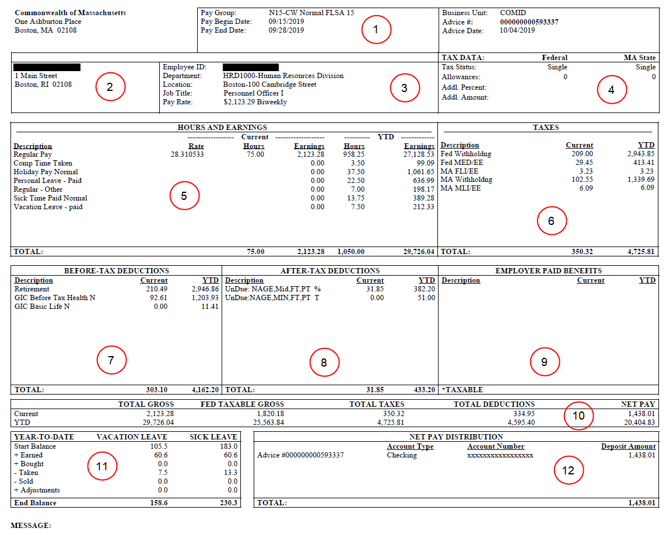

Area | Description
1 | Indicates the pay-period for which you are being paid, as well as the date your pay is issued.
2 | Your name and address prints here. This is the "Home Address" and is used for W2 Mailings as well.
3 | Contains your Employee ID, Dept. and location of employment, job title and pay-rate.
4 | Identifies your Federal and State tax information as reported on your W-4/M-4 form.
5 | Details of earnings paid in the current period and all earnings paid Year to Date (YTD).
6 | Details of taxes paid in the current period and all taxes paid YTD. Withholding is regular federal and state taxes. MED/EE is Medicare Tax. FLI/EE is Paid Family Leave Tax. MLI/EE is Paid Medical Leave Tax.
7 | Details of before-tax deductions paid in the current period and all before-tax deductions paid YTD.
8 | Details of after-tax deductions paid in the current period and all after-tax deductions paid YTD.
9 | Details of Commonwealth paid deductions in the current period and all Commonwealth paid deductions YTD.
10 | Your paycheck totals are in this section, including your year-to-date gross and tax amounts.
11 | Leave Balances shown are as of the last Leave Accrual run. Actual Leave Balances are available to view on your Self-Service Timesheet.
12 | Your direct deposit distribution is shown here (Note: Your bank account number is not shown here)

