IDENTIFYING INCOMPLETE ATTENDANCE IN CCFA

In order to submit billing through CCFA, all of your attendance records must be successfully entered and accepted for billing in CCFA. CCFA will not accept billing requests from providers with incomplete attendance entries.

To determine if you have any incomplete attendance entries in CCFA, log into CCFA and follow these steps:

- Go to the Provider tab and select "Submit Monthly Billing" under the dropdown menu:

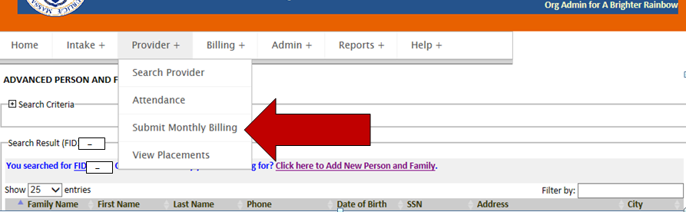

- The "Billing Status" must say "complete". If it does not, a hyperlink will appear for the service month:

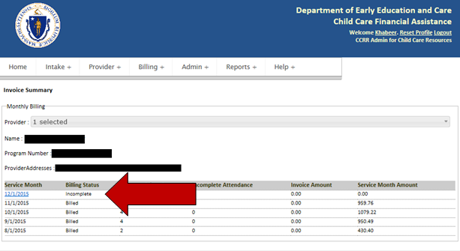

- Click the hypelinked date to view the attendance:

- Click "Save and Review":

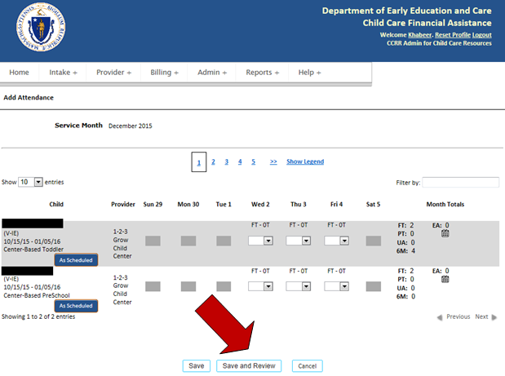

- You will now see the list of children whose attendance is incomplete:

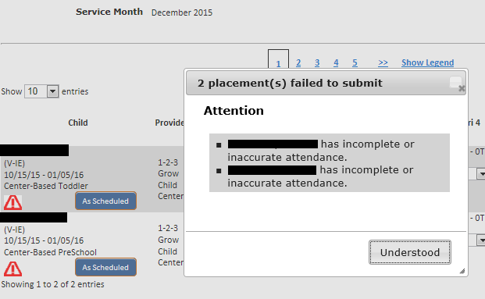

To view the attendance records for the providers under your agency/organization:

- Go to the Provider module and select "Attendance" from the drop down menu.

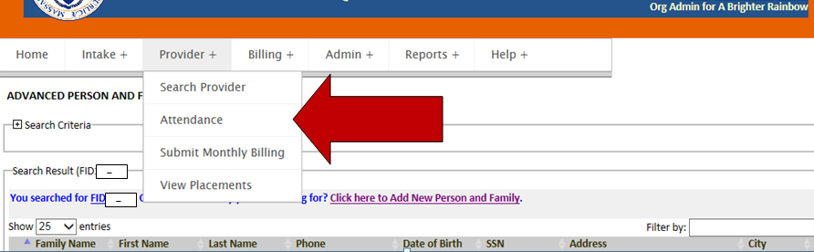

- Select the service month and then select the provider(s) to view their placements and attendance

