
View Payable Time
COMMONWEALTH OF MASSACHUSETTS

Header on each page throughout document reads
“View Payable Time Detail (EMPLOYEE) – Job Aid.”
Footer on each page throughout document reads
“MassHR: An Executive Branch Interagency Human Resources collaboration.”

November 2010

SELF SERVICE TIME AND ATTENDANCE
EMPLOYEE (VIEW PAYABLE TIME)
Job Aid

View Payable Time Detail
The View Payable Time Detail page allows employees a view of their attendance entered and displays the approval status (Approved, Needs Approval, Closed or Rejected by Payroll) of reported time following the Time Administration cycle.

Employees will be able to view the following:
- Reported Hours for each day
- Approval Status
- Time Reporting Codes (TRC)

STEP 1 - LOGIN
Navigation:
HR/CMS Login Page

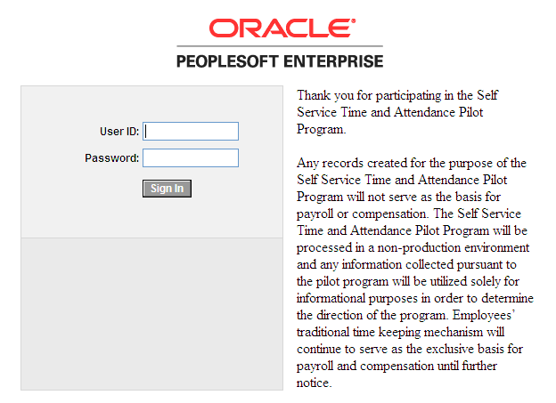

Step | Field/Button/Link | Action
1.1 | User ID | Enter your User ID.
1.2 | Password | Enter your password.
1.3 | Sign in Button | Click the button.

STEP 2 - VIEW PAYABLE TIME DETAIL
Navigation: Self Service>Time Reporting>View Time>Payable Time Detail

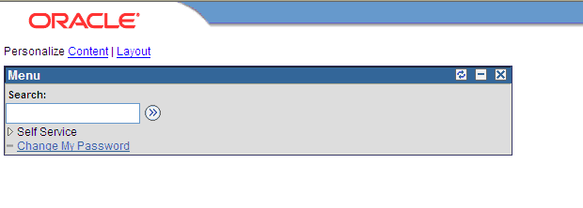

Step | Field/Button/Link | Action
2.1 | Self Service | Navigate to the link.
2.2 | Time Reporting | Click the link.
2.3 | View Time | Click the link.
2.4 | Payable Time Detail | Click the link.

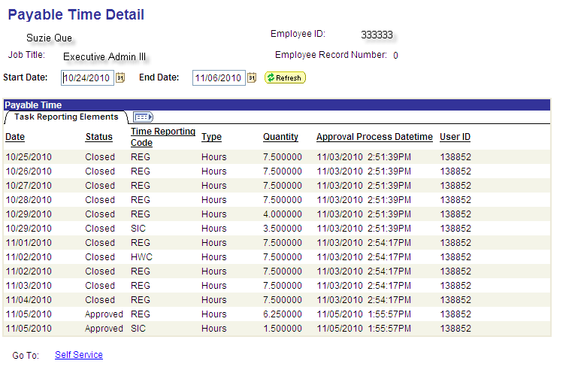

Payable Time Detail Page
Field | Description
Start Date/ End Date | Defaults to the current pay period. In addition, it allows you to view your time for the date range selected, not to exceed 14 days from the start date.
Status | Displays the approval status of the employee’s time.
  Approved | Reported hours have been approved.
  Closed | Reported hours have been approved and sent to payroll.
  Needs Approval | Reported hours requiring approval.
  Rejected by Payroll | Reported hours that have been rejected by the payroll process.
Time Reporting Code | Time Reporting Codes are 3 to 5 alphanumeric combination codes that are used in the timesheet to specify the hours directed toward a specific activity (e.g., REG, VAC and SIC). A list of Time Reporting Codes can be found on the HR/CMS Knowledge Center.
Quantity | Total number of hours reported for the day.
User ID | ID of the approver (supervisor/manager or Payroll Staff/Timekeeper)
NOTE: Corrections and/or Adjustments
Contact your supervisor/manager if corrections and/or adjustments to your time are needed. After corrections and adjustments are finished by the supervisor/manager, the time will be resubmitted for approval. Another Time Admin cycle must be completed before the adjusted time is ready for payroll processing.

Step | Field/Button/Link | Action
2.5 | Sign Out | Click on the button in the upper right hand corner of your screen to exit HR/CMS.

