INDOOR AIR QUALITY ASSESSMENT

William Gould Vinal Elementary School
102 Old Oaken Bucket Road
Norwell, MA

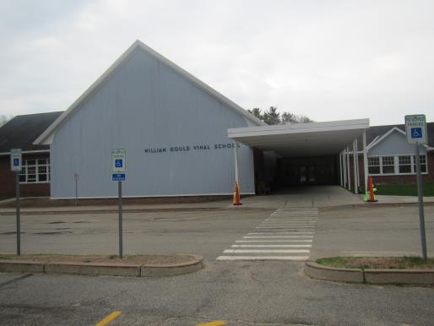

Prepared by:
Massachusetts Department of Public Health
Bureau of Environmental Health
Indoor Air Quality Program
March 2017

Background

Building: | Vinal Elementary School (VES)
Address: | 102 Old Oaken Bucket Road, Norwell, MA
Assessment Requested by: | Brian Flynn, Health Agent, Town of Norwell
Reason for Request: | Follow-up after one year since last assessment to determine effectiveness of actions on previous recommendations.
Date of Assessment: | January 30, 2017
Massachusetts Department of Public Health/Bureau of Environmental Health (MDPH/BEH) Staff Conducting Assessment: | Ruth Alfasso, Environmental Engineer, Indoor Air Quality (IAQ) Program
Date of Building Construction: | 1960s with a two-story addition added in 2002
Building Description: | Elementary School, brick construction, slanted shingled roof
Building Population: | 550 students in grades pre-k through 5 with a staff of approximately 150
Windows: | Mostly openable

IAQ Testing Results
Please refer to the IAQ Manual for methods, sampling procedures, and interpretation of results (MDPH, 2015). The following is a summary of indoor air testing results (Table 1).
- Carbon dioxide levels were below 800 parts per million (ppm) in all but two locations, indicating adequate air exchange.
- Temperature was within the recommended range of 70°F to 78°F in about three quarters of areas tested and below in the remaining areas, which included the gymnasium and cafeteria.
- Relative humidity was below the recommended range of 40 to 60% in all areas tested. This was reflective of outdoor conditions.
- Carbon monoxide levels were non-detectable in all indoor areas tested. Background (outside) levels were 0.8 ppm, likely due to vehicle traffic.
- Fine particulate matter (PM2.5) concentrations measured were below the NAAQS limit of 35 μg/m³ in all areas tested.

Ventilation
A heating, ventilating and air conditioning (HVAC) system has several functions. First it provides heating and, if equipped, cooling. Second, it is a source of fresh air. Finally, an HVAC system will dilute and remove normally occurring indoor environmental pollutants by not only introducing fresh air, but by filtering the airstream and ejecting stale air to the outdoors via exhaust ventilation. Even if an HVAC system is operating as designed, point sources of respiratory irritation may exist and cause symptoms in sensitive individuals. The following analysis examines and identifies components of the HVAC system and likely sources of respiratory irritant/allergen exposure due to water damage, aerosolized dust and/or chemicals found in the indoor environment.
Fresh air is provided by a combination of unit ventilators (univents) located in individual classrooms either along the outside wall (Picture 1) or on the ceiling. Rooftop air handling units (AHUs) serve central areas such as the gym and cafeteria as well as supplement fresh air in some classrooms. The unit ventilators draw fresh air through a vent on the outside wall or roof. Air is mixed with return air from the room, filtered, heated (if needed) and delivered back to the room (Figure 1). Air from the AHUs is filtered, heated and delivered to rooms via ducted supply vents (Picture 2). Exhaust vents are located on the walls or ceilings of classrooms (Picture 3) and are ducted to fans on the roof. Additional exhaust vents are located in toilet rooms and areas, such as kitchens and the kiln room, which produce pollutants.
According to facility staff, in response to recommendations in the previous reports, a contractor was hired to perform more specific maintenance and adjustments of HVAC equipment including univents. During the visit, carbon dioxide in the music room (Room 20) was measured at 916 ppm, and air coming directly from the top vent of the univent was measured at about 800 ppm. Some adjustments to the amount of fresh air were made, and levels in the room were measured at 649 ppm, with levels in air directly from the univent supply much lower as well.
Temperature readings in many areas were slightly below the BEH/IAQ recommended levels. However, it was reported that this was at the request of staff who preferred the slightly cooler temperatures.

Microbial/Moisture Concerns
Two water-damaged ceiling tiles were observed (Table 1; Picture 4) which indicate leaks from the building envelope or plumbing system. These tiles should be replaced after the leak is found and repaired.
Plants were observed in a few areas (Table 1). Plants can be a source of pollen and mold, which can be respiratory irritants to some individuals. Plants should be properly maintained and equipped with drip pans and should be located away from air diffusers to prevent the aerosolization of dirt, pollen and mold. A small aquarium was found in a classroom (Picture 5). Aquariums should be kept clean to prevent odors.

Other IAQ Evaluations
Exposure to low levels of total VOCs (TVOCs) may produce eye, nose, throat, and/or respiratory irritation in some sensitive individuals. To determine if VOCs were present, BEH/IAQ staff examined rooms for products containing VOCs. BEH/IAQ staff noted hand sanitizers, cleaners, and dry erase materials in use within the building (Table 1). All of these products have the potential to be irritants to the eyes, nose, throat, and respiratory system of sensitive individuals. A laminator was located in a staff workroom. Equipment that may produce TVOCs should be used in well-ventilated areas.
Items were observed hanging above a univent in one classroom (Picture 1) which can allow accumulated dusts to be reaerosolized. Several pencil sharpeners had spilled debris on the surface next to them (Picture 6). Pencil shavings can be an irritating dust, and care should be taken not to spill the shavings when the sharpeners are emptied, and cleaning up afterward.
Some personal fans, supply and exhaust vents were observed to be dusty (Table 1). In some areas, items were observed on the floor, windowsills, tabletops, counters, bookcases, and desks (Table 1). Most classrooms had area rugs, which should be cleaned regularly. One area rug was significantly frayed (Table 1; Picture 7), which can be a source of dust as well as a tripping hazard. This should be repaired or replaced.

Conclusions/Recommendations
The findings during this visit show that significant work has been performed to improve the IAQ in the VES. The following additional recommendations are made to assist in improving IAQ and maintaining that improvement:
- Continue with regular filter changes and cleaning of univents and AHUs. Keep front and top clear of blockages.
- Avoid hanging anything above univents or placing items on top of them which block airflow or may lead to distributing dust and odors.
- Repair leaks and replace water-damaged ceiling tiles.
- Properly maintain aquariums and plants to prevent odors and water damage.
- Reduce use of products and appliances that create VOCs and use in well-ventilated areas.
- Clean pencil sharpeners carefully to avoid spilling shavings.
- Clean carpeting and area rugs regularly and discard those that are worn out or too soiled to be cleaned.
- Consider adopting the US EPA (2000) document, “Tools for Schools”, as an instrument for maintaining a good IAQ environment in the building. This document is available at: http://www.epa.gov/iaq/schools/index.html.
- Refer to resource manual and other related IAQ documents located on the MDPH’s website for further building-wide evaluations and advice on maintaining public buildings. These documents are available at: http://mass.gov/dph/iaq.

References
Massachusetts Department of Public Health (MDPH). 2015. “Indoor Air Quality Manual: Chapters I-III”. Available at: http://www.mass.gov/eohhs/gov/departments/dph/programs/environmental-health/exposure-topics/iaq/iaq-manual/.
US EPA. 2000. Tools for Schools. Office of Air and Radiation, Office of Radiation and Indoor Air, Indoor Environments Division (6609J). EPA 402-K-95-001, Second Edition. http://www.epa.gov/iaq/schools/index.html.
Picture 1
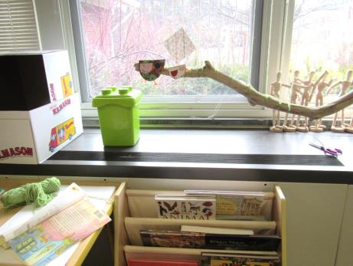
Unit ventilator (univent); note items hanging above it and partial obstruction of front
Picture 2
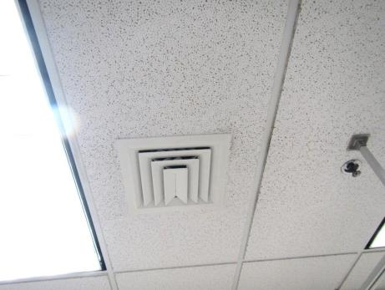
Supply vent
Picture 3
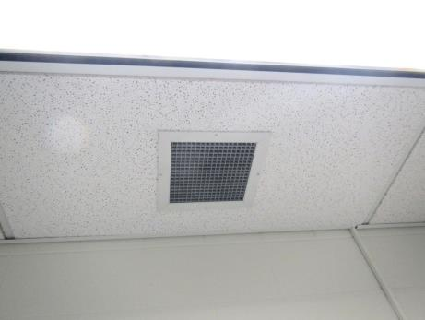
Ceiling-mounted exhaust vent
Picture 4
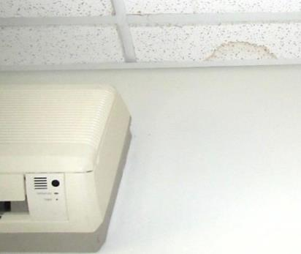
Water-damaged ceiling tile
Picture 5
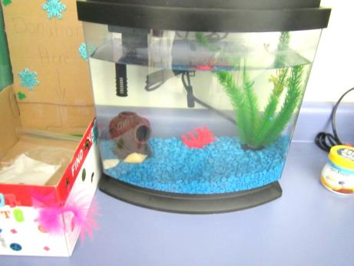
Small aquarium
Picture 6
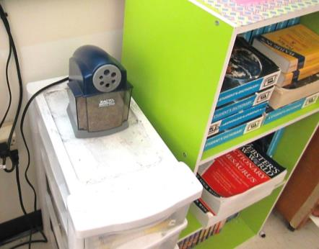
Pencil sharpener and spilled debris
Picture 7
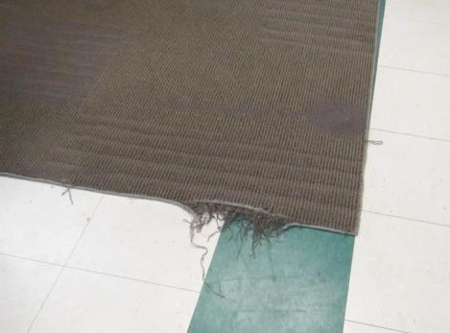
Frayed area rug

Location | Carbon  Dioxide  (ppm) | Carbon Monoxide  (ppm) | Temp  (°F) | Relative  Humidity  (%) | PM2.5  (µg/m³) | Occupants  in Room | Windows  Openable | Ventilation |  | Remarks
 |  |  |  |  |  |  |  | Supply | Exhaust
Background | 425 | 0.8 |  | 20 | 7 |  |  |  |  | Cold, recent bus departures
Custodian | 500 | ND | 69 | 15 | 7 | 0 | N | Y | Y | Janitorial equipment, floor drain (slop sink)
Library | 599 | ND | 71 | 16 | 7 | 15-20 | N | Y | Y
Lobby | 656 | ND | 63 | 23 | 7 | 4 | N | Y | Y | Door to outside (no airlock)
McCarthy and Riordan | 421 | ND | 68 | 16 | 11 | 0 | Y | Y | Y | DEM, one WD CT, carpeted
Office main area | 450 | ND | 67 | 16 | 7 | 1 | N | Y | Y | Carpeted
Stairwell room | 595 | ND | 69 | 17 | 7 | 2 | Y (door) | N | N | Door to outside, DEM
1 kindergarten | 550 | ND | 71 | 15 | 8 | 15 | Y | Y | Y | DEM, PF – dusty, HS
2 kindergarten | 493 | ND | 72 | 16 | 8 | 5 | Y | Y | Y | DEM, area rug, plants
2 Storage/toilet room next to room |  |  |  |  |  |  |  | Y | Y | Toilet room, WD CT in toilet room, items
3 | 647 | ND | 73 | 17 | 8 | 17 | Y | Y | Y | Area rug, DEM, sink
4 | 623 | ND | 73 | 15 | 9 | 20 | Y | Y | Y | Area rug, DEM
4 | 795 | ND | 69 | 18 | 8 | 21 | Y | Y | Y | Area rug (fraying), DEM
5 | 635 | ND | 73 | 14 | 8 | 18 | Y | Y | Y | Area rug, DEM, bowed tiles in storage area
6 | 677-780 | ND | 74 | 15 | 8 | 18 | Y | Y | Y | Area rug
7 Special education | 521 | ND | 71 | 15 | 8 | 1 | Y | Y | Y | Area rug, DEM
8 kindergarten | 575 | ND | 71 | 16 | 8 | 19 | Y | Y | Y | Sink, area rug
9 kindergarten | 687 | ND | 72 | 13 | 7 | 17 | Y | Y | Y | Area rug, sink
10 community | 495 | ND | 71 | 14 | 6 | 4 | Y | Y | Y | Carpeted, DEM, HS
11 | 701 | ND | 71 | 14 | 9 | 20 | Y | Y | Y | DEM, area rug
12 | 682 | ND | 70 | 16 | 8 | 22 | Y | Y | Y | Area rug
13 | 670 | ND | 70 | 16 | 8 | 19 | Y | Y | Y | DEM, PF, area rug
15 | 556 | ND | 69 | 15 | 7 | 0 | Y | Y | Y | DEM
16 | 700 | ND | 69 | 17 | 8 | 24 | Y | Y | Y | Area rug, DEM, crayons on floor
17 | 687 | ND | 69 | 17 | 7 | 20 | Y | Y | Y | DEM
18 | 819 | ND | 70 | 18 | 9 | 0 (class just left) | Y | Y | Y | Area rug, DEM
20 Music | 916 | ND | 72 | 18 | 13 | 22 | Y | Y | Y | Carpet, sink with plastic mat
20 Music (retest) | 649 | ND | 70 |  |  |  | Y | Y | Y
21 | 742 | ND | 69 | 15 | 9 | 24 | Y | Y | Y
22 | 626 | ND | 70 | 14 | 8 | 13 | Y | Y | Y | Area rug, DEM, plant on UV
23 | 534 | ND | 69 | 14 | 7 | 0 | Y | Y | Y | HS, aa rug, microwave, food odors
24 | 570 | ND | 70 | 16 | 8 | 0 | Y | Y | Y | DEM
25 | 559 | ND | 70 | 15 | 7 | 0 (just left) | Y | Y | Y | DEM, tiny aquarium, PS
26 | 583 | ND | 69 | 16 | 7 | 1 (gone 30 minutes) | Y | Y | Y | DEM, PS, HS, area rug
27 | 729 | ND | 70 | 18 | 7 | 19 | Y | Y | Y | DEM, area rug, HS
28 | 650 | ND | 70 | 17 | 8 | Just left | Y | Y | Y
102 cafeteria | 448 | ND | 69 | 14 | 6 | 0 | Doors to outside | Y | Y
118 gym | 493 | ND | 69 | 15 | 8 | 14 | N | Y | Y
122 computer lab | 594 | ND | 70 | 14 | 6 | 24 | N | Y | Y
128 art | 511 | ND | 71 | 16 | 7 | 20 | Y | Y | Y | Area rug, hanging items over UV, DEM, kiln, sink
129 guidance | 560 | ND | 70 | 16 | 7 | 0 | N | N | Y | DEM
130 special education | 578 | ND | 69 | 19 | 6 | 0 | N | Y | Y | DEM
131 nurse | 593 | ND | 68 | 20 | 6 | 1 | N | Y | Y
132 B Principal |  | ND |  |  |  |  | Y | Y | Y
132 conference | 458 | ND | 67 | 16 | 7 | 0 | Y | Y | Y | Carpeted
133 | 520 | ND | 72 | 15 |  | 2 | Y | Y | Y | Toilet room, area rug, DEM
153 Teachers training | 511 | ND | 73 | 14 | 7 | 0 | Y | Y | Y | Laminator (slight odor), PCs
155 Teachers’ lunch | 479 | ND | 73 | 13 | 7 | 0 | Y | Y | Y | 2 refrigerators (clean), stove, toaster with crumbs

