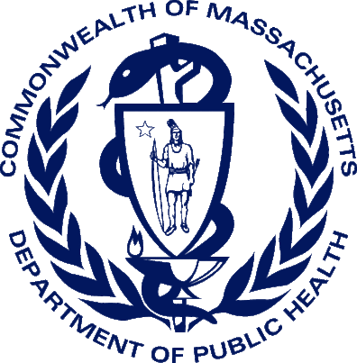
Getting Started with the New Massachusetts Death Certificate:
Online and Offline Medical Facilities & Certifiers

On September 1, 2014, Massachusetts began transitioning the current paper death certificate process to the Vitals Information Partnership (VIP) electronic death registration system (EDRS). Funeral Directors, Burial Agents, and City and Town Clerks will process death records online. Medical Certifiers will certify deaths either online or through a fax attestation process.
Beginning November 1, 2014, the paper death certificate will no longer be accepted. Begin using the new process now.
Get More Information about your Options
Go to http://www.mass.gov/dph/edrs. In the Medical Certifier and Medical Facilities sections, you will find recorded webinars and instructional materials that describe various online and offline processes for you to decide upon.
For example, many facilities and private practices have online staff members that will prepare an EDRS record for both online and offline certifiers. Some certifiers will themselves enter the entire medical portion online. Infrequent death certifiers may choose to provide the funeral director (or other family designee) with a Certifier Worksheet for data entry that must then be verified by the certifier through an Attestation Form.
Start Using the Certifier Worksheet Now
Stop using the paper death certificate now, even if you are in the process of obtaining an online account. While processes within facilities and practices may vary, most offline certifiers will be providing the standard Certifier Worksheet to online staff or funeral homes for data entry into EDRS. After data entry, certifiers will receive an Attestation form to verify the information entered.
Find the Certifier Worksheet online here: http://www.mass.gov/eohhs/docs/dph/vital-records/vip-medical-certifier-worksheet.pdf. This is a form-fillable PDF document, but you may also print blank forms for your use.
Request User Accounts
Enrollment forms and guides for medical certifiers and staff are available at the VIP website at http://www.mass.gov/dph/edrs. If you already have an account that accesses the Virtual Gateway, such as the Controlled Substances Program, you must still submit new forms. When your forms are processed, permissions for the VIP EDRS will be added to your existing account.
Practice in the Sandbox
If you are in the process of obtaining a user account, or just thinking about getting an online account, take some time to practice in the VIP Sandbox. The password and guides for using this practice environment are available by request at vip@state.ma.us.
Subscribe to Our Listserv
Sign up for our listserv(s) to receive updates. To subscribe to the Listserv, send an email to the address provided for your role. Please include “Subscribe” in the subject line.
Certifiers of Death Certificates: Subscribe-dph_edrsmedicalcertifiers@listserv.state.ma.us
Medical Administrators and Staff: Subscribe-dph_rvrsmedicalfacilities@listserv.state.ma.us

