Some Virginia overdose deaths attributed to medication used to control addiction, 6/11/2018
Virginia’s Chief Medical Examiner’s Office reported that 16 Virginians died in 2016 and seven in the first half of 2017 after taking buprenorphine. All but four of them had taken some other drug, including antihistamines and medication to treat anxiety, depression or seizures.
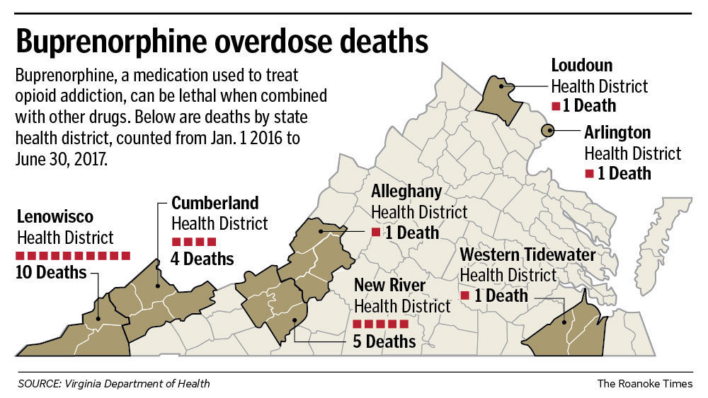
Tennessee
Tennessee Department of Health found a total of 67 deaths associated with buprenorphine in 2016. Most people had taken multiple drugs prior to death. However, the latest TDH analysis of drug overdose death data shows abuse of buprenorphine alone can sometimes lead to death. TDH data show ten Tennesseans only had buprenorphine present when they died between 2013 and 2016.

