COMMONWEALTH OF MASSACHUSETTS
EXECUTIVE OFFICE OF HEALTH AND HUMAN SERVICES

Enterprise Invoice Management and Enterprise Service Management



Virtual Gateway EIM/ESM: Quarter 1 Newsletter Fiscal Year 2025
(Date: August 15th 2024 Volume 1 Issue 1)

Table of Contents
EIMESM Billing Statuses 3
Client Enrollments Discrepancies (DMH/DDS users) 4
Application Updates 4
EIM/ESM Provider Resource Center 5
Contact Information 6
VG Customer Service (Password Resets and log in assistance): 7

EIMESM Billing Statuses

Refreshing your knowledge on the various EIMESM statuses throughout the billing process could come handy to make decisions and take necessary actions while working on PRC, CEC, SDR or Invoices. These statuses can be reviewed in detail from the Status Job Aid located at Mass.gov-EIM/ESM website under the training and User Materials section. Below are some of these statuses explained.
Service Delivery Report (SDR) Statuses
- Partially released status- this status occurs when an SDR is released for authorization but contains one or more clients with no services delivered. In this case, you may still go ahead and authorize the SDR and the clients without services will change from ‘Draft’ status to ‘No delivered service’. The clients with delivered services will change to authorized status for further processing.
CR, AR, SDR Invoice Statuses
- Pending Status – There are multiple reasons for this status to occur. The most common one is that the agency contract manager is working on making certain changes to the contract which will temporarily send the contract to pending status (example: adjusting account mapping rules). While the contract is in pending status, any in process invoices will go to pending status. The status will eventually change once the agency contract manager activates the contract. You may follow-up with the agency contract manager if the contract status does not change back to active status.
Other Common Statuses across PRC, CEC, SDR or Invoices
- PRC Ready – Payment Request for Commodity (PRC) Ready status occurs when payment document PRC is created in response to a valid invoice or SDR cleared for payment processing by an agency.
- Deny – On the contrary, when an agency deems any changes or corrections to a provider submitted invoice or SDR, then it goes to denied status. If the denial by agency happens after the PRC is generated, then both the PRC and its respective Invoice or SDR will also go to denied status. If the billing involved an UR SDR, then Agency Contract Manager will provide further instructions.
- Rejected – This status occurs when the PRC has been approved by agency staff in EIM but rejected in MMARS due to data discrepancies. Agency staff will take the necessary further actions in this regard.

Statuses That Allow Provider to Edit Billing
- SDRs– SDRs must be in ‘Draft’ status to make changes. If the SDR has already been released then have the provider authorizer disapprove the SDR and that will change it back to draft status, which will allow you to make changes again and will follow the normal processing after you make the changes. On the other hand, If the SDR has been Authorized, the Provider can no longer make any edits to the SDR and cannot change it back to draft status. However, you may contact the Agency Contract Manager to have them deny the client or clients in question and they can approve the clients that do not need correction. You can then create a Supplemental SDR and submit the corrected services for the denied clients.
Note: Does not apply to DPH Providers. Please contact DPH for further instructions.

- AR, CR Invoices: These invoices can also be disapproved by the Authorizer on the provider side to change the invoice back to draft status. However, if the invoice is already authorized on the provider side, then you may contact the Agency Contract Manager to discuss next steps.
Client Enrollments Discrepancies (DMH/DDS users)
Providers are reminded to contact your agency contract manager as soon as possible when:
- You are seeing duplicate enrollments on your SDR. Your agency Contract Manager will be able to confirm which enrollment you should use for billing.
- A client is not appearing on your SDR. It is possible that the client is not:
  - Entered in Meditech.
  - Enrolled to the correct contract in Meditech.
The agency can make these corrections.
- A client is still appearing on your SDR after he/she no longer receives services. It is possible that the client was not yet end dated in Meditech. Your agency can correct the client record.

Application Updates

A production release had been deployed on 06/16/2024 with following code fixes.
- A code fix had been made to accurately display the breadcrumb on the loading screen for Print SDR as ‘Service Delivery Apply Pattern in Progress’

- A code fix has been made to accurately display SDR header offset amount on the SDR report for Rejected services.

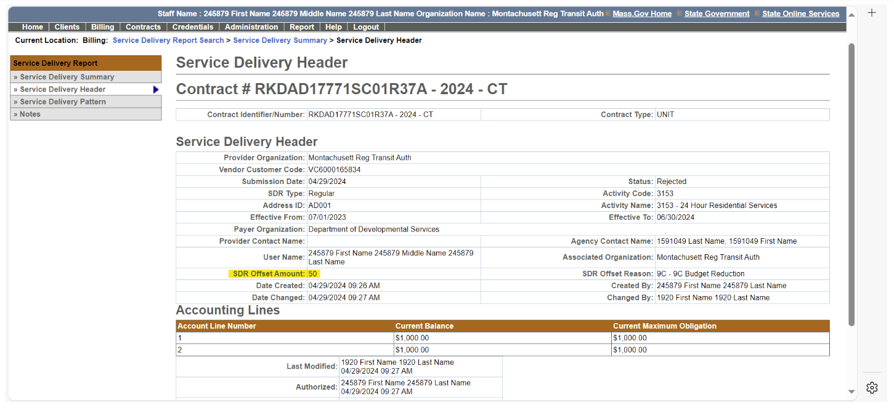

- On the Accommodation Rate Summary screen when save changes and Finalize button is selected an inappropriate message is displayed “Effective to Date must be the last day of a month”. This has been reworded as following for better understanding “Effective to Date cannot be later than the Account Line End Date”

EIM/ESM Provider Resource Center

The EIM/ESM Provider Resource Center Contains:
• An overview
• How to access EIM/ESM
• Announcements
• Newsletters
• FAQs
• HIPAA - Version 5010 Transactions in EIM/ESM
• Training and User Materials that have been specifically designed for provider users.
Provider Job Aids are located at Mass.gov-EIM/ESM Website under the training and User Materials section. This section can also be accessed quickly by selecting the “Help” tab when you are logged into EIM/ESM.

Contact Information

EIM/ESM Business Operations (application assistance):
Email: EHS-DL-EIMESMBusinessOperations@massmail.state.ma.us
When contacting EIM Business Operations with a billing or funding question(s), please provide the following information:
• Your Name:
• User ID(s):
• Phone Number:
• Location you log into (if more than 1):
• Provider Organization Name:
• Complete 20-digit Contract Number(s):
• Brief description of the issue:
For Billing Issues:
• Contract Type (AR, CR or UR):
• Month & Year of the billing:
For SDR Issues:
• Service Code:
• Attendance Status Code:
For Client Issues: (Please do not include Client Names)
• Client ID(s):
• HUBLIVE Number (if client missing from DDS SDR):

VG Customer Service (Password Resets and log in assistance):

1-800-421-0938 TTY: (617) 847-6578)
Monday – Friday 8:30 am – 5:00 pm
EIM/ESM Application availability: Daily:
7:00 AM – 1:00 AM

DPH Provider Support
DPH EIM/ESM Management Office:
Email: DPH-DL-EEMO@MassMail.State.MA.US
* If you have DPH contracts, you should follow instructions from DPH in closing out the Fiscal year for your DPH contract only.

