Summary of Job Aid
To access a Virtual Gateway’s Legacy business service, you must first log on to the Virtual Gateway (VG). From the Mass.Gov website (www.mass.gov), select the Log In to … link and select the Virtual Gateway option to access the Virtual Gateway login page. A successful logon will take you to the Virtual Gateway Applications page to access your specific applications.
Refer to this reference guide, Reset Virtual Gateway Legacy User Password Reference Guide, for more information on how to reset your Virtual Gateway Legacy password, if forgotten.
Table of Contents:
Steps to Reset a Forgotten Virtual Gateway (VG) Password 1
Password and Security Notes and Tips 5
Questions or Need Assistance? 6

Steps to Reset a Forgotten Virtual Gateway (VG) Password
The following steps guide you through resetting your Virtual Gateway Password:
- From the Virtual Gateway website, click Legacy Log In button.

Figure 1: Virtual Gateway website.
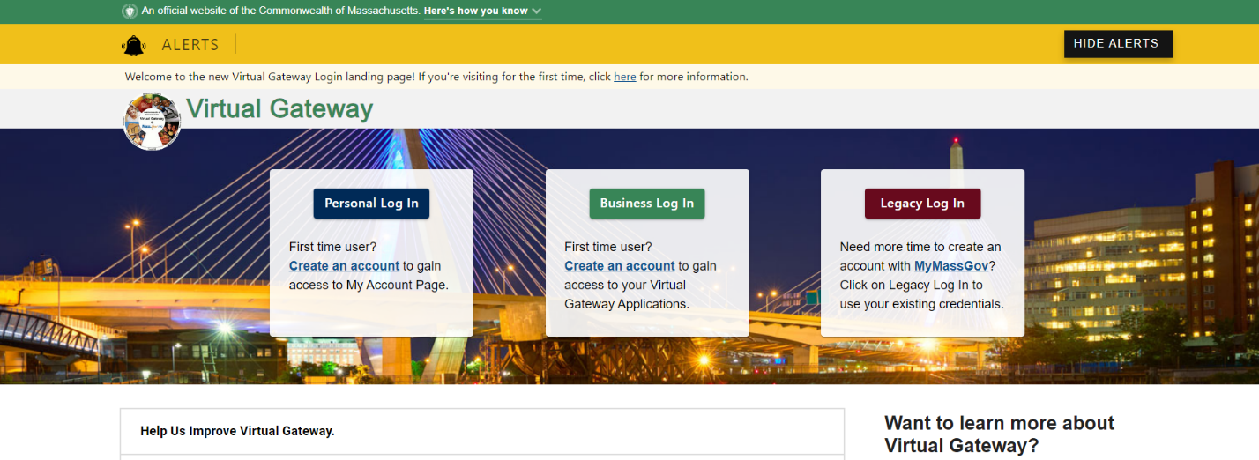
- Click the Proceed button on the System Notice-Security Warning page.

Figure 2: Welcome to Virtual Gateway-System Notice page.
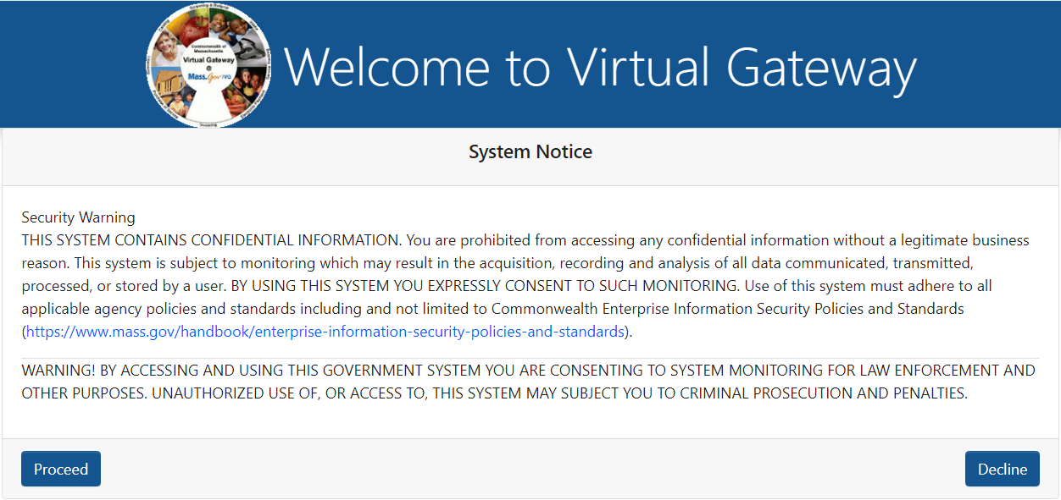
- From the Welcome to Virtual Gateway Sign In page, select the Forgot Password >> link.
Figure 3: Welcome to Virtual Gateway Sign In page
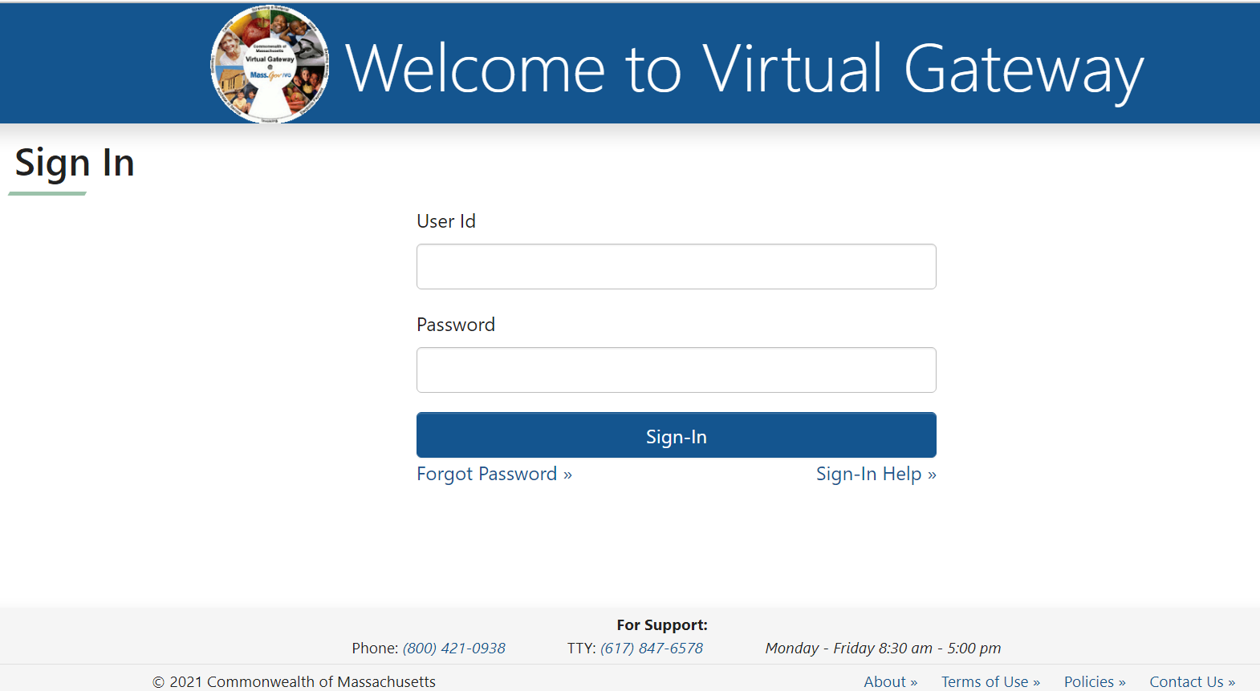
- Enter your [Username].
- Select the [Submit] button.
Note: If you have forgotten your username, you will need to call Virtual Gateway Customer.

Figure 4: Forgot Password page
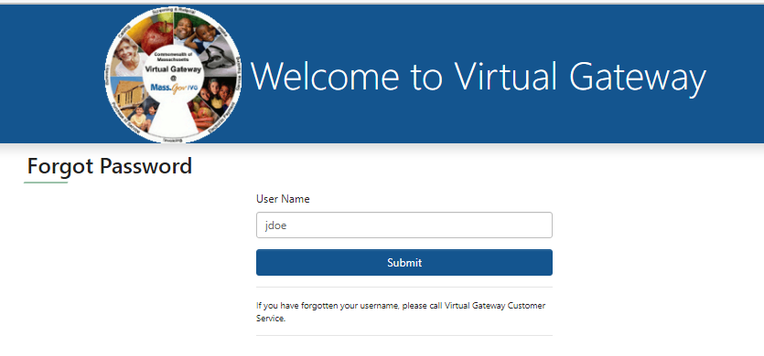
The Forgot Password page will display.
The first time you logged in to the Virtual Gateway you were asked to answer a series of secret questions (also known as ‘Authentication Questions’). Two of these secret questions (randomly chosen) will appear on your screen.
- Answer all questions listed (answers are not case sensitive).
- Select the [Submit] button.
Note: If you make a mistake or answer a question incorrectly, you will be asked two additional secret questions.
Figure 5: Forgot Password, Answer Questions page
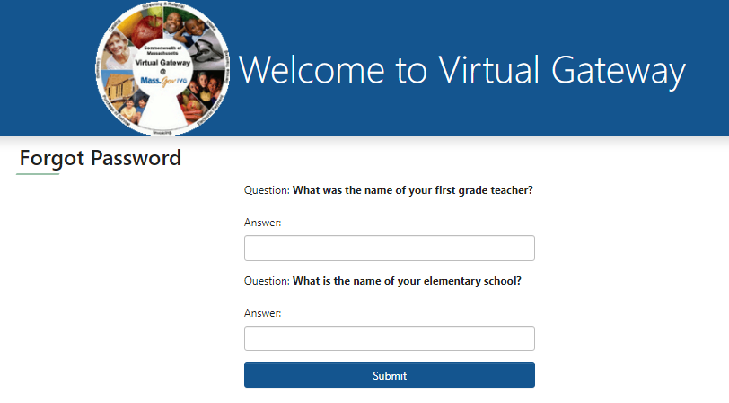
- The Forgot Password page will appear with a confirmation message stating that your password has been reset and that you will receive an email with your new password.
Note: The message will be sent to the email address listed in your Virtual Gateway account. If you do not receive the email message within a reasonable period (please allow at least 20 minutes), please call Virtual Gateway Customer Service at 800-421-0938.
- Select the [Submit] button.
Figure 6: Forgot Password, Confirmation page
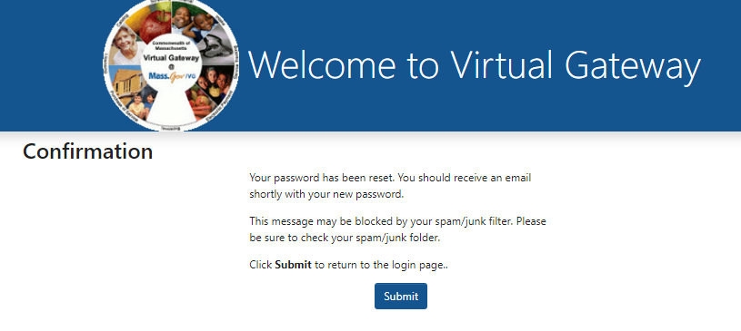
You will be returned to the Welcome to Virtual Gateway Sign In page.
Figure 7: Welcome to Virtual Gateway Sign In page
Once you receive your new (temporary) password via email (email Subject: Virtual Gateway Password Reset), log in to the Virtual Gateway using your Username and Temporary Password.

Figure 8: Sample Email with VG Username and Temporary Password
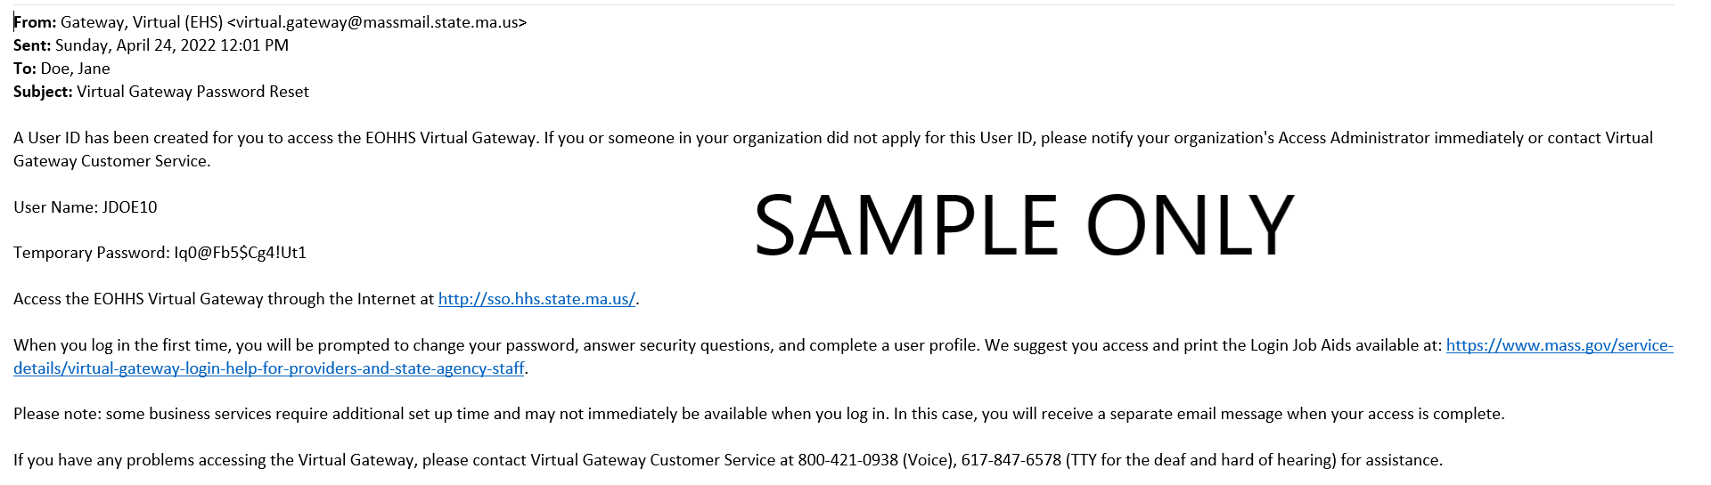
Important: To successfully change your password, read and follow the password requirements shown on the Change Password page.
- Enter your [Existing Password]. (Note: This is the temporary password you received via email)
- Enter [New Password] and [Confirm New Password].
- Select the [Submit] button.
Figure 9: Change Password page
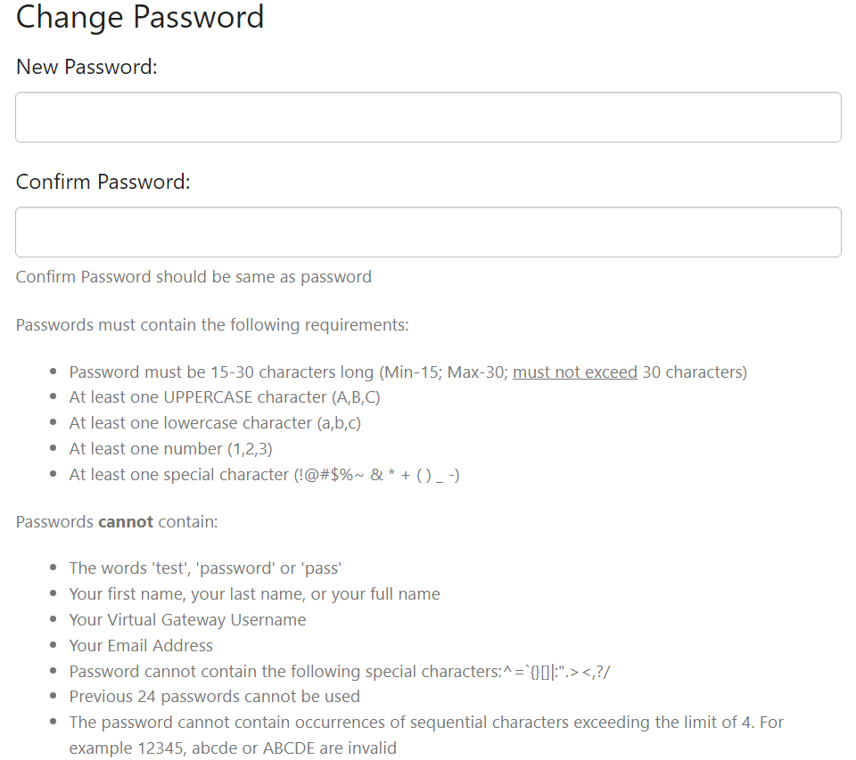
Once your password has been accepted, the Applications page will display.

Password and Security Notes and Tips
- Any time you change your password, forget your password, or call Virtual Gateway Customer Service with a password question, you will need to answer some of the seven secret questions or provide other security information as verification. Questions are chosen at random.
- Use passwords and responses that you are likely to remember and be sure not to post this information where others can access it.
- If you feel your password has been compromised, change your password immediately.
- If you receive the error message “Invalid username & password. Please try again,” retype your Username and Password and select Submit. If after several attempts you still receive this message, call Virtual Gateway Customer Service for assistance.
- You cannot reuse recently used passwords.
- Temporary Password must be entered exactly as it appears in the email received from Virtual Gateway.
- Please use care when typing a temporary password as some letters and numbers look alike. The letter 'O' and the number '0' or the letter 'l' and the number '1' are very similar in appearance.

Questions or Need Assistance?
Call Virtual Gateway Customer Service
1-800-421-0938
617-847-6578 - TTY for the deaf and hard of hearing
8:30 am to 5:00 pm Monday through Friday

