Commonwealth of Massachusetts - Executive Office of Health and Human Services

Virtual Gateway Informational Session

April 2024

Slide 2 - Today’s Agenda
- Welcome and Introductions
- Overview of Virtual Gateway Project
- What is Changing/Not Changing with Virtual Gateway
- Project Timelines
- Business Login: How to Register Account, Setup MFA and Login to Virtual Gateway
- Public and Legacy Login Options
- Communication/Outreach Plan/Q & A Session
Slide 3 - Overview of Virtual Gateway Project
Authentication and Authorization in VG Portal/AIMS will be handled in a phased approach.
- Phase 1: Go Live May 19, 2024
  - Replace current Oracle AIMS Authentication login with Microsoft Azure ID for Virtual Gateway
  - Authorization will remain at AIMS.
- Phase 2: Go Live To Be Determined at later date
  - Modernize VG Authorization system (AIMS)

Slide 4 - What is Changing on the VG
- URL will change from sso.hhs.state.ma.us to New URL.
- Bookmarked URL’s will redirect automatically to the new URL.
- User Interface or look and feel of the Virtual Gateway pages will change to comply with EOTSS Digital Mayflower guidelines for mass.gov websites.
- Authentication layer will change from AIMS to Azure. (Authorization will remain at AIMS.)
- Email address and password will be used to log in.
- User registration process will change to require self-register.
- Multifactor authentication will be used at log in.
- VG users must have their own email address.
Slide 5 - What is Not Changing on the VG
- User Request Form (URF) will remain in place.
- Self-service option for user profile updates (Manage My Account).
- Authorization will continue to use AIMS.
- Single sign-on for all VG applications will continue as-is.
- Access of webservices will continue as-is.
- Virtual Gateway login support will continue as-is.
- Reporting capability will continue as-is.
Slide 6 - Project Timelines
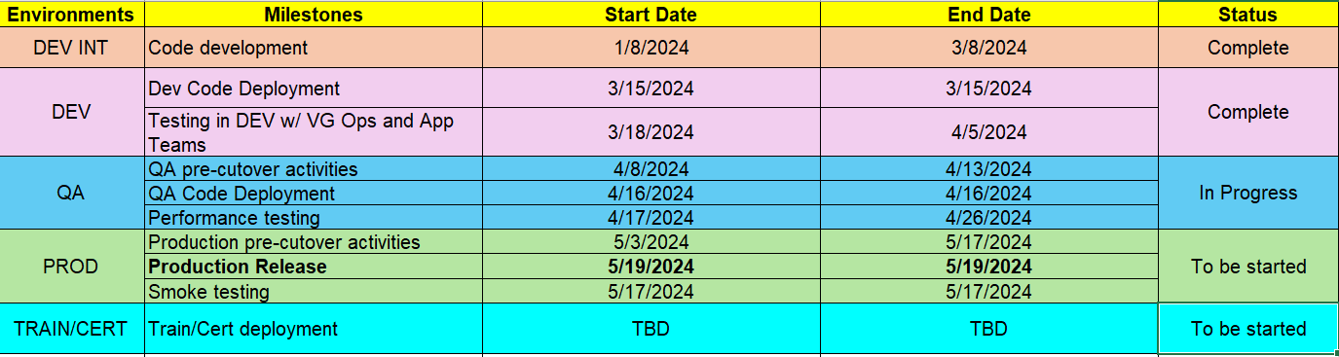

Slide 7 - Business Users (Providers): How to Register Account: Create Account
New User Receives Email from Virtual Gateway
- Keep/Review Email – Refer to Next Steps section
  - Link to new Virtual Gateway Home page.
  - Register email address (User Name = Email Address)
  - Setup MFA
  - Use Business Login (Green option) button to register and/or Login to Virtual Gateway
    - Email will tell user which Login option to use - Very important to select correct Login option!
    - User clicks on link to access the New Virtual Gateway login site.
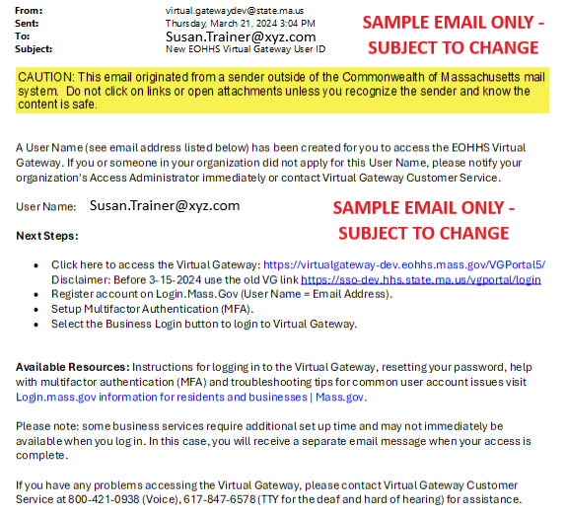

Slide 8 - Business Users (Providers): How to Register Account: Create Account (Continued)
NEW Virtual Gateway Home Page
Refer to User Email - Very important to select correct Login option!
Which Login Option to use?
- Personal Login (blue): Public Users for My Account Page (MAP) only.
- Business Login (green): State Agency staff, Provider staff and DCF Mandate Reporters with 1 VG User Account and 1 Email Address.
- Legacy Login (yellow): Any user (State Agency staff, Provider staff, DCF Mandate Reports, or Public) can use this option for limited time.
Legacy Login Example:
John Smith has 2 VG User IDs, but the same email address linked to both-
- VG User ID: JSMITH & JSMITH2
- Email with VG: JSMITH@xyz.com
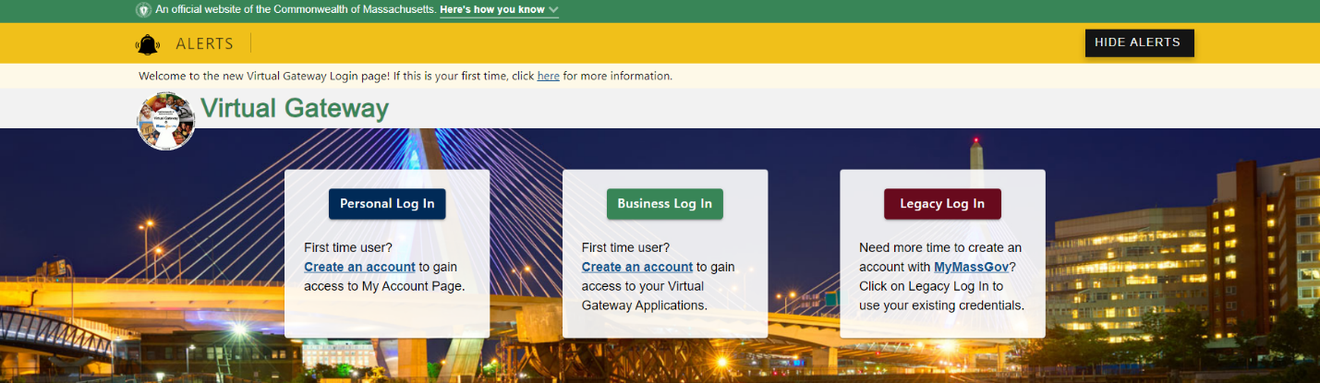

Slide 9 - How to Register Account: Create Account
Important Note: Login.mass.gov to be rebranded to MyMassGov per EOTSS
FOR BUSINESS (green banner) – Provider staff or DCF Mandate Reporters should create their Login.mass.gov account under this option.
First time using Login.mass.gov?
All VG users (New or Existing) will need to register or create an account before logging into the Virtual Gateway.
- Click CREATE AN ACCOUNT button.
State Agency Employees: If you are a state agency employee with 1 VG UserID linked to 1 email address you do not need to create an account/setup MFA since you are already registered under your Network login.
Use the Log in as an MA state employee link (must have email address on file with VG using the @Mass.gov email domain) to login to VG.
If you have multiple VG UserID's linked to 1 email address, you need to use the Legacy Login option to login to VG.
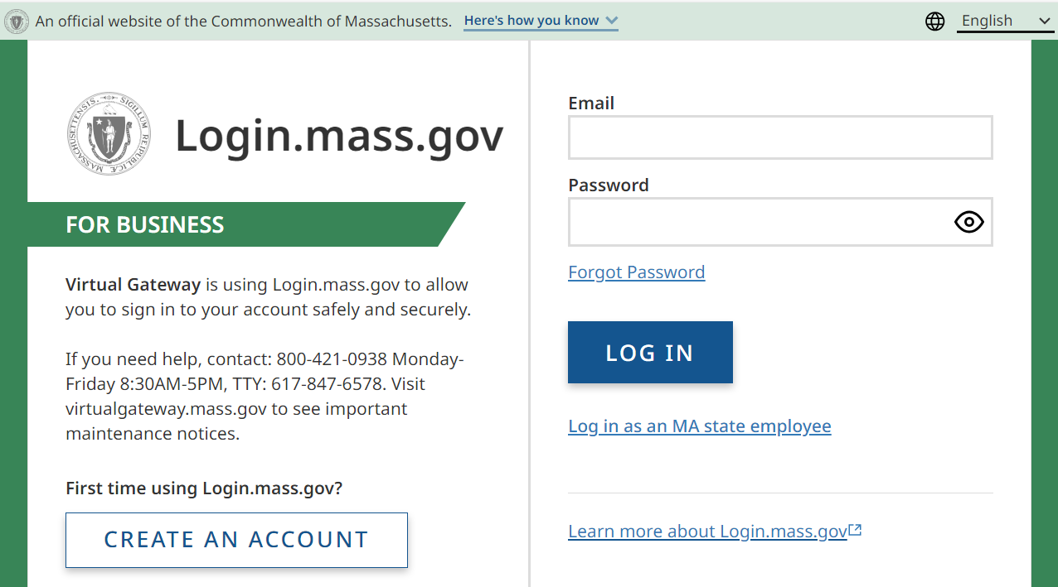

Slide 10 - How to Register Account: Create Account (Continued)
Important Note: Login.mass.gov to be rebranded to MyMassGov per EOTSS
FOR BUSINESS: Create your account
Step 1 of 3: Verify your Email
Refer to the email received from Virtual Gateway which contains the email address on file with Virtual Gateway. When creating your account, you must use the email address displayed in the User account email. If a different email address is used, the user will receive an error message that there is no Username found for the registered email address.
- Type the Email Address (as listed in the email from Virtual Gateway).
- Click the SEND VERIFICATION CODE button.
An email will be sent to the email address listed on Step 1 with a Subject: Verify your email address. Monitor both Inbox and JUNK/SPAM folders for email from login@noreply.mass.gov.
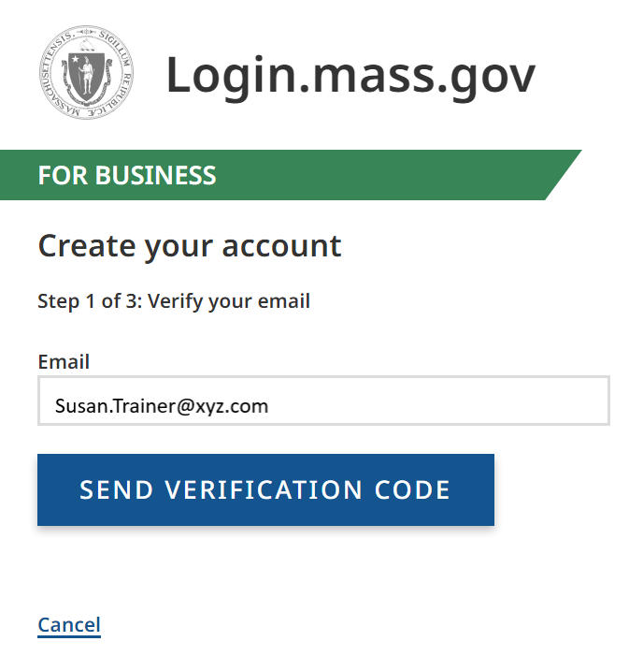

Slide 11: How to Register Account: Create Account (Continued)
FOR BUSINESS: Create your account
Step 1 of 3: Verify your Email
To the right is a sample email with the Subject: Verify your email address.
A 6-digit code is displayed in the email. The code will expire in 5 minutes and can only be used once.
- Copy and paste the code into the verification fields at Login.mass.gov to complete the verification process.
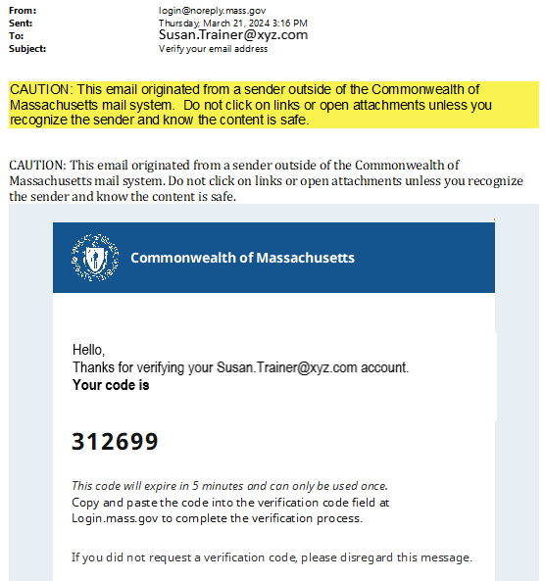

Slide 12 - How to Register Account: Create Account (Continued)
FOR BUSINESS: Create your account
Step 1 of 3: Verify your Email
- Copy and paste the code from the email into the verification field at Login.mass.gov to complete the verification process.
- Click the VERIFY EMAIL button.
The code will expire in 5 minutes, click the Get a new code link and follow instructions, if a new code is needed.
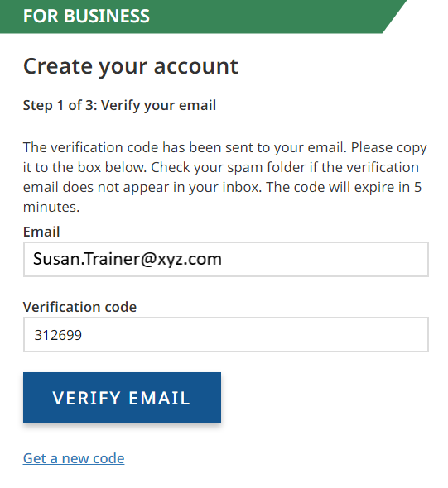

Slide 13 - How to Register Account: Create Account (Continued)
FOR BUSINESS: Create your account
Step 2 of 3: Add account details
Email: Pre-populated with the email address entered in Step 1 of 3. If the email address is incorrect, click the Cancel button.
If email address is correct,
- Type your First Name
- Type your Last Name
- Click the CONTINUE button
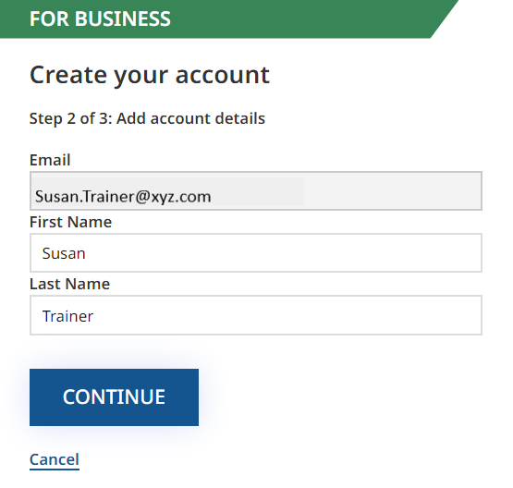

Slide 14 - How to Register Account: Create Account (Continued)
FOR: BUSINESS Create your account
Step 3 of 3: Set up your password
The final step for the Create your account set up is to create a password. Follow the Password Rules as listed on the screen. When there a checkmark next to each rule, you have met the password requirements.
- Enter New Password
- Enter Password to Confirm New Password
- Click the CREATE AN ACCOUNT button
Important Note about Passwords: The password on the new Virtual Gateway login site does not expire. If at any time you feel your password has been compromised, use the Forgot Password link on the login page.
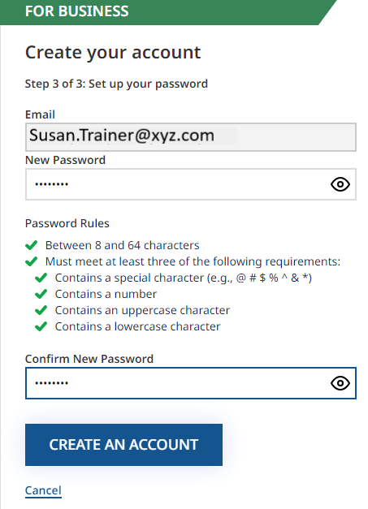

Slide 15 - How to Register Account: Create Account (Continued)
FOR BUSINESS: Create your account
Your account was successfully created.
The next step is to Set up Multifactor Authentication (MFA) to keep your account secure. If you cancel out of this process, you will be prompted to set up MFA the next time you log in.
Click the SET UP MFA button.
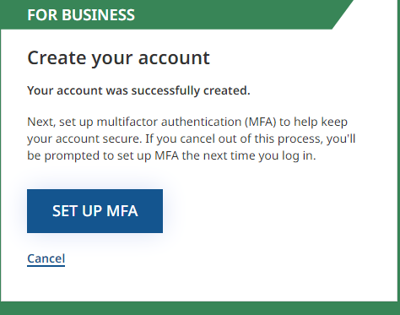

Slide 16 - How to Register Account: Set up Multifactor Authentication (MFA)
FOR BUSINESS: Set up multifactor authentication
Choose your authentication method (recommend more than one)
- Authenticator App*
- Phone (Voice & Text Message)
- Secondary Phone (Voice & Text Message)
- Check the checkbox to select the MFA method.
- Click the CONTINUE button.
*Use an authenticator app you have installed or download a free one such as Google Authenticator, Authy, or Microsoft Authenticator. Follow download/set up process as directed.
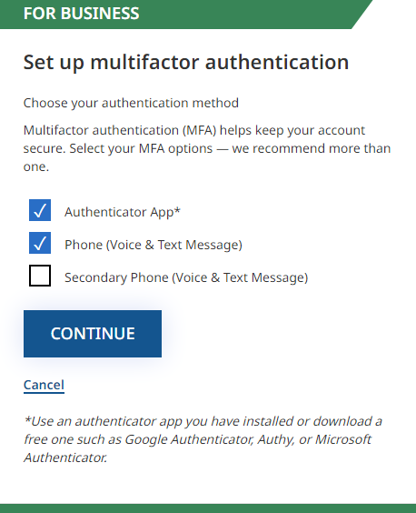

Slide 17 - How to Register Account: Set up Multifactor Authentication (MFA) (Continued)
OPTION 1: To setup an Authentication App
- Open your authenticator app
- Scan the QR Code with your app
- Enter the code
- Click the CONTINUE button.
OPTION 2: To setup a phone number (Voice and Text Message)
- At the ‘Link your phone number’ screen select the correct country code
- Enter the phone number you’d like to use to receive a one-time code
- Click either ‘Text me’ or ‘Call me’
- Enter the code sent to your phone
- Click ‘Verify code’
If you don’t receive a code or the code you received doesn’t work or expires, select ‘Get a new code’ and a new code will be sent to your phone.
OPTION 3: To setup a second phone number Phone (Voice and Text Message)
- At the ‘Link your phone number’ screen select the correct country code
- Enter a different second phone number you’d like to use to receive a one-time code
- Click ‘Continue’
- Click either ‘Text me’ or ‘Call me’
- Enter the code sent to your phone
- Click ‘Verify code’
If you don’t receive a code or the code you received doesn’t work or expires, select ‘Get a new code’ and a new code will be sent to your phone.
Refer to Login.mass.gov help for residents and businesses | Mass.gov for assistance.

Slide 18 - How to Register Account: Set up Multifactor Authentication (MFA) (Continued)
FOR BUSINESS: Set up multifactor authentication
Once MFA has been successfully set up, you will be provided with the following message:
A Virtual Gateway account reference for email address Susan.Trainer@xyz.com has been created successfully.
- Click the Virtual Gateway Home button to login.
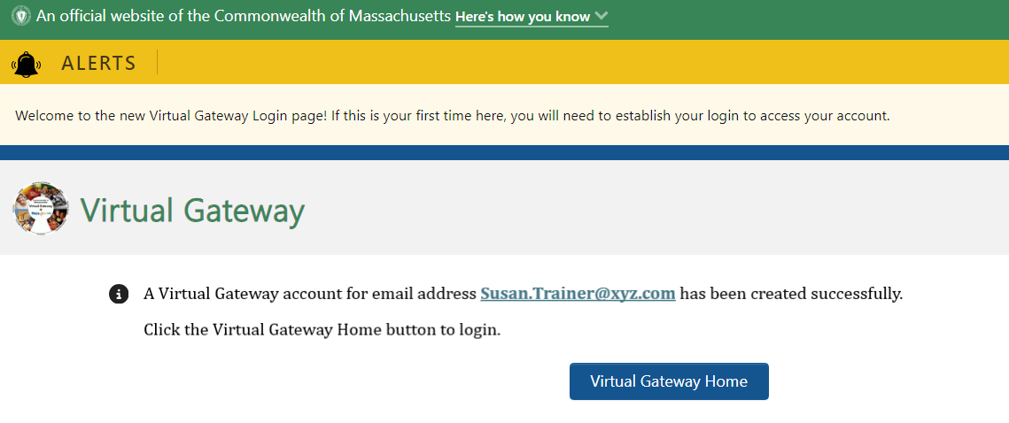

Slide 19 - Login to Virtual Gateway
FOR BUSINESS: Login to Virtual Gateway
- Click the Business Login button.
The Virtual Gateway Security Warning (disclaimer) will appear.
- Click the Proceed button to accept the Virtual Gateway Security Warning (disclaimer).
If the Decline button is clicked, you will be returned to the Virtual Gateway Home page.
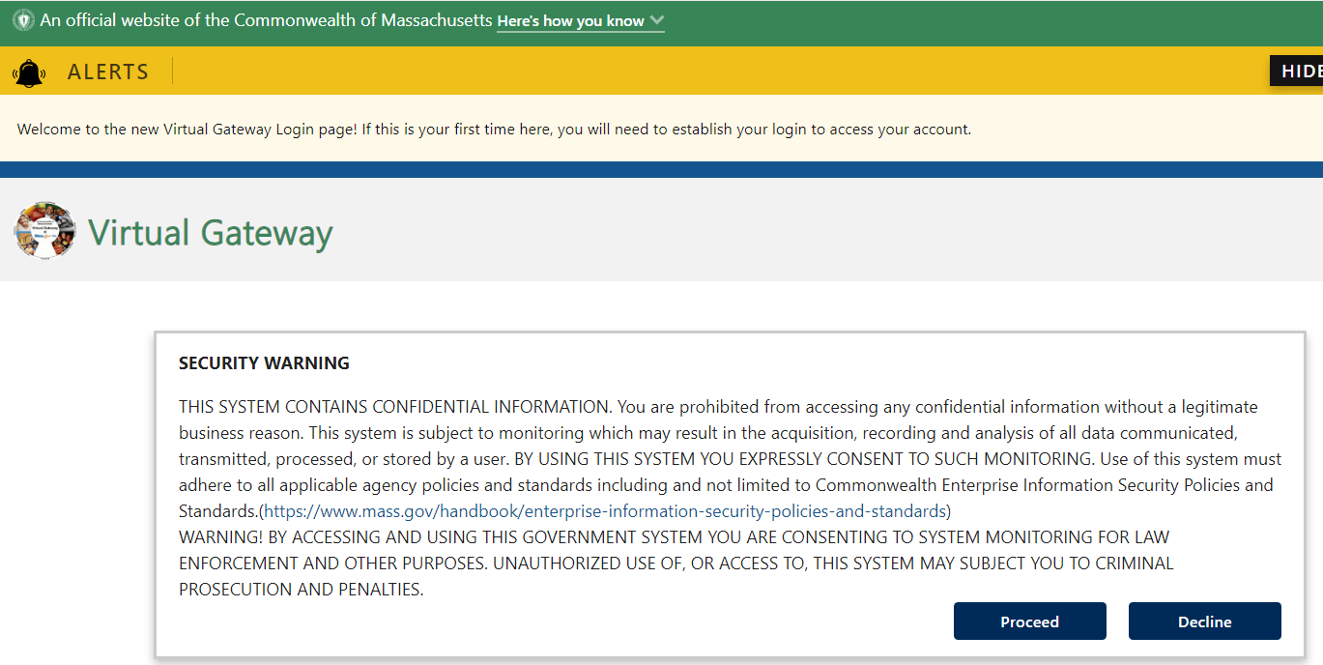

Slide 20 - Login to Virtual Gateway (Continued)
Important Note: Login.mass.gov to be rebranded to MyMassGov per EOTSS
FOR BUSINESS: Login to Virtual Gateway
- Enter Email Address
- Enter Password.
- Click the LOG IN button.
If you have forgotten your password, click the Forgot Password link to reset your password.
Note: Virtual Gateway Customer Service will only reset passwords for Legacy users once the new Virtual Gateway Login site goes live.
State Agency Employees: If you are a state agency employee with 1 VG UserID linked to 1 email address, use the Log in as an MA state employee link (must have email address on file with VG using the @Mass.gov email domain) to login to VG.
If you have multiple VG UserID's linked to 1 email address, you need to use the Legacy Login option to login to VG.
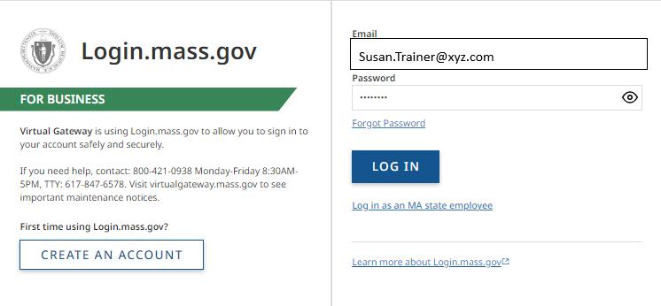

Slide 21 - Login to Virtual Gateway (Continued)
Important Note: Login.mass.gov to be rebranded to MyMassGov per EOTSS
FOR BUSINESS: Login to Virtual Gateway
How MFA was set up during the Create an account process will determine which options you are presented with when logging in to the Virtual Gateway.
- Click the option to verify your account (authenticator app or phone).
Note: You will need to enter a verification code each time you login to the Virtual Gateway.
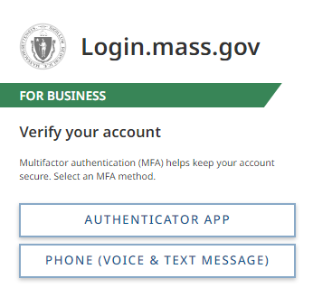

Slide 22 - Login to Virtual Gateway (Continued)
FOR BUSINESS: Login to Virtual Gateway
Verify your account
If you select the Phone method for MFA, you will see the last 4-digits of the telephone you setup MFA under. You will receive a 6-digit code by telephone or text.
- Enter the code or click Get a new code, if you do not receive one
- Click the VERIFY CODE button
Note: You will need to enter a verification code each time you login to the Virtual Gateway.
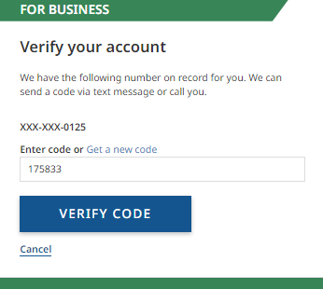

Slide 23 - Login to Virtual Gateway (Continued)
FOR BUSINESS: Login to Virtual Gateway
Virtual Gateway Terms and Conditions
New Users: First time users are required to accept the Virtual Gateway Terms and Conditions the first time they login.
Existing Users: Virtual Gateway has updated their Terms and Conditions. All existing users will be required to accept the Virtual Gateway Terms and Conditions the first time they login after we move to the new Virtual Gateway Login site.
- Review Virtual Gateway Terms and Conditions (click View Terms and Conditions in PDF format if you want to review and /or print a copy).
- Click the I Agree to terms and conditions checkbox.
- Click the Complete Sign In button.
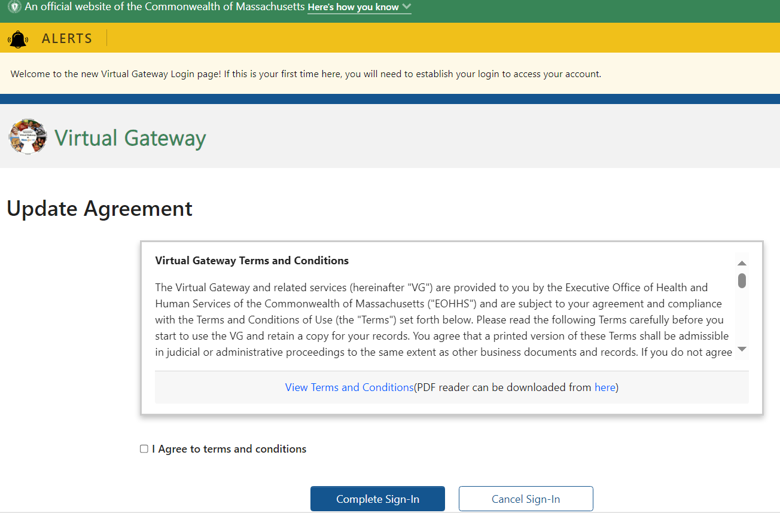

Slide 24 - Login to Virtual Gateway (Continued)
FOR BUSINESS: Login to Virtual Gateway
A successful login will take you to the Accessible Applications page. This page will list the Virtual Gateway applications that you have access to under your email address.
Note: If you have access to other Organizations on the Virtual Gateway, you will be taken to the Select Organization page prior to this page.
Congratulations!
You have successfully registered and logged into the new Virtual Gateway Login site.
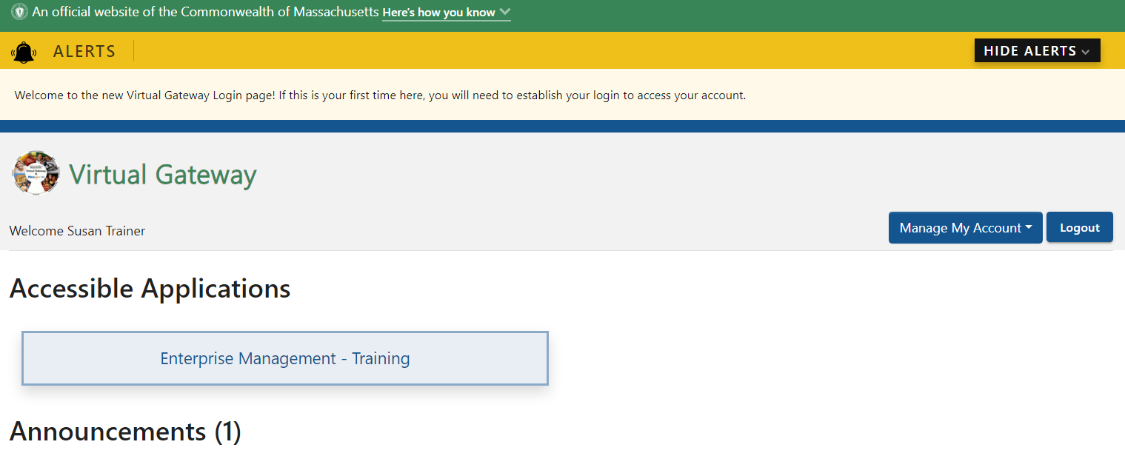

Slide 25 - Public or Legacy Login Options
Important Note: Login.mass.gov to be rebranded to MyMassGov per EOTSS
FOR PERSONAL: Login to Virtual Gateway
The Personal option should only be used by individuals who want to view their MassHealth-related information using the My Account Page (MAP) application on the VG. This option is for Public users only. Self-registration is available under this option.
FOR LEGACY: Login to Virtual Gateway
The Legacy option will be available to all Public users, State Employees, Provider Staff and DCF Mandate Reporters as of Go Live Date of 5/19/2024. This option will only be available for a limited time. Users should use the Personal Login or Business Login option whenever possible.
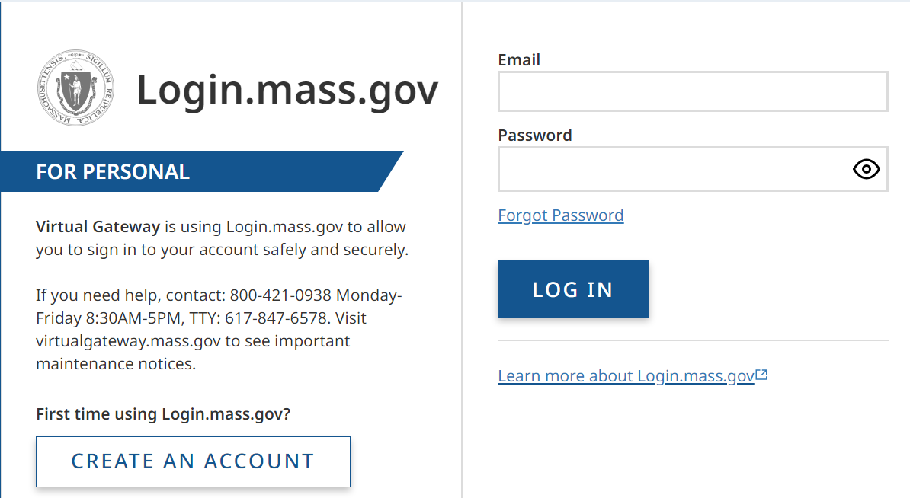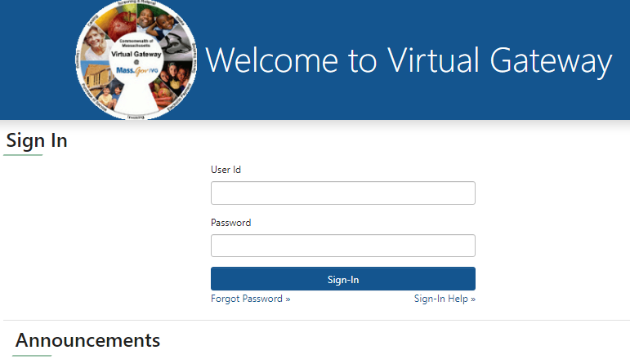

Slide 26 - Communication/Outreach Plan
VG has several communication channels in which end users will learn about the changes to the VG URL and login process.
- VG Application Business Teams: We will ask that you, our VG Application Business teams, begin spreading the word about this change when communicating with your providers/users.
- Weekly IT Process Control Meeting: VG Operations will add project updates to the Agenda that is sent to all application teams who are testing their application releases.
- VG Portal Notifications: VG will post messages about the upcoming changes on the VG Portal.
- VG Website: VG Operations will be setting up a dedicated webpage on our Mass.gov/VG site with information about this change and how it will impact users. We plan to post job aids, bulletins, and FAQs along with other important information. We will let you know once this website is up and running.
- Weekly TGIF Email: Looking to have this update added to the weekly TGIF Email that EOHHS sends. This emails is sent to all EOHHS staff and agencies who fall under the EOHHS Secretariat.

Slide 27 - Communication/Outreach Plan (Continued)
Email Notifications:
- Week of April 22nd – Email to all active VG users letting them know about the upcoming changes.
- Week of May 6th – Email to all active VG users will receive an email from VG (auto-generated out of AIMS) outlining the changes and how users can prepare for Go Live.
  - It is very important for users to act when they receive this email. This email will contain the email address that is linked to their VG Account.
  - If the email address needs to be updated, it should be done prior to the Go Live date.
  - Users can update their email address after logging into the VG from the Accessible Application page.
    - Refer to the Manage My Account > Update Personal Information section on this page.
    - If assistance is needed, call the Virtual Gateway Customer Service team at 800-421-0938 and they can walk you through the process of updating.
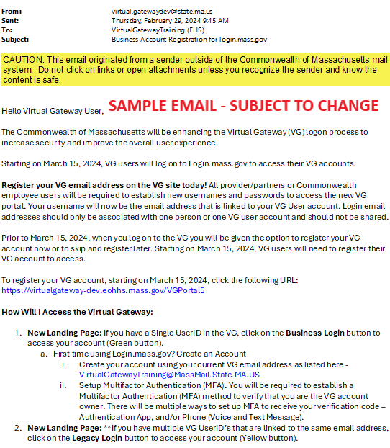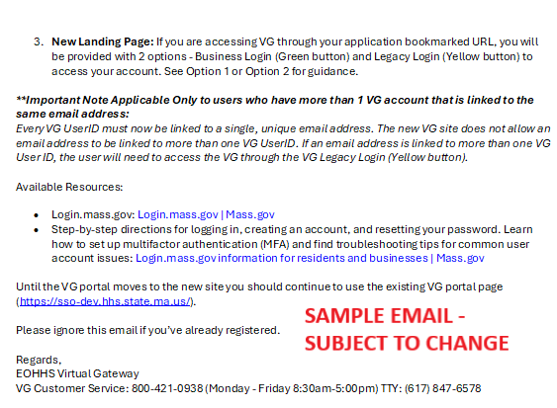

Slide 28 - Virtual Gateway Customer Service
Virtual Gateway Customer Service at 800-421-0938 will continue to be the group to contact if you encounter issues when accessing and logging into Virtual Gateway.
- Legacy Users
  - Password Resets: Legacy Users should continue to contact VG Customer Service for Password Resets, if user cannot reset password on their own (secret questions).
  - If other issue need to be escalated to Virtual Gateway Operations, a CA Service Desk ticket will be created and assigned for follow-up.
- Public and Business Users Who Have Created MyMassGov account and setup MFA
  - Password Resets: Use Forgot Password link on Virtual Gateway MyMassGov landing page and follow password reset steps. Virtual Gateway Customer Service CANNOT reset passwords for these accounts.
  - Refer to Login.mass.gov help for residents and businesses | Mass.gov until new VG Resource webpage is up and running.

Slide 29 - Q & A Session


