Summary of Job Aid
To access a Virtual Gateway’s Legacy business service, you must first log on to the Virtual Gateway (VG). From the Mass.Gov website (www.mass.gov), select the Log In to … link and select the Virtual Gateway option to access the Virtual Gateway login page. A successful logon will take you to the Virtual Gateway Applications page to access your specific applications.
Refer to this reference guide, Virtual Gateway Legacy Log In Assistance Reference Guide, for more information on how to access the Virtual Gateway as a first-time user and how to manage your Virtual Gateway account.
Table of Contents for this job aid:
Logon Process for the Virtual Gateway (VG) 1
Existing Password, Terms and Conditions, Change Password, and Secret Questions 5
Manage My Account 9
Password and Security Notes and Tips 11
Questions or Need Assistance? 11

Logon Process for the Virtual Gateway (VG)
The following steps guide you through logging in to the Virtual Gateway (VG):
- Access the Virtual Gateway website at www.mass.gov and select the Log In to … link.

Figure 1: Mass.gov with Login In to ... link highlighted.
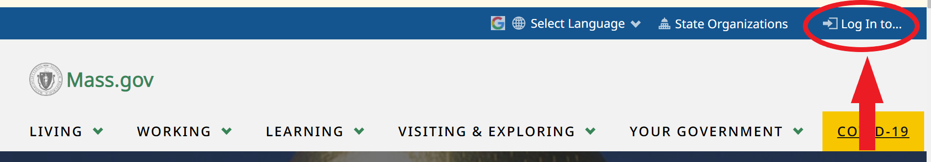
- Select the Virtual Gateway link.
Figure 2: Select the Virtual Gateway link.
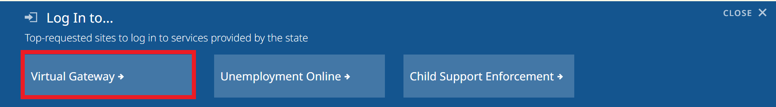
- From the Virtual Gateway website, click Legacy Log In button.

Figure 3: Virtual Gateway website.
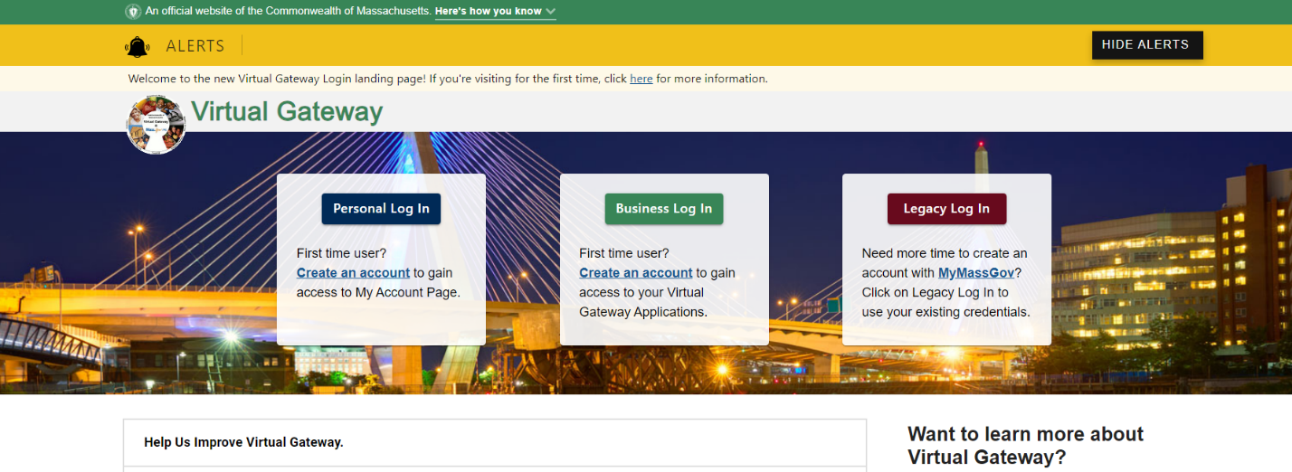
- Click the Proceed button on the System Notice-Security Warning page.

Figure 4: Welcome to Virtual Gateway-System Notice page.
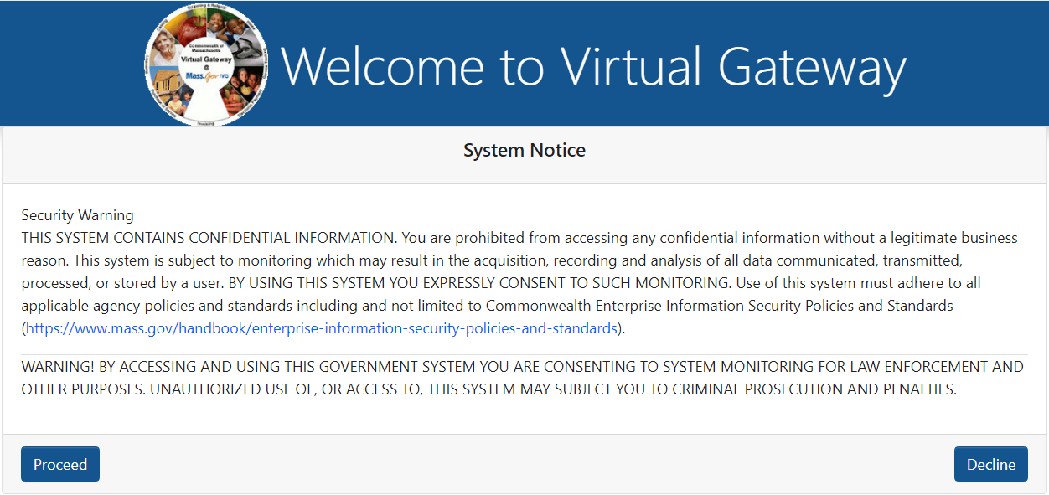
- Enter your Virtual Gateway User ID.
- Enter you password.
- Click the Sign-In button
Figure 5: Welcome to Virtual Gateway Sign In page
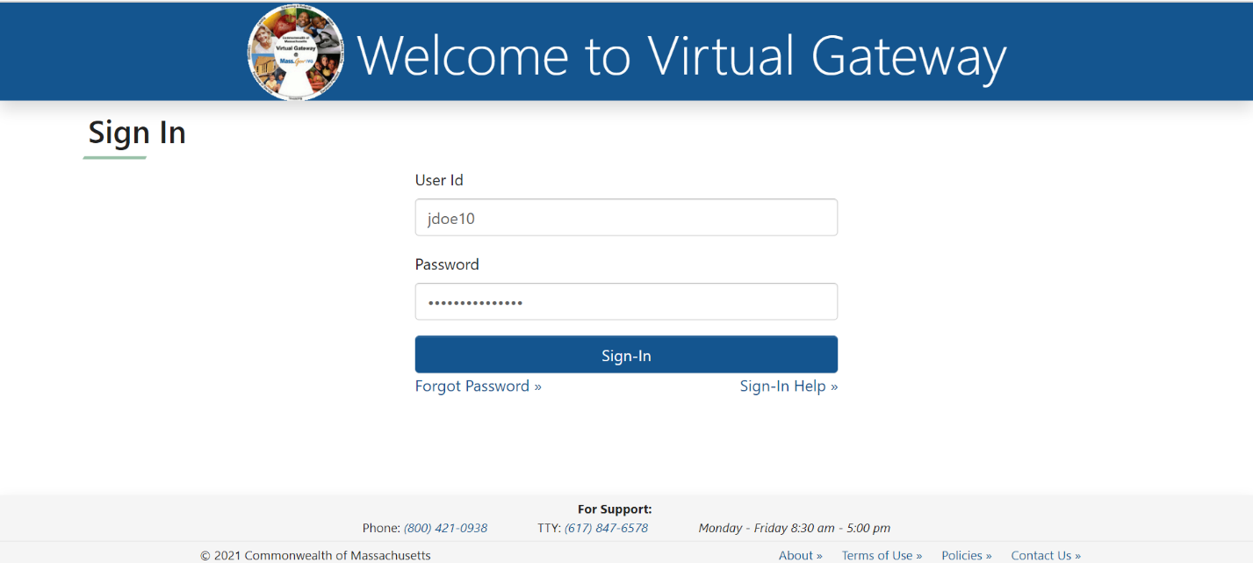
- Select the Sign-In button.

The Applications page will appear; it provides you with access to your applications.
Figure 6: Virtual Gateway Business Service page displaying accessible applications user has access to use
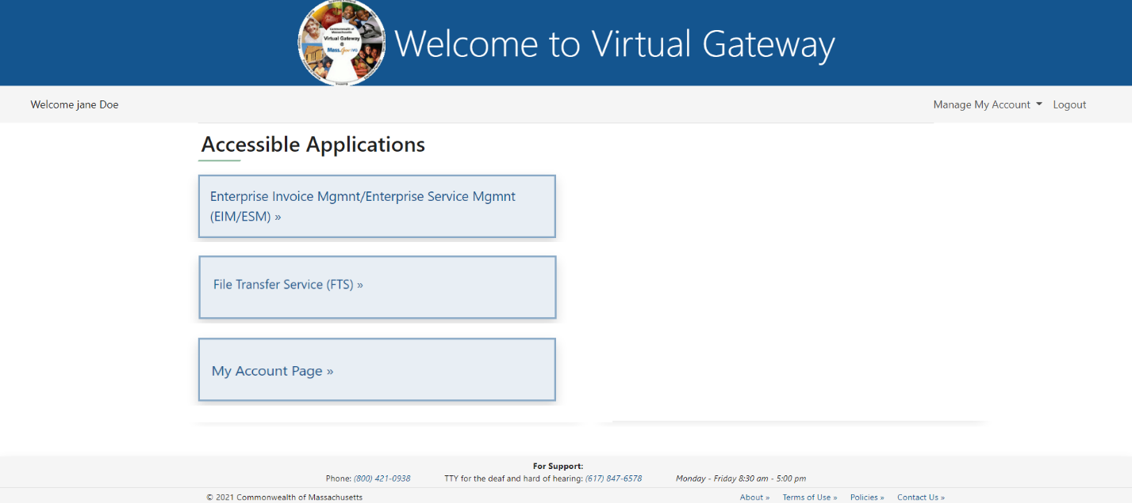
Business Service Page:
- “Manage My Account” drop-down menu is located on the right-hand side to allow for easy updates/changes to your account information or logout of the VG.
- Announcements display at bottom of the Virtual Gateway Sign In and Business Service pages.
Figure 7: Sample Announcement displayed on the Virtual Gateway Sign In page
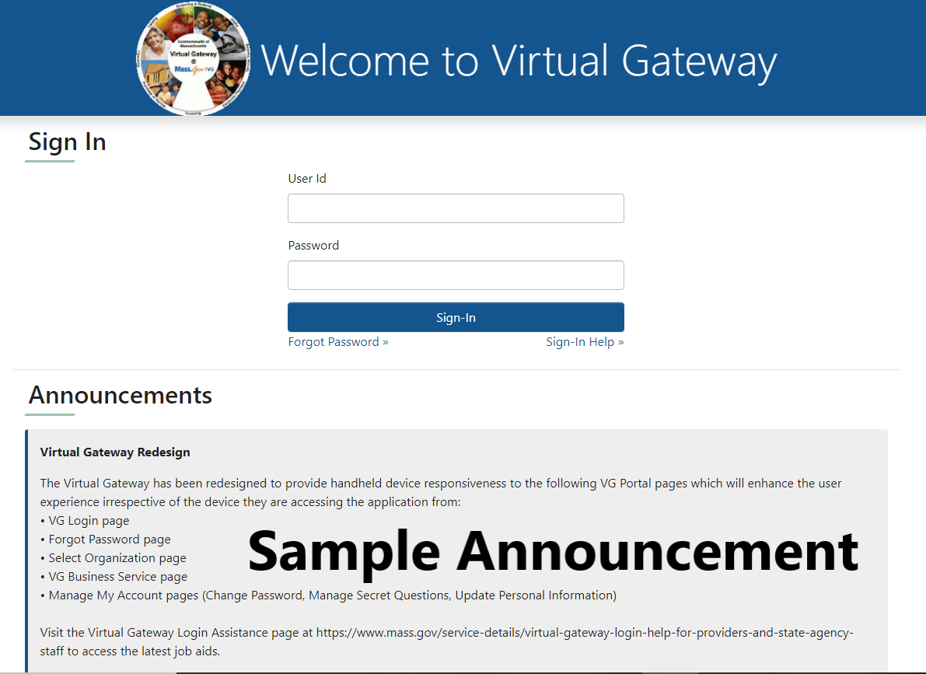
If you are associated with more than one organization/work location, you may be directed to the Select Organization page prior to the Business Service page:
- Select the appropriate organization/work location from the drop-down list
- Select the Complete Sign-In button to continue.
You will be directed to the appropriate business service page.
Figure 8: Select Organization page
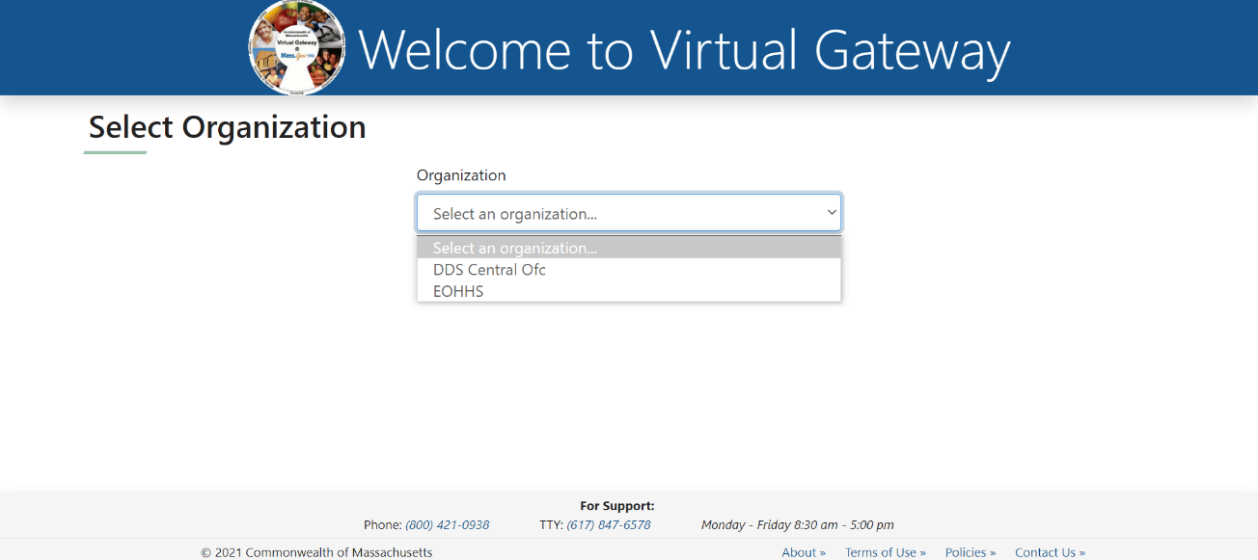

Existing Password, Terms and Conditions, Change Password, and Secret Questions
The Incomplete Profile page appears if you are a new user. You must complete all four sections on this page before selecting the [Submit] button at the bottom of the page. You will need to refer to the New EOHHS Virtual Gateway User ID email you received to complete these steps.
Figure 9: Sample of the New EOHHS Virtual Gateway User ID email
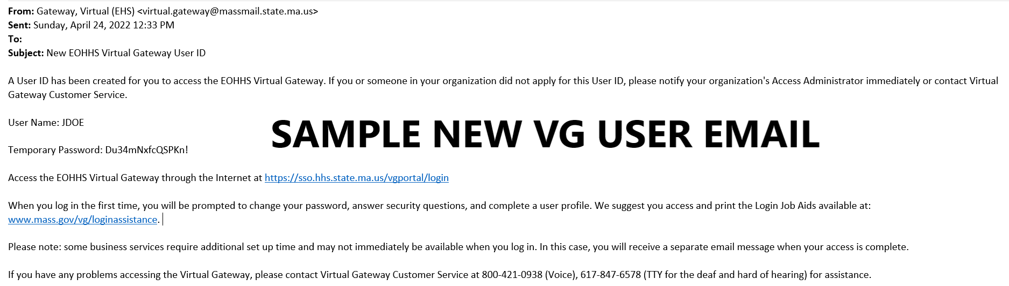
Existing Password
- Type in the Existing/Temporary Password from the New User Email.
Figure 10: Incomplete Profile - Enter Existing Password page
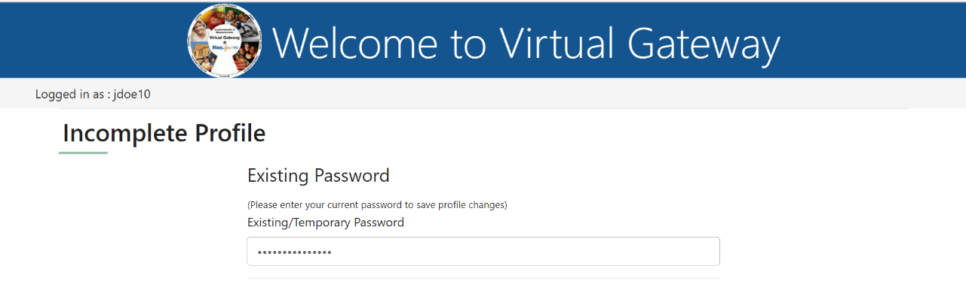
Terms and Conditions
- [New Users] Read the Terms and Conditions and select the checkbox I Agree to terms and conditions.
Note: Users are required to agree to the Virtual Gateway Terms and Conditions upon first login. If you choose to not select the checkbox you will not be able to access the Virtual Gateway.
Figure 11: Terms and Conditions page.
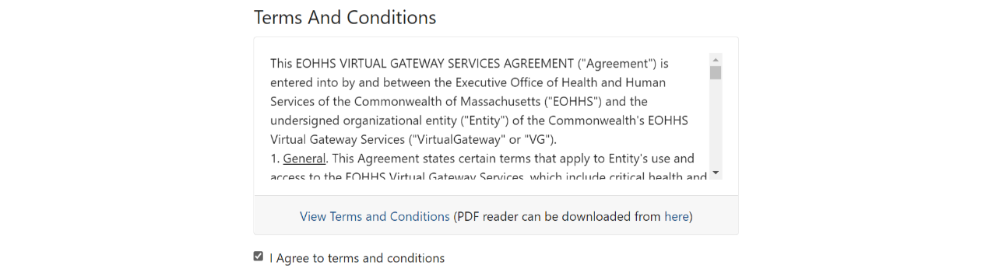
Change Password
- Read the password requirements on the Change Password section. The format for your password must match the minimum password requirements listed in this section.
- Enter your Existing Password. Reminder: This will be the temporary password you received from the Virtual Gateway in your New User email.
- Enter New Password and Confirm New Password.

Figure 12: Change Password page
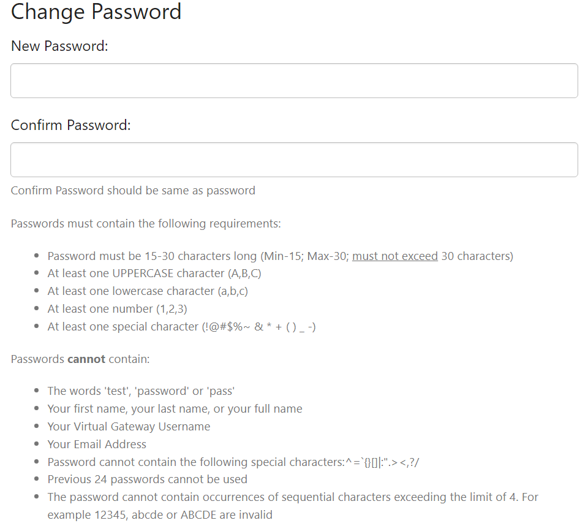
Note:
To successfully change your password, you must adhere to the minimum password requirements listed on this page.
If resetting a password, do not enter passwords that you have recently used.
Secret Questions
- Answer at least 5 of the secret questions (they are not case sensitive). Select responses that will be easy for you to remember.
- Select the Complete Sign-In button to save your responses for the entire page.

Figure 13: Answer Secret Questions page
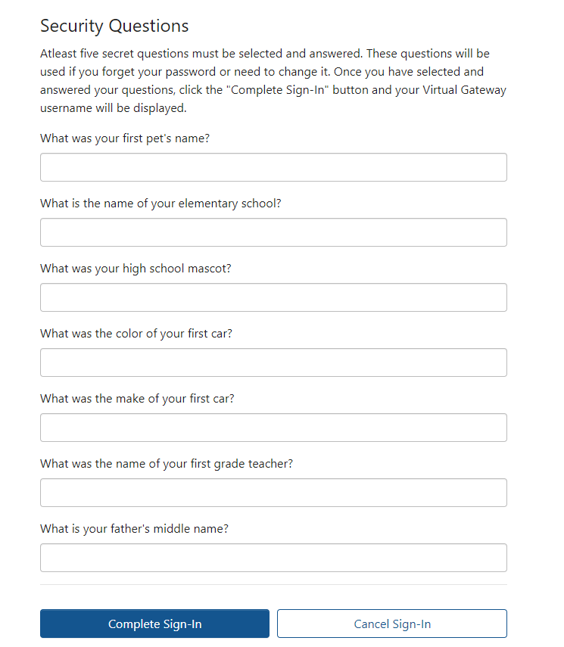
You will be redirected to the Business Service page. Note that the Business Service page displays your name and the last VG login (Date and Time) for security purposes.
Figure 14: VG Business Service page
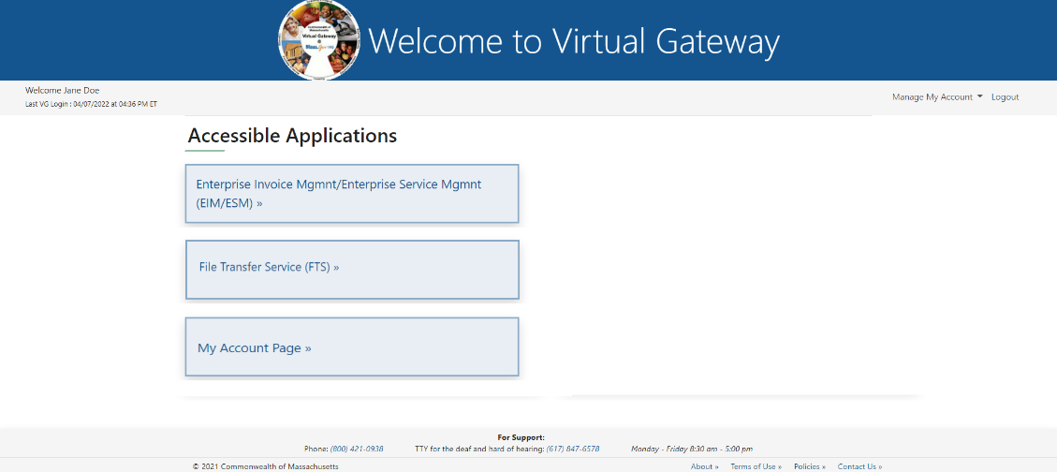
The Virtual Gateway Customer Service team is available to help if you have any questions or run into problems (see contact information on the last page).

Manage My Account
The Manage My Account section displays on upper right side of Business Service page. Under Manage My Account, a user can Change Password, Manage Secret Questions and Update Personal Information.
- Log in to the Virtual Gateway using your Username and Password.
Under Manage My Account, select the appropriate link to change your account information. Follow all instructions provided on the individual pages. After the Submit button is Selected, the system returns you to the Business Services page.
Figure 15: Manage My Account page
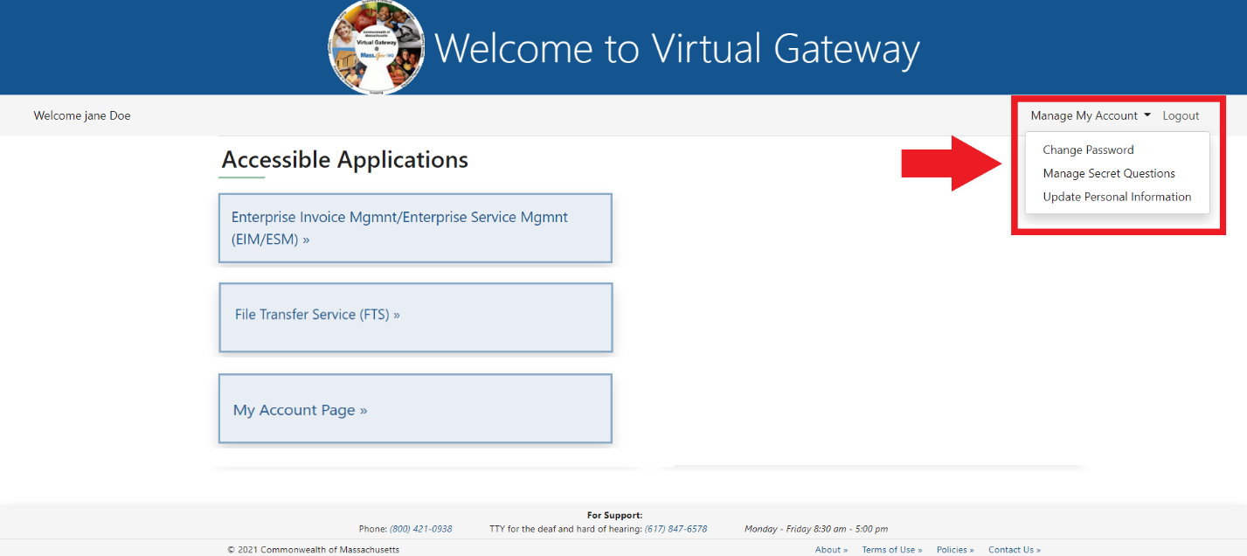
- Select the Change Password link.
- Select Submit button.
Figure 16: Change Password page
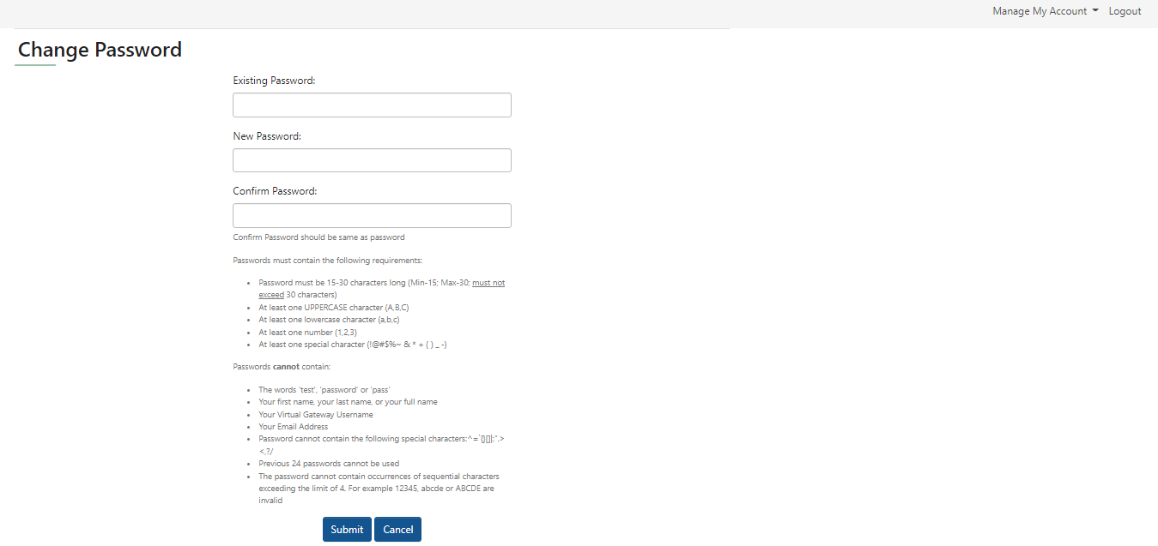
- Select the Manage Secret Questions link.
- Update the answers to your secret questions.
- Select the Submit button.
Figure 17: Answer Secret Question page
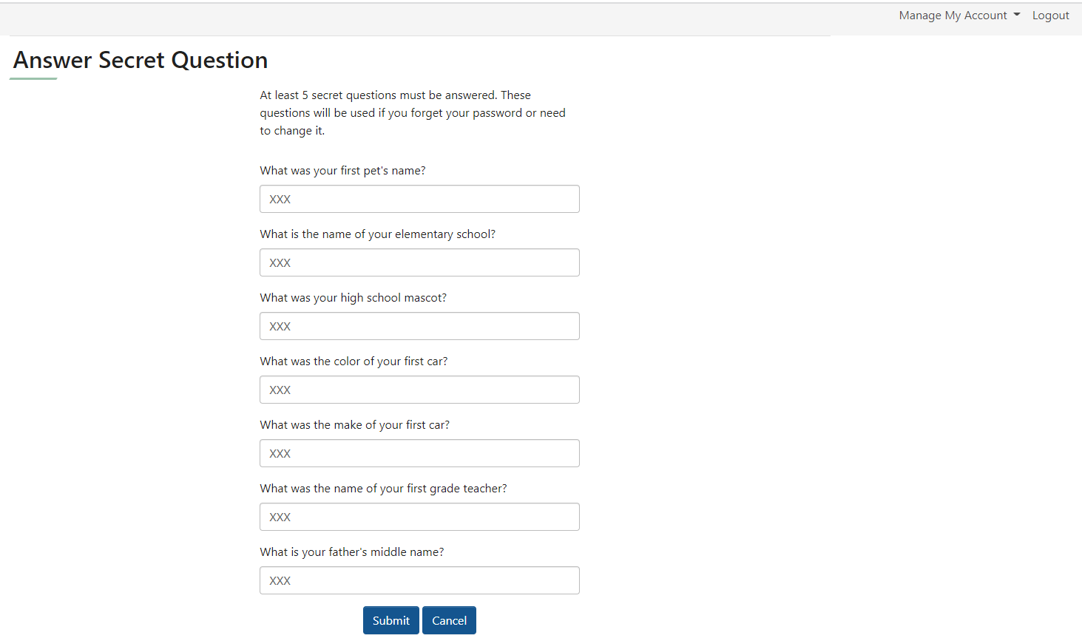
- Select the Personal Information link.
- Update this page as needed (First, Last Name, PIN, Date of Birth, Email Address, Telephone).
- Select the Submit button.
Figure 18: Update Profile page
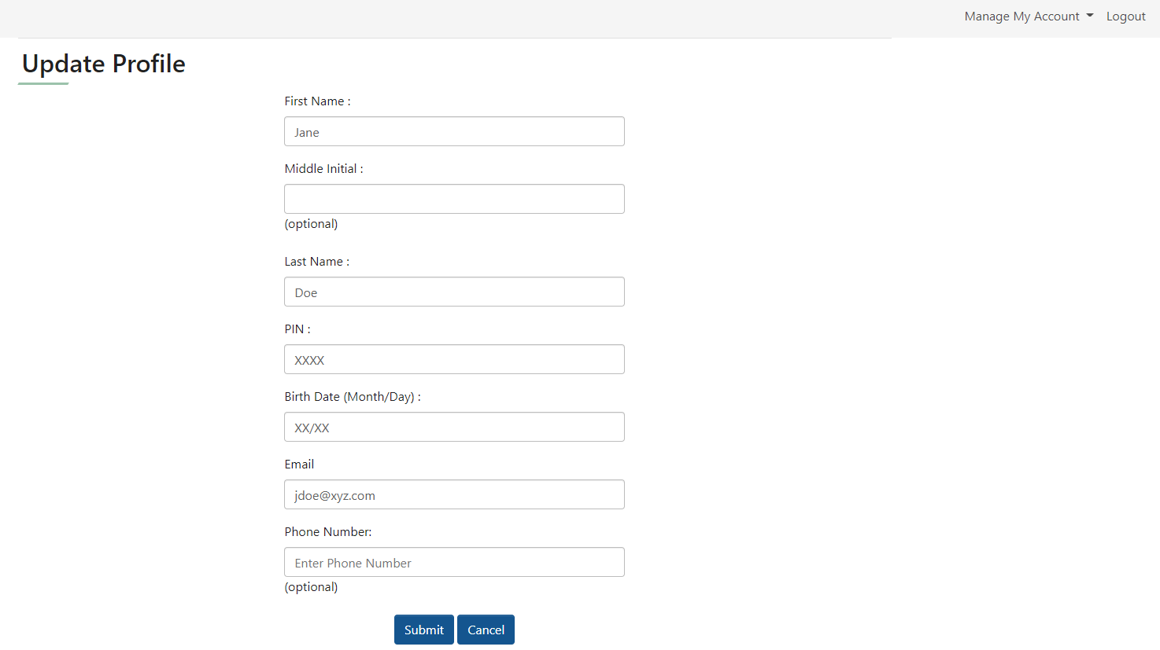

Password and Security Notes and Tips
- Any time you change your password, forget your password, or call Virtual Gateway Customer Service with a password question, you will need to answer some of the secret questions or provide other security information as verification. Questions are chosen at random.
- Use passwords and responses that you are likely to remember and be sure to not post this information where others can access it.
- If you feel your password has been compromised, change your password immediately.
- If you receive the error message “Invalid username & password. Please try again,” retype your Username and Password and Select the Sign-In button. If after several attempts you still receive this message, call Virtual Gateway Customer Service for assistance.
- You cannot reuse recently used passwords.

Questions or Need Assistance?
Call Virtual Gateway Customer Service
1-800-421-0938
617-847-6578 - TTY for the deaf and hard of hearing
8:30 am to 5:00 pm Monday through Friday

