**Commonwealth of Massachusetts May 13, 2024**

**Executive Office of Health and Human Services Volume 1, Issue 2**

Table of Contents

Save the Date: Sunday, May 19, 2024: Virtual Gateway Website & Log In Process is Changing 1

Ways to access new Virtual Gateway site starting after May 19, 2024: 1

Attention Existing Virtual Gateway State Employee Users 1

Questions About the Upcoming Changes to VG 2

Business Log In —Existing Provider Users 2

Legacy Log In —All Existing Virtual Gateway Users 3

Personal Log In —Existing My Account Page Public Users 3

Legacy Log In —Existing My Account Page Public Users 4

Additional Virtual Gateway Information 4

User Request Form (URF) Submission Process—No Change in Process 4

Virtual Gateway Account Merger Requests 4

Virtual Gateway Customer Service 4

## Save the Date: Sunday, May 19, 2024: Virtual Gateway Website & Log In Process is Changing

The Virtual Gateway (VG) is moving its log in portal to a new site on Sunday, May 19, 2024. All Virtual Gateway users will access the log in page via a new web site.  The exact site will be communicated soon. MyMassGov account creation and multifactor authentication (MFA) set up may be required.

## Ways to access new Virtual Gateway site starting after May 19, 2024:

* Visit the [Mass.gov](https://www.mass.gov/) website to access the new Virtual Gateway log in page. Recommend bookmarking as a favorite for easy access. Go to **Mass.gov** > Select **Log In to …** > Select **Virtual Gateway**. Refer to specific web browser (Google Chrome or Microsoft Edge) for instructions on how to bookmark a website as a favorite.
* If you have the current Virtual Gateway Portal page saved as a favorite or bookmarked site in your browser, when you select from your list of favorites after 5/19/2024, the system will automatically take you to the new Virtual Gateway log in website.

## Attention Existing Virtual Gateway State Employee Users

Existing state employees who have 1 Virtual Gateway User ID linked to their Mass.gov email should select the **Business Log In** option, then the **Log in as an MA state employee** link. This link allows a state employe user to log into Virtual Gateway under their network login and enter the multifactor authentication (MFA) verification code when asked.

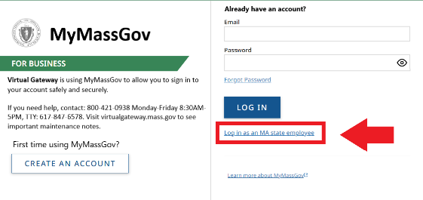*Note: MA state employees, who have a Mass.gov email, will already have a MyMassGov account and multifactor authentication (MFA) would have been setup per your network log in account—no additional setup is needed.*

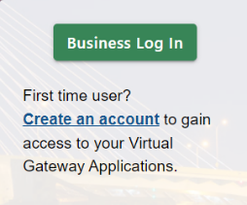

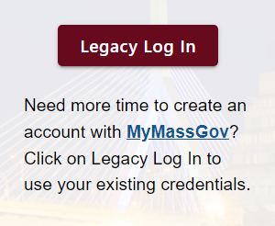

If a state employee has multiple Virtual Gateway accounts (JDOE, JDOE5) linked to their Mass.gov email, they should log into Virtual Gateway using the **Legacy Log In** option. Users will log into their existing account using their User ID and password. Refer to **Legacy Log In —Existing Virtual Gateway Users** on Page 2 for instructions.

## Questions About the Upcoming Changes to VG

* Have questions about how these changes affect the applications you use? Contact your application point of contact about the upcoming changes.
* Review emails that have been sent from Virtual Gateway to prepare for upcoming changes. All active Virtual Gateway users were sent emails.
  + Email 1: 4/26/2024 and 4/27/24
  + Email 2: 5/6/2024 and 5/7/24
* Review email that was sent to active users who have multiple Virtual Gateway User ID’s linked to 1 email.
  + Email: 5/2/24
* Review Virtual Gateway Portal Announcements as posted on the current VG log in portal page.
* Refer to [Virtual Gateway Resource Assistance for Providers and State Agency Staff | Mass.gov](https://www.mass.gov/info-details/virtual-gateway-resource-assistance-for-providers-and-state-agency-staff) for the latest information regarding the upcoming changes. Content is being added daily so be sure to check back often.

## Business Log In —Existing Provider Users

The Business Log In option should be used by any Provider staff, or DCF Mandated Reporter who is an existing Virtual Gateway user with 1 Virtual Gateway User ID linked to their 1 email. Setting up a MyMassGov account and multifactor authentication (MFA) will be required.

*Note: If a user has multiple Virtual Gateway User ID’s linked to the same email, refer to* ***Legacy Log In —Existing Virtual Gateway Users*** *below for guidance on how to log into their account after May 19th.*

**Scenario 1:** Kerry works at XYZ Organization. She uses the EIM/ESM application. Kerry has 1 User ID for EIM/ESM and it is linked to her work email.

**How will Kerry log in to her EIM/ESM account on Monday, May 20th?** Since Kerry has 1 EIM/ESM User ID which is linked to her work email, she will click the Business Log In button, create a MyMassGov account and set up multifactor authentication (MFA) prior to accessing EIM/ESM.

* Go to **Mass.gov** > Select **Log In to …** > Select **Virtual Gateway**.
* 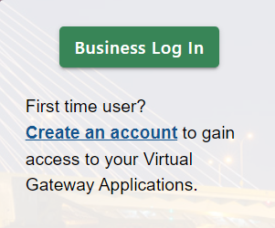From the **Business Log In** option — Under the First time user? Click on **Create an account**.
* Create a MyMassGov account and set up multifactor authentication (MFA) per the instructions as they appear on the page.
  + *Your MyMassGov account must be setup under the email on file with Virtual Gateway.*
  + *Refer to email received on 5/6/2024 with Subject ‘Important Update: Changes Coming to Virtual Gateway URL and Log In Process’ which contains your email with Virtual Gateway.*
  + *To verify your email, log into Virtual Gateway before May 19th and under Manage My Account > Update Personal Information you will see the email that you need to use.*
* Click the Virtual Gateway Home button. Log into your MyMassGov account with your email and password.
* Refer to [Virtual Gateway Resource Assistance for Providers and State Agency Staff | Mass.gov](https://www.mass.gov/info-details/virtual-gateway-resource-assistance-for-providers-and-state-agency-staff) to download the **Business Log In Guide** (Available on 5/19/2024).

## Legacy Log In —All Existing Virtual Gateway Users

The Legacy Log In option will be available to all existing Virtual Gateway users who have multiple Virtual Gateway User IDs linked to one email. MyMassGov account creation and multifactor authentication (MFA) are not required. The Legacy Log In option is available to all users for a limited time.

**Scenario 2:** Mark works at XYZ Senior Services and has 2 Virtual Gateway accounts under the same email. Mark requires 2 separate accounts today as he uses the Money Follows the Person (MFP) application which requires separate accounts when needing access to multiple MFP roles.

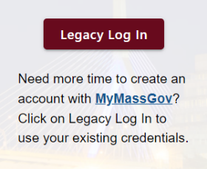**How will Mark login on Monday, May 20th?** Mark will log in to his MFP accounts by selecting the **Legacy Log In** option and entering his User ID and password, just as he currently does.

* Go to **Mass.gov** > Select **Log In to …** > Select **Virtual Gateway**.
* Click the **Legacy Log In** button.
* Click **Proceed** on the Welcome to Virtual Gateway System Warning page.
* Enter **User** **ID** and **Password** and click the **Sign-In** button.
* From the **Application** page select the application to access.

## Personal Log In —Existing My Account Page Public Users

The Personal Log In option is to be selected by existing MAP Public users. The Personal Log In option should be used by existing MAP users who have 1 User ID linked to their personal email. Setting up a MyMassGov account and multifactor authentication (MFA) will be required.

**Scenario:** Tom receives MassHealth benefits and has a current MAP public account.

**How will Tom log in to his MAP account on Monday, May 20th?** Since Tom has 1 MAP User ID which is linked to his personal email, he will need to create a MyMassGov account and setup multifactor authentication (MFA) prior to accessing his existing MAP account.

* Go to **Mass.gov** > Select **Log In to …** > Select **Virtual Gateway**.
* 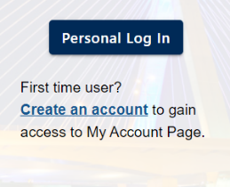Create a MyMassGov account and set up multifactor authentication (MFA) per the instructions as they appear on the page.
  + *Your MyMassGov account must be setup under the email on file with Virtual Gateway.*
  + *Refer to email received on 5/7/2024 with Subject ‘Important Update: Changes Coming to Virtual Gateway URL and Log In Process’ which contains your email with Virtual Gateway.*
  + *To verify your email, log into Virtual Gateway before May 19th and under Manage My Account > Update Personal Information you will see the email that you need to use.*
* Refer to [Virtual Gateway My Account Page | Mass.gov](https://www.mass.gov/virtual-gateway-my-account-page) for more information. (Available on 5/19/2024).

## Legacy Log In —Existing My Account Page Public Users

The Legacy Log In option can be used by any existing My Account Page (MAP) public users who has multiple MAP User ID’s linked to one email. MyMassGov account creation and multifactor authentication (MFA) are not required. This log in option is available for a limited time.

* Go to **Mass.gov** > Select **Log In to …** > Select **Virtual Gateway**.
* Click the **Legacy Log In** button.
* Click **Proceed** on the Welcome to Virtual Gateway System Warning page.
* Enter **User** **ID** and **Password** and click the **Sign-In** button.
* From the **Application** page select My Account Page to access.

## Additional Virtual Gateway Information

### User Request Form (URF) Submission Process—No Change in Process

The current User Request Form (URF) submission process is not changing. Designated Access Administrators (AA’s) should continue to follow the existing processes when submitting both new and existing user modification requests. Refer to [Become a Virtual Gateway User | Mass.gov](https://www.mass.gov/info-details/become-a-virtual-gateway-user).

### Virtual Gateway Account Merger Requests

Existing Virtual Gateway users should refer to [Virtual Gateway Resource Assistance for Providers and State Agency Staff | Mass.gov](https://www.mass.gov/info-details/virtual-gateway-resource-assistance-for-providers-and-state-agency-staff) after Sunday, May 19, 2024 for guidance on how to submit account merger requests. Requests to merge accounts will not be accepted by Virtual Gateway until after June 3, 2024.

### Virtual Gateway Customer Service

The Virtual Gateway Customer Service team will continue to offer Tier 1 support to all Virtual Gateway users. Virtual Gateway Customer Service: (800) 421-0938/TTY: (617) 847-6578 - Monday - Friday 8:30 am - 5:00 pm

**Legacy Users**: You should continue to call Virtual Gateway Customer Service if you need a password reset. Virtual Gateway Customer Service can only reset Legacy user accounts.

**MyMassGov Personal or Business Users**: If you have created a MyMassGov account and set up your multifactor authentication (MFA), you will need to use the Forgot Password link found under the Personal or Business Log In options. Virtual Gateway Customer Service cannot reset passwords for MyMassGov accounts.