INDOOR AIR QUALITY ASSESSMENT

Executive Office of Health & Human Services
200 Harvard Mill Square
Wakefield, Massachusetts

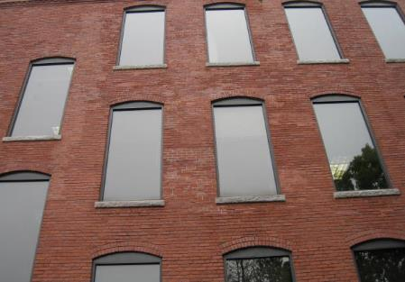

Prepared by:
Massachusetts Department of Public Health
Bureau of Environmental Health
Indoor Air Quality Program
May 2019

Background

Building: | Executive Office of Health & Human Services (EOHHS) Service Center
Address: | 200 Harvard Mill Square Wakefield, MA
DCAMM Project Manager: | Paul Burke, Senior Project Manager, Division of Capital Asset Management and Maintenance (DCAMM)
Reason for Request: | Post-occupancy assessment
Date of Assessment: | April 11, 2019
Massachusetts Department of Public Health/Bureau of Environmental Health (MDPH/BEH) Staff Conducting Assessment: | Jason Dustin, Environmental Analyst/Inspector, Indoor Air Quality (IAQ) Program
Building Description: | The EOHHS Center space is located in a large, brick four-story former mill building. The space is composed of private offices, open work areas, and conference rooms. Most areas have carpet tiles or vinyl flooring.
Windows: | Windows are not openable.

Methods
Please refer to the IAQ Manual for methods, sampling procedures, and interpretation of results (MDPH, 2015).

Results and Discussion
The following is a summary of indoor air testing results (Table 1).
- Carbon dioxide levels were below the MDPH guideline of 800 parts per million (ppm) in two thirds of areas assessed.
- Temperature was within the MDPH recommended range of 70°F to 78°F in most areas.
- Relative humidity was below the MDPH recommended range of 40% to 60% in all areas as is typical during the heating season in the Northeast.
- Carbon monoxide levels were non-detectable (ND) in all indoor areas assessed.
- Fine particulate matter (PM2.5) concentrations measured were below the National Ambient Air Quality Standard (NAAQS) level of 35 micrograms per cubic meter (μg/m³) in all occupied areas.

Ventilation
A heating, ventilating, and air conditioning (HVAC) system has several functions. First it provides heating and, if equipped, cooling. Second, it is a source of fresh air. Finally, an HVAC system will dilute and remove normally occurring indoor environmental pollutants by not only introducing fresh air, but by filtering the airstream and ejecting stale air to the outdoors via exhaust ventilation. Even if an HVAC system is operating as designed, point sources of respiratory irritation may exist and cause symptoms in sensitive individuals.
The HVAC system in the EOHHS space consists of large rooftop air handling units (AHUs) that draw in fresh air from intakes on the roof and supply fresh air to mechanical rooms through round supply ducts. These ducts are not connected to the AHUs so the mechanical rooms act as a mixing room (Picture 1). Return air is brought back to the AHUs through a combination of return vents, partial ceiling plenums, and passive vents.
BEH staff noted that most thermostat controls were set to “Fan Auto” instead of the recommended “Fan On” setting (Picture 2). This will turn off the supply of fresh air/exhaust ventilation when the thermostat temperature settings are reached which can lead to the buildup of commonly found indoor air pollutants. To maximize air exchange, the MDPH recommends that both supply and exhaust ventilation operate continuously during periods of occupancy. In order to have proper ventilation with a mechanical supply and exhaust system, the systems must be balanced to provide an adequate amount of fresh air to the interior of a room while removing stale air from the room. It is recommended that HVAC systems be re-balanced every five years to ensure adequate air systems function (SMACNA, 1994).
The kitchen did not have a dedicated local exhaust vent to eject moisture and food odors directly outdoors. The fresh air supply and return vents did not appear to be functioning at the time. The door to this room was noted to be closed at the time of the assessment. As a result, the humidity was nearly double the outside humidity reading and the temperature was nearly 80°F (Table 1). This condition may increase irritant effects of particulates/odors and also affect occupant comfort.

Microbial/Moisture Concerns
BEH staff noted some water-damaged wood ceilings and timbers. This water damage was reported to be historic. Hardwood is semi-porous and not very susceptible to mold growth. Porous building materials (e.g., carpeting, gypsum wallboard, ceiling tiles) that are not dried within 24 to 48 hours of being wet may support mold growth and should be discarded if water-damaged. BEH staff did not observe any visual signs of mold growth or any musty odors during the assessment.
Evidence of water penetration was observed on the exterior walls in the form of efflorescence (Picture 3). Efflorescence is a characteristic sign of water damage to brick and mortar, but it is not mold growth. As moisture penetrates and works its way through mortar, brick or plaster, water-soluble compounds dissolve, creating a solution. As the solution moves to the surface of the material, the water evaporates, leaving behind white, powdery mineral deposits. It should be noted that occupants have not reported any recent water infiltration and the efflorescence noted is likely historic in nature.
Plants were noted in some occupied areas (Picture 4, Table 1). Plants can be a source of odors, pollen and mold. Plants should be kept in good condition, not overwatered, and not placed on porous materials.

Other Issues
Hand sanitizers, scented cleaning products, and air fresheners were noted in some areas of the office space. These products can cause irritation of the eyes, nose, and respiratory system of some people.
Most flooring is covered with carpet. The Institute of Inspection, Cleaning and Restoration Certification (IICRC), recommends that carpeting be cleaned annually (or semi-annually in soiled high traffic areas) (IICRC, 2012). Daily vacuuming with a HEPA-filtered vacuum is also recommended.
A missing ceiling tile was noted in conference room #4105 (Picture 5). This missing tile is most likely a return vent requiring an exhaust grate rather than a ceiling tile. All ceiling tiles/grates should be properly seated in the ceiling grid system since they act as a system and also function as the return plenum for the air handlers.
Some conference rooms were fitted with local exhaust vents that are activated by a carbon dioxide sensor (Picture 6). It is important that these sensors are calibrated or replaced as recommended by the manufacturer.

Conclusions/Recommendations
Based on the observations made during the visit, the following is recommended:
- Operate the HVAC system to provide for continuous fresh air ventilation during occupied hours. Inspect all thermostats to ensure that they are set for “fan on” instead of the “fan auto” setting.
- Consider installing local exhaust ventilation in the kitchen area to remove excess humidity, odors, heat, and particulates. Keep the door open to this room until the supply/return vents are inspected and made operational.
- Ensure that the mechanical rooms are kept clean to prevent entrainment of dust, debris or odors into supply air.
- Continue to change filters for HVAC equipment 2-4 times a year. Use pleated filters of MERV 8 (or higher), which are adequate in filtering out pollen and mold spores (ASHRAE, 2012), if these can be used with current equipment.
- Consider adopting a balancing schedule of every 5 years for all mechanical ventilation systems, as recommended by ventilation industrial standards (SMACNA, 1994).
- Monitor any areas of suspected water infiltration and ensure porous building materials are dried within 24-48 hours. Discard any water-damaged porous materials that have not been properly dried. Refrain from storing porous items in areas of known water infiltration.
- Investigate methods to eliminate water infiltration through the building envelope.
- Properly maintain plants, including drip pans, to prevent water damage to porous materials. Plants should also be located away from air diffusers to prevent the aerosolization of dirt, pollen, and mold.
- Reduce or eliminate the use of scented cleaners, hand sanitizers, and personal air fresheners.
- Clean carpeting at least once per year according to IICRC recommendations (IICRC 2012). Regularly vacuum carpeting with a HEPA-filtered vacuum cleaner even after construction is completed.
- Replace ceiling return/exhaust grate in room #4105.
- Consult manufacturer recommendations on the regular calibration or replacement of the carbon dioxide sensors in the conference rooms.
- Refer to resource manuals and other related IAQ documents for further building-wide evaluations and advice on maintaining public buildings. Copies of these materials are located on the MDPH’s website: http://mass.gov/dph/iaq.

References
ASHRAE. 2012. American Society of Heating, Refrigeration and Air Conditioning Engineers (ASHRAE) Standard 52.2-2012 -- Method of Testing General Ventilation Air-Cleaning Devices for Removal Efficiency by Particle Size (ANSI Approved).
IICRC. 2012. Institute of Inspection Cleaning and Restoration Certification. Institute of Inspection, Cleaning and Restoration Certification. Carpet Cleaning: FAQ. Retrieved from https://www.iicrc.org/general/custom.asp?page=SANSIIICRCS100.
MDPH. 2015. Massachusetts Department of Public Health. “Indoor Air Quality Manual: Chapters I-III”. Available at: http://www.mass.gov/eohhs/gov/departments/dph/programs/environmental-health/exposure-topics/iaq/iaq-manual/.
SMACNA. 1994. HVAC Systems Commissioning Manual. 1st ed. Sheet Metal and Air Conditioning Contractors’ National Association, Inc., Chantilly, VA.
Picture 1
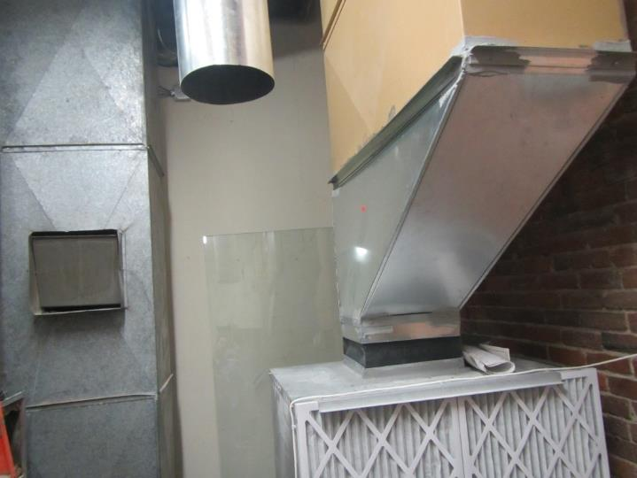
Fresh air duct in mechanical room
Picture 2
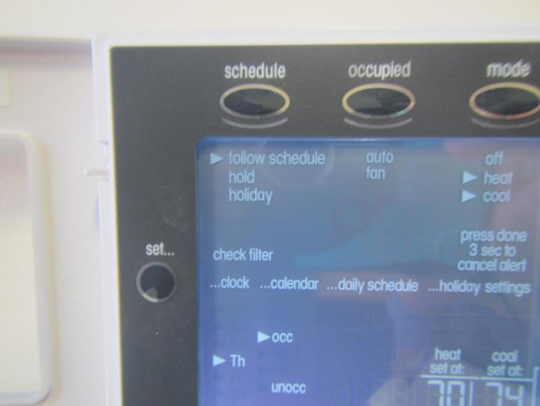
Fan controls set to “auto” instead of recommended “on”
Picture 3
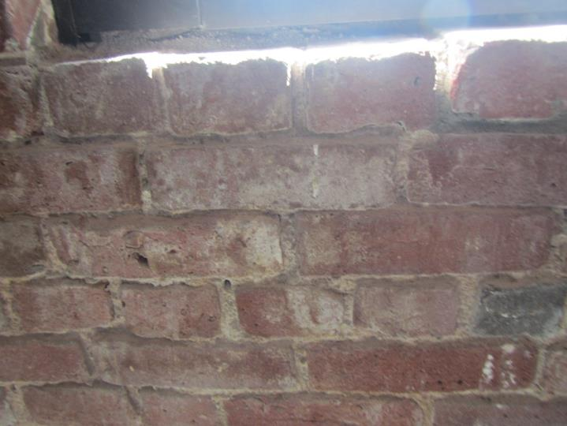
Efflorescence on brickwork
Picture 4
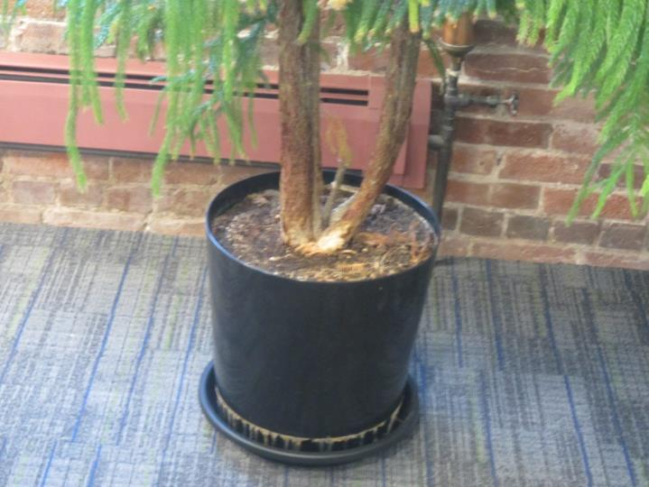
Plant in occupied area
Picture 5
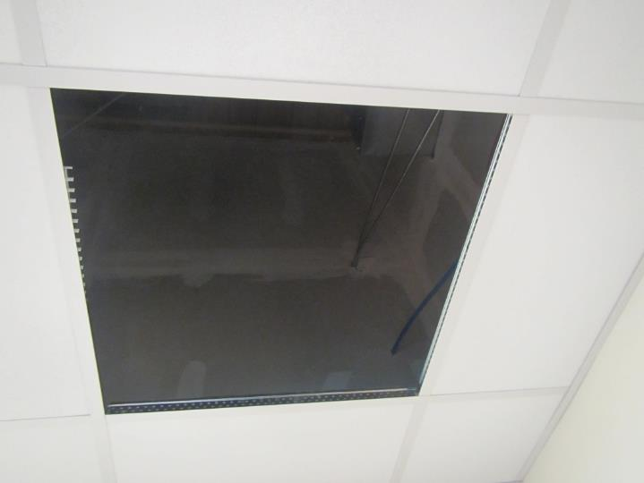
Exhaust/return grate not seated in ceiling grid
Picture 6
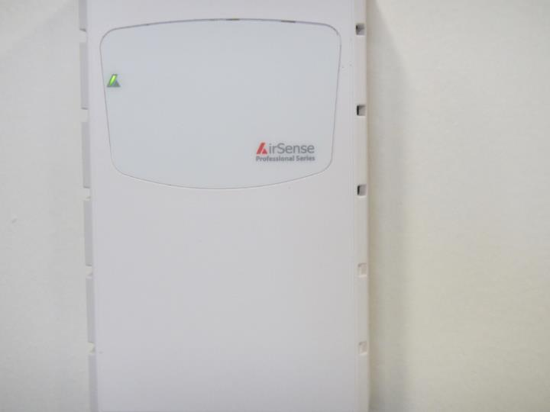
Carbon dioxide sensor which activates exhaust in conference rooms
Location | Carbon  Dioxide  (ppm) | Carbon Monoxide  (ppm) | Temp  (°F) | Relative  Humidity  (%) | PM2.5  (µg/m³) | TVOCs  (ppm) | Occupants  in Room | Windows  Openable | Ventilation |  | Remarks
 |  |  |  |  |  |  |  |  | Supply | Exhaust
Background | 385 | ND | 51 | 20 | 19 | ND | - | - | - | - | Clear, cool
Waiting room | 694 | ND | 66 | 37 | 5 | ND | 3 | N | Y | Y | Vinyl flooring
4103 | 693 | ND | 69 | 33 | 4 | ND | 0 | N | Y | Y | HS, tile flooring
4104 | 706 | ND | 70 | 32 | 4 | ND | 0 | N | Y | Y | HS, tile flooring
4105 | 787 | ND | 70 | 33 | 4 | ND | 1 | N | Y | Y | MT (plenum return grate not seated)
4106 | 725 | ND | 71 | 31 | 4 | ND | 0 | N | Y | Y | Tile flooring
4107 | 748 | ND | 71 | 31 | 3 | ND | 1 | N | Y | Y | Plant/tree, local exhaust w/CO² activation
4184 | 743 | ND | 72 | 32 | 2 | ND | 0 | N | Y | Y | Tile flooring
4108 | 712 | ND | 72 | 29 | 1 | ND | 1 | N | Y | Y | Carpet tiles, plant, local exhaust w/CO² activation
4109 | 718 | ND | 71 | 30 | 1 | ND | 0 | N | Y | Y
4110 | 733 | ND | 71 | 31 | 1 | ND | 1 | N | Y | Y | AI
4113 | 759 | ND | 72 | 32 | 2 | ND | 0 | N | Y | Y | AF odor, Plant carpet
4114 | 768 | ND | 72 | 31 | 1 | ND | 1 | N | Y | Y | Carpet tiles
4119 open cubes | 794 | ND | 72 | 32 | 2 | ND | 1 | N | Y | Y | Carpet tiles, plants
4115 | 797 | ND | 73 | 31 | 2 | ND | 1 | N | Y | Y
4123 open cubes | 798 | ND | 73 | 30 | 3 | ND | 1 | N | Y | Y | HS
4129 open cubes | 787 | ND | 73 | 31 | 1 | ND | 1 | N | Y | Y | Carpet tiles
4134 | 749 | ND | 75 | 30 | 2 | ND | 1 | N | Y | Y | Solar glare, local exhaust w/CO² activation
4136-kitchen | 1442 | ND | 79 | 38 | 5 | ND | 4 | N | Y | Y | Hot/humid, fan “auto”-no airflow, need local exhaust, door closed
4138 open cubes | 787 | ND | 75 | 28 | 2 | ND | 0 | N | Y | Y | Carpet tile
4102-reception | 822 | ND | 74 | 29 | 3 | ND | 2 | N | Y | Y | DEM, carpet tile
4141 open cubes | 798 | ND | 74 | 29 | 3 | ND | 3 | N | Y | Y
4183 | 807 | ND | 75 | 28 | 2 | ND | 1 | N | Y | Y | Carpet tile
4182 | 832 | ND | 76 | 29 | 4 | ND | 1 | N | Y | Y | PF, DEM
4147 | 797 | ND | 76 | 28 | 3 | ND | 2 | N | Y | Y
4156 | 816 | ND | 76 | 29 | 4 | ND | 2 | N | Y | Y | Carpet tile
4176 | 833 | ND | 76 | 28 | 2 | ND | - | N | Y | Y | Carpet tile
4165 open | 787 | ND | 76 | 28 | 3 | ND | 2 | N | Y | Y | Plant
4175 | 910 | ND | 76 | 28 | 3 | ND | 1 | N | Y | Y | Door was closed
4174 | 795 | ND | 75 | 28 | 4 | ND | 1 | N | Y | Y | Tile flooring
4167 | 807 | ND | 75 | 29 | 4 | ND | 1 | N | Y | Y | Carpet tile
4168 | 809 | ND | 75 | 29 | 4 | ND | 0 | N | Y | Y | HS
4172 | 769 | ND | 75 | 28 | 5 | ND | 1 | N | Y | Y | Stored items
4171 | 772 | ND | 74 | 28 | 4 | ND | 0 | N | Y | Y | Brick efflorescence
4170 | 872 | ND | 73 | 30 | 5 | ND | 1 | N | Y | Y | HS, carpet tile
4173 | 822 | ND | 74 | 29 | 4 | ND | 1 | N | Y | Y | AI

