INDOOR AIR QUALITY ASSESSMENT

Wakefield High School
60 Farm Street
Wakefield, MA

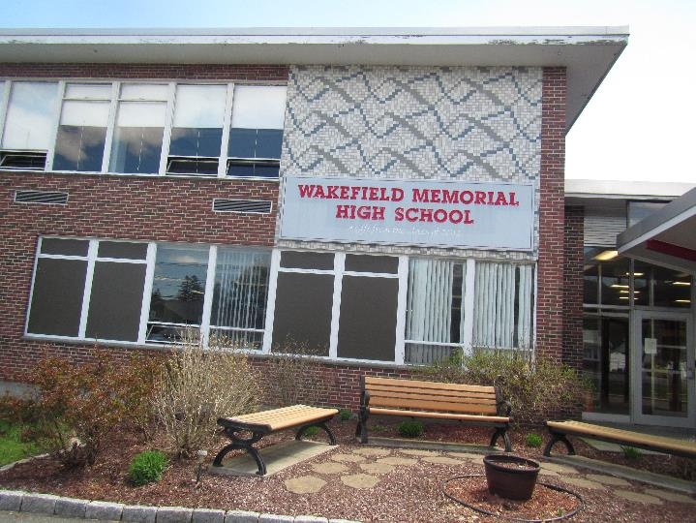

Prepared by:
Massachusetts Department of Public Health
Bureau of Environmental Health
Indoor Air Quality Program
May 2019

Background

Building: | Wakefield High School (WHS)
Address: | 60 Farm Street, Wakefield, MA
Assessment Requested by: | Bob Schiaroli  Director of Facilities  Wakefield Public Schools
Reason for Request: | General indoor air quality (IAQ)
Date of Assessment: | April 25, 2019
Massachusetts Department of Public Health/Bureau of Environmental Health (MDPH/BEH) Staff Conducting Assessment: | Ruth Alfasso, Environmental Engineer/Inspector, IAQ Program and Jason Dustin, Environmental Analyst/Inspector, IAQ Program
Building Description: | The WHS is a brick and cement-slab structure originally built in 1960 with renovations and additions in 1974. The building has a lower floor, an upper floor and a third floor with a smaller footprint. The school contains general classrooms, science classrooms, art classrooms, home economics and shop classrooms, a gym and field house, two cafeterias, a library and a variety of offices. Also included in this assessment was the administration wing.
Building Population: | Approximately 1050 total students and staff
Windows: | Most windows are openable

This building has been visited several times in the past, most recently in 2012. Reports from those previous visits are available on request.

IAQ Testing Results
Please refer to the IAQ Manual for methods, sampling procedures, and interpretation of results (MDPH, 2015). The following is a summary of indoor air testing results (Table 1).
- Carbon dioxide levels were above the MDPH guideline of 800 parts per million (ppm) in approximately half of all rooms tested, indicating inadequate air exchange in those areas.
- Temperature was within or close to the MDPH recommended range of 70°F to 78°F the day of the assessment, however many occupants expressed temperature complaints.
- Relative humidity was within or close to the lower end of the MDPH recommended range of 40 to 60% in all areas the day of assessment.
- Carbon monoxide levels were non-detectable (ND) in all areas tested.
- Fine particulate matter (PM2.5) concentrations measured were below the National Ambient Air Quality (NAAQS) limit of 35 μg/m³ in most areas tested. There were a few areas in the lower level with PM2.5 measurements above the NAAQS limit, discussed further below.

Ventilation
A heating, ventilating and air conditioning (HVAC) system has several functions. First it provides heating and, if equipped, cooling. Second, it is a source of fresh air. Finally, an HVAC system will dilute and remove normally occurring indoor environmental pollutants by not only introducing fresh air, but by filtering the airstream and ejecting stale air to the outdoors via exhaust ventilation. Even if an HVAC system is operating as designed, point sources of respiratory irritation may exist and cause symptoms in sensitive individuals.
Fresh air to classrooms along exterior walls is supplied by unit ventilator (univent) systems (Pictures 1). A univent draws air from the outdoors through a fresh air intake located on the exterior wall of the building (Picture 2). Return air from the classroom is drawn through an air intake located at the base of the unit (Figure 1). Fresh and return air are mixed, filtered, heated and provided to classrooms through an air diffuser located in the top of the unit. Univents were found deactivated in many rooms in the school at the time of the assessment. Most occupants reported that due to extremely hot temperatures in the units, they shut down the univent fans. In addition, some univents were found obstructed by furniture and other items on top of air diffusers and/or in front of return vents along the bottom of the units (Pictures 3 and 4). Some univents were also found with missing/damaged covers and panels ajar (Picture 4), which can allow air to bypass the filter and allow dust and dirt to be entrained inside. Univent cabinets, intakes and diffusers should be vacuumed out each time the filter is changed to remove dust and debris. In order for univents to provide fresh air as designed, they must remain “on” and operating while rooms are occupied. Furthermore, units must remain free of obstructions.
Exhaust ventilation in classrooms with univents is provided by either unit exhaust ventilators or wall- or ceiling-mounted exhaust vents ducted to rooftop motors. While similar in appearance to a univent, unit exhaust ventilators lack a fresh air supply on the top of the unit and are designed to draw air directly to the outside of a building (Picture 5). Some wall-mounted exhaust vents were blocked at the time of assessment, many were found off/not drawing air, and a few were in very bad condition, allowing debris to be inserted into the ductwork (Table 1). As with supply ventilation, exhaust ventilation must be free of blockages and allowed to operate while the building is occupied.
Note that the univents and unit exhausts are original equipment, and therefore greater than 40 years old. Function of equipment of this age is difficult to maintain, since compatible replacement parts are often unavailable. According to the American Society of Heating, Refrigeration and Air-Conditioning Engineers (ASHRAE), the service life for a unit heater, hot water or steam is 20 years, assuming routine maintenance of the equipment (ASHRAE, 1991). Despite repeated attempts to maintain these units, the operational lifespan of the equipment has been exceeded. Maintaining the balance of fresh air to exhaust air as well as controlling temperature becomes more difficult as the equipment ages and as replacement parts become increasingly difficult to obtain.
Mechanical ventilation for interior classrooms and common areas (e.g., auditorium, gymnasium) is provided by rooftop air-handling units (AHUs). Fresh air is distributed via ceiling or wall-mounted air diffusers (Picture 6) and ducted back to AHUs via ceiling or wall-mounted return vents. In many rooms exhaust vents are located near hallway doors, which are generally left open. However, with the hallway doors open the exhaust vent will tend to draw air from the hallway into the classroom, instead of drawing stale air from the classroom. Therefore it is recommended that classroom doors remain shut while exhaust vents are operating to function as designed. Many of the supply vents and nearby ceiling tiles were dusty (Picture 6).
There were chemistry hoods in a few science classrooms (Table 1). These units need to be calibrated/tested yearly to ensure proper function. Stickers on the front of the cabinets indicate when the next test/calibration is required.
In order to have proper ventilation with a mechanical supply and exhaust system, these systems must be balanced to provide an adequate amount of fresh air while removing stale air from a room. It is recommended that existing ventilation systems be re-balanced every five years to ensure adequate air systems function (SMACNA, 1994).

Microbial/Moisture Concerns
Water-damaged ceiling tiles were observed in many areas (Pictures 7 through 10; Table 1), which indicate leaks from the building envelope or plumbing system. A few of the stains were dark which may indicate microbial colonization. Stained tiles should be discarded and replaced. Active leaks are reported in some classrooms and hallways during heavy rain (Table 1). Occupants in a few classrooms report that water that leaks in those classrooms is a brown color, and facility staff believe these are from a broken roof drain pipe. Facility staff reports that repairs of this pipe are planned. Until the pipe and other building envelope leaks can be repaired, occupants are advised not to store/place items in areas where leaks occur and to report any leaks or water infiltration promptly.
Indoor plants were observed in a few areas (Table 1). Plants can be a source of pollen and mold, which can be respiratory irritants to some individuals. Plants should be properly maintained, equipped with non-porous drip pans, and should be located away from air diffusers to prevent the aerosolization of dirt, pollen and mold.
BEH staff noted gaps under a few exterior doors where light could be seen penetrating (Picture 11). This is an indicator that these doors need to be fitted with tighter fitting weather stripping/door sweeps to prevent moisture, pests, and unconditioned air from infiltrating occupied areas. Facility staff report that many exterior doors were recently replaced.

Other IAQ Evaluations
Exposure to low levels of total volatile organic compounds (TVOCs) may produce eye, nose, throat, and/or respiratory irritation in some sensitive individuals. To determine if VOCs were present, BEH/IAQ staff examined rooms for products containing VOCs. BEH/IAQ staff noted hand sanitizers, scented cleaners, air fresheners, and dry erase materials in use within the building (Picture 12). All of these products have the potential to be irritants to the eyes, nose, throat, and respiratory system of sensitive individuals (e.g., asthmatics). There was a sharp odor of cleaning product or isopropyl alcohol in room 2211, a staff break room. No obvious source of the odor was identified. Only cleaning products supplied by the school should be used, and they should be used in accordance with package directions, including dilution and ventilation. Due to the pervasive use of these products in schools throughout Massachusetts, the MDPH has produced a guideline called “Clean Air Is Odor-Free” which is included as Appendix A.
There is a darkroom located in a former boys’ bathroom on the lower level. There is no vent hood or source of specialized ventilation in this room. The standard bathroom exhaust vents in this room were also off/nonfunctional at the time of the assessment. This means there is no means for removal of chemical vapors, odors, and water vapor from the use of photographic developing chemicals in this room. Photographic developing uses a variety of chemicals, many of which are irritating to inhale or get on the skin and eyes. To prevent exposure to these chemicals, sufficient exhaust ventilation and make-up air is required, as well as use of protective clothing. Depending on the types and amounts of specific chemicals used, additional measures may be required to perform photo developing safely. Note that there was a High-Efficiency Particulate Arrestance (HEPA) filter air purifier in this room. HEPA filters only remove particulates, not gases or vapors from the air, and do not supply fresh air or exhaust.
Levels of PM2.5 were elevated in a few rooms on the lower level (Table 1). The source of the PM2.5 in most of the rooms where it was elevated appeared to be from cooking activities in one or more of the kitchen classrooms, e.g. in room 1312 where some food (sandwiches, bacon) was being prepared on a griddle, and in room 1301 which had an odor of burned food. The stoves in the kitchen classrooms appeared to have hoods with recirculating filters, which do not eject smoke, particulates, and odors from the building. Room 1312 had all the windows closed as well. Opening the windows during cooking activities would allow some of the smoke/odors to exit the building. From an examination of the exterior of the building, there are or were exterior-directed vents for classrooms with kitchens (Picture 13). It was not known if these units are connected or functional, but if possible they should be returned to service in rooms with active kitchens. Note that one of these vents had bird nesting material, indicating that it is likely not used.
Levels of PM2.5 were also elevated in the TV studio classroom, which may be related to cooking particulates being transferred via the ventilation system or there may be additional sources in or near that room, such as fraying carpeting, or the use of cooking equipment inside the TV studio suite. The effectiveness of supply and exhaust ventilation is especially important in a small, windowless crowded area with a variety of heat-producing electronic equipment in it.
Kitchen appliances (e.g., toaster ovens) in some areas were noted to contain accumulated food particles (Picture 14). Unless cleaned regularly, these appliances will serve as a source of airborne particulates, odors, and pest food source. Many classrooms had food in them. Mice were reported in various locations in this school, including the cafeteria kitchen. Several measures have reportedly been taken to address mouse issues, including improved food storage and contracting with a licensed pest control operator for mouse baiting and removal.
Mice can be a source of allergens, particularly in urine and dander which may remain after the mice have been removed. The principals of Integrated Pest Management (IPM) which include the removal of sources of food, water, warmth and harborage in the building, should be followed. Enhanced cleaning and reduction in clutter can assist in pest control, as well as removing pests and pest wastes. A certified pest control professional may be needed to assist with these issues. The document “Integrated Pest Management Kit for Building Managers” provides additional strategies for IPM (MDFA, 1996).
There are two electric kilns in a small room connected to an art room by a door. Each have vents to direct exhaust from operation outside the building; however there is no exhaust fan for this room. WHS staff report that when the kilns are operated, the door from the kiln room to the hallway is opened and fitted with a fan to remove excess heat and any odors. This manual venting procedure should be conducted whenever the kilns are in use, the door between the kiln room and the art classroom should be kept closed, and the kiln and nearby area should be kept clean and free of materials and dust that could give off odors when heated.
Some classrooms had personal fans. Some of these had dusty blades/housings (Picture 15; Table 1). Many supply diffusers and exhaust/return vents were also observed to be dusty (Picture 6; Table 1). This dust can be reaerosolized when the equipment is activated.
In many areas, accumulated items including books, papers, and decorative items were observed on floors, windowsills, tabletops, counters, bookcases, and desks. Excess items on surfaces can make it more difficult for custodial staff to clean. Items should be stored neatly (e.g., shelves, totes) and moved periodically to allow wet wiping of surfaces. Some chalk trays had debris from chalk or dry erase markers; this material should be wet-wiped frequently to prevent it becoming aerosolized. Pencil shavings on flat surfaces were also found in a few classrooms.
Some areas of the school have carpeting. Carpets should be cleaned annually (or semi-annually in soiled/high traffic areas) in accordance with Institute of Inspection, Cleaning and Restoration Certification (IICRC) recommendations, (IICRC, 2012). Regular cleaning with a high efficiency particulate air (HEPA) filtered vacuum in combination with an annual cleaning will help to reduce accumulation and potential aerosolization of materials from carpeting.
It is important to note that due to the age of the building, asbestos-containing materials (ACM) may be present. Ensure the school is in compliance with the Asbestos Hazard Emergency Response Act (AHERA), which requires inspection of asbestos containing materials every three years as well as a semi-annual walkthrough to determine current conditions of asbestos-containing materials.
Note that the Environmental Protection Agency (EPA) conducted a National School Radon Survey in which it discovered nearly one in five schools had “…at least one frequently occupied ground contact room with short-term radon levels above 4 [picocuries per liter] pCi/L” (US EPA 1993). The BEH/IAQ Program therefore recommends that every school be tested for radon, and that this testing be conducted during the heating season while school is in session in a manner consistent with USEPA radon testing guidelines. Radon measurement specialists and other information can be found at www.nrsb.org and http://aarst-nrpp.com/wp, with additional information at: http://www.mass.gov/eohhs/gov/departments/dph/programs/environmental-health/exposure-topics/iaq/radon.

Conclusions/Recommendations
The conditions related to IAQ problems at the WHS raise a number of issues. Some of these conditions can be remedied by actions of building occupants. Other remediation efforts will require alteration to the building structure and equipment. For these reasons, a two-phase approach is required for remediation. The first consists of short-term measures to improve air quality and the second consists of long-term measures that will require planning and resources to adequately address overall IAQ concerns.

Short-term measures:
- Consult with an HVAC contractor to troubleshoot heating control issues for unit ventilators which is currently preventing staff from utilizing the units as designed for adequate ventilation. Once these repairs are made, investigate methods to restrict access to the fan controls so that occupants cannot shut them off.
- Ensure there is a method for staff to report issues with temperature control, malfunctioning ventilation equipment, leaks and other building related concerns to facilities staff. This should include a tracking method to ensure follow-up and communication back to the reporter regarding the status of issues.
- Operate all supply and exhaust ventilation equipment continuously during occupied hours.
- Remove items and furniture blocking univents, unit exhausts and exhaust vents.
- Use openable windows to supplement fresh air during temperate weather. Ensure all windows are tightly closed at the end of the day.
- Check return and exhaust vents for draw periodically and repair any non-operating motors/vents.
- Replace missing vent covers, fix door panels and otherwise ensure ventilation equipment parts fit together to avoid short-circuiting of airflow around filters, entrainment of dust or debris, or insertion of objects into system components.
- Consider adopting a balancing schedule of every 5 years for all mechanical ventilation systems, as recommended by ventilation industrial standards (SMACNA, 1994).
- Ensure filters for univents and AHUs are changed a minimum of twice a year, or more often if possible. Vacuum out univent and AHU cabinets during filter changes to remove dust and debris. The MDPH recommends using pleated filters of Minimum Efficiency Reporting Value (MERV) of 8, which are adequate in filtering out pollen and mold spores (ASHRAE, 2012), if these can be used with current equipment.
- In rooms where exhaust ventilation is located near doors, close the door to allow for designed airflow from the room.
- Ensure chemistry hoods are calibrated yearly as required.
- Ensure any roof and plumbing leaks are repaired promptly and replace any water-damaged ceiling tiles or other porous building materials.
- Avoid storing any items, particularly porous items in areas with known leaks.
- Properly maintain plants, including drip pans, to prevent water damage to porous materials. Plants should also be located away from air diffusers to prevent the aerosolization of dirt, pollen, and mold.
- Repair or replace weather-stripping on doors with gaps.
- Consult the Safety Data Sheet for all chemicals used for photographic developing and ensure that appropriate ventilation and protective equipment can be used. At a minimum, ensure that the existing exhaust ventilation is on and functioning at all times the room is used, and that make-up air can be supplied from outside. The use of a HEPA filtered air purifier in this room will not remove VOCs, fumes, or water vapor from the room.
- Reduce the use of products and equipment that contain VOCs and eliminate the use of scented products such as air fresheners, reed diffusers and similar products. Ensure only school-supplied cleaning products are used in the building and that they are used in accordance with package instructions, including any need for dilution or ventilation.
- Ensure that sufficient fresh air and exhaust ventilation is available for rooms where cooking may occur. Investigate the presence of exhaust vents and return these to service if possible in rooms still used for cooking. At a minimum, use openable windows during cooking activities.
- Ensure all cooking appliances such as toasters, toaster ovens and microwaves are kept clean and in good condition to avoid smoke, odors and pests.
- Keep food in sealed containers and clean crumbs regularly.
- Use the principles of IPM to address rodent issues including the use of a licensed pest control professional. Ensure that areas with rodent issues are thoroughly cleaned to remove dander and urine that can cause allergic reactions.
- Keep the kiln area clean, free of dust and keep the door between the kiln room and the art room closed while the hallway door is open to provide additional exhaust ventilation.
- Ensure that the school is in compliance with AHERA regulations for asbestos-containing materials including inspection and planning.
- Regularly clean supply/return/exhaust vents and fans to avoid aerosolizing accumulated particulate matter.
- Consider reducing the amount of items stored in rooms to make cleaning easier. Periodically move items to clean flat surfaces. Store porous items on shelving and away from walls.
- HEPA vacuum carpeting daily and clean carpeting annually (or semi-annually in soiled high traffic areas). Clean area rugs similarly.
- For buildings in New England, periods of low relative humidity during the winter are often unavoidable. Therefore, scrupulous cleaning practices should be adopted to minimize common indoor air contaminants whose irritant effects can be enhanced when the relative humidity is low. To control dusts, a high efficiency particulate arrestance (HEPA) filter equipped vacuum cleaner in conjunction with wet wiping of all surfaces is recommended. Avoid the use of feather dusters. Drinking water during the day can help ease some symptoms associated with a dry environment (throat and sinus irritations).
- The school should be tested for radon by a certified radon measurement specialist during the heating season when school is in session. Radon measurement specialists and other information can be found at: www.nrsb.org, and http://aarst-nrpp.com/wp.
- Consider adopting the US EPA (2000) document, “Tools for Schools”, as an instrument for maintaining a good IAQ environment in the building available at: http://www.epa.gov/iaq/schools/index.html
- Refer to resource manual and other related IAQ documents located on the MDPH’s website for further building-wide evaluations and advice on maintaining public buildings. These documents are available at: http://mass.gov/dph/iaq.

Long-term measures
- Contact an HVAC engineering firm for an assessment of the ventilation system’s components and control systems (e.g., controls, air intake louvers, thermostats). Based on the age, physical deterioration, and availability of parts for ventilation components, such an evaluation is necessary to determine the operability and feasibility of repairing/replacing the equipment.
- Examine the feasibility of initiating capital improvement plans for major roof repairs/replacement.

References
ASHRAE. 1991. ASHRAE Applications Handbook, Chapter 33 “Owning and Operating Costs”. American Society of Heating, Refrigeration and Air Conditioning Engineers, Atlanta, GA.
ASHRAE. 2012. American Society of Heating, Refrigeration and Air Conditioning Engineers (ASHRAE) Standard 52.2-2012 -- Method of Testing General Ventilation Air-Cleaning Devices for Removal Efficiency by Particle Size (ANSI Approved).
IICRC. 2012. Carpet Cleaning FAQ 4 Institute of Inspection, Cleaning and Restoration Certification. Institute of Inspection Cleaning and Restoration, Vancouver, WA.
MDFA. 1996. Integrated Pest Management Kit for Building Managers. Massachusetts Department of Food and Agriculture, Pesticide Bureau, Boston, MA.
MDPH. 2015. Massachusetts Department of Public Health. “Indoor Air Quality Manual: Chapters I-III”. Available at: http://www.mass.gov/eohhs/gov/departments/dph/programs/environmental-health/exposure-topics/iaq/iaq-manual/.
SMACNA. 1994. HVAC Systems Commissioning Manual. 1st ed. Sheet Metal and Air Conditioning Contractors’ National Association, Inc., Chantilly, VA.
US EPA. 1993. Radon Measurement in Schools, Revised Edition. Office of Air and Radiation, Office of Radiation and Indoor Air, Indoor Environments Division (6609J). EPA 402-R-92-014. https://www.epa.gov/sites/production/files/2014-08/documents/radon_measurement_in_schools.pdf
US EPA. 2000. Tools for Schools. Office of Air and Radiation, Office of Radiation and Indoor Air, Indoor Environments Division (6609J). EPA 402-K-95-001, Second Edition. http://www.epa.gov/iaq/schools/index.html.
Picture 1
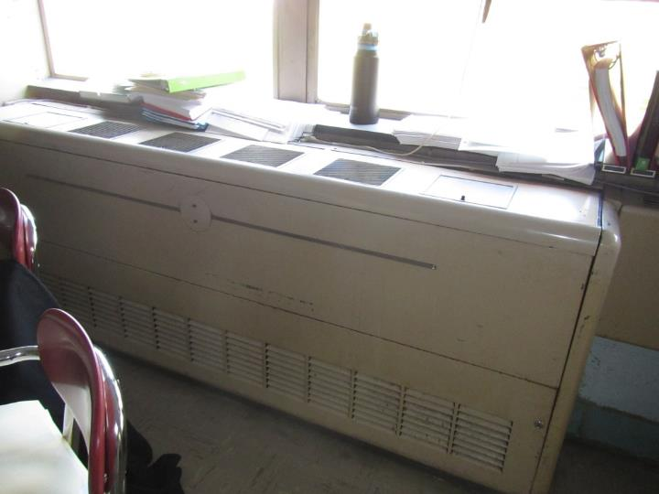
Unit ventilator (univent)
Picture 2
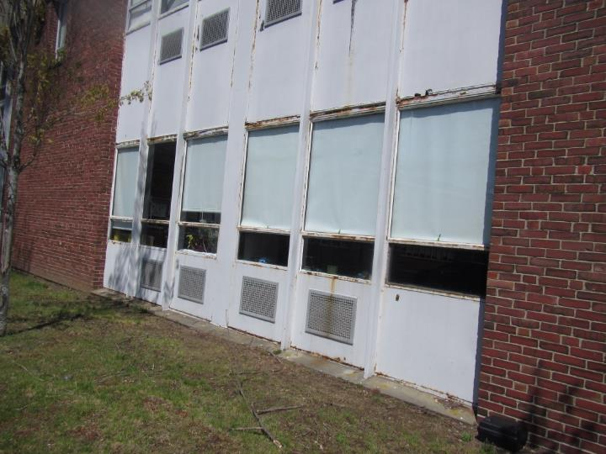
Air intake grills for univents, note some vents are for unit exhausts
Picture 3
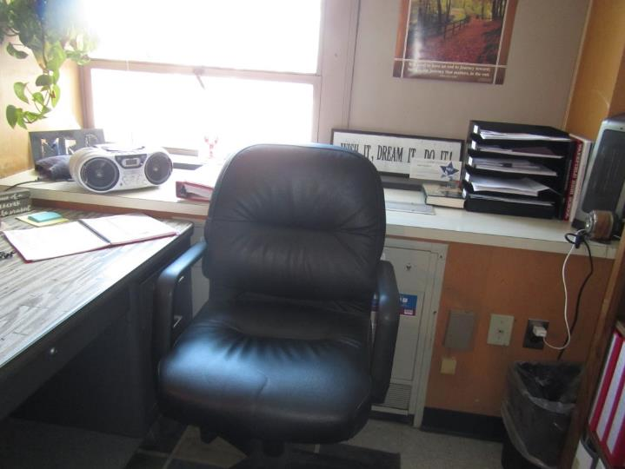
Unit ventilator blocked by items and furniture
Picture 4
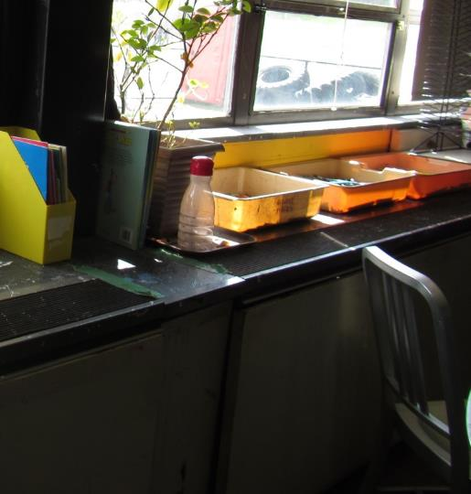
Unit ventilator with ajar cover, plants and items on top
Picture 5
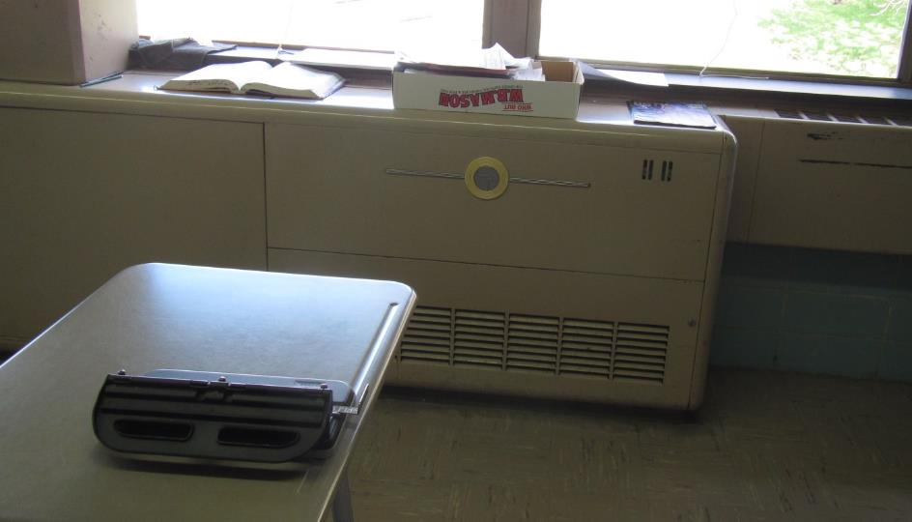
Unit Exhaust
Picture 6
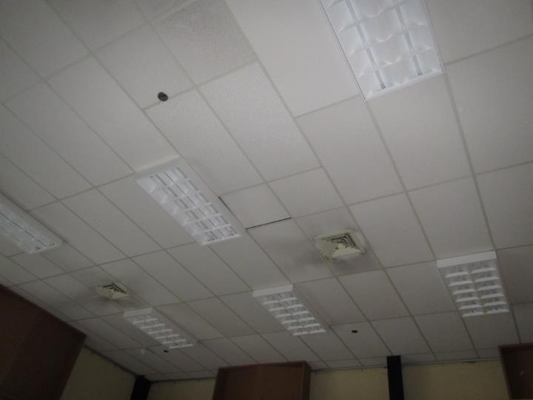
Supply vents, note dust on louvers and nearby tiles
Picture 7
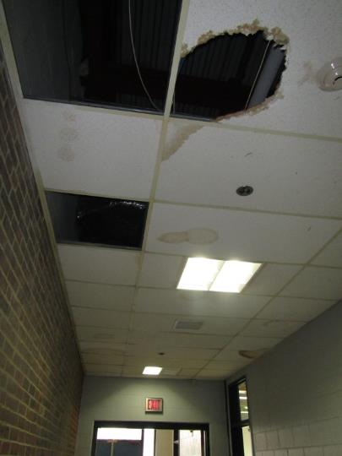
Water-damaged and missing ceiling tiles
Picture 8
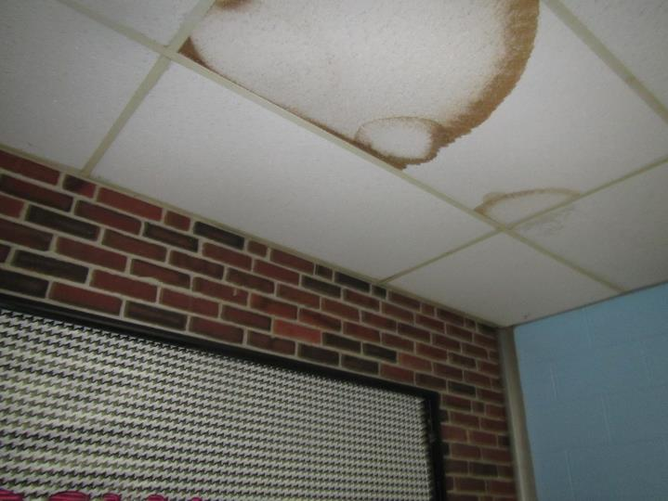
Water-damaged ceiling tiles
Picture 9
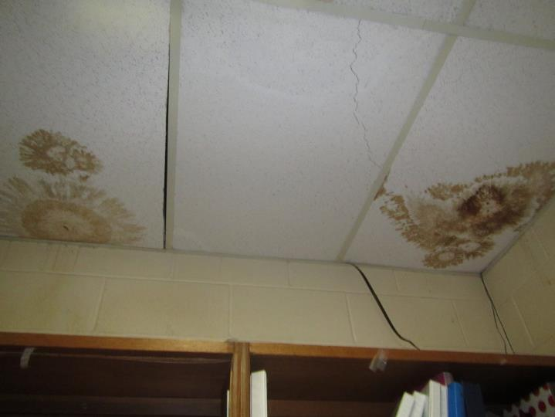
Dark color on water-damaged ceiling tiles may indicate microbial growth
Picture 10
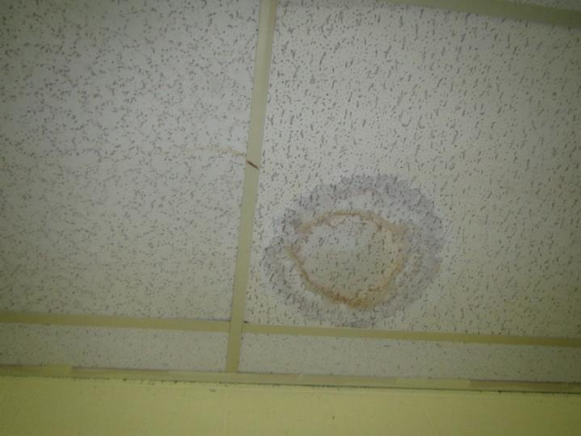
Water-damaged ceiling tile, lighter color around stain suggests recent leak
Picture 11
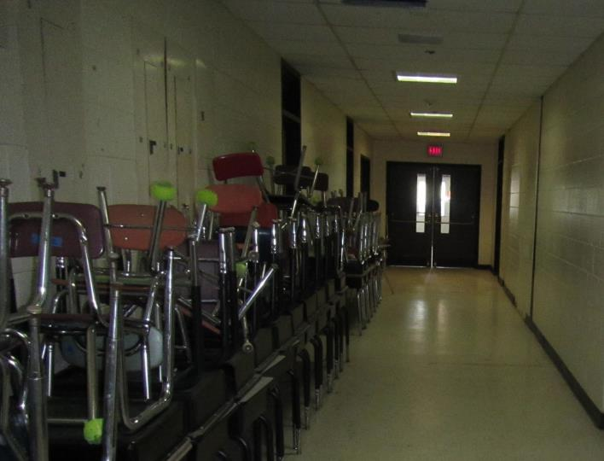
Light visible around exterior door
Picture 12
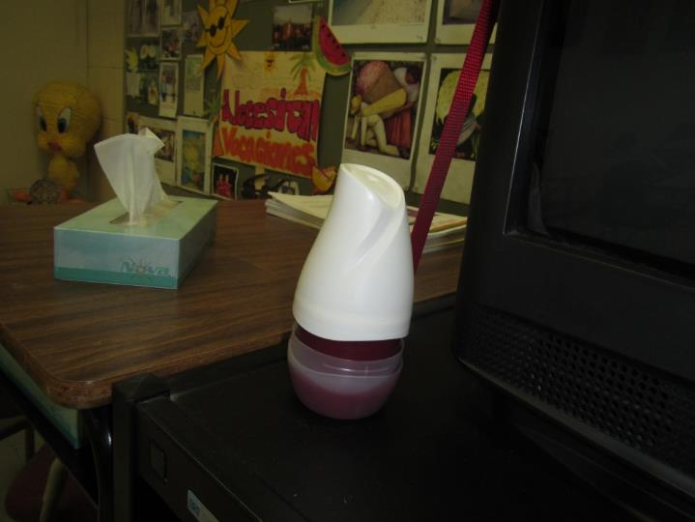
Pop-up air freshener product
Picture 13
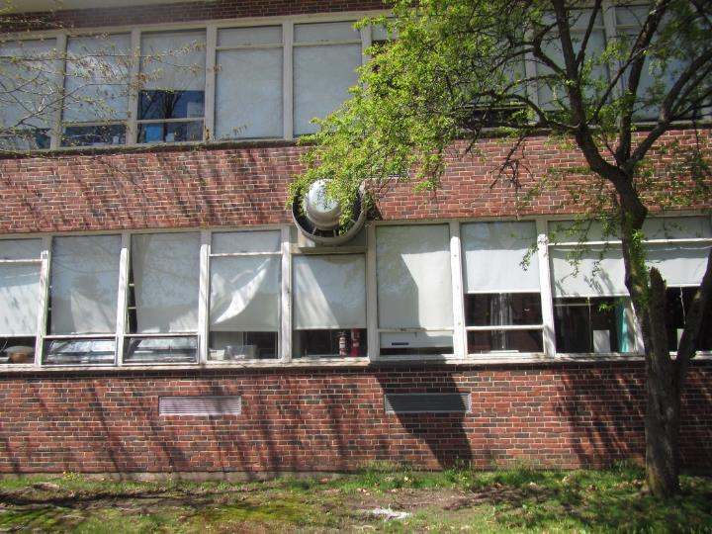
Exterior of lower level showing exhaust vent, likely on kitchen classroom
Picture 14
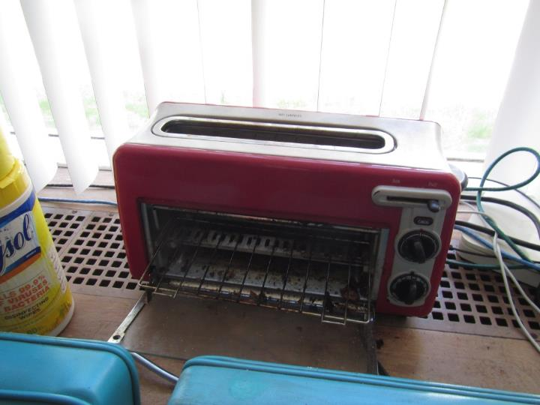
Toaster oven with crumbs on top of univent or heating unit
Picture 15
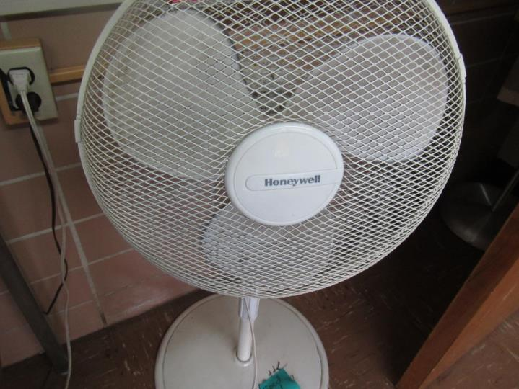
Dusty fan blades

Location | Carbon  Dioxide  (ppm) | Carbon Monoxide  (ppm) | Temp  (°F) | Relative  Humidity  (%) | PM2.5  (µg/m³) | Occupants  in Room | Windows  Openable | Ventilation |  | Remarks
 |  |  |  |  |  |  |  | Supply | Exhaust
Background | 394 | ND | 60 | 35 | 11 |  |  |  |  | Sunny
Main level
2007 | 644 | ND | 74 | 31 | 6 | 0 | N | Y | Y | NC
2008 | 1018 | ND | 78 | 36 | 9 | - | N | Y | Y
2109 | 922 | ND | 73 | 38 | 5 | 15 | Y | Y |  | UV blocked, DEM, HS
2114 | 1011 | ND | 73 | 39 | 2 | 1 | N | Y | Y
2200 | 693 | ND | 73 | 31 | 4 | 1 | N | Y | Y | NC, DEM, dusty univent
2201 | 1028 | ND | 71 | 37 | 5 | 14 | Y | Y | Y | NC
2201 | 965 | ND | 72 | 38 | 8 | 15 | N | Y | Y | DEM
2203 | 1169 | ND | 72 | 37 | 4 | 1 | Y | Y | Y
2204 | 1013 | ND | 73 | 39 | 8 | 20+ | N | Y | Y | DO, NC
2206 | 1067 | ND | 73 | 40 | 4 | 9 | N | Y | Y | DEM
2207 | 976 | ND | 73 | 34 | 7 | 13 | N | Y | Y | AF, NC, chalk
2209 | 878 | ND | 73 | 36 | 3 | 14 | N | Y | Y | NC, vents dusty
2211 Break room | 741 | ND | 73 | 36 | 9 | 2 | N | Y | Y | Strong isopropyl alcohol odor (HS/CP use??)
2215 science | 888 | ND | 72 | 37 | 21 | 0 | Y | Y | Y
2217 | 731 | ND | 72 | 34 | 3 | 1 | N | Y | Y | reported air issues, water leaks, DEM, PS
2219 | 666 | ND | 73 | 32 | 4 | 0 | N | Y | Y | area rug, NC, DEM, cloth wall
2221 | 716 | ND |  | 32 | 3 | 0 | Y | Y | Y | chalk
2223 | 714 | ND | 73 | 35 | 4 | 22 | Y | Y | Y | chalk, new unit
2226 | 1169 | ND | 74 | 40 | 4 | 11 | N | Y | Y | WD CTs in Hall outside room
2227 | 1267 | ND | 73 | 41 | 7 | 18 | Y | Y | Y | Lab hood
2229 | 1430 | ND | 73 | 44 | 8 | 20 | Y | Y | Y | Windows leak, odors from UV
2231 | 1234 | ND | 72 | 43 | 7 | 21 | N | Y | Y | CPs, DEM
2236 | 938 | ND | 72 | 38 | 36 | 14 | Y | Y | Y | NC, DEM, lab sinks, safety shower
2239 | 1517 | ND | 74 | 44 | 12 | 19 | N | Y | Y | DEM, Plants
2241 | 1059 | ND | 73 | 39 | 17 | 0 | Y | Y | Y | DEM
2247 storage |  |  |  |  |  |  |  | Y |  | WD CT, sink, PF
2247 workroom | 863 | ND | 73 | 37 | 18 | 0 | Y | Y | Y | NC, PCs
2300 | 1108 | ND | 74 | 39 | 11 | 12 | Y | Y | Y | PF, DEM, acoustic tiles, PF
2301 | 940 | ND | 75 | 37 | 3 | 1 | N | Y on | Y
2303 | 1011 | ND | 76 | 36 | 11 | 23 | N | Y | Y | DEM, windows open, plants
2304 | 1342 | ND | 74 | 43 | 13 | 18 | Y | Y | Y | acoustic tiles, DEM, NC, plants, PF, chalk
2306 | 1392 | ND | 75 | 40 | 6 | 1 | Y | Y | Y | DEM, NC, leaks reported
2307 | 1167 | ND | 76 | 38 | 12 | 21 | N | Y off | Y | AF
2308 | 1870 | ND | 74 | 41 | 6 | 2 | Y | Y | Y | chalk, DEM, PF, leaks reported
2309 | 723 | ND | 70 | 38 | 10 | 1 | Y open | Y | Y
2310 | 1298 | ND | 74 | 41 | 6 | 21 | Y | Y | Y | PF, chalk, DEM
2311 | 907 | ND | 72 | 38 | 12 | 18 | Y open | Y | Y | DEM, PF
2313 | 1045 | ND | 74 | 33 | 4 | 1 | Y | Y 1 open | Y | DEM, wood walls - dusty, chalk
2313 storage |  | ND |  |  |  |  |  | Y |  | books on shelving
Assistant principal | 500 | ND | 77 | 30 | 6 | 1 | Y | Y | Y | vent on
Conference | 622 | ND | 75 | 32 | 4 | 4 | Y | Y | Y | DEM, NC
Conference A | 516 | ND | 76 | 38 | 5 | 0 | Y | Y | Y | shared wall - cloth/board with conference B, DEM, NC
Guidance area | 537 | ND | 76 | 29 | 7 | 3 | Y | Y dusty | Y | Portable AC, exhaust not on
gymnastics gym | 663 | ND | 73 | 34 | 5 | 0 | N | Y | Y | maps, exhaust dusty and not working
Gymnastics-rear | 441 | ND | 72 | 37 | 7 | 3 | N | Y | Y
Health -Nurse | 560 | ND | 80 | 29 | 7 | 4 | N | Y | Y | Dusty vents, solar gain
Health suite | 609 | ND | 76 | 35 | 5 | 0 | N | Y | Y | Solar gain, old windows
Health -Treatment room | 541 | ND | 81 | 28 | 9 | 3 | N | Y | Y
main office | 507 | ND | 75 | 31 | 7 | 4 | Y 1 open | Y | Y | NC, has univents and overhead vents
Mr. Beech | 557 | ND | 76 | 29 | 4 | 0 | Y | Y | Y | UF, blocked UV
Mr. Robertson | 580 | ND | 76 | 29 | 5 | 0 | Y | Y | Y | Area rug, plant, blocked UV
Mrs. Burns | 576 | ND | 75 | 30 | 4 | 0 | Y | Y | Y
Mrs. Healey | 601 | ND | 75 | 29 | 4 | 1 | Y | Y | Y | Plants, area rug, AI on wall/floor, scented product
music 1 | 500 | ND | 72 | 31 | 8 | 0 | Y | Y | Y | dusty vents and tiles, DEM
music 3 | 465 | ND | 73 | 33 | 7 | 8 | Y | Y | Y | carpet, PF
music 5 | 446 | ND | 73 | 29 | 7 | 0 | Y | Y | Y | 2 WD CT, exhaust off, NC, sink, carpet
Music conference | 492 | ND | 73 | 32 | 5 | 0 | N | Y | Y | AI, old carpet on slab
Music Hall | 673 | ND | 72 | 36 | 4 | 0 | N | Y | Y | DEM, items on floor
Music Instrumental office | 457 | ND | 74 | 32 | 3 | 1 | N | Y | Y | Old carpet, on slab, DEM
Music practice 1 | 435 | ND | 73 | 30 | 7 | 0 | N | Y |  | Heater, acoustic wall and ceiling tiles, carpet
Music Practice 3 | 430 | ND | 73 | 32 | 3 | 0 | N | Y | Y | Acoustic wall tiles, carpet, blocked exhaust vent
Music practice 4 | 424 | ND | 72 | 30 | 7 | 0 | N | Y |  | Heater, acoustic wall and ceiling tiles, carpet, dirty walls
Music practice 5 (2417) | 623 | ND | 72 | 30 | 5 | 0 | N | Y |  | Heater, acoustic wall and ceiling tiles, carpet, piano
Music practice 6 | 413 | ND | 72 | 29 | 5 | 0 | N | Y |  | Instrument storage, acoustic tiles
Music practice drums | 411 | ND | 72 | 30 | 5 | 0 | N | Y |  | Broken wall tiles
Office | 742 | ND | 75 | 31 | 5 | 1 | Y | Y | Y | Plant, carpet
principal | 483 | ND | 77 | 28 | 7 | 0 | Y | Y | Y | plant on UV
Resource Center | 711 | ND | 73 | 34 | 15 | 14 | N | Y | Y | Carpet tile, musty odor, MTs
Science lecture hall | 1076 | ND | 72 | 41 | 4 | 0 | N | Y | Y | Old carpet, formalin-like odor (frog dissection?)
SPED admin office | 547 | ND | 74 | 31 | 3 | 1 | N | Y | Y | NC, food, plant, HS
SPED conference | 582 | ND | 73 | 30 | 3 | 0 | Y 2 open | Y | Y | Acoustic CT, NC, chalk
SPED office | 491 | ND | 73 | 31 | 4 | 1 | Y 2 open |  |  | NC, plants
SPED workroom | 508 | ND | 74 | 34 | 4 | 1 | Y | Y | Y | Food, NC
Staff meeting | 938 | ND | 73 | 39 | 17 | 0 | N | Y | ? | DEM
Upper Level
3000 | 592 | ND | 75 | 38 | 11 | 0 | N | Y | Y | MT in back
3002 | 629 | ND | 74 | 35 | 10 | 0 | N | Y | Y | Boxes on floor
3005 | 1005 | ND | 76 | 36 | 5 | 12 | Y 1 open | Y | Y | DEM
3006 | 669 | ND | 76 | 32 | 8 | 0 | Y open | Y | Y | Musty odor
3007 | 1046 | ND | 76 | 37 | 5 | 16 | Y 1 open | Y | Y | PF, DEM, PC
3008 | 627 | ND | 77 | 32 | 5 | 2 | Y | Y | Y
3009 | 875 | ND | 75 | 31 | 8 | 16 | Y 2 open | Y | Y | DEM, WD CT
3010 | 761 | ND | 76 | 32 | 9 | 14 | Y | Y | Y | DEM, PF
3011 | 732 | ND | 73 | 29 | 6 | 12 | Y 3 open | Y | Y | 4 MT
3012 | 846 | ND | 76 | 35 | 6 | 22 | Y | Y | Y
3013 | 746 | ND | 73 | 34 | 10 | 25 | Y | Y | Y
3033 | 968 | ND | 75 | 38 | 7 | 23 | Y | Y | Y | DEM, AF, HS
Custodial storage | 642 | ND | 71 | 37 | 3 | 1 | N | Y | Y
Library | 629 | ND | 74 | 33 | 4 | 7 | Y | Y | Y | Carpet tile, musty odor
Lower Level
1142 weight room | 519 | ND | 72 | 39 | 2 | 1 | N | Y | Y | WD CT in hallway, gym mat odor
1209 | 606 | ND | 71 | 34 | 4 | 0 | Y | Y | Y | DEM, plants, PC
1210 | 854 | ND | 71 | 37 | 4 | 1 | N | Y | Y | DEM
1211 | 1019 | ND | 71 | 38 | 3 | 17 | Y | Y | Y off | DEM, candle
1213 | 893 | ND | 71 | 38 | 3 | 22 | Y | Y | Y | CP, DEM, chalk
1214 | 821 | ND | 73 | 37 | 7 | 20 | N | Y | Y | MT, HS, past airflow complaints (blocked), ants
1215 | 738 | ND | 72 | 34 | 4 | 0 | Y | Y | Y off | dust and debris on vents, DEM
1217 | 930 | ND | 71 | 37 | 4 | 15 | N | Y | Y off | DEM, dusty vents
1219 | 740 | ND | 72 | 34 | 3 | 0 | N | Y | Y off | DEM, dusty vents
1221 |  | ND |  |  |  |  |  |  |  | storage for 1223
1223 | 829 | ND | 71 | 36 | 4 | 13 | N | Y | Y | DEM, WD CT, vents dusty, HS
1225 | 1246 | ND | 71 | 36 | 4 | 18 | N | Y | Y | DEM
1227 | 758 | ND | 71 | 35 | 3 | 2 | Y 1 open | Y | Y | DEM, cloth covering shelves
1228 | 669 | ND | 71 | 35 | 4 | 1 | N | Y | Y | Musty odor complaint
1229 | 873 | ND | 71 | 34 | 3 | 16 | Y 1 open | Y | Y | DEM
1230 | 803 | ND | 73 | 36 | 5 | 0 | N | Y | Y | DEM
1231 | 1076 | ND | 71 | 40 | 5 | 13 | Y | Y | Y | DEM
1236 | 681 | ND | 71 | 37 | 6 | 1 | N | Y | Y
1237 | 1107 | ND | 71 | 39 | 4 | 0 | Y | Y | Y | plug-in, HS
1239 | 702 | ND | 75 | 38 | 4 | 17 | N | Y | Y | Temperature complaints
1240 | 904 | ND | 75 | 37 | 23 | 8 | Y | Y | Y | UV dust and odor complaints
1241 | 449 | ND | 73 | 29 | 4 | 2 | Y 3 open | Y | Y | sinks, PFS
1243 | 701 | ND | 74 | 37 | 9 | 3 | Y 1 open | Y | Y | ductless AC, art supplies, sink
1245 | 920 | ND | 73 | 37 | 7 | 0 | N | Y | Y | vent dusty, computers
1247 | 1029 | ND | 74 | 40 | 5 | 19 | Y | Y | Y | sink, debris in V, plants, CT holders are rusty
1249 | 901 | ND | 71 | 40 | 5 | 6 | Y | Y | Y
1253 | 775 | ND | 71 | 38 | 3 | 0 | Y | Y | Y | UF, AI, CPs
1301 | 695 | ND | 72 | 36 | 52 | 7 | Y open | Y | Y | Burnt food odor
1303 | 824 | ND | 73 | 40 | 46 | 22 | Y | Y | Y
1305 | 891 | ND | 75 | 39 | 115 | 7 | Y | Y | Y
1307 | 680 | ND | 74 | 33 | 19 | 15 | Y open | Y | Y
1312 | 874 | ND | 74 | 35 | 135 | 4 | Y | Y | Y | home ec cooking bacon, plants, hood over stove is recirc.
1316 | 1153 | ND | 73 | 38 | 27 | 25 | Y | Y | Y | DEM, sink
1401 | 560 | ND | 72 | 34 | 6 | 4 | Y | Y | Y | high ceiling
1418 | 441 | ND | 71 | 33 | 2 | 0 | N | Y | Y | NC, odor, PC
art area girls RR |  | ND |  |  |  |  |  |  | Y, off | WD ceiling
auditorium | 770 | ND | 73 | 37 | 8 | 0 | N | Y | Y | cloth and carpet
Cafe | 884 | ND | 73 | 37 | 114 | 0 | Y | Y | Y | chalk, food
cafeteria- rear | 865 | ND | 72 | 40 | 6 | 100+ | Y | Y | Y
cafeteria, small room | 801 | ND | 72 | 37 | 5 | many | Y | Y | Y | WD and missing CT
Dark Room | - | - | - | - | - | 0 |  |  | Y* | *Exhaust vents not functioning, strong photo processing odors, HEPA filter (recirculates only)
field house | 433 | ND | 72 | 30 | 1 | 25 | Door | Y | Y
film developing |  | ND |  |  |  |  |  |  |  | no vents?
hallway to field house |  | ND |  |  |  |  |  |  |  | many WD CT
Kitchen | 960 | ND | 74 | 38 | 7 | 11 | N | Y | Y | Reports of mice/droppings, under contract with Waltham pest and sealed pathways
Mac Lab/design | 836 | ND | 72 | 38 | 4 | 11 | N | Y | Y
office | 749 | ND | 74 | 37 | 8 | 3 | N | Y | Y | CP, 3 WD CT, food
Teacher lounge | 936 | ND | 75 | 39 | 119 | 3 | Y | Y | Y
TV studio office | 938 | ND | 74 | 39 | 5 | 0 | N | Y | Y | AP in hallway
TV studio classroom | 1368 | ND | 73 | 43 | 87 | 18 | N | Y | Y | carpet
Administration wing
admin main | 893 | ND | 72 | 36 | 6 | 2 | Y | Y | Y | WD CT
admin main rear | 801 | ND | 73 | 37 | 5 | 4 | N | Y | Y
admin break | 798 | ND | 74 | 35 | 5 | 0 | N | Y | Y | food and food prep equipment, WD CT
Superintendent Suite-Main open office | 661 | ND | 73 | 37 | 8 | 4 | N | Y | Y | AI
Bob’s office | 610 | ND | 73 | 36 | 7 | 0 | N | Y | Y | Carpet, DEM

The service life is the median time during which a particular system or component of …[an HVAC]… system remains in its original service application and then is replaced. Replacement may occur for any reason, including, but not limited to, failure, general obsolescence, reduced reliability, excessive maintenance cost, and changed system requirements due to such influences as building characteristics or energy prices (ASHRAE, 1991).

