COMMONWEALTH OF MASSACHUSETTS

SUFFOLK COUNTY

In the Matter of )
Walgreens # 2011 )
DS1587 )
BOARD OF REGISTRATION IN PHARMACY

PHA-2020-0011

CONSENT AGREEMENT FOR REPRIMAND

The Massachusetts Board of Registration in Pharmacy ("Board") and Walgreens # 2011 ("Pharmacy" or "Licensee"), a pharmacy licensed by the Board, DS1587, do hereby stipulate and agree that the following information shall be entered into and become a permanent part of the Pharmacy's record maintained by the Board:

- The Pharmacy acknowledges the Board opened a Complaint against its Massachusetts pharmacy license · related to the conduct set forth in Paragraph 2, identified as Docket Number PHA-2020-0011 ("Complaint'').

- The Board and the Pharmacy acknowledge and agree to the following facts:
a. The Pharmacy failed to submit an application for a Change of Manager of Record in May 2019, in violation of 247 CMR 6.03(1). The Pharmacy
operated without submitting an application for a Change of Manager of Record from May 2019 until August 15, 2019.

- The Pharmacy acknowledges that the facts described in Paragraph 2 warrant disciplinary action by the Board under M.G.L. c. 12, §§ 42A & 61 and 247 CMR 10.03(l)(a).

- The Pharmacy agrees that the Board shall impose a REPRIMAND on its license based on the facts admitted in Paragraph 2, effective as of the date on which the Board signs this Agreement ("Effective Date").

- The Board agrees that in return for the Pharmacy's execution and successful compliance with all the requirements of this Agreement, the Board will not prosecute the Complaint.

- The Pharmacy understands that it has a right to formal adjudicatory hearing concerning the Complaint and that during said adjudication the Pharmacy would possess the right to confront and cross-examine witnesses, to call witnesses, to present evidence, to testify on its own behalf, to contest the allegations, to present oral argument, to appeal to the courts, and all other

rights as set forth in the Massachusetts Administrative Procedures Act,
M.G.L. c. 30A, and the Standard Adjudicatory Rules of Practice and Procedure, 801 CMR 1.01 et seq. The Pharmacy further understands that by executing this Agreement the Pharmacy is knowingly and voluntarily waiving it's right to a formal adjudication of the Complaint.

- The Pharmacy acknowledges that it has been at all times free to seek and use legal counsel in connection with the Complaint and this Agreement.

- The Pharmacy acknowledges that after the Effective Date, the Agreement constitutes a public record of disciplinary action by the Board subject to the Commonwealth of Massachusetts' Public Records Law, M.G.L. c. 4, § 7. The Board may forward a copy of this Agreement to other licensing boards, law enforcement entities, and other individuals or entities as required or permitted by law.

- The Pharmacy understands and agrees that entering into this Agreement is a voluntary and final act and not subject to reconsideration, appeal or judicial review.

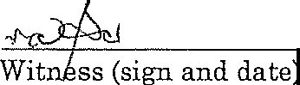
•.

The individual signing this Agreement certifies that he/she is authorized to enter into this Agreement on behalf of the Pharmacy, and that he/she has read this agreement

6-19-20
gh, R.'Ph.
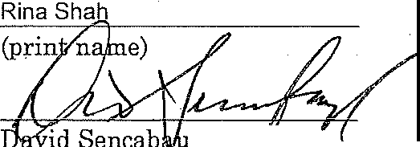
Executive Director

Board of Registration in Pharmacy

Effective Date of Reprimand Agreement
Fully Signed Agreement Sent to Licensee on 7/2/2020 b Certified Mail No. 7019 1640 0001 0886 4463

Walgreens # 2011
DS1587
PHA-2020-0011

Page2of2

