CHARLES D. BAKER
Commonwealth of Massachusetts Executive Office of Health and Human Services Department of Public· Health

Division of Health Professions Licensure Board of Registration in Pharmacy
239 Causeway Street, Suite 500, Boston, MA 02114 MARYLOU SUDDERS

Governor Secretary
Tel: 617-973-0960

KARYN E. POLITO
Lieutenant Governor

Fax: 617-973-0980
. TTY: 617-973-0988
www.mass.gov/dph/boards/pharmacy
MONICA BHAREL, MD, MPI
Commissioner

August 12, 2015

Sent Via First Class Mail & Certified Mail No. 7014 0510 00010375 2299

Pharmacy Manager of Record Walgreens Pharmacy #1862
450 Paradise Road
Swampscott, MA 01907

Re: In the Matter of Walgreens Pharmacy #1862; DS1380; PHA-2014-0250 Dear Sir/Madam:
Please find enclosed a fully executed Consent Agreement for Reprimand,
effective August 11, 2015. This agreement constitutes full and final disposition of the above-referenced complaint.

You may contact me at (617) 973 - 0950 with any questions that you may have concerning this agreement.

Enclosures
Sincerely,

Heather A. Engman Board Counsel

COMMONWEALTH OF MASSACHUSETTS

SUFFOLK COUNTY BOARD OF REGISTRATION IN PHARMACY

In the Matter of ) Walgreens Pharmacy #1862) License Number: DS1380) Expiration: December 31, 2015)

PHA-2014-0250
Received

AUG 11, 2015

BOARD OF

CONSENT AGREEMENT FOR REPRIMAND
PHARMACY

The Massachusetts Board of Registration in Pharmacy ("Board") and Walgreens Pharmacy #1862 ("Walgreens" or "Pharmacy"), a pharmacy licensed by the Board, license number DS1380, do hereby stipulate and agree that the following information shall be entered into and become a permanent part of the Pharmacy's record maintained by the Board:

1. The Pharmacy acknowledges that the Board opened a Complaint against its Massachusetts pharmacy license related to the conduct set forth in Paragraph 2, identified as Docket Number PHA.-2014-0250 ("Complaint").

- The Board and the Pharmacy acknowledge and agree to the following facts:

  - On or about April 6, 2014, the Office of Public Protection ("OPP") was notified that the Pharmacy had significant losses of hydrocodone products.

  - Pharmacy employed Alexandria Valdez as a pharmacy technician.

  - From approximately April 2, 2012 to March 27, 2014, Alexandria Valdez worked in excess of 2000 hours at the Pharmacy without a valid pharmacy technician license.

  - The foregoing facts warrant disciplinary action by the Board under M.G.L. c. 112 §§ 42A and 61, 247 CMR 8.03(3), and 247 CMR 10.03(m).

- The Pharmacy agrees that the Board shall impose a REPRIMAND on its license based on the facts admitted in Paragraph 2, effective as of the date on which the Board signs this Agreement ("Effective Date").

- The Board agrees that in return for the Pharmacy's execution and successful compliance with all the requirements of this Agreement, the Board will not prosecute the Complaint.

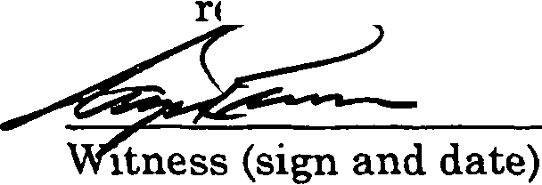

- The Pharmacy understands that it has a right to formal adjudicatory hearing concerning the Complaint and that during said, adjudication the Pharmacy would possess the right to confront and cross-examine witnesses, to call witnesses, to present evidence, to testify on its own behalf, to contest the allegations, to present oral argument, to appeal to the courts, and all other rights as set forth in the Massachusetts Administrative Procedures Act,
M.G.L. c. 30A, and the Standard Adjudicatory Rules of Practice and Procedure, 801 CMR 1.01 et seq. The Pharmacy further understands that by executing this Agreement the Pharmacy is knowingly and voluntarily
waiving its right to a formal adjudication of the Complaint.
- - -

- The Pharmacy acknowledges that it has been at all times free to seek and use legal counsel in connection with the Complaint and this Agreement.

7. The Pharmacy acknowledges that after the Effective Date, the Agreement constitutes a public record of disciplinary action by the Board subject to the Commonwealth of Massachusetts' Public Records Law, M.G.L. c. 4, § 7. The Board may forward a copy of this Agreement to other licensing boards, law enforcement entities, and other individuals or entities as required or permitted by law.

- The Pharmacy understands and agrees that entering into this Agreement is a voluntary and final act and not subject to reconsideration, appeal, or judicial rev1ew.

- 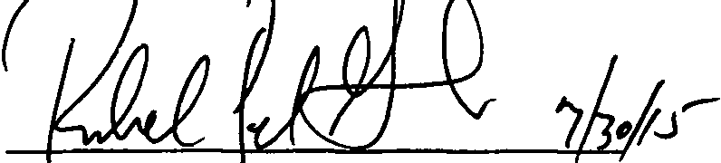The individual -signing this Agreement certifies that he/she is authorized to enter into this Agreement on be f the bar ac , and that he/she has
read this agreement.

Walgreens Pharmacy #1862 (sign and date)

Richard Gates
Print name

Walgreens Pharmacy #1862 DS1380
PHA-2014-0250

2 of 3

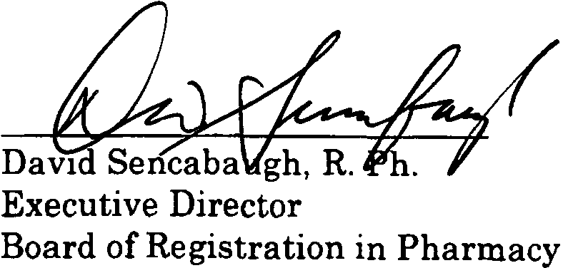

Effective Date of Reprimand Agreement

Fully Signed Agreement Sent to Registrant on 08/12/2015 by
Certified Mail No. 7014 0510 0001 0375 2299

Walgreens Pharmacy #1862 DS1380
PHA-20 14-0250

_ Page 3 of 3

