INDOOR AIR QUALITY ASSESSMENT

Walpole High School
275 Common Street
Walpole, Massachusetts

Prepared by:
Massachusetts Department of Public Health
Bureau of Environmental Health
Indoor Air Quality Program
August 2020

BACKGROUND
Building: | Walpole High School (WHS)
Address: | 275 Common Street, Walpole, MA
Assessment Requested by: | Melissa Ranieri, Public Health Director, Walpole Board of Health
Reason for Request: | Indoor air quality (IAQ) concerns in the Nurse’s suite and several other rooms within the building.
Date of Assessment: | March 2, 2020
Massachusetts Department of Public Health/Bureau of Environmental Health (MDPH/BEH) Staff Conducting Assessment: | Cory Holmes, Environmental Analyst/Inspector IAQ Program
Date of Building Construction: | The main building housing the Nurse’s Suite was constructed in the early 2000s. The original building was built in the early 1900s and renovated during the construction of the new building (2000-2002).
Windows: | Openable, however the Nurse’s Suite consists of interior rooms with no windows.

METHODS
Please refer to the IAQ Manual and appendices for methods, sampling procedures, and interpretation of results (MDPH, 2015).

RESULTS and DISCUSSION
The following is a summary of indoor air testing results (Table 1). Note that only specific areas were tested and examined during this visit.
- Carbon dioxide levels were below the MDPH recommended level of 800 parts per million (ppm) in all areas with the exception of room 2108, which was a small office that did not contain any mechanical ventilation components; this area had a window for a fresh air source.
- Temperature was within or close to the MDPH recommended range of 70°F to 78°F.
- Relative humidity was below the MDPH recommended range of 40 to 60% and reflective of outdoor (dry) conditions, which are typical of New England in the winter. Low relative humidity can lead to common symptoms such as: dry skin, lips, and scalp; dry/scratchy throats and noses (nose bleeds); exacerbation of asthma, eczema, or allergies; dry/irritated eyes; and irritation of respiratory tract.
- Carbon monoxide levels were non-detectable (ND) in all areas examined.
- Particulate matter (PM2.5) concentrations measured were below the National Ambient Air Quality (NAAQS) level of 35 μg/m³.

Ventilation
A heating, ventilating and air conditioning (HVAC) system has several functions. First it provides heating and, if equipped, cooling. Second, it is a source of fresh air. Finally, an HVAC system will dilute and remove normally occurring indoor environmental pollutants by not only introducing fresh air, but by filtering the airstream and ejecting stale air to the outdoors via exhaust ventilation. Even if an HVAC system is operating as designed, point sources of respiratory irritation may exist and cause symptoms in sensitive individuals.
Mechanical ventilation for the Nurse’s Suite (and other internal areas/rooms) is provided by a rooftop air handling unit (AHU) located in a penthouse (Picture 1). The AHU draws in fresh air, filters/heats and distributes it to occupied area via ceiling-mounted diffusers (Picture 2). Return air is drawn into ceiling-mounted vents (Picture 2) and ducted back to the AHU. Although the system was operating at the time of assessment, there was very little airflow detected from the supply diffuser in the Nurse’s office, which may indicate a closed damper or other obstruction. Without adequate introduction of fresh air/air exchange excess heat and environmental pollutants can build up and lead to indoor air/comfort complaints.
Mechanical ventilation for classrooms consists of ceiling-mounted unit ventilators (univents, Picture 3). Fresh air is distributed via supply diffusers (Picture 1). Some of which were sealed with plastic and tape (Pictures 4 and 5), which prevents proper distribution of air throughout the space. Exhaust ventilation is provided by ducted vents, some of which were located near classroom doors. This design works best with the doors to the hallway closed, otherwise the exhaust vents tend to draw air from the hallway rather than the room which reduces the effectiveness of air circulation.
To maximize air exchange, the IAQ program recommends that both supply and exhaust ventilation operate continuously during periods of occupancy. In order to have proper ventilation with a mechanical ventilation system, the systems must be balanced after installation to provide an adequate amount of fresh air to the interior of a room while removing stale air from the room. It is recommended that HVAC systems be re-balanced every five years to ensure adequate air systems function (SMACNA, 1994).

Microbial/Moisture Concerns
At the time of assessment, musty odors were present in room 2108. The odors were traced to an unfinished/unconditioned mechanical room located directly below room 2018. The most likely pathway for odors into room 2108 were via open spaces around utility pipes for the radiator (or any other penetrations), it was recommended at the time of assessment that these be sealed (Picture 6).
Several water-damaged ceiling tiles were also observed (Pictures 7 and 8). The areas above stained tiles should be examined for the source of leaks and for any additional water-damaged materials. Once the leak(s) are repaired, the ceiling tiles should be replaced.

Other Conditions
Carpeting should be vacuumed regularly with a high efficiency particulate arrestance (HEPA) filter equipped vacuum cleaner to avoid particulates from causing further irritation or serving as a reservoir for microbial colonization. Also, carpeting and rugs should be cleaned at least once per year according to Institute of Inspection Cleaning and Restoration Certification recommendations (IICRC, 2012). Area rugs too worn to be effectively cleaned should be replaced. Area rugs should be rolled up and stored in a clean, dry place when rooms are not occupied during the summer months to prevent moistening due to condensation.
In some areas, exhaust vents, supply diffusers, personal fans and the interior of the rooftop AHU had accumulated dust/debris (Table 1, Pictures 9 through 11). This material can be reaerosolized under certain conditions, and can also be a medium for mold growth. AHU cabinets should be thoroughly cleaned out when filters are changed (e.g., 2 to 4 times/year).
Note that each AHU is equipped with filters to remove dust and other particulates from the airstream. The filters used on these units appeared to be of a pleated type with a Minimum Efficiency Rating (MERV) of 8 (Pictures 12 and 13), which are adequate in filtering out pollen and mold spores (ASHRAE, 2012). The MDPH recommends that filters should also be changed two to four times a year, or per the manufacturer’s recommendations. Facility staff change filters once a year (October), but report that they are checked periodically and frequency is increased when the filters are found to be soiled.
Finally, exposed fiberglass was observed in room 1140 around the exhaust vent (Picture 9). Fiberglass can provide a source of eye, skin and respiratory irritation if damaged or otherwise disturbed.

CONCLUSIONS and RECOMMENDATIONS
In view of the findings at the time of the visit, the following recommendations are made:
- Work with HVAC vendor to examine/adjust the system to increase supply air in the Nurse’s office/suite.
- Operate all supply and exhaust ventilation equipment continuously during occupied periods. Ensure both general exhaust vents and restroom exhaust vents are operational.
- Unblock fresh air intakes and close classroom doors to provide proper air circulation/exchange.
- Continue to use pleated filters with a Minimum Efficiency Reporting Value (MERV) of 8 or higher, which are adequate in filtering out pollen and mold spores (ASHRAE, 2012). The MDPH recommends that filters should also be changed two to four times a year, or per the manufacturer’s recommendations.
- Thoroughly clean HVAC cabinets of debris and dust when filters are changed (Picture 11).
- For buildings in New England, periods of low relative humidity during the winter are often unavoidable. Therefore, scrupulous cleaning practices should be adopted to minimize common indoor air contaminants whose irritant effects can be enhanced when the relative humidity is low. To control for dusts, a high efficiency particulate arrestance (HEPA) filter equipped vacuum cleaner in conjunction with wet wiping of all surfaces is recommended. Avoid the use of feather dusters. Drinking water during the day can help ease some symptoms associated with a dry environment (throat and sinus irritation).
- Investigate source of water leaks and make repairs. Once leaks are repaired, replace water-damaged ceiling tiles and/or refinish areas of water damage. Inspect the area above the stained tiles for water damage or odors and remediate or clean as necessary.
- Seal holes in room 2108 to prevent communication/eliminate pathways for drafts/odors from the mechanical room. If this does not work, consider ducting supply air from adjacent hallway into room to pressurize, which will help keep odors at bay.
- Continue to clean carpeting (and area rugs) annually or semi-annually in soiled high traffic areas as per the recommendations of the Institute of Inspection, Cleaning and Restoration Certification (IICRC, 2012).
- Clean supply/exhaust vents and personal fans regularly to remove accumulated dust/debris.
- Seal/cover fiberglass around ductwork in room 1140 (Picture 9).
- Consider adopting the US EPA (2000) document, “Tools for Schools,” as an instrument for maintaining a good IAQ environment in the building available at: http://www.epa.gov/iaq/schools/index.html.
- Refer to resource manual and other related indoor air quality documents located on the MDPH’s website for further building-wide evaluations and advice on maintaining public buildings. These documents are available at http://mass.gov/dph/iaq.

REFERENCES
ASHRAE. 2012. American Society of Heating, Refrigeration and Air Conditioning Engineers (ASHRAE) Standard 52.2-2012 -- Method of Testing General Ventilation Air-Cleaning Devices for Removal Efficiency by Particle Size (ANSI Approved).
IICRC. 2012. Institute of Inspection, Cleaning and Restoration Certification. Carpet Cleaning: FAQ.
MDPH. 2015. Massachusetts Department of Public Health. Indoor Air Quality Manual: Chapters I-III. Available at: http://www.mass.gov/eohhs/gov/departments/dph/programs/environmental-health/exposure-topics/iaq/iaq-manual/.
SMACNA. 1994. HVAC Systems Commissioning Manual. 1st ed. Sheet Metal and Air Conditioning Contractors’ National Association, Inc., Chantilly, VA.
US EPA. 2000. Tools for Schools. Office of Air and Radiation, Office of Radiation and Indoor Air, Indoor Environments Division (6609J). EPA 402-K-95-001, Second Edition. http://www.epa.gov/iaq/schools/index.html.
Picture 1
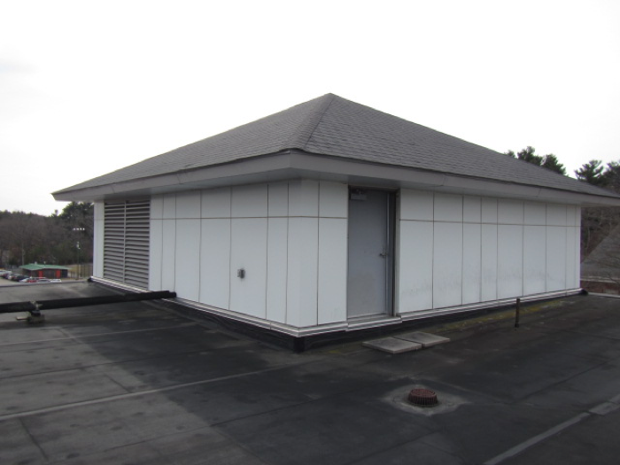
Rooftop penthouse containing air handling unit for Nurse’s Suite, arrow indicates fresh air intake
Picture 2
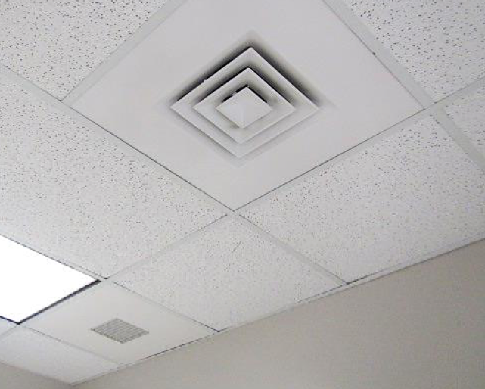
Fresh air diffuser (top/middle), return/exhaust vent (lower left), arrows indicate direction of air movement
Picture 3
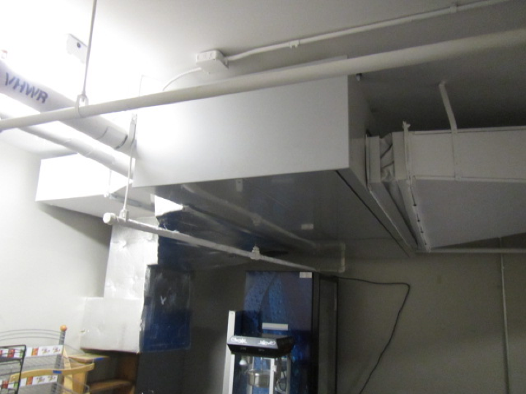
Ceiling–mounted univent in room 1154 ducted to adjacent rooms
Picture 4
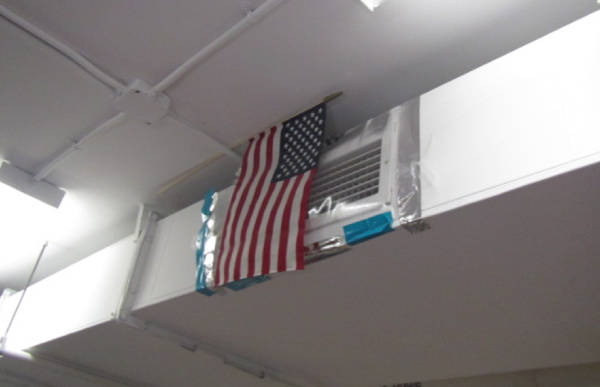
Supply vent sealed with plastic and tape
Picture 5
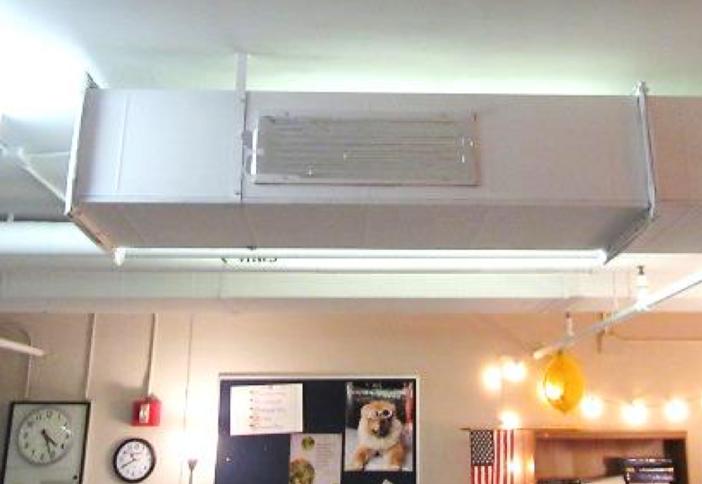
Supply vent sealed with tape
Picture 6
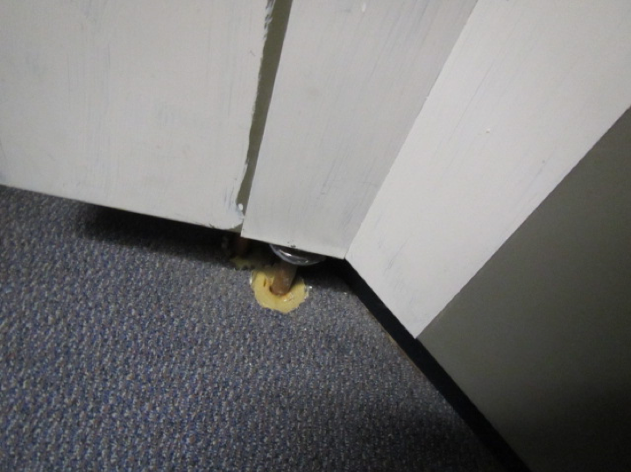
Heating pipe in room 2108 through floor (arrow) to unfinished mechanical room
Picture 7
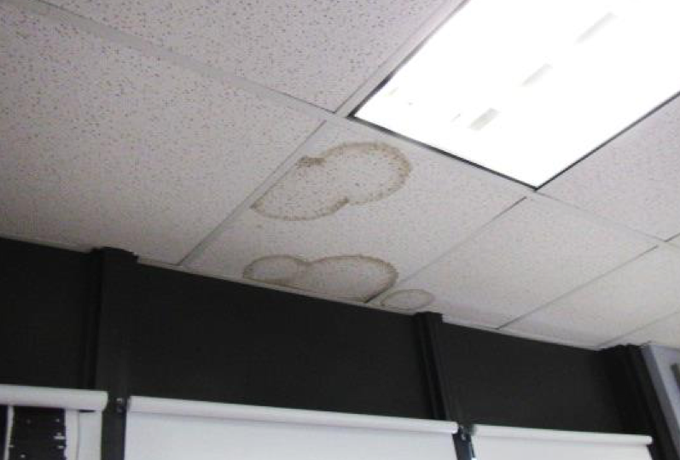
Water-damaged ceiling tiles
Picture 8
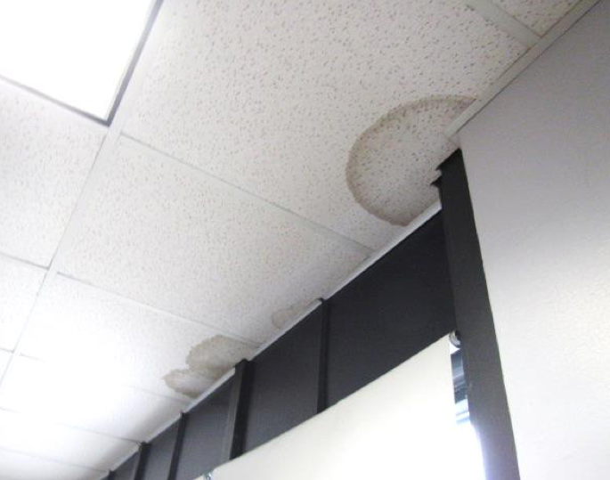
Water-damaged ceiling tiles
Picture 9
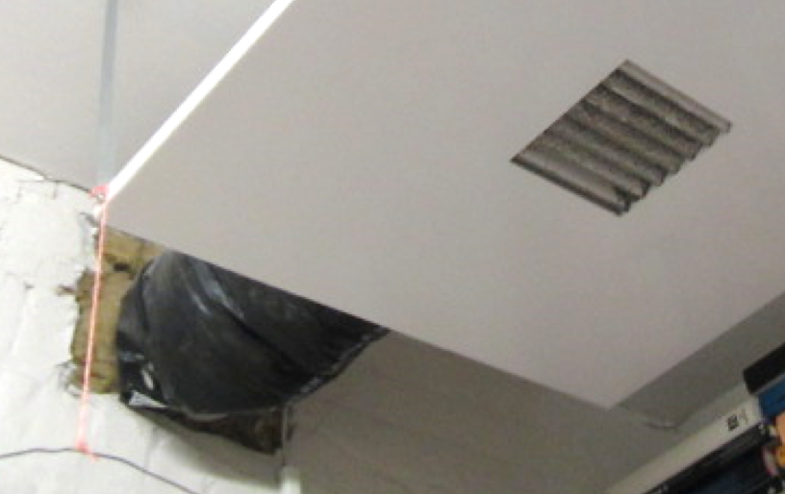
Accumulated dust/debris on exhaust vent, also note exposed fiberglass around exhaust duct (arrow)
Picture 10
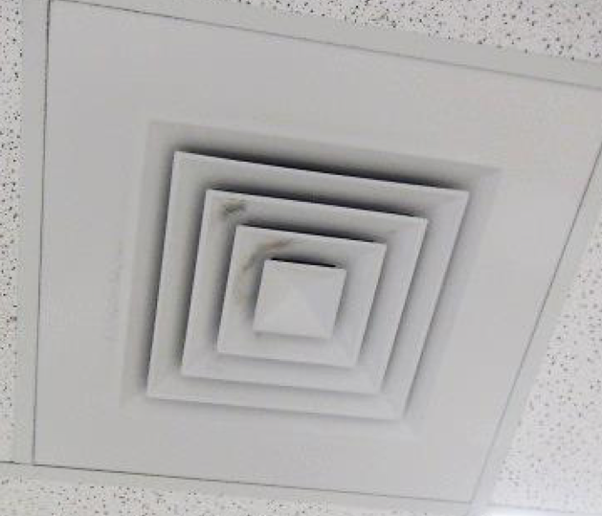
Accumulated dust/debris on supply diffuser
Picture 11
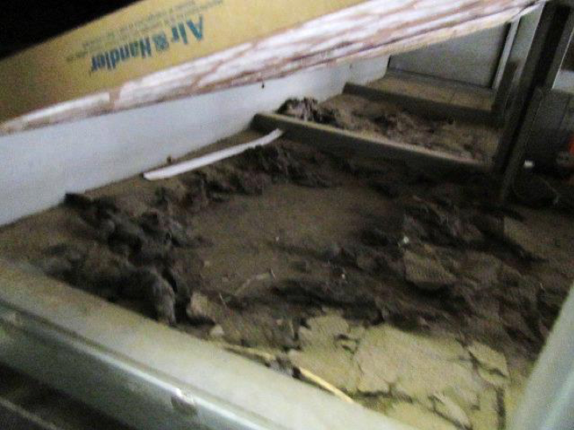
Loose dust/debris on floor of penthouse air handling unit
Picture 12
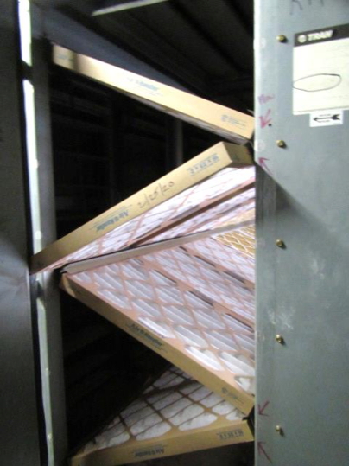
Pleated filters in rooftop AHU
Picture 13
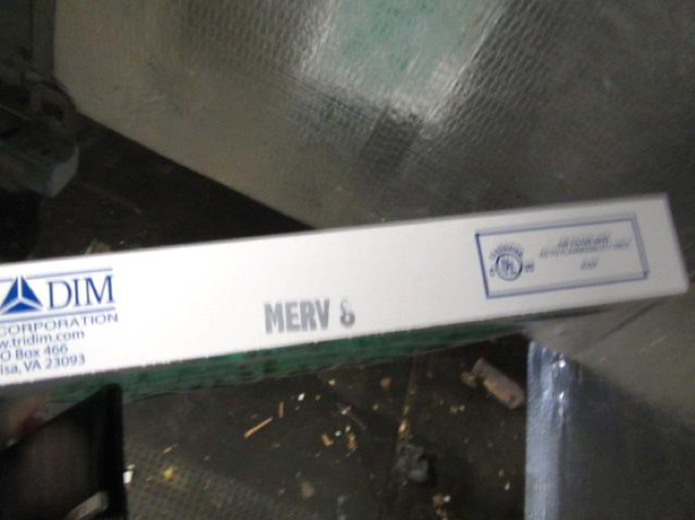
MERV 8 filter for rooftop AHUs

Location | Carbon  Dioxide  (ppm) | Carbon Monoxide  (ppm) | Temp  (°F) | Relative  Humidity  (%) | PM2.5  (µg/m³) | Occupants  in Room | Windows  Openable | Ventilation |  |  | Remarks
 |  |  |  |  |  |  |  | Intake | Exhaust
Background (Outside) | 392 | ND | 43 | 37 | 4 |  |  |  |  |  | Cool, mostly cloudy
Nurse’s Office | 677 | ND | 69 | 22 | 3 | 0 | N | Y |  | Y | Very little airflow detected from supply vent
Recovery | 561 | ND | 72 | 17 | 3 | 0 | N | Y |  | Y | Weak air flow from supply vent
Main Nurse’s Area | 702 | ND | 73 | 17 | 3 | 4 | Y | Y |  | Y | WD CT
1140 | 643 | ND | 72 | 18 | 4 | 0 | N | Y |  | Y | Dust/debris on vents, PF, exposed fiberglass (around duct), PF
1149 | 628 | ND | 75 | 18 | 5 | 0 | N | Y |  | Y | 1 of 2 supply vents covered, wall to wall carpet
1152 | 587 | ND | 76 | 18 | 5 | 0 | N | Y |  | Y
1153 | 647 | ND | 76 | 20 | 5 | 10 | N | Y |  | Y | PF, 1 of 2 supply vents covered
1154 | 646 | ND | 75 | 17 | 3 | 0 | N | Y |  | Y | Univent ducted to adjacent rooms, wall to wall carpet
1157 | 709 | ND | 73 | 18 | 4 | 1 | N | Y |  | Y | Dust/debris on vents, chronic heat control/complaints, PFs
1161 | 619 | ND | 76 | 15 | 4 | 1 | Y | N |  | N | Window AC, wall to wall carpet
Special Education Main Area | 714 | ND | 76 | 16 | 4 | 5 | N | Y |  | Y | Dust/debris vents, wall to wall carpet
2108 | 990 | ND | 72 | 23 | 6 | 0 | Y | N |  | N | Musty odor, pipe penetrations through floor, no signs/evidence of water damage/mold
Mechanical/Maint Room (below 2108) |  |  |  |  |  |  | N | N |  | N | Musty odors, unfinished mechanical room
2127 | 655 | ND | 74 | 22 | 6 | 18 | Y | Y |  | Y | PF, 3 WD CTs, wall to wall carpet, dust/debris on vents, DEM
2132 | 632 | ND | 74 | 20 | 5 | 5 | Y | Y |  | Y | DO, 5 WD CTs

