INDOOR AIR QUALITY ASSESSMENT

Walpole High School, TV Studio
275 Common Street
Walpole, Massachusetts

Prepared by:
Massachusetts Department of Public Health
Bureau of Environmental Health
Indoor Air Quality Program
May 2016

BACKGROUND
Building: | Walpole High School, TV Studio
Address: | 275 Common Street, Walpole, MA
Assessment Requested by: | Robin Chapell, Health Director, Walpole Board of Health
Reason for Request: | Respiratory issues and general indoor air quality (IAQ) concerns
Date of Assessment: | May 3, 2016
Massachusetts Department of Public Health/Bureau of Environmental Health (MDPH/BEH) Staff Conducting Assessment: | Cory Holmes, Environmental Analyst/Inspector
Date of Building Construction: | Early 2000s
Building Description: | Multi-story red brick with flat rubber membrane roof; TV Studio is located on the ground floor
Building Population: | The TV Studio employs 4 staff, typically 3 during the day and 1 evening shift
Windows: | Openable

METHODS
Please refer to the IAQ Manual and appendices for methods, sampling procedures, and interpretation of results (MDPH, 2015).

RESULTS and DISCUSSION
The following is a summary of indoor air testing results (Table 1).
- Carbon dioxide levels were below the MDPH recommended level of 800 parts per million (ppm) in all areas surveyed.
- Temperature was within the MDPH recommended range of 70°F to 78°F in all areas surveyed.
- Relative humidity was within or close to the MDPH recommended range of 40 to 60% in all areas tested.
- Carbon monoxide levels were non-detectable (ND) in all areas tested.
- Particulate matter (PM2.5) concentrations measured were below the National Ambient Air Quality (NAAQS) level of 35 μg/m³ in all areas tested.
- Total volatile organic compounds (TVOCs) levels were ND in all areas tested.

Ventilation
The heating, ventilation and air conditioning (HVAC) system for the TV Studio consists of an air handling unit (AHU) (Picture 1) located in a mechanical room (penthouse) on the roof (Picture 2). The AHU unit draws air from a vent at roof level on the exterior of the penthouse (Picture 3), which is filtered, heated/cooled, and directed to occupied spaces via ducted ceiling vents (Picture 4). Return air is vented through ceiling-mounted vents (Picture 5) back to the AHU.
The interior of several AHUs, including the TV Studio, were examined. It was reported that filters are replaced once per year. It is typically recommended to change filters 2-4 times per year. Filters were found soiled and with accumulations of debris in several of the units (Pictures 6 and 7), and appeared due for changing. In addition, some of the filters examined were of a mid-grade rating minimum efficiency reporting value (MERV) of 7 (Picture 8), the MDPH typically recommends a MERV 8 or higher.
During the assessment, the majority of interior doors within the TV Studio suite were found open. With doors left ajar, the exhaust vents will tend to pull air from hallway/adjacent areas instead of removing stale air and airborne pollutants within the space as intended. Therefore, interior doors should be shut to improve air exchange.

Microbial/Moisture Concerns
In order for building materials to support mold growth, a source of water is necessary. No sources of interior leaks, water infiltration, damage to building materials or visible mold growth was observed in the TV Studio area. A plant was noted on paper towels in room A 236, which is a porous material that can grow mold if wetted repeatedly (Picture 9).
Some boxes were found on the floor of the mechanical room (Picture 10), which can be subject to moistening from condensation. The majority of stored materials however, were stored on pallets. Consider using shelves or pallets to elevate all stored materials.

Volatile Organic Compounds (VOCs)
Exposure to low levels of total VOCs (TVOCs) may produce eye, nose, throat, and/or respiratory irritation in some sensitive individuals. To determine if VOCs were present, BEH/IAQ staff conducted testing for TVOCs; no TVOCs were detected in any of the rooms examined (Table 1). BEH/IAQ staff noted hand sanitizers, cleaners, and dry erase materials in use within the building (Table 1). All of these products have the potential to be irritants to the eyes, nose, throat and respiratory system of sensitive individuals.

Other Conditions
Other conditions that can affect IAQ were observed during the assessment. Several supply, exhaust, and return vents were observed to have accumulated dust/debris (Pictures 4 and 5). If exhaust vents are not functioning, backdrafting can occur, which can re-aerosolize accumulated dust particles. Supply vents can aerosolize accumulated dust once activated.
Concerns were raised whether the mechanical ventilation system for the TV Studio shared common ductwork with other areas, specifically the locker rooms and a mechanical room where the chemical collection tank for the science wing was located. BEH/IAQ staff determined that each of these areas is supplied by completely different AHUs/systems and that there is no communication between these areas and the TV Studio (Pictures 11 and 12).

CONCLUSIONS and RECOMMENDATIONS
In view of the findings at the time of the visit, the following recommendations are made:
- Increase filter changes to 2-4 times a year or as per the manufacturer’s instructions.
- Use a consistent type of high quality filter (MERV 8 or higher) in AHUs and store them in a clean, dry area before use.
- Shut interior doors as designed to improve air exchange within individual spaces.
- For buildings in New England, periods of low relative humidity during the winter are often unavoidable. Therefore, scrupulous cleaning practices should be adopted to minimize common indoor air contaminants whose irritant effects can be enhanced when the relative humidity is low. To control for dusts, a high efficiency particulate arrestance (HEPA) filter equipped vacuum cleaner in conjunction with wet wiping of all surfaces is recommended. Avoid the use of feather dusters. Drinking water during the day can help ease some symptoms associated with a dry environment (throat and sinus irritation).
- Ensure plants are well maintained with non-porous drip pans and not overwatered.
- Do not store porous materials (e.g., cardboard boxes, paper items) directly on floors; place on pallets or shelving to prevent water damage and mold growth.
- Reduce the use of products containing VOCs.
- Clean supply, exhaust, and return vents periodically of accumulated dust.
- Refer to resource manual and other related indoor air quality documents located on the MDPH’s website for further building-wide evaluations and advice on maintaining public buildings. These documents are available at http://mass.gov/dph/iaq.

REFERENCES
MDPH. 2015. Massachusetts Department of Public Health. Indoor Air Quality Manual: Chapters I-III. Available at: http://www.mass.gov/eohhs/gov/departments/dph/programs/environmental-health/exposure-topics/iaq/iaq-manual/.
Picture 1
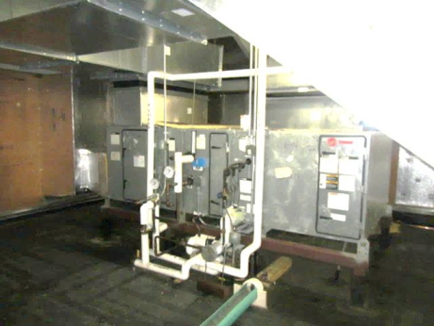
Air handling unit in rooftop penthouse/mechanical room serving the TV Studio
Picture 2
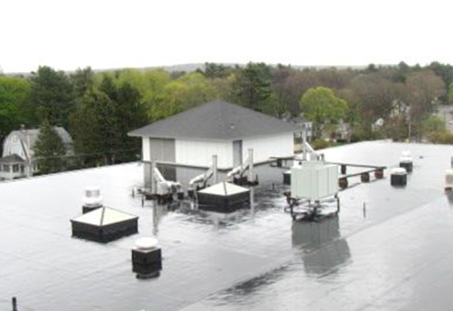
Rooftop mechanical room/penthouse containing air handling unit for the TV Studio
Picture 3
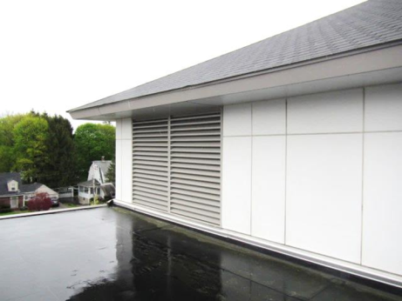
Fresh air intake for TV Studio air handling unit
Picture 4
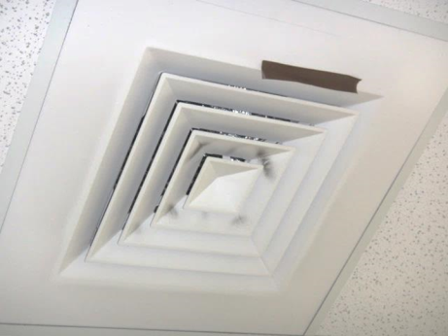
Supply air diffuser in TV Studio, note dust/debris accumulation on louvers
Picture 5
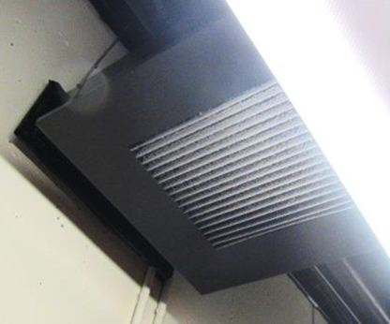
Typical return/exhaust vent in TV Studio suite (A 240), note dust/debris accumulation on louvers
Picture 6
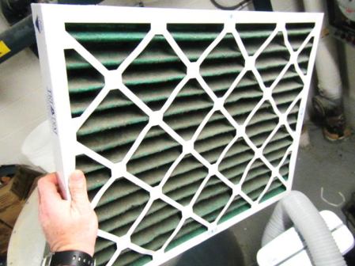
Soiled filter inside AHU
Picture 7
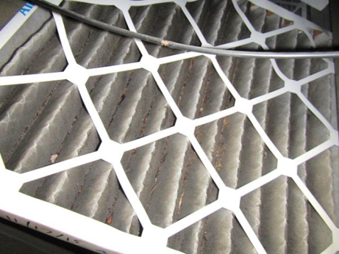
Soiled filter inside AHU
Picture 8
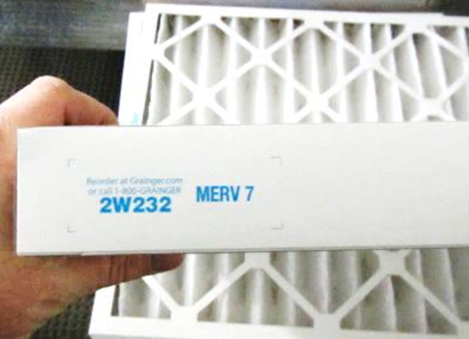
MERV 7 Filter in TV Studio AHU
Picture 9
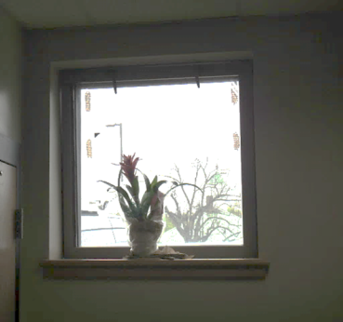
Plant on paper towels
Picture 10
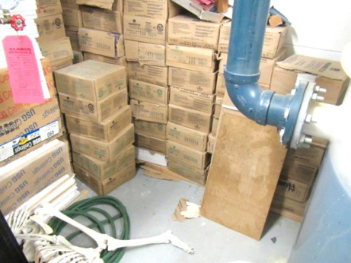
Cardboard boxes directly on floor in mechanical room
Picture 11
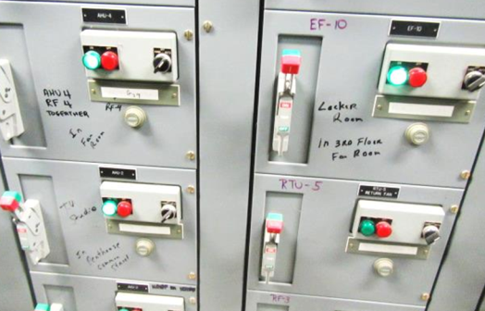
Power panel indicating separate systems/controls to the Locker Rooms and TV Studio (arrows)
Picture 12
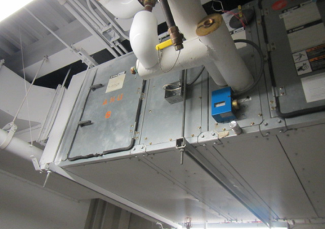
AHU in mechanical room on the ground floor where chemical collection tank is located, separate unit from TV Studio (rooftop/penthouse unit)
Pre-Location | Carbon  Dioxide  (ppm) | Carbon Monoxide  (ppm) | Temp  (°F) | Relative  Humidity  (%) | PM2.5  (µg/m³) | TVOC  (ppm) | Occupants  in Room | Windows  Openable | Ventilation |  | Remarks
 |  |  |  |  |  |  |  |  | Supply | Exhaust
Background | 393 | ND | 57 | 97 | 3 | ND |  |  |  |  | Cold/raw, intermittent rain, winds ENE 2-9 MPH
Mechanical/  Chemical Tank Room |  | ND |  |  | 2 | ND | 0 |  |  |  | Cardboard on floor, chemical collection tank, no odors detected
A 236 | 589 | ND | 77 | 39 | 3 | ND | 3 | Y | Y | Y | Plant on paper towels, dust/debris on vents, DO
A 240 | 560 | ND | 76 | 38 | 2 | ND | 15 | N | Y | Y | Dust/debris on vents, DO
A 243 | 566 | ND | 76 | 39 | 3 | ND | 1 | Y | Y | Y | DO
A 246 | 523 | ND | 73 | 45 | 2 | ND | 0 | Y | Y | Y | DO
TV Studio Main | 496 | ND | 77 | 38 | 2 | ND | 0 | N | Y | Y | DO

