Bureau of Climate and Environmental Health
Public Health Advisory on Recall of WanaBana, Schnucks, Weis Brand Applesauce Fruit Puree
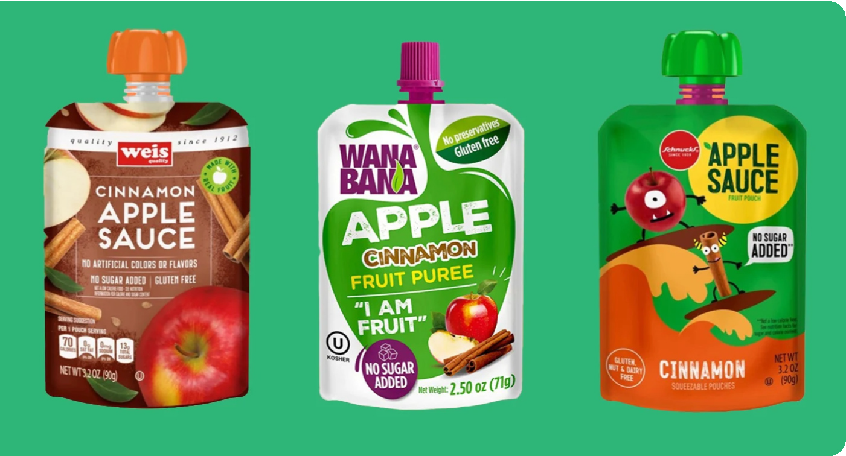
Affected Products
WanaBana, Schnucks, and Weis have initiated voluntary recalls of specific lots of products that were available online and in Dollar Tree stores across Massachusetts.
These products had a potential link to lead exposure in children.
LEAD
WARNING
Protecting children from exposure is essential to lifelong good health. Even low levels
of lead in the blood can affect IQ, ability to pay attention, and academic achievement.
Action Steps
If you or your family have eaten cinnamon applesauce pouches from the identified brands or batches in the FDA advisory, take the following steps immediately:
#1
Stop Eating the Affected Products
#2
Monitor Symptoms and Lead Levels
for Sources of Lead
Please read the attached letter for more details on this issue and the appropriate action steps.
#3 Learn About and Look
IMPORTANT:
Check Your Home!
The applesauce recall is important to be aware of, but:
A child's home is still
the LEADING SOURCE
of LEAD EXPOSURE.
Homes built before 1978 may contain lead-based paint hazards. If you live in your own home, have it tested by a lead inspector. If you rent your pre-1978 home, ask the owner if there is a Letter of Compliance. If there is no Letter of Compliance, ask the owner to have the home inspected or call your local Board of Health and ask for an inspection.
MASS.GOV Finding and Removing Lead:
https://www.mass.gov/finding-and-removing-lead

To learn more, visit www.mass.gov/orgs/childhood-lead-poisoning-prevention-program or call the Childhood Lead Poisoning Prevention Program at 1-800-532-9571

