Biwo Klima ak Sante Anviwònmantal
Avi Sante Piblik sou Rapèl pou Pire Konpòt Pòm ak Fwi nan Mak WanaBana, Schnucks, ak Weis
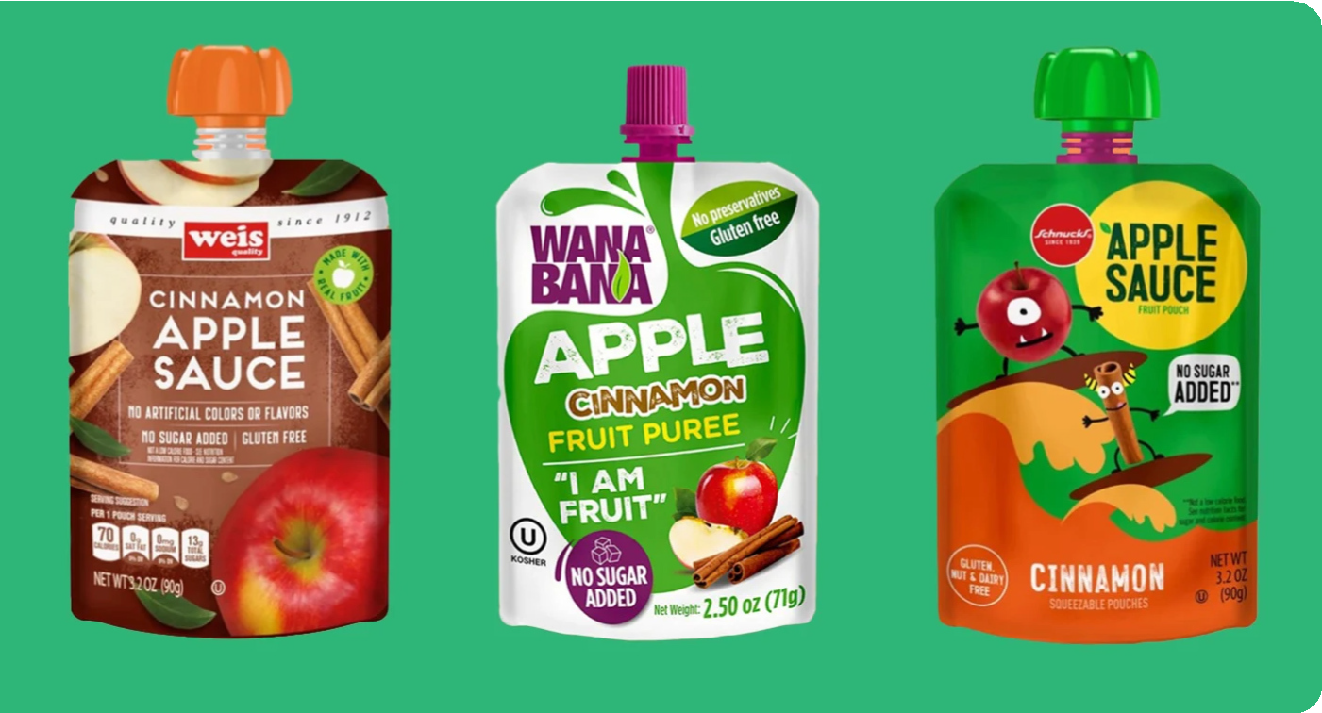
Pwodwi ki Afekte yo
WanaBana, Schnucks, ak Weis te chwazi lanse yon rapèl konsènan yon seri lo pwodui byen presi ki te disponib anliy epi nan magazen Dola Tree yo toupatou nan Massachusetts.
Pwodwi sa yo te gen yon potansyèl lyen ak ekspozisyon plon sou timoun.
ENPÒTAN:
Verifye Kay ou!
Rapèl sou konpòt pòm nan enpòtan pou nou sonje, men:
Se kay yon timoun ki
rete SOUS PRENSIPAL pou
EKSPOZE nan PLON an.
Gen risk pou kay ki bati anvan ane 1978 yo kapab gen penti abaz plon. Si w ap viv nan pwòp kay ou, fè yon enspektè nan kesyon plon teste li. Si ou lwe kay ki bati anvan 1978 ou a, mande mèt kay la si gen yon Lèt Konfòmite. Si pa gen Lèt Konfòmite, mande mèt kay la fè enspekte kay la, oswa rele Komisyon sou Sante lokal ou a, epi mande yo fè yon enspeksyon.
MASS.GOV Jwenn epi Retire Plon:
https://www.mass.gov/finding-and-removing-lead
AVÈTISMAN
Li enpòtan pou pwoteje timoun yo kont ekspozisyon nan plon pou yo gen bon sante tout lavi yo. Menm nivo plon ki ba nan san an kapab afekte IQ a, ki se kapasite pou fè atansyon, ak akonplisman akademik.
PLON
Mezi pou Pran
Si ou menm oswa fanmi w te manje sachè konpòt pòm abaz kannèl ki soti nan mak oswa lo yo idantifye nan avi FDA a, suiv etap ki vin apre yo san pèdi tan:
#1
Sispann Manje Pwodwi ki Afekte a
#2
Siveye Sentòm yo ak Nivo Plon yo
Sous Plon yo
Tanpri li lèt ki nan atachman an pou jwenn plis detay sou pwoblèm sa a, ak mezi ki apwopriye pou w pran.
Aprann epi Siveye
#3
Pou aprann plis, ale sou www.mass.gov/orgs/childhood-lead-poisoning-prevention-program
oswa rele Childhood Lead Poisoning Prevention Program nan 1-800-532-9571

