INDOOR AIR QUALITY ASSESSMENT

Wareham District Court
2200 Cranberry Highway
West Wareham, MA

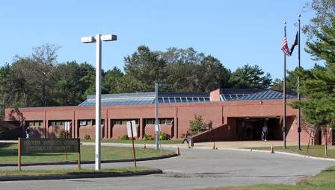

Prepared by:
Massachusetts Department of Public Health
Bureau of Environmental Health
Indoor Air Quality Program
January 2015

Background/Introduction
In response to a referral from Christopher McQuade, Administrative Attorney, Administrative Office of the Trial Court (AOTC), the Massachusetts Department of Public Health (MDPH), Bureau of Environmental Health (BEH) provided assistance and consultation regarding indoor air quality (IAQ) concerns at the Wareham District Court (WDC) located at 2200 Cranberry Highway, West Wareham, MA.
On October 10, 2014, a visit to conduct an assessment was made to this building by Mike Feeney, Director of BEH’s IAQ Program. The assessment was prompted by concerns of respiratory symptoms, mold growth and chronic complaints of poor indoor environmental conditions throughout the building. Michael Lane of the AOTC accompanied Mr. Feeney during this assessment.
The building is a one-story brick building with an occupied ground level section that was constructed in 1970s. Court rooms and offices have wall to wall carpeting. Windows are openable. The rear of the building contains a sally port and heating, ventilating and air-conditioning (HVAC) chiller located immediately adjacent to the sally port (Picture 1).

Methods
Air tests for carbon dioxide, carbon monoxide, temperature and relative humidity were taken with the TSI, Q-Trak, IAQ Monitor 7565. Air tests for airborne particle matter with a diameter less than 2.5 micrometers were taken with the TSI, DUSTTRAK™ Aerosol Monitor Model 8520. BEH/IAQ staff also performed visual inspection of building materials for water damage and/or microbial growth.

Results
The WDC has an employee population of approximately 50 and can reportedly be visited by several hundred members of the public on a daily basis. The tests were taken during normal operations. Test results appear in Table 1. Locations of samples are depicted in Map 1.

Discussion

Ventilation
It can be seen from Table 1 that carbon dioxide levels were below 800 parts per million (ppm) in all areas, indicating adequate air exchange in the large majority of areas surveyed at the time of the assessment. The heating, ventilation and air conditioning (HVAC) system is made up of air-handling units (AHUs) located in mechanical rooms within the building. Of note is the AHU that services the various courtrooms. The actuator motor for the HVAC system is disconnected from the AHU louvers that control airflow to the courtrooms. WDC personnel report that the louvers are set by maintenance staff by hand. The louver position was found to be held in place by use of a plastic coat hanger (Picture 2). This AHU was designed to provide heated and chilled air that is controlled by thermostats that activate the actuator motor automatically. Without this control, the provision of fresh air to courtrooms is likely inadequate, particularly when the building is fully occupied.
Conditioned air is supplied by ducted ceiling-mounted fresh air diffusers and returned to the AHU via ductwork. A variety of exhaust fans exist on the roof. IAQ staff noted that 4 of 7 exhaust vents examined on the roof were found deactivated at the time of the assessment. IAQ staff were shown the ventilation system for the holding cells. Each cell appeared to have both a supply and exhaust vents system. It appears that a number of cells had part of the ductwork removed (Pictures 3 and 4), with one section crimped closed. This condition was noted in a MA Division of Occupational Safety 2010 letter requesting that this condition be investigated and “if necessary, eliminate them” (DOS, 2010). It appears that no action to restore the function of this ventilation system was implemented. At minimum, holding cells should have functioning exhaust ventilation to remove odor and water vapor from plumbing facilities.
To maximize air exchange, the MDPH recommends that both supply and exhaust ventilation operate continuously during periods of occupancy. In order to have proper ventilation with a mechanical supply and exhaust system, the systems must be balanced to provide an adequate amount of fresh air to the interior of a room while removing stale air from the room. It is recommended that HVAC systems be re-balanced every five years to ensure adequate air systems function (SMACNA, 1994). The system was reportedly balanced within the last year.
Minimum design ventilation rates are mandated by the Massachusetts State Building Code (MSBC). Until 2011, the minimum ventilation rate in Massachusetts was higher for both occupied office spaces and general classrooms, with similar requirements for other occupied spaces (BOCA, 1993). The current version of the MSBC, promulgated in 2011 by the State Board of Building Regulations and Standards (SBBRS), adopted the 2009 International Mechanical Code (IMC) to set minimum ventilation rates. Please note that the MSBC is a minimum standard that is not health-based. At lower rates of cubic feet per minute (cfm) per occupant of fresh air, carbon dioxide levels would be expected to rise significantly. A ventilation rate of 20 cfm per occupant of fresh air provides optimal air exchange resulting in carbon dioxide levels at or below 800 ppm in the indoor environment in each area measured. MDPH recommends that carbon dioxide levels be maintained at 800 ppm or below. This is because most environmental and occupational health scientists involved with research on IAQ and health effects have documented significant increases in indoor air quality complaints and/or health effects when carbon dioxide levels rise above the MDPH guidelines of 800 ppm for schools, office buildings and other occupied spaces (Sundell et al., 2011). The ventilation must be on at all times that the room is occupied. Providing adequate fresh air ventilation with open windows and maintaining the temperature in the comfort range during the cold weather season is impractical. Mechanical ventilation is usually required to provide adequate fresh air ventilation.
Carbon dioxide is not a problem in and of itself. It is used as an indicator of the adequacy of the fresh air ventilation. As carbon dioxide levels rise, it indicates that the ventilating system is malfunctioning or the design occupancy of the room is being exceeded. When this happens, a buildup of common indoor air pollutants can occur, leading to discomfort or health complaints. The Occupational Safety and Health Administration (OSHA) standard for carbon dioxide is 5,000 parts per million parts of air (ppm). Workers may be exposed to this level for 40 hours/week, based on a time-weighted average (OSHA, 1997).
The MDPH uses a guideline of 800 ppm for publicly occupied buildings. A guideline of 600 ppm or less is preferred in schools due to the fact that the majority of occupants are young and considered to be a more sensitive population in the evaluation of environmental health status. Inadequate ventilation and/or elevated temperatures are major causes of complaints such as respiratory, eye, nose and throat irritation, lethargy and headaches. For more information concerning carbon dioxide, please see Appendix A.
Temperature readings ranged from 68º F to 74º F during the assessment, which were within the MDPH recommended comfort guidelines in most areas sampled. The MDPH recommends that indoor air temperatures be maintained in a range of 70º F to 78º F in order to provide for the comfort of building occupants. In many cases concerning indoor air quality, fluctuations of temperature in occupied spaces are typically experienced, even in a building with an adequate fresh air supply.
The relative humidity measured during the assessment ranged from 40 to 47 percent, which was within the MDPH recommended comfort range in all areas surveyed. The MDPH recommends a comfort range of 40 to 60 percent for indoor air relative humidity. Relative humidity levels in the building would be expected to drop during the winter months due to heating.

Microbial/Moisture Concerns
As mentioned earlier, one of the issues prompting the assessment related to concerns over potential mold growth from previous water damage. In order for building materials to support mold growth, a source of water exposure is necessary. Identification and elimination of the source of water moistening building materials is necessary to control mold growth. It was reported to IAQ staff that gypsum wallboard (GW) in the probation office was water- damaged. IAQ staff found this area to have a musty odor with signs of water damage to the GW as well as the modular furniture and wall to wall carpeting around this cubicle.
Moisture content of the GW was measured with a moisture meter. In general, GW will have a reading of “non-detectable” for moisture. Moisture was detectable in the damaged GW above the cubicle, which indicates water penetration through the exterior wall. GW was found to be moistened to a level that a pencil could easily be inserted into the wall (Picture 5). Water damage was also found in the modular furniture adjacent to this wall (Picture 6). It is likely that the wall space behind the water damage contains fiberglass insulation. Water-damaged fiberglass insulation can serve as a moisture source; moist insulation also loses its ability to properly insulate the wall cavity, which can lead to cold penetration and ultimately, condensation generation within the wall cavity.
Please note moisture content is detected as a real time measurement of the conditions present in the building at the time of the assessment. The building was evaluated on a cloudless, humid day with an outdoor temperature of 66°F and relative humidity of 40 percent. Moisture content of materials may increase or decrease depending on building and weather conditions. For example, during the normal operation of a heating, ventilating and air-conditioning (HVAC) system, moisture is introduced into a building during weather with high relative humidity. As indoor relative humidity levels increase, porous building materials, such as GW can absorb moisture. The moisture content of materials can fluctuate with increases or decreases in indoor relative humidity. The likely source of moisture causing this water damage is a water leak from the roof assembly above this office. The roof membrane was loose from its attachment in another location near this office, which can indicate the condition of the remainder of the roof membrane (Picture 7). A number of other areas in the building have water-damaged GW (Pictures 8 through 10) from water leaks through exterior wall door frames, roof leaks or moistening from custodial sinks.
A number of other sources of mold colonization exist in areas within the building. The basement has a number of pipes that have water-damaged/mold colonized pipe insulation (Picture 11). Insulation in this condition will continue to degrade when exposed to moisture.
FCUs in offices provide both heating and air-conditioning and are equipped with drip pans to collect and drain condensation from cooling coils. The interior of the FCUs examined have not been appropriately cleaned or maintained for a significant period of time. The interior of each unit examined had a significant amount of scale from corroding coils (Picture 12). Insulation on FCU pipes had failed (Picture 13) likely resulting in wetting of the insulation, interior of the FCU cabinet and surrounding carpets due to accumulating condensation during the operation of the HVAC system in cooling mode during hot, humid weather. Water-damaged fiberglass insulation and GW, can also be a source of mold growth. Please note that the FCUs were installed when the building was constructed, approximately 40 years ago. The age of the equipment makes service and repairs of these units difficult. According to the American Society of Heating, Refrigeration and Air-Conditioning Engineers (ASHRAE), the service life for a unit heater using hot water or steam is 20 years, assuming routine maintenance of the equipment (ASHRAE, 1991). The operational lifespan of the equipment has been exceeded. The provision and control of heating and cooling air by the FCUs will become more difficult as the equipment ages and as replacement parts become increasingly difficult to obtain.
The US Environmental Protection Agency (US EPA) and the American Conference of Governmental Industrial Hygienists (ACGIH) recommend that porous materials be dried with fans and heating within 24 to 48 hours of becoming wet (US EPA, 2001; ACGIH, 1989). If not dried within this time frame, mold growth may occur. Once mold has colonized porous materials, they are difficult to clean and should be removed.

Other IAQ Evaluations
Indoor air quality can be negatively influenced by the presence of respiratory irritants, such as products of combustion. The process of combustion produces a number of pollutants. Common combustion emissions include carbon monoxide, carbon dioxide, water vapor, and smoke (fine airborne particle material). Of these materials, exposure to carbon monoxide and particulate matter with a diameter of 2.5 micrometers (μm) or less (PM2.5) can produce immediate, acute health effects upon exposure. To determine whether combustion products were present in the indoor environment, BEH/IAQ staff obtained measurements for carbon monoxide and PM2.5.

Carbon Monoxide
Carbon monoxide is a by-product of incomplete combustion of organic matter (e.g., gasoline, wood and tobacco). Exposure to carbon monoxide can produce immediate and acute health effects. Several air quality standards have been established to address carbon monoxide and prevent symptoms from exposure to these substances. The MDPH established a corrective action level concerning carbon monoxide in ice skating rinks that use fossil-fueled ice resurfacing equipment. If an operator of an indoor ice rink measures a carbon monoxide level over 30 ppm, taken 20 minutes after resurfacing within a rink, that operator must take actions to reduce carbon monoxide levels (MDPH, 1997).
The American Society of Heating Refrigeration and Air-Conditioning Engineers (ASHRAE) has adopted the National Ambient Air Quality Standards (NAAQS) as one set of criteria for assessing indoor air quality and monitoring of fresh air introduced by HVAC systems (ASHRAE, 1989). The NAAQS are standards established by the US EPA to protect the public health from six criteria pollutants, including carbon monoxide and particulate matter (US EPA, 2006). As recommended by ASHRAE, pollutant levels of fresh air introduced to a building should not exceed the NAAQS levels (ASHRAE, 1989). The NAAQS were adopted by reference in the Building Officials & Code Administrators (BOCA) National Mechanical Code of 1993 (BOCA, 1993), which is now an HVAC standard included in the Massachusetts State Building Code (SBBRS, 2011). According to the NAAQS, carbon monoxide levels in outdoor air should not exceed 9 ppm in an eight-hour average (US EPA, 2006).
Carbon monoxide should not be present in a typical, indoor environment. If it is present, indoor carbon monoxide levels should be less than or equal to outdoor levels. On the day of the assessment, outdoor carbon monoxide concentrations were non-detect (ND) (Table 1). No measureable levels of carbon monoxide were detected in the building during the assessment (Table 1).

Particulate Matter
The US EPA has established NAAQS limits for exposure to particulate matter. Particulate matter includes airborne solids that can be irritating to the eyes, nose and throat. The NAAQS originally established exposure limits to PM with a diameter of 10 μm or less (PM10). In 1997, US EPA established a more protective standard for fine airborne particulate matter with a diameter of 2.5 μm or less (PM2.5). This more stringent PM2.5 standard requires outdoor air particle levels be maintained below 35 μg/m³ over a 24-hour average (US EPA, 2006). Although both the ASHRAE standard and BOCA Code adopted the PM10 standard for evaluating air quality, MDPH uses the more protective PM2.5 standard for evaluating airborne PM concentrations in the indoor environment.
Outdoor PM2.5 concentration was measured at 37 μg/m³ (Table 1). PM2.5 levels measured indoors ranged from 33 to 39 μg/m³ (Table 1), most of which were slightly above the NAAQS PM2.5 level of 35 μg/m³. Frequently, indoor air levels of particulate matter (including PM2.5) can be at higher levels than those measured outdoors. A number of mechanical devices and/or activities that occur indoors can generate particulate matter during normal operations. Sources of indoor airborne particulate matter may include but are not limited to particles generated during the operation of fan belts in the HVAC system, use of stoves and/or microwave ovens in kitchen areas; use of photocopiers, fax machines and computer printing devices; operation of an ordinary vacuum cleaner and heavy foot traffic indoors.

Other Conditions
Other conditions that can affect indoor air quality were observed during the assessment.
One restroom appeared to have a floor tile system that had failed near a toilet and was repaired using duct tape (Picture 14). Bathroom floors should be continuous consisting of a non-porous material. This condition would be considered unsanitary.
The building has a skylight in the section of its roof that shelters the front entrance. Due to its construction a ledge exist beneath the skylight glass. BEH staff noted dead birds, bird waste and other debris (Picture 15). Guidelines concerning the cleaning of bird waste are included in Appendix B.
During this assessment, the HVAC system chiller was operating. The chiller had significant corrosion on its fixtures (Picture 16) and electrical control (Picture 17). In addition, a significant amount of water was seen spraying from the top of this unit (Picture 18). These conditions can indicate lack of preventive maintenance, which can rapidly reduce the service life and function of this equipment.
Several areas had wall-to-wall carpeting. The carpeting was frayed and in some places, sealed using duct tape. Carpeting, if well maintained, is expected to have a service life of 7 to 11 years (Bishop, 2002). The Institute of Inspection, Cleaning and Restoration Certification (IICRC), recommends that carpeting be cleaned annually (or semi-annually in soiled high traffic areas) (IICRC, 2005).
Of note is the location of an oil tank directly in front of a fresh air intake for the HVAC system (Picture 19). Court officials report oil odors in the building while this tank is filled. The odor is likely due to the oil pressure relief valve located in front of this fresh air intake.
One area has an abandoned water bubbler (Picture 20). In addition, the AHU in the mechanical room has drip pan pipes that empty condensation directly over floor drains. The traps for these drains can dry out which can lead to sewer gas odors penetrating the room through unsealed traps. The purpose of a drain trap is to prevent sewer system gases and odors from entering the occupied space. When water is poured into a trap, an air tight seal is created by the water in the U-bend section of the pipe. These drains must have water poured into the traps at least twice a week to maintain the integrity of the seal. Without water, the drain opens the room to the sewer system. Sewer gas odors can be irritating to the eyes, nose, and throat. Of note is the drain pan pipe in Picture 21, which is drawing air at a sufficient rate to hold a dollar bill against its opening. This condition can allow for septic system odors to be drawn into the HVAC system when this trap is dry during the heating season.
A retaining wall above the HVAC chiller appears to be splaying from water damage (Pictures 22 through 24). In addition, a section of the asphalt walkway that serves as the accessibility ramp for the building has subsided (Picture 25), indicating significant water pooling in this area around this wall. It is possible that the exposure to rainwater has undermined the structural integrity of this wall.

Conclusions/Recommendations
There is significant evidence that water infiltration, water damage and elevated humidity are significant problems in this building, to such a degree that it is suggested a building engineer examine the various mechanical, roof and exterior walls/brickwork for function and structural integrity and to make remedial recommendations as soon as feasible. Correcting some of the issues may take significant amounts of planning and capital resources. In view of these findings, two sets of recommendations are made: short-term measures that may be implemented as soon as practicable and long-term measures that will require planning and resources to address overall IAQ concerns:

Short-Term Recommendations
- Remove mold-colonized GW and other materials in a manner consistent with Mold Remediation in Schools and Commercial Buildings published by the US Environmental Protection Agency (US EPA) (US EPA, 2001). Copies of this document can be downloaded from the US EPA website at: http://www.epa.gov/mold/mold_remediation.html. Materials to be removed include GW, pipe insulation and carpeting.
- Repair the HVAC system motor in Picture 2.
- Clean the interior of each FCU. Install proper insulation on FCU pipework.
- Remove and replace carpeting around FCU. Consider installing carpet tiles.
- Remove bird related waste from the entrance skylight. Install bird netting on its underside opening to prevent roosting.
- Repair the roof membrane where damaged.
- Repair the floor of the restroom in Picture 14.
- Have a building inspector/structural engineer examine the retaining wall above the HVAC chiller for structural integrity and repair as needed.
- Either move the tank in Picture 19, or extend the pressure relief valve over the building’s roof edge.
- Work with an HVAC engineering firm to examine all FCU and associated piping and ductwork to find/repair water damage, leaks and sources of condensation. Ensure insulation is intact and continuous over surfaces where needed.
- Ensure that holding cell exhaust vents are in working order. Reinstall ductwork as needed.
- Consider a long-term plan to replace carpeting that is past its useful life as funds become available.
- Pour water into the mechanical room drains twice a week to maintain the seal of its trap.
- Seal the drain on abandoned water bubblers.
- Ensure AHU filters are changed as per the manufacturers’ instructions or more frequently if needed. Consider upgrading to pleated MERV 9 (or higher) dust-spot efficiency filters. Prior to any increase of filtration, HVAC system components should be evaluated by a ventilation engineer as to whether they can maintain function with more efficient filters.
- Ensure exterior doors remain watertight. Look for light penetration/drafts around doors, replace/install weather stripping as needed.
- For buildings in New England, periods of low relative humidity during the winter are often unavoidable. Therefore, scrupulous cleaning practices should be adopted to minimize common indoor air contaminants whose irritant effects can be enhanced when the relative humidity is low. To control for dusts, a high efficiency particulate arrestance (HEPA) filter equipped vacuum cleaner in conjunction with wet wiping of all surfaces is recommended. Avoid the use of feather dusters. Drinking water during the day can help ease some symptoms associated with a dry environment (throat and sinus irritations).
- Clean fresh air diffusers, exhaust vents and personal fans on a regular basis.
- Remove duct tape from the floor of the rest room in Picture 14 and repair with an appropriate, non-porous tile material.
- Relocate or consider reducing the amount of materials stored in offices to allow for more thorough cleaning.
- Clean carpeting annually or semi-annually in soiled high traffic areas as per the recommendations of the Institute of Inspection, Cleaning and Restoration Certification (IICRC). Copies of the IICRC fact sheet can be downloaded at: http://1.cleancareseminars.net/?page_id=185 (IICRC, 2012).
- Refer to resource manuals and other related indoor air quality documents for further building-wide evaluations and advice on maintaining public buildings. Copies of these materials are located on the MDPH’s website: http://mass.gov/dph/iaq.

Long-Term Recommendations
- Have a professional building envelope specialist/building engineer examine the roof and upper walls for sources of water infiltration that are leading to efflorescence and intrusion into the building. This should include an investigation of the rooftop and internal drainage systems to assess the likelihood of continued issues with leaks/flooding and alternative methods for providing drainage for the building.
- Given the age and lack of routine maintenance of HVAC system equipment, have a ventilation engineer check the entire HVAC system for function and to make recommendations for repair or replacement of system components.
- Seek a professional opinion regarding issues of chronic dampness in the basement, correction of which may require additional drainage work outside the building foundation to direct groundwater away. If chronic dampness in the basement cannot be corrected, consider methods to isolate basement areas from occupied areas (e.g., doors) to prevent moisture/odor intrusion.

References
. 1989. Guidelines for the Assessment of Bioaerosols in the Indoor Environment. American Conference of Governmental Industrial Hygienists, Cincinnati, OH.
ASHRAE. 1989. Ventilation for Acceptable Indoor Air Quality. American Society of Heating, Refrigeration and Air Conditioning Engineers. ANSI/ASHRAE 62-1989.
Bishop, J. & Institute of Inspection, Cleaning and Restoration Certification. 2002. A Life Cycle Cost Analysis for Floor Coverings in School Facilities.
BOCA. 1993. The BOCA National Mechanical Code/1993. 8th ed. Building Officials and Code Administrators International, Inc., Country Club Hill, IL. Section M-308.1.1.
IMC. 2009. 2009 International Mechanical Code. International Code Council Inc., Country Club Hills, IL.
IICRC. 2012. Institute of Inspection, Cleaning and Restoration Certification. Carpet Cleaning: FAQ. Retrieved from http://www.iicrc.org/consumers/care/carpet-cleaning/#faq.
MDPH. 1997. Requirements to Maintain Air Quality in Indoor Skating Rinks (State Sanitary Code, Chapter XI). 105 CMR 675.000. Massachusetts Department of Public Health, Boston, MA.
OSHA. 1997. Limits for Air Contaminants. Occupational Safety and Health Administration. Code of Federal Regulations. 29 C.F.R 1910.1000 Table Z-1-A.
SBBRS. 2011. Mechanical Ventilation. State Board of Building Regulations and Standards. Code of Massachusetts Regulations, 8th edition. 780 CMR 1209.0.
SMACNA. 1994. HVAC Systems Commissioning Manual. 1st ed. Sheet Metal and Air Conditioning Contractors’ National Association, Inc., Chantilly, VA.
Sundell. 2011. Sundell, J., H. Levin, W. W. Nazaroff, W. S. Cain, W. J. Fisk, D. T. Grimsrud, F. Gyntelberg, Y. Li, A. K. Persily, A. C. Pickering, J. M. Samet, J. D. Spengler, S. T. Taylor, and C. J. Weschler. Ventilation rates and health: multidisciplinary review of the scientific literature. Indoor Air, Volume 21: pp 191–204.
US EPA. 2001. Mold Remediation in Schools and Commercial Buildings. US Environmental Protection Agency, Office of Air and Radiation, Indoor Environments Division, Washington, DC. EPA 402-K-01-001. March 2001.
US EPA. 2006. National Ambient Air Quality Standards (NAAQS). US Environmental Protection Agency, Office of Air Quality Planning and Standards, Washington, DC. http://www.epa.gov/air/criteria.html.
Map 1

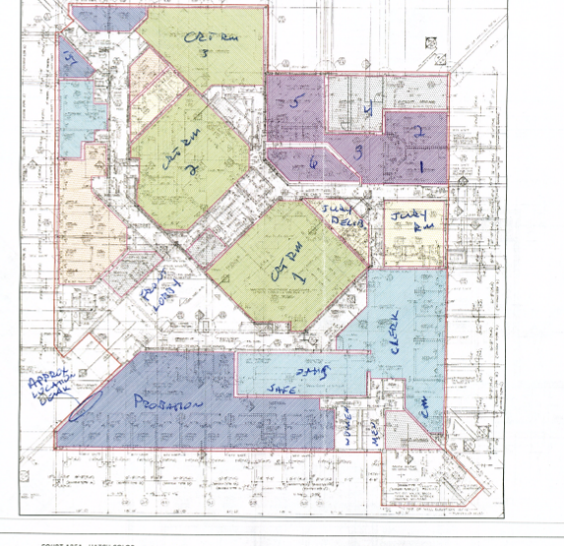
Picture 1
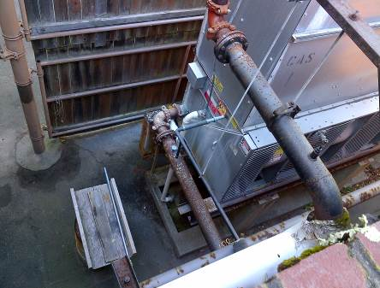
HVAC System Chiller
Picture 2
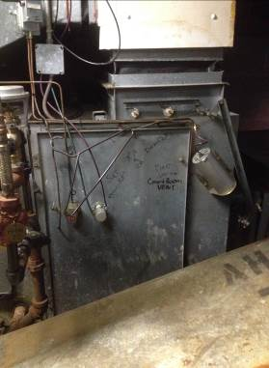
AHU louver held in place by plastic coat hanger, note actuator motor (arrow) control rod missing
Picture 3
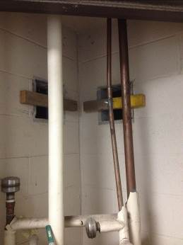
Interior view of HVAC cell vent opening with ductwork removed
Picture 4
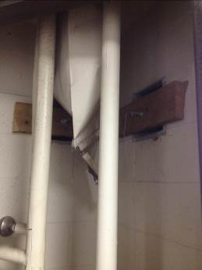
Interior view of HVAC cell vent opening with ductwork removed, note crimped duct (arrow)
Picture 5
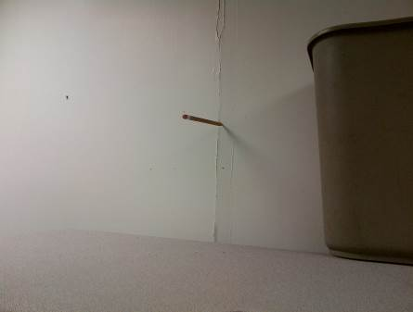
GW softened enough to easily insert pencil into the wall, note trash bin
used to collect water during rainstorms as reported by court staff

Picture 6
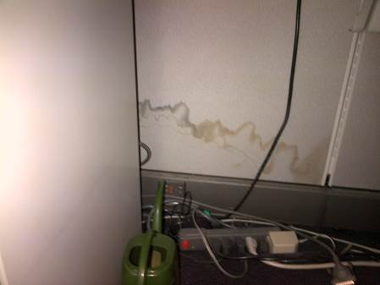

Water damage to wall of modular furniture

Picture 7

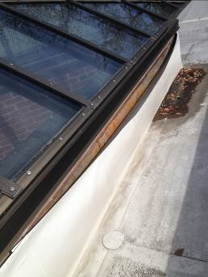

Loose roof membrane
Picture 8
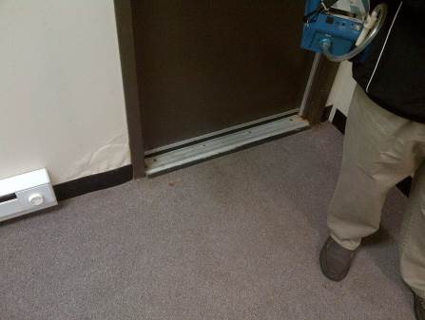
Water-damaged GW around doorframe

Picture 9
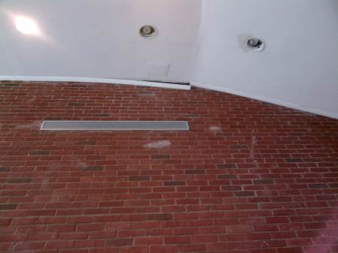
Distended GW, note white spots on brick (efflorescence) which is a sign of water intrusion
Picture 10
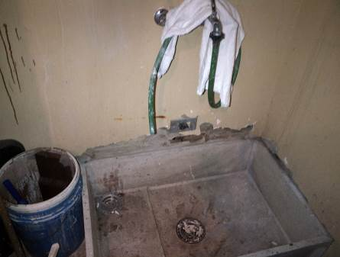
Water-damaged GW around custodial sink
Picture 11
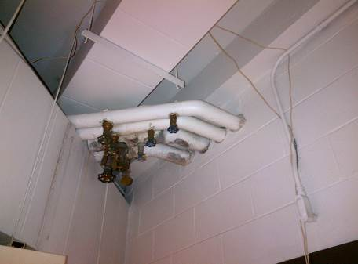
Mold-colonized pipe insulation
Picture 12
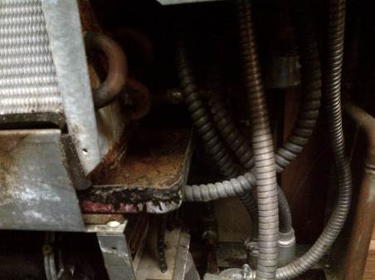
Scale in FCU drip pans, indicating lack of routine maintenance

Picture 13
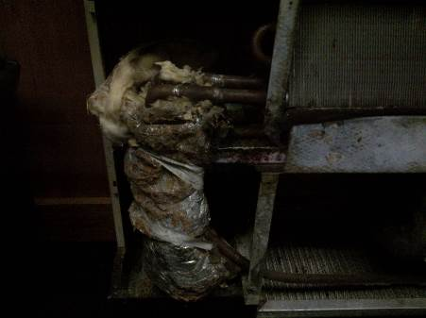
Damaged fiberglass insulation inside FCU
Picture 14
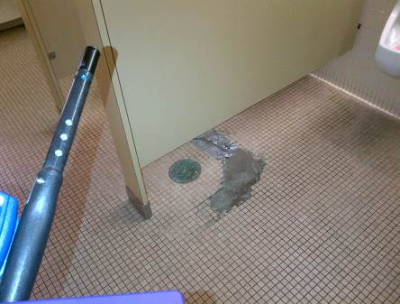
Restroom floor repaired with duct tape

Picture 15
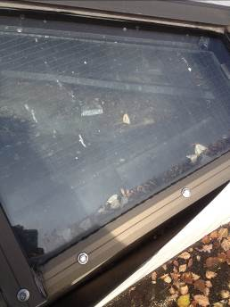
Bird carcass and other debris in skylight

Picture 16
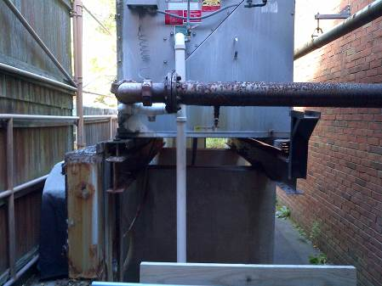
Corroded chiller fixtures
Picture 17
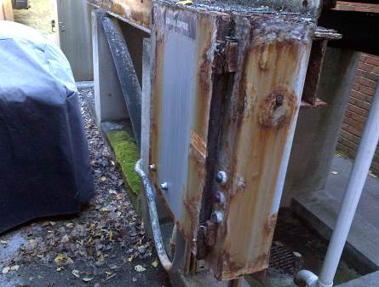
Corroded chiller electrical control box
Picture 18
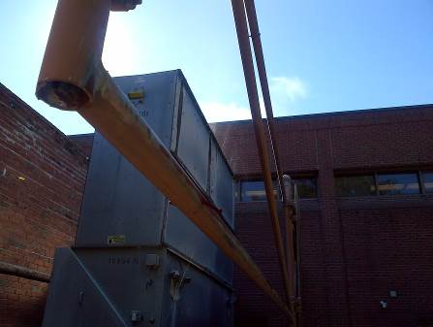
Top of chiller unit

Picture 19
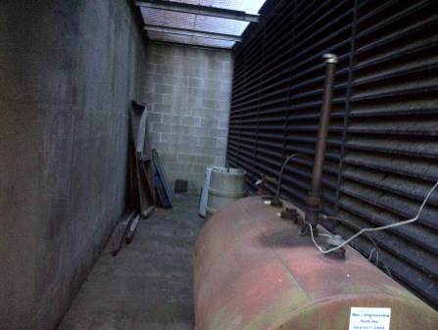
Oil tank in front of HVAC system fresh air intake
Picture 20
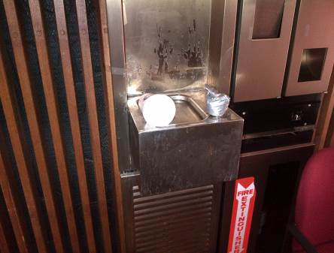
Abandoned water bubbler

Picture 21
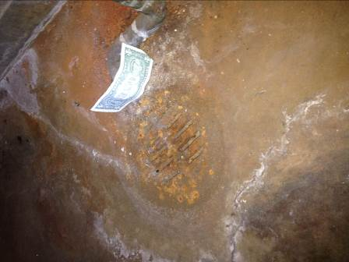
AHU condensation drain is depressurized
Picture 22
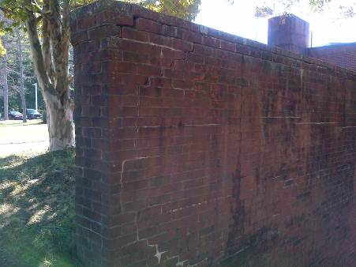
Retaining wall above chiller

Picture 23
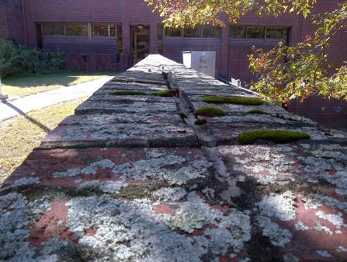
Retaining wall above chiller
Picture 24
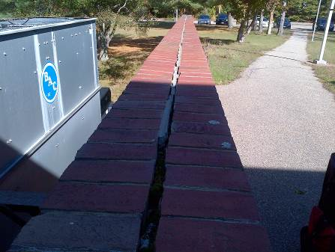
Retaining wall above chiller

Picture 25
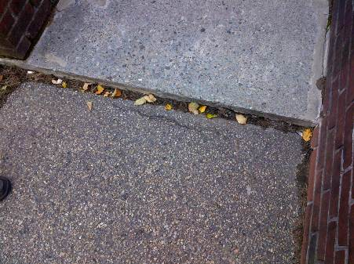
Subsisting asphalt of access ramp for building

Location | Carbon  Dioxide  (ppm) | Carbon Monoxide  (ppm) | Temp  (°F) | Relative  Humidity  (%) | PM2.5  (µg/m³) | Occupants  in Room | Windows  Openable | Ventilation |  |  | Remarks
 |  |  |  |  |  |  |  | Supply | Exhaust |  | Remarks
Background | 340 | ND | 66 | 40 | 37
6 | 615 | ND | 74 | 44 | 33 | 0 | Y | N |  | Y | DO FCU
Judge Lobby | 611 | ND | 71 | 44 | 36 | 0 | Y | Y
1 | 631 | ND | 71 | 44 | 36 | 0 | Y | N |  | Y | DO FCU
2 | 670 | ND | 70 | 47 | 36 | 0 | Y | N |  | Y | FCU
3 | 707 | ND | 70 | 46 | 35 | 0 | N | N |  | Y | FCU
4 | 671 | ND | 70 | 47 | 38 | 1 | N | Y |  | N | FCU
7 | 645 | ND | 70 | 45 | 39 | 0 | Y | N |  | Y | FCU
Jury Room | 589 | ND | 69 | 40 | 38 | 0 | Y | Y |  | Y off | Exhaust vent in restroom off
Deliberation Room | 694 | ND | 70 | 42 | 36 | 0 | N | Y |  | Y | RR, WD-wall
Clerk | 719 | ND | 69 | 43 | 36 | 6 | N | Y |  |  | WD-GW ceiling
Clerk magistrate | 649 | ND | 69 | 44 | 39 | 0 | Y | Y |  | N | FCU
Court 1 | 758 | ND | 70 | 42 | - | 8 | N | Y |  | Y
Court 2 | 536 | ND | 68 | 41 | - | 0 | N | Y |  | Y | Brick uneven
Probation main office | 726 | ND | 68 | 45 |  |  |  |  |  |  | WD exterior wall, carpet, cubicle wall
Probation kitchen | 706 | ND | 70 | 46 |  | 2 | 2 | N |  | Y off
Lock up control room | 661 | ND | 70 | 41 |  | 1 | N | Y |  | Y | Smoke pipe, mold on pipe wrap

