**WATER DAMAGE ASSESSMENT**

**Water Department Garage**

**694 Main Street**

**West Newbury, MA**

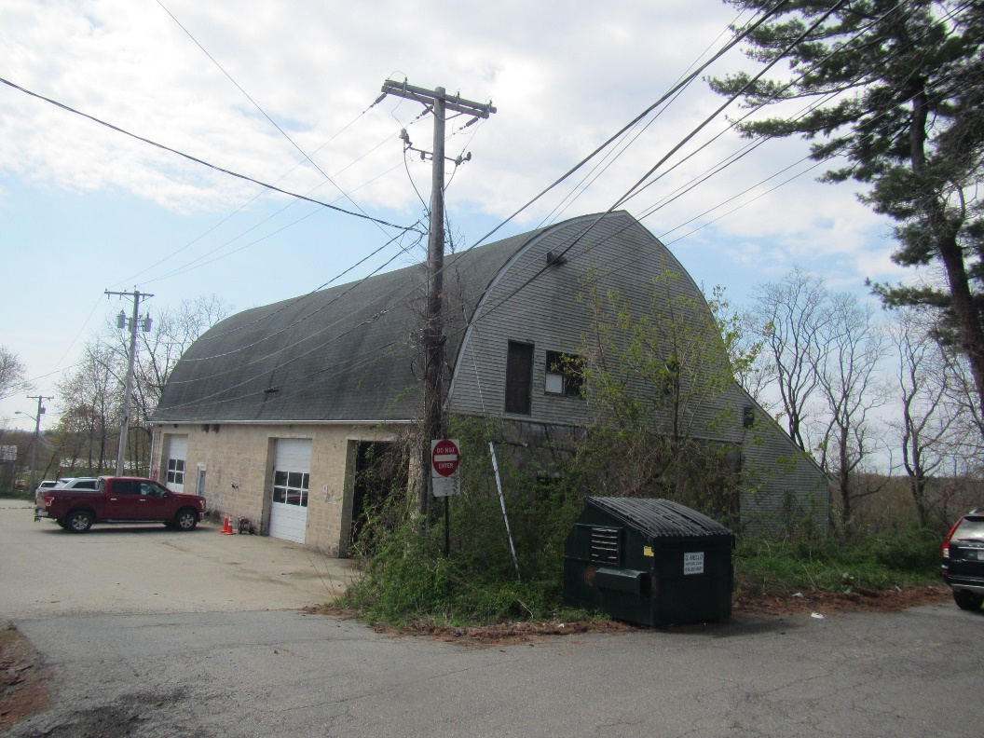

Prepared by:

Massachusetts Department of Public Health

Bureau of Climate and Environmental Health

Indoor Air Quality Program

May 2024

# BACKGROUND

|  |  |
| --- | --- |
| Building: | West Newbury Water Department Garage (WDG) |
| Address: | 694 Main Street, West Newbury |
| Reason for Request: | Water damage and mold concerns |
| Date of Assessment: | May 6, 2024 |
| Massachusetts Department of Public Health/Bureau of Environmental Health (MDPH/BEH) Staff Conducting Assessment: | Ruth Alfasso, Environmental  Engineer/Inspector, Indoor Air Quality (IAQ)  Program |
| Building Description: | The WDG building was originally a gym and maintenance area belonging to the adjacent school building, both built in the 1920s. It is a barn-shaped building with several roll-up doors on the lower level, and a large open area, the former gym, on the upper level. A small lean-to-style addition was made to the rear of the building in the last 20 years. |
| Windows: | Openable |

# METHODS

Please refer to the IAQ Manual for methods, sampling procedures, and interpretation of results (MDPH, 2015).

# RESULTS AND DISCUSSION

The following is a summary of indoor air testing results (Table 1). Note that one of the large roll-up doors was open during the assessment.

* ***Carbon dioxide*** measurements were below the MDPH guideline of 800 parts per million (ppm).
* ***Temperature*** was below the recommended range of 70°F to 78°F.
* ***Relative humidity*** was slightly above the recommended range of 40% to 60% in all areas tested.
* ***Carbon monoxide*** levels were non-detectable (ND) in all areas tested.
* ***Fine particulate matter (PM2.5)*** concentrations were below the National Ambient Air Quality Standard (NAAQS) level of 35 μg/m3 in all indoor areas tested.

## Ventilation

This building has no mechanical ventilation. It relies on open windows and the large roll-up doors for fresh air (Picture 1). Some of the original windows in the building have been blocked by the lean-to style addition (Picture 2). In the original configuration, open windows on both sides of the building would have allowed for cross ventilation. The building is not heavily occupied, with a maximum of two employees in the building for short periods during the day. The building contains a single restroom, which has no windows or exhaust vent.

There are several oil-fired heaters in the building (Picture 3), but they are reportedly rarely used. The upstairs also has radiators that are no longer functional (Picture 4).

## Microbial/Moisture Concerns

The main reason for this visit was a concern about mold. Mold grows on porous, carbon-containing materials when they are moistened and not dried quickly enough. The United States Environmental Protection Agency (US EPA) and the American Conference of Governmental Industrial Hygienists (ACGIH) recommend that porous materials be dried with fans and heating within 24 to 48 hours of becoming wet (US EPA, 2008). If porous materials are not dried within this time frame, mold growth may occur. Once mold has colonized porous materials, they are difficult to clean and should be removed and discarded.

To prevent or control mold growth it is important to reduce sources of moisture and remove porous mold-susceptible materials from areas where water damage may occur. One significant source of water damage to this building is roof leakage. The roof of the building is scheduled to be repaired. During roof repairs, it is necessary to address the seam (Picture 5) where the lean-to style addition was added to the main building. The inside wall of this section was the exterior of the original building (Picture 2). Joints where different materials manufactured at different times meet are often subject to leaks. This roof seam may need repair or additions to flashing to accommodate the connection of the old and new part of the building. Roof leaks have reportedly led to puddling on the floor inside (Picture 6).

Several ceiling locations have signs of water damage and possible mold colonization. (Pictures 7 through 9). Any porous materials that have become moldy cannot be cleaned and need to be replaced. Other materials may have only a surface layer of mold that can be cleaned, or, in the case of wood, potentially sanded off and resealed.

Because this building is typically open to the elements via the roll-up doors, issues may occur with both rainwater intrusion and with condensation due to high humidity. With the doors open and no mechanical ventilation, temperature and humidity inside will be similar to outside. When exposed to high humidity conditions, porous materials such as cardboard, paper, leather, and cloth may become moistened and colonized with mold. According to the American Society of Heating, Refrigerating and Air-Conditioning Engineers (ASHRAE); if relative humidity exceeds 70%, mold growth may occur due to wetting of building materials (ASHRAE, 2022) even in the absence of liquid water.

In addition, it is unlikely the cement floor is insulated, which means the floor temperature is similar to the soil temperature underneath. In the summer, floors may be significantly cooler than the surrounding air. Hot, humid air passing over cooled surfaces will condense and moisten anything that is stored on the floor. Thermally conductive materials, like metal shelving, in contact with the ground may also be below the dew point of the incoming hot, humid air and water may condense on the metal surfaces.

Hot humid summers are becoming more frequent due to climate change. Massachusetts has experienced hot, humid, and rainy summers in 2018, 2021, and 2023. July of 2021 was the wettest ever recorded in Massachusetts, and the three-month period from June through August, known as the meteorological summer, was the fourth wettest on record, according to the National Oceanic and Atmospheric Administration’s (NOAA) Centers for Environmental Information (NOAA, 2021). The summer of 2023 was also hot, and wet, being measured as the second rainiest on record (WBUR, 2023). These conditions are challenging for buildings, particularly those without air conditioning.

Because of the condition and function of this building, there is no way to exclude humid outdoor air or rain completely. Therefore, it is important to minimize the number of porous materials present in the building. Furniture used in the building should be made of non-porous materials. A leather chair was noted (Picture 10) that did not appear to be mold-colonized at the time of the visit. Paper materials that need to be kept on site (e.g., logs, manuals, safety data sheets), should be stored up off the floor and away from any known areas of leaks. Sealable plastic boxes can be used to further reduce moistening of important paper.

Note that the DPH IAQ program does not recommend testing for mold. See <https://www.mass.gov/info-details/guidance-regarding-testing-for-mold-in-water-damaged-public-buildings> for more information.

## Other Issues

A variety of other issues were noted in the WDG. Vehicles are stored in the building in both the main garage and the lean-to section. Vehicles inside a building can be a source of:

* Vehicle exhaust containing carbon monoxide and soot,
* Vapors from diesel fuel, motor oil and other vehicle liquids which contain volatile organic compounds,
* Rubber odors from tires, and
* Residues from use such as water, salt, sand, and grass.

Of particular importance is vehicle exhaust which involves the process of combustion. The garage is not equipped with any tailpipe exhaust collection system to remove exhaust during idling. Vehicles and equipment should not be idled inside the garage, and the roll-up doors should be kept open until all combustion engines have been turned off.

Heat for the building is primarily provided by oil-fired heaters (Picture 3). While these are designed to be used inside garage-style buildings, they may still produce odors and products of combustion when in use, particularly if they aren’t in good condition.

Fuel and lubrication oils are also stored in the building, in both small containers (Picture 5) and in a tank used by the heaters (Picture 11). Care should be taken during filling and use to avoid spills, and the tank and associated piping should be checked periodically for integrity. Spills of fuel, lubrication oils, or other petroleum products should be cleaned up promptly using appropriate spill clean-up products. Antifreeze was also noted in the building. Depending on the composition of this material, it may contain VOCs or have an odor. Spills of antifreeze should also be cleaned up promptly. Other VOC-containing materials such as cleaners and paints were also noted (Picture 12).

A significant amount of dust and debris was noted in all areas of the building (Pictures 13 and 14). Dust and debris can become airborne and be a source of irritation. Fiberglass insulation in particular (Picture 15) can be a source of dust that is very irritating to the eyes, respiratory system, and skin. Many of the components of dust are also capable of supporting mold growth if they are moistened.

Evidence of rodents and birds were noted in the building. Rodent waste and dander can be a source of allergens. Birds and bird waste may carry diseases that can affect humans. Animals of any kind can damage building materials. Due to the use of the building, excluding animals completely is not possible. Occupants should reduce conditions that encourage pest animals including trimming back plants from around the building, storing any food in pest-proof containers, reducing interior clutter to remove hiding areas, and closing any holes or breaches that can provide access or nesting areas.

Dust and debris should be cleaned up using methods that minimize aerosolizing dust and debris. In addition, personal protective equipment should be used to protect the cleaners’ eyes, skin, and respiratory tract from fiberglass, microbial contaminants, and general irritation.

An air purifier was noted in the main garage area (Picture 12). This air purifier is too small to effectively remove dust from the air in this building. In addition, it is currently located next to containers of materials that may produce odors and VOCs, so in use it would distribute these odors. An air purifier in this situation would work best when placed to direct the stream of clean air into the breathing zone of occupants.

# CONCLUSIONS/RECOMMENDATIONS

The WDG has a number of issues that are common to the Department of Public Works and similar buildings. Due to the nature of the work and the style of the building, exposures to outdoor temperatures, dust and debris, and other contaminants can be minimized but not eliminated. To remedy building problems, the following recommendations are made:

## Ventilation Recommendations

1. Keep roll-up doors open whenever vehicles or any equipment are operating inside. Avoid idling.
2. Keep oil-fired heaters clean and in good condition to reduce the potential for products of combustion to be emitted.
3. Install carbon monoxide alarms in the building to warn occupants if hazardous conditions occur.
4. Consider installing a large-volume switch-operated exhaust vent in the building wall to remove fumes and odors during activities such as painting or vehicle maintenance.
5. If the upstairs is to be occupied, use the windows for fresh air. Ensure they are tightly closed after use.

## Water Damage Recommendations

1. Management of buildings in extreme relative humidity and rain can be challenging. The following documents can provide guidance that can be used to reduce the impact of hot, humid weather in buildings; Mold Growth Prevention during Hot, Humid Weather <https://www.mass.gov/service-details/preventing-mold-growth-in-massachusetts-schools-during-hot-humid-weather> and Remediation and Prevention of Mold Growth and Water Damage in Public Schools <https://www.mass.gov/service-details/remediation-and-prevention-of-mold-growth-and-water-damage-in-public-schools-and>
2. Continue with plans to fix the roof. Ensure that roof repairs include attention to the seam between the old and new building.
3. Water-damaged wallboard, other building material, and items should be cleaned or removed in a manner consistent with the US EPA’s “Mold Remediation in Schools and Commercial Buildings”. Available at: <http://www.epa.gov/mold/mold-remediation-schools-and-commercial-buildings-guide>.
4. Avoid storing porous materials in contact with the floor.
5. Store important papers in waterproof containers.
6. Reduce the presence of other porous materials such as leather furniture. Use furniture suitable for indoor/outdoor use.

## Other Recommendations

1. Periodically monitor the condition of the oil tank and piping to detect spills or leaks.
2. Keep all containers of fuel, lubricant, paint, antifreeze, cleaners and similar items tightly closed when not in use. Clean up spills promptly using appropriate materials and remove from the building.
3. Keep trucks and combustion equipment in good condition. Avoid bringing very dirty vehicles into the building.
4. Trim plants away from the building and remove clinging plants to reduce harborage and transportation for pests.
5. Seal openings that may be used for access or nesting. Consult with a licensed pest control technician as to the best methods for reducing bird nesting and mouse access.
6. Clean and organize the items stored in the building. Discard unneeded and outdated equipment and materials. Store the remainder in an organized manner.
7. Clean floors and other surfaces to remove dust and debris. Because the dust/debris may contain fiberglass, mold, and pest waste, use personal protective equipment to protect the eyes, skin and respiratory system while cleaning.
8. If an air purifier is used, consider raising it up on a table to place the stream of cleaned air near where people will be breathing. Avoid obstructing them or placing VOC-containing items in the airstream. Clean the units and change the filters regularly. Avoid using any air purifiers that may produce ozone.
9. Refer to resource manual and other related IAQ documents located on the MDPH’s website for further building-wide evaluations and advice on maintaining public buildings. These documents are available at: <http://mass.gov/dph/iaq>.

# REFERENCES

ASHRAE, 2022. American Society of Heating, Refrigeration and Air Conditioning Engineers (ASHRAE) Ventilation for Acceptable Indoor Air Quality. ANSI/ASHRAE Standard 62.1-2022. Atlanta, GA.

MDPH. 2015. Massachusetts Department of Public Health. Indoor Air Quality Manual: Chapters I-III. Available at: <https://www.mass.gov/lists/indoor-air-quality-manual-and-appendices#indoor-air-quality-manual->.

NOAA. 2021. Summer 2021 neck and neck with Dust Bowl summer for hottest on record. National Oceanic and Atmospheric Administration, 1401 Constitution Avenue NW, Room 5128, Washington, DC 20230 <https://www.noaa.gov/news/summer-2021-neck-and-neck-with-dust-bowl-summer-for-hottest-on-record>.

US EPA. 2008. “Mold Remediation in Schools and Commercial Buildings”. Office of Air and Radiation, Indoor Environments Division, Washington, DC. EPA 402-K-01-001. September 2008. Available at: <http://www.epa.gov/mold/mold-remediation-schools-and-commercial-buildings-guide>.

WBUR. 2023. “It's been a summer of rain and flooding misery in Mass.” WBUR local news. September 12, 2023. <https://www.wbur.org/news/2023/09/12/summer-flooding-rain-massachusetts>.

**Picture 1**

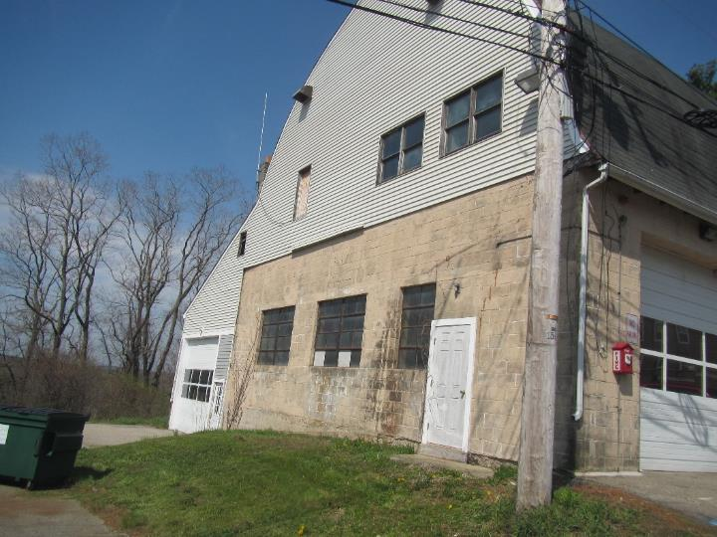

**Side of building showing windows and roll-up doors; the section on the left side of the building is the recent addition**

**Picture 2**

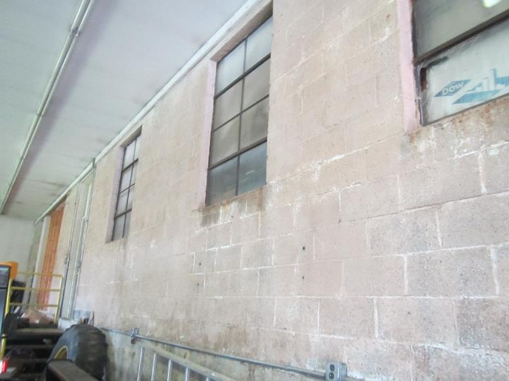

**Inner wall of the lean-to addition was originally an exterior wall; note windows**

**Picture 3**

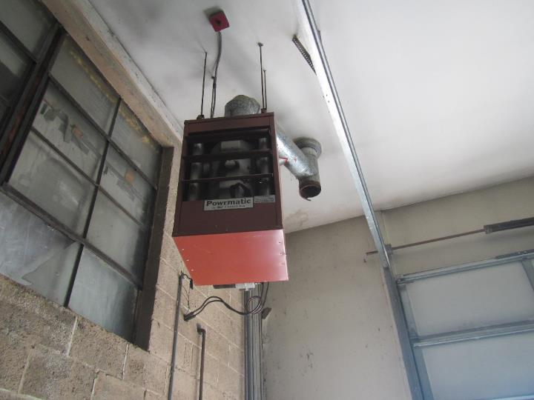

**Oil-fired heater**

**Picture 4**

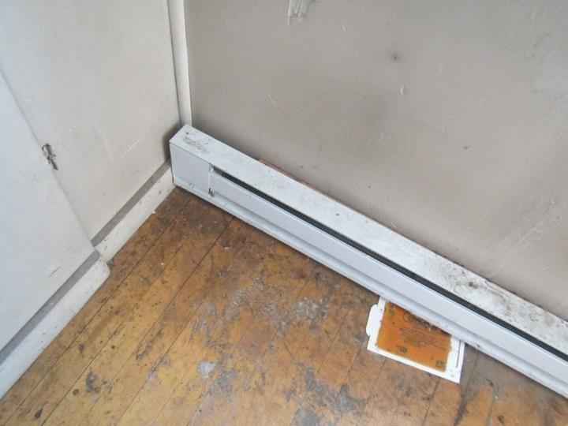

**Disused radiator in the office on the upper level**

**Picture 5**

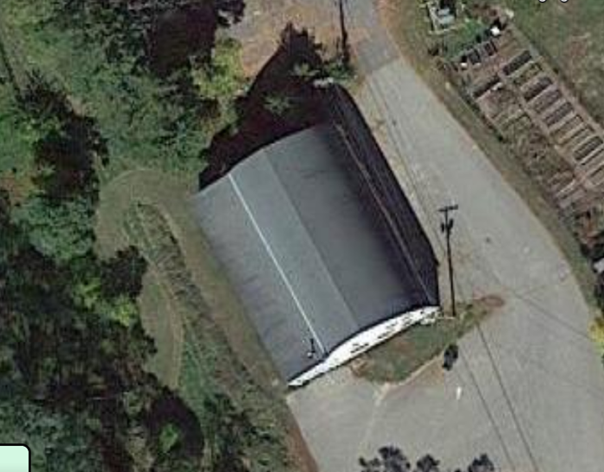

**Roof joint of new addition (Arrow)**

**Picture 6**

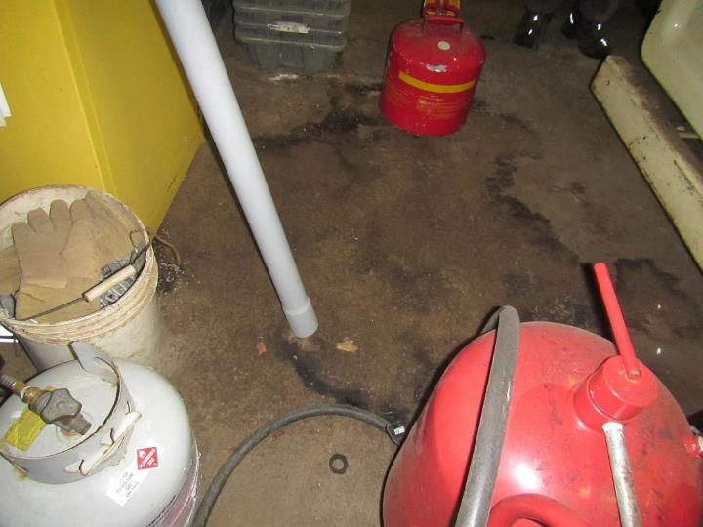

**Water stains on floor, also note fuel containers**

**Picture 7**

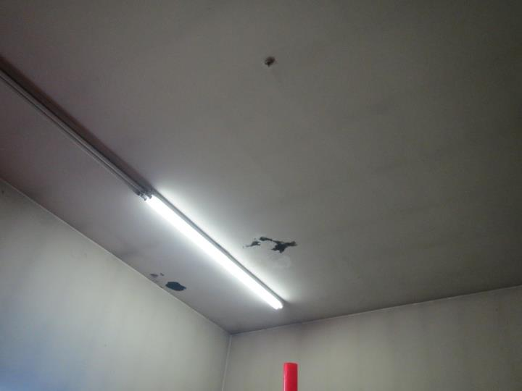

**Stains on the ceiling that may be mold growth**

**Picture 8**

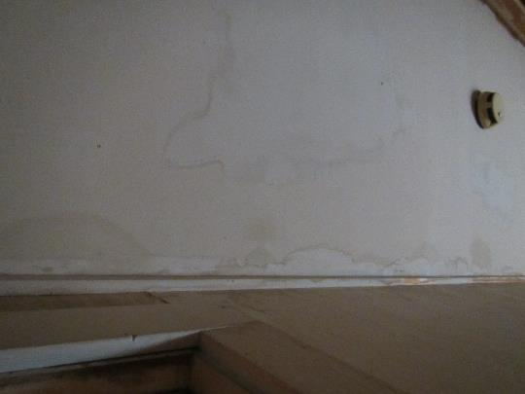

**Water stains on ceiling of stairwell from upper level**

**Picture 9**

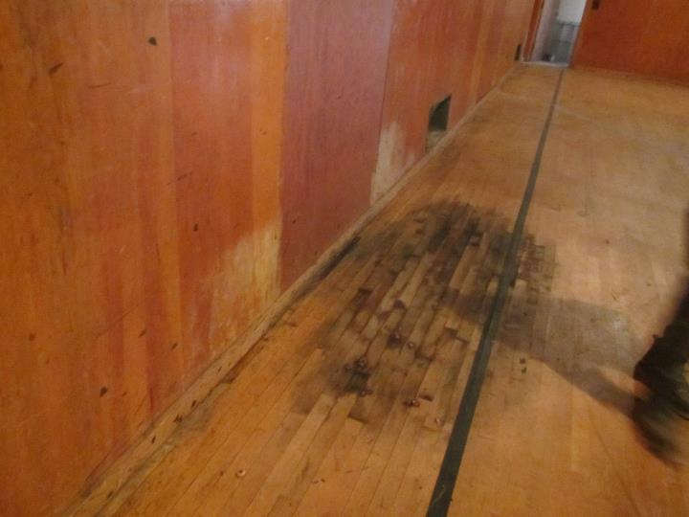

**Dark staining on upstairs wooden floor that may be oil or mold growth**

**Picture 10**

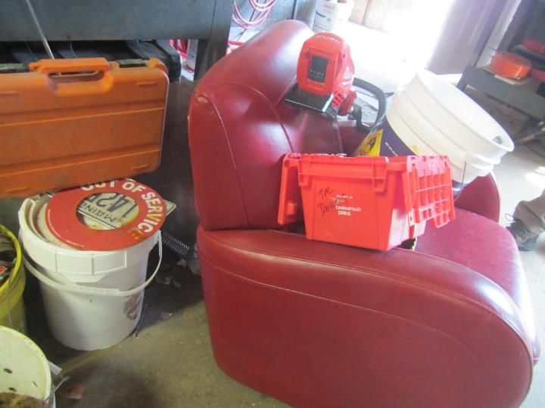

**Leather chair; also note equipment and clutter**

**Picture 11**

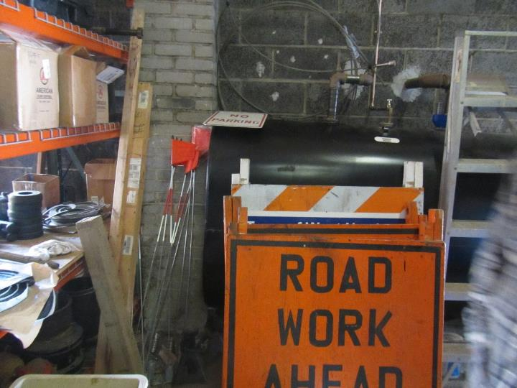

**Fuel tank for the heaters**

**Picture 12**

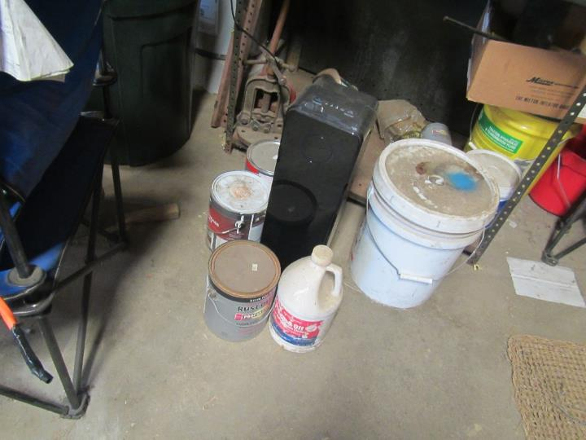

**Paints and other materials, along with an air purifier**

**Picture 13**

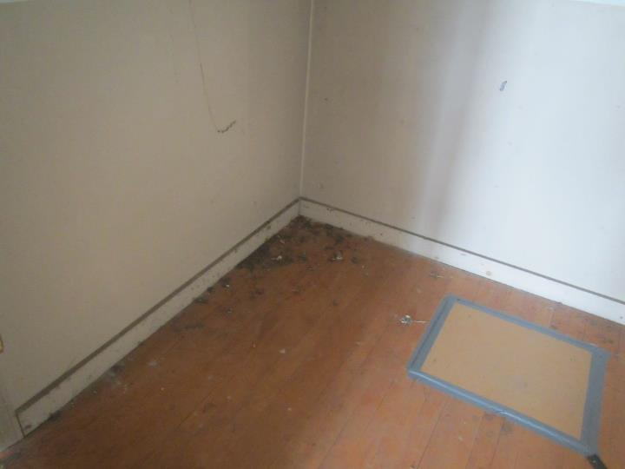

**Dust and debris on the upper level**

**Picture 14**

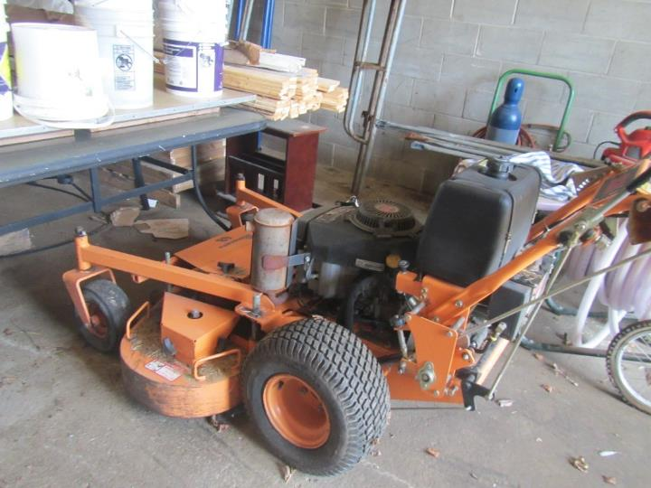

**Debris on the floor in the main garage**

**Picture 15**

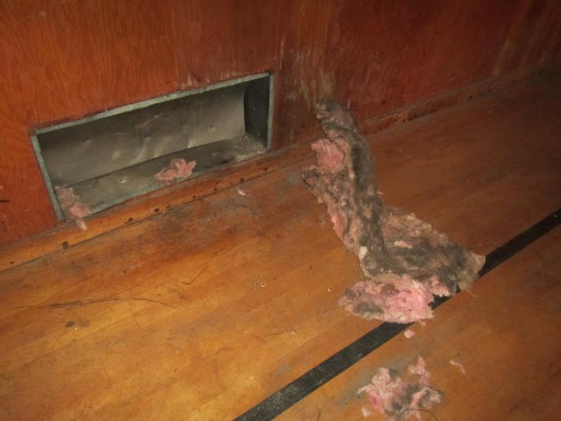

**Fiberglass insulation debris on the upper level**

| **Location** | **Carbon**  **Dioxide**  **(ppm)** | **Carbon Monoxide**  **(ppm)** | **Temp**  **(°F)** | **Relative**  **Humidity**  **(%)** | **PM2.5**  **(µg/m3)** | **Occupants**  **in Room** | **Windows**  **Openable** | **Ventilation** | | **Remarks** |
| --- | --- | --- | --- | --- | --- | --- | --- | --- | --- | --- |
| **Supply** | **Exhaust** |
| Background | 373 | ND | 68 | 63 | 5-985 |  |  |  |  | Sunny and breezy, higher PM2.5 during mowing nearby |
| Main garage area | 654 | ND | 65 | 61 | 2 | 0 | Y | N | N |  |
| Upstairs old gym | 486 | ND | 64 | 53 | ND | 0 | Y | N | N |  |