Massachusetts Department of Environmental Protection
Bureau of Resource Protection – Drinking Water Program
BRP WM 01
Water Management Act Program
Registration and/or Permit Transfer Form

 | A. Applicant Information
Important: When filling out forms on the computer, use only the tab key to move your cursor - do not use the return key.  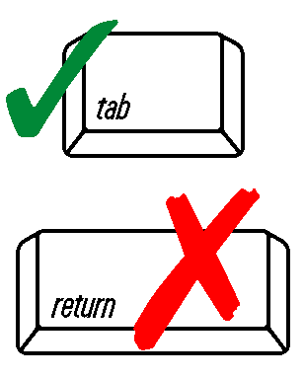 | 1. Registration and/or Permit Holder:
 | Name
 | Title
 | Mailing Address
 | City |  |  |  | State |  |  | Zip Code
 | Email
 | Contact Person |  |  |  | Telephone
 | 2. Registration and/or Permit Transferee
 | Name
 | Title
 | Mailing Address
 | City |  |  |  | State |  |  | Zip Code
 | Email
 | Contact Person |  |  |  | Telephone
 | B. Registration and/or Permit Information
 |  |  |  | Registration and/or Permit # |  | Watershed |  |  | Volume(s) to be transferred (mgd*)
 | 1. General Information
 | 2. For Cranberry Growers: Acreage to be transferred: |  |  |  |  |  |  |  | Acreage
 | * mgd = million gallons per day
 | B. Registration and/or Permit Information (cont.)
 | 3. Withdrawal point(s) to be transferred:
 | Name of Source(s) | PWS ID# (if applicable) | Watershed |  |  |  | R and/or P # |  | Volume to be transferred (mgd)
 | a.
 | b.
 | c.
 | d.
 | e.
 | f.
 | g.
*A Permit Transfer application that amends these permit provisions also requires that a Permit Amendment application be filed. Contact DEP Water Management Act Program staff at appropriate Regional Office for more information. | 4. Will there be a change of use?* Yes No If yes, please describe:
 | 5. Will there be a change of discharge point?*
 | Yes No If yes, please describe:
 | 6. Will there be a change in the number of days each year that the withdrawal will be made?*
 | Yes No If yes, please describe:
 | 7. Give the date the transfer is to take place: |  |  |  | Date
 | C. Certification Statement
Note: If a letter of agreement, signed by both parties, stating the terms of the transfer has been forwarded to the Department or is included with this application, only one signature is required on the application. | I certify, under penalty of law, that this application and all attachments were prepared under my supervision, in accordance with a system designed to insure that qualified personnel properly gathered and evaluated the information submitted. Based on my inquiry of the person or persons who manage the system, or those persons directly responsible for gathering the information submitted in this application, the information submitted is, to the best of my knowledge and belief, true, accurate and complete.
 | Name of Registration and/or Permit holder |  |  |  | Position or Title
 | Signature of current holder |  |  |  | Date
 | Name of transferee |  |  |  | Position or Title
 | Signature of transferee |  |  |  | Date

