*****Water-Smart & Media Outreach Toolkit**

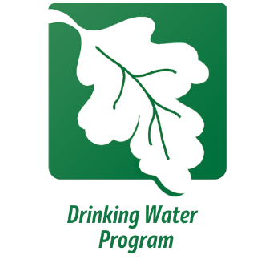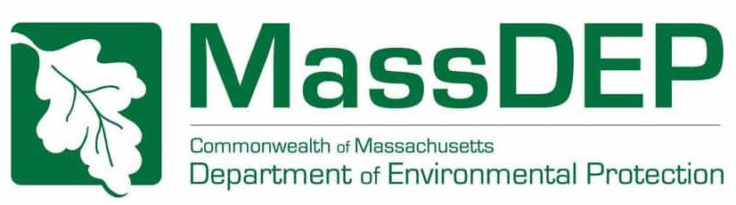

**Table of Contents**

Introduction……………………………………….3

**Social Media Posts**

Water-Smart Program Introduction Part 1…………4

Water-Smart Program Introduction Part 2…………5

Water-Smart Program Introduction Part 3…………9

Brita Filters Post………………….……….……...12

Water-Smart Program Banners……………..…….13

**Spanish Outreach**

Water-Smart Program Spanish Introduction……...17

Water-Smart Program Spanish Banners……...…..19

**Videos**

Step by Step…………………………..………..…20

Sample Collection……………………………….. 21

**Interactive Web Maps**

Water-Smart StoryMap…………………………..22

**Reports**

2020-2022 Water-Smart Report………………....23

***Introduction***

This Toolkit is a compilation of materials and information about the MassDEP Water-Smart Program (formerly the Expanded Assistance Program) that can be shared digitally (social media) to your community and interested childcare providers, bringing awareness about the dangers of lead in drinking water and the services our program can offer to address this.

**What is the program?**

MassDEP’s Water-Smart Program offers FREE lead in drinking water testing, technical assistance, and outreach materials for eligible schools and childcare programs. After testing and consultation, participants will receive certification acknowledging that they have tested their drinking water and taken any needed actions. Participants will also receive the Water-Smart Seal of Approval to display at their school or facility.

Water-Smart is funded through the US Environmental Protection Agency (EPA) Water Infrastructure Improvements for the Nation (WIIN) Act Voluntary School and Child Care Lead Testing and Reduction Grant Program with additional support for testing of private schools from the Massachusetts Clean Water Trust.

Learn more about the program at the MassDEP Water-Smart webpage: <https://www.mass.gov/water-smart>

**How does a school or facility apply?**

Eligible public and private schools and childcare facilities in Massachusetts sign up for the free lead testing here: <https://tinyurl.com/Lead-Testing-Application>.

**How can interested organizations or individuals help?**

With your help as a trusted source of news and information to members of the general public, MassDEP asks for your help to spread this information and encourage schools and childcare facilities in Massachusetts to apply for the free lead testing program to protect the public health of Massachusetts students and faculty. MassDEP requests that you share the resources included in this toolkit to educate your audience on this important goal.

Please use the following social media posts to help us disseminate this information. Thank you for helping us to deliver these important messages.

***Social Media Posts***

This section contains three different posts related to the MassDEP Water-Smart Program for Lead in Drinking Water. These posts are formatted to be posted on Facebook, Instagram, and X (formerly known as Twitter). For posting on Facebook and Instagram, there is no character limit. For X, if you do not have a premium account, you are limited to 280 characters in a post. View examples of the following posts, and follow the MassDEP Water-Smart Program on Facebook, here: <https://www.facebook.com/DEPWaterSmartProgram/>

**Water-Smart Program Introduction Part 1**

**Instagram/Facebook Caption:**

The Massachusetts Department of Environmental Protection, in partnership with UMass, has a free lead testing program for schools and childcare programs in Massachusetts! Apply for free lead testing

Apply at the link in our bio and visit the MassDEP website for more information!

#massdep #water #drinkingwater #lead #filter #cleandrinkingwater #leadfree #WaterSmart #free #childcare

**X Caption:**

#MassDEP, in partnership with #UMass, has a #free lead testing program for #schools and #childcare programs in Massachusetts! Apply for free lead testing here: <https://tinyurl.com/Lead-Testing-Application>

#water #drinkingwater #lead #filter #cleandrinkingwater #leadfree #WaterSmart

**Water-Smart Program Introduction Part 2**

**Instagram/Facebook Caption:**

The Water-Smart Program is open for applicants! All Schools and Child Care Facilities are encouraged to apply if you have not participated before! Water-Smart is a program that tests for levels of lead in drinking water, as lead exposure can harm the developing brain of a child and there is NO safe level of lead exposure.

If parents would like to see whether their School/Child Care Facility has participated in this program, and what their most recent lead and copper results were, check the last slide in this post, or go to the link in our bio. The Water-Smart Program provides FREE drinking water testing, technical assistance, and outreach materials for schools and childcares. Use our application link in our bio or scan the QR Code in the slides to apply today!

Check our bio for the EEA Data Portal, and more information.

#massdep # Water-Smart #FREE #lead #schools #childcare #leadfree #drinkingwater #publichealth

**X Caption:**

The #Water-Smart Program for Lead in School Drinking Water is open for #Schools and #Child Care Facilities. This program tests for levels of #lead in #drinkingwater, as lead exposure can harm the developing brain of a child and there is NO safe level of lead exposure. Apply today: <https://tinyurl.com/Lead-Testing-Application>

#massdep # WaterSmart #FREE  #leadfree #publichealth

**Water-Smart Program Introduction Part 3**

**OPTION 1**

**OPTION 2**

**OPTION 3**

**Instagram/Facebook Caption:**

Lead is a toxic metal found in nature that can get into your body in different ways including by drinking water that contains lead. Children are most at risk, and there are often no signs or symptoms of lead exposure. Lead is odorless and tasteless. The only way to know if it's in your water is to test for it.

The MassDEP Water-Smart Program provides free lead testing for schools and childcare facilities in Massachusetts.

Apply today: <https://tinyurl.com/Lead-Testing-Application>  .

Questions? Contact: [lccadep@umass.edu](mailto:lccadep@umass.edu)

#massdep # WaterSmart #FREE  #leadfree #publichealth

**X Caption:**

Lead is a toxic metal found in nature and can get into your body in different ways including by drinking water that contains lead. Children are most at risk and there are often no signs or symptoms of lead exposure. Lead is odorless and tasteless. The only way to know if it's in your water is to test for it.

The MassDEP Water-Smart Program provides free lead testing for schools and childcare facilities in Massachusetts.

Apply today: <https://tinyurl.com/Lead-Testing-Application>  .

Questions? Contact: lccadep@umass.edu

#massdep # WaterSmart #FREE  #leadfree #publichealth

**Brita Filters Post**

**Instagram/Facebook Caption:**

Are you a Family Child Care Program in Massachusetts? If so, you can apply for FREE testing for lead in your drinking water and have a chance to receive a FREE Brita water pitcher! Apply at the link in our bio!

Reach out to us by phone & email with any questions on water sampling & more! Contact: [lccadep@umass.edu](mailto:lccadep@umass.edu) or 413-545-0840.

#massdep #water #drinkingwater #lead #filter #cleandrinkingwater #leadfree #Water-Smart #childcare

**X Caption:**

Are you a Family #ChildCare Program in #Massachusetts? If so, you can apply for #FREE testing for #lead in your drinking water and have a chance to receive a FREE #Brita water pitcher! Apply here: <https://tinyurl.com/Lead-Testing-Application>

For questions, contact: [lccadep@umass.edu](mailto:lccadep@umass.edu) or 413-545-0840.

#water #drinkingwater #filter #cleandrinkingwater #leadfree #Water-Smart

**Water-Smart Program Social Media Banners**

Use these banners as your cover photo or temporary profile picture on Facebook and share on your other social media accounts.

**OPTION 1**

**OPTION 2**

**OPTION 3**

**OPTION 4**

**OPTION 5**

**OPTION 6**

**OPTION 7**

***Spanish Outreach***

The MassDEP Water-Smart program has made significant efforts to reach Spanish-speaking communities in Massachusetts by translating communications and outreach materials for areas with a high concentration of Spanish-speaking Family Childcare Facilities.

Download the below Water-Smart Program Spanish materials and share with your network.

**Water-Smart Program Introduction in Spanish**

***Spanish Flyer:***

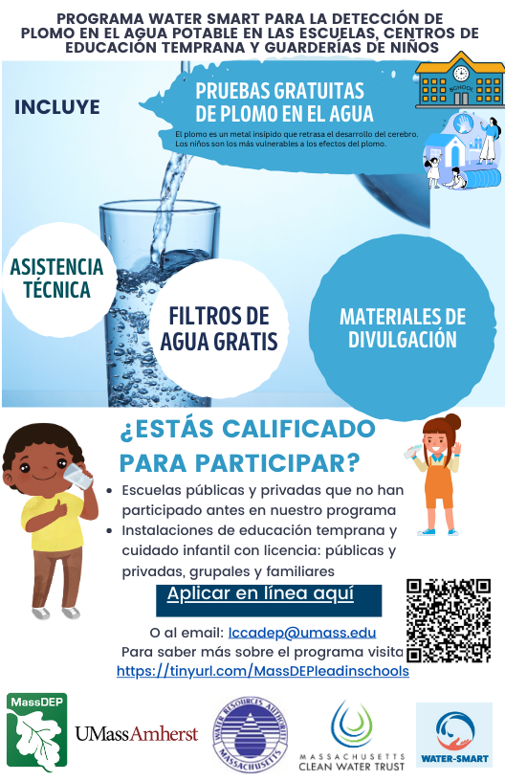

***English Translation:***

**Water-Smart Program Spanish Social Media Banner**



***MassDEP Water-Smart Program Videos***

**MassDEP Water-Smart Program: Step by Step**

**[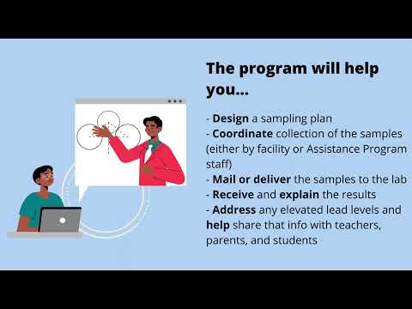](https://www.youtube.com/embed/VaFbhkeM6Wc?feature=oembed)**

**Video Description:**

This video describes MassDEP's Water-Smart Program (previously known as MassDEP Expanded Assistance Program) that includes the application process, eligibility, testing and information on technical assistance provided by MassDEP.

The video is located at: <https://www.mass.gov/info-details/technical-assistance-for-lead-in-school-and-child-care-center-drinking-water>

**[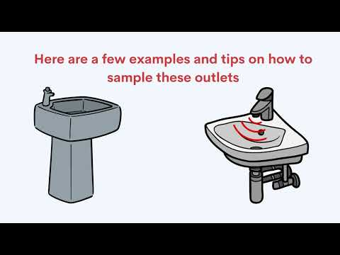](https://www.youtube.com/embed/83Nd5O4jNEs?feature=oembed)Sample Collection of Lead in Drinking Water at Schools and Childcare Facilities**

**Video Description:**

This video provides step-by-step instructions for schools and childcare facilities to collect lead drinking water samples under MassDEP's Water-Smart (previously known as MassDEP Expanded Assistance Program).

The video is located at: <https://www.youtube.com/watch?v=83Nd5O4jNEs>

***Interactive Web-Maps***

The Water-Smart StoryMap offers an interactive way for viewers to learn about the program. It features several tabs that highlight essential information about lead, instructions for applying to the program, and additional resources.

The StoryMap also includes an interactive web map that shows the communities that have facilities participating in the program and the number of facilities located in Environmental Justice communities. Users can view the locations of participating facilities, check their sampling status, and access links to their lead testing results. Additionally, previous Water-Smart Program reports are available for download.

1. A screenshot of a video game

   Description automatically generatedTo view the StoryMap here: <https://mass-eoeea.maps.arcgis.com/apps/MapSeries/index.html?appid=c8f635cf3a4b443998245f6045b4c013>
2. A screenshot of a computer screen

   Description automatically generatedTo view the web-map here:

<https://experience.arcgis.com/experience/7f58049174f84073bae7d7bcaa159ca7>

***2020-2022 MassDEP Water-Smart Program Report***

Water -Smart create report detailing the programs’ management, outreach activities, facilities sampled, sampling results, remediation actions, and more.

View the 2020-2022 Report here: <https://www.mass.gov/doc/2020-2022-massachusetts-expanded-assistance-program-for-lead-in-school-and-early-education-and-childcare-facilities-drinking-water-annual-report-september-2023/download>

