Add municipal logo here or delete this text | Add municipal entity’s name here  Add municipal entity’s address here  Water Supply Certificate Application |  |  |  |  |  | Date
 | A. General Information
Important: When filling out forms on the computer, use only the tab key to move your cursor - do not use the return key.  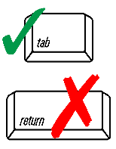 | 1. Property Address
 | Street Address
 | City |  | State |  |  | Zip
 | Assessor’s Map | Parcel
 | 2. Property Owner
 | Name  e-mail address (optional) |  | Signature
Address

State

 | City |  | State |  | Zip
 | Email address: |  | Phone
 | B. Attachments
 | Attach the following documents:
 | Copy of Well Construction Permit
 | Copy of Well Completion Report as required by MassDEP Well Driller Program regulations (310 CMR 46.00)
 | Pumping Test Report
 | Water Quality Report

