The Commonwealth of Massachusetts

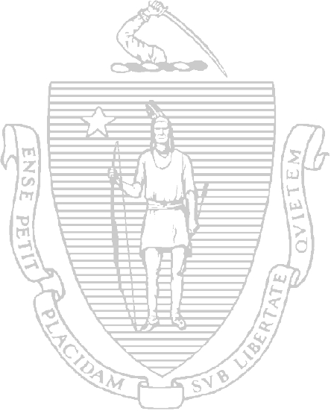

***Department of Environmental Protection***

***Division of Environmental Analysis Senator William X. Wall Experiment Station***

***certifies***

**M- MA116**

**MASS DPH ENVIRONMENTAL CHEMISTRY LAB 305 SOUTH ST**

**JAMAICA PLAIN, MA 02130-0000**

# Laboratory Director:

**LIJUAN SU**

***for the analysis of***

**POTABLE WATER (CHEMISTRY)**

pursuant to 310 CMR 42.00

This certificate supersedes all previous Massachusetts certificates issued to this laboratory. The laboratory is regulated by and shall be responsible for being in compliance with Massachusetts regulations at 310 CMR 42.00.

This certificate is valid only when accompanied by the latest dated Certified Parameter List as issued by the Massachusetts D.E.P. Contact the Division of Environmental Analysis to verify the current certification status of the laboratory.

Certification is no guarantee of the validity of the data. This certification is subject to unannounced laboratory inspections.

*Director, Division of Environmental Analysis*

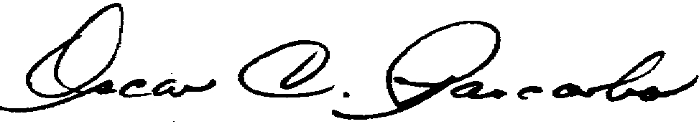

# Issued: Expires:

**01 JUL 2024**

**30 JUN 2025**