Department of Environmental Protection Division of Environmental Laboratory Sciences Senator William X. Wall Experiment Station
certifies
M-MA116 MASS DPH ENVIRONMENTAL CHEMISTRY LAB 305 SOUTH ST
JAMAICA PLAIN, MA 02130
Laboratory Director: NICOLAS EPIE
for the analysis of POTABLE WATER (CHEMISTRY)

pursuant to 310 CMR 42.00

This certificate supersedes all previous Massachusetts certificates issued to this laboratory. The laboratory is regulated by and shall be responsible for being in compliance with Massachusetts regulations at 310 CMR 42.00.
This certificate is valid only when accompanied by the latest dated Certified Parameter List as issued by the Massachusetts D.E.P. Contact the Division of Environmental Laboratory Sciences to verify the current certification status of the laboratory.
Certification is no guarantee of the validity of the data. This certification is subject to unannounced laboratory inspections.
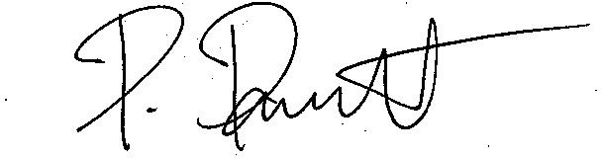

Parinya Panuwet, PhD, MSc, DABT

Director, Division of Environmental Laboratory Sciences

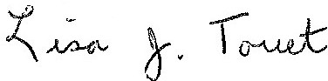

Lisa J. Touet

Director, Laboratory Certification Program


https://www.mass.gov/certified-laboratories

Issued: 07/01/2026
Expires: 06/30/2027

