 | Massachusetts Department of Environmental Protection  Bureau of Water Resources – Drinking Water Program  Water Treatment Chemical Feed System Control and Alarm Testing Log |  |  |  |  |  |  |  |  | PWS Name  PWS ID#
PWSs with chemical treatment must test controls and alarms for critical chemical feed systems quarterly.
A log must be maintained for inspection by the MassDEP DWP when requested.
 | Alarms shall be checked every: |  | Interval (weeks or months) |  |  | (at least quarterly per MassDEP requirements) |  |  |  | Quarter
Important: When filling out forms on the computer, use only the tab key to move your cursor - do not use the return key.  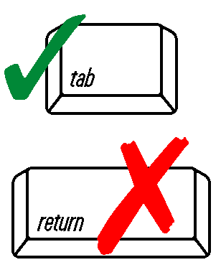 | Identified Alarm  Points | Original Value |  | Alarm Sounded?  Yes/No | Plant  Shutdown?¹  Yes/No/NA | Operator Received Call Out?²  Yes/No/NA | Alarm Reset to Original Value  Check | Date | Operator Signature |  | Comments
¹ Describes if the identified alarm point caused a plant shutdown. If NA, explain in the Comments column.

² Describes if a call out was received on SCADA, on the on-call operator’s phone, on a SCADA phone app, etc. Use the Comments column to describe where call outs were received. If NA, explain in the Comments column.

