Pain 105 (2003) 71–78

www.elsevier.com/locate/pain

Controlled-release oxycodone relieves neuropathic pain:
a randomized controlled trial in painful diabetic neuropathy
C. Peter N. Watsona,*, Dwight Moulinb, Judith Watt-Watsona, Allan Gordonc, John Eisenhofferd
aUniversity of Toronto, Toronto, ON, Canada
bLondon Regional Cancer Centre, London, ON, Canada
cWasser Pain Management Centre, Mount Sinai Hospital, Toronto, ON, Canada
dPurdue Pharma, Pickering, ON, Canada
Received 18 September 2002; received in revised form 24 March 2003; accepted 31 March 2003

Abstract
Background: Painful neuropathy is one of the most common long-term complications of diabetes mellitus and often proves difficult to relieve.
Methods: Patients with diabetic neuropathy with moderate or greater pain for at least 3 months, were evaluated for efficacy, safety and
health-related quality of life (QOL) while receiving controlled-release (CR) oxycodone (OxyContinw) or active placebo. Patients underwent washout from all opioids 2 – 7 days before randomization to 10 mg CR oxycodone or active placebo (0.25 mg benztropine) q12h. The dose was increased, approximately weekly, to a maximum of 40 mg q12h CR oxycodone or 1 mg q12h benztropine, with crossover to the alternate treatment after a maximum of 4 weeks. Acetaminophen, 325 – 650 mg q4-6h prn was provided as rescue.
Results: Thirty-six patients were evaluable for efficacy (21 men, 15 women, mean age 63.0 ^ 9.4 years). CR oxycodone resulted in significantly lower ðP ¼ 0:0001Þ mean daily pain (21.8 ^ 20.7 vs. 48.6 ^ 26.6 mm VAS), steady pain (23.5 ^ 23.0 vs. 47.6 ^ 30.7 mm VAS), brief pain (21.8 ^ 23.5 vs. 46.7 ^ 30.8 mm VAS), skin pain (14.3 ^ 20.4 vs. 43.2 ^ 31.3 mm VAS), and total pain and disability (16.8 ^ 15.6 vs. 25.2 ^ 16.7; P ¼ 0:004). Scores from 6 of the 8 SF-36 domains and both summary scales, Standardized Physical Component ðP ¼ 0:0002Þ and Standardized Mental Component ðP ¼ 0:0338Þ were significantly better during CR oxycodone treatment. The number needed to treat to obtain one patient with at least 50% pain relief is 2.6 and clinical effectiveness scores favoured treatment with CR oxycodone over placebo ðP ¼ 0:0001Þ.
Conclusion: CR oxycodone is effective and safe for the management of painful diabetic neuropathy and improves QOL.
q 2003 International Association for the Study of Pain. Published by Elsevier Science B.V. All rights reserved.
Keywords: Oxycodone; Controlled-release; Analgesia; Non-cancer pain; Diabetic neuropathy; Neuropathic pain; Quality of life

- Introduction

Up to 50% of patients with diabetes mellitus develop long-term complications of peripheral neuropathy of whom 10% experience pain (American Diabetes Association and the American Academy of Neurology, 1988; Clark and Lee, 1995; Dyck, 1990; Greene and Stevens, 1993; Vinik et al., 1992). Painful diabetic neuropathy (PDN) is a major cause of morbidity, and may have a profound impact on patients’ functioning and well-being. Forty-five percent of patients have pain for longer than one year, which is usually described as a steady aching or burning (Calissi and Jaber,

* Corresponding author. 1, Sir Williams Lane, Toronto, Canada M9A 1T8. Tel.: þ 416-239-3494; fax: þ 416-239-6365.
E-mail address: peter.watson@utoronto.ca (C.P.N. Watson).
1995; Young et al., 1988). This type of neuropathic pain may be characterized by hyperesthesia, dysesthesia, hyper- algesia, paresthesia, or allodynia, and may be accompanied by sensory loss and absent reflexes. Of the numerous types of diabetic neuropathy, symmetrical distal sensory neuro- pathy is one of the commonest.
The most common choices of therapy for neuropathic pain such as PDN are tricyclic antidepressants and anti- convulsants (Watson and Watt-Watson, 1999). Randomized controlled trials (RCT’s) have indicated that tricyclic antidepressants such as amitriptyline (Max et al., 1987, 1992), desipramine (Max et al., 1991), and imipramine (Kvinesdal et al., 1984; Sindrup et al., 1989) are successful in relieving PDN. These drugs are often limited by anticholinergic, hypotensive and CNS side effects. The anticonvulsant carbamazepine has also been reported to be

0304-3959/03/$20.00 q 2003 International Association for the Study of Pain. Published by Elsevier Science B.V. All rights reserved. doi:10.1016/S0304-3959(03)00160-X

effective in two double-blind, placebo-controlled trials; however, the placebo effect was large compared to that of active treatment (Rull et al., 1969; Wilton, 1974). Two controlled studies of phenytoin have produced conflicting results (Chadda and Mathur, 1978; Saudek et al., 1977). A randomized placebo-controlled trial showed that gabapentin is effective in relieving PDN, with drowsiness and dizziness reported by approximately one quarter of the patients receiving gabapentin (Backonja et al., 1998).
Opioids have typically been considered a last resort for patients with neuropathic pain refractory to tricyclic antidepressants, anticonvulsants and other analgesics. Neuropathic pain has previously been regarded as less responsive to opioids than nociceptive pain (Cherny et al., 1994). There is, however, growing evidence that opioids are effective as long as patients are carefully selected and dosed appropriately to achieve an optimal balance between maximal analgesia and adverse effects (Portenoy and Coyle, 1990; Rowbotham et al., 1991). There is also evidence that the risk of psychological dependence or addiction is low in the absence of a history of substance abuse (Porter and Jick, 1980). Only a few trials have evaluated opioids in neuro- pathic pain. The first definitive evidence of the efficacy of opioids in neuropathic pain was a single-dose placebo- controlled, randomized, double-blind crossover comparison of intravenous lidocaine and morphine in post-herpetic neuralgia (PHN) (Rowbotham et al., 1991). Both lidocaine and morphine provided significant pain relief, although a majority of patients preferred morphine to lidocaine. Other studies in PHN and other neuropathic pain conditions with controlled-release (CR) morphine and transdermal fentanyl also showed a good response to opioid therapy (Dellemijn et al., 1998; Pappagallo and Campbell, 1994). In a RCT in patients with PDN, tramadol compared to placebo, relieved pain, paresthesias and allodynia (Harati et al., 1998). Sindrup et al. (1999) showed that tramadol is effective in the treatment of patients with polyneuropathy (NNT 4.3) of whom 15 out of the 34 patients had diabetic neuropathy while the rest had neuropathy of varying aetiology.
A CR formulation of oxycodone has been shown to be effective in the treatment of cancer pain and postoperative pain, and to improve quality of life (QOL) in patients suffering from osteoarthritis (Hagen and Babul, 1997; Roth et al., 2000). This opioid formulation also significantly reduced steady pain, brief pain and allodynia in the treatment of PHN in a RCT (Watson and Babul, 1998). The purpose of the current study was to examine the efficacy, safety and effect on QOL of CR oxycodone in the treatment of PDN.

- Patients and methods

  - Patients

Forty-fi adults with diabetes mellitus in stable glycemic control suffering painful symmetrical distal
sensory neuropathy were enrolled in the study. Patients had at least moderate pain in the lower extremities assessed at the screening visit on a 5-point categorical scale (0, none; 1, mild; 2, moderate; 3, severe; 4, excruciating), a medical history of moderate daily pain based on the patient’s recall over the previous 3 months, one or more symptoms of diabetic neuropathy (including paresthesia, dysesthesia, hyperesthesia, hyperalgesia, and allodynia) and signs of reduced sensation, strength or tendon reflexes not attribut- able to any other cause. Patients with intolerance to oxy- codone, a history of drug or alcohol abuse, or significant pain of alternate etiology were not eligible for enrolment. Research Ethics Boards at the two participating centres (the University of Toronto, Toronto, ON and the University of Western Ontario, London, ON) approved the protocol and informed consent, and each patient gave written informed consent before participating in the study.

  - Medications

Oral CR oxycodone 10 mg tablets (OxyContinw, Purdue Pharma, Pickering, Ontario, Canada) or active placebo (PMS Benztropinew, Pharmascience, Montreal, Quebec, Canada) 0.25, 0.5, 0.75 or 1 mg tablets were administered every 12 h at 8:00 a.m. and 8:00 p.m. All patients started on a dose of 10 mg q12h CR oxycodone or 0.25 mg active placebo and were titrated approximately every 2 – 7 days to their optimal dose (10, 20, 30 or 40 mg q12h CR oxycodone
or 0.25, 0.5, 0.75 or 1 mg benztropine) to a maximum daily
dose of 80 mg CR oxycodone or 2 mg benztropine. Breakthrough pain was managed with 325 – 650 mg acet- aminophen (Tylenolw, McNeil, Guelph, Ontario, Canada) every 4 – 6 h, as required.

  - Study design

The study was a randomized, double-blind, crossover comparison of the efficacy, safety and clinical effectiveness of CR oxycodone and active placebo in the treatment of PDN. Patients were withdrawn from all opioid analgesics 2 – 7 days prior to randomization to either active CR oxy- codone or active placebo. Study medication was prepack- aged with assigned randomization numbers, according to a computer-generated random code in blocks of four. Patients were given consecutive numbers after screening to ensure balanced treatment assignment at both centres. Patients were allowed to continue on stable doses of antidepressants, anticonvulsants, or non-opioid analgesics.
At the completion of the first 4-week phase, or earlier if patients experienced inadequate pain relief at the highest tolerated dose, patients were crossed-over to the alternate therapy without washout.
Pain intensity and pain relief were recorded daily in the patient’s diary, at noon and at the time of the evening dose. Pain intensity was assessed using a 100 mm visual analogue scale (anchors: no pain and unbearable pain) and a 5-point

categorical scale (0, no pain; 1, mild pain; 2, moderate pain; 3, severe pain; and 4, unbearable pain). Pain relief was assessed using a 6-point categorical scale (0, complete relief; 1, a lot of relief; 2, moderate relief; 3, slight relief; 4, no relief; and 5, pain worse). Patients also recorded their rescue medication use in the diaries.
Pain intensity and steady, brief, and skin pain were also measured weekly using visual analogue scales (100 mm) and 5-point categorical scales. Brief pain refers to electric shock-like or lancinating pain and skin pain refers to pain elicited by non-painful stimulation of the skin.
Pain-related disability was assessed weekly using the Pain Disability Index (PDI, Tait et al., 1987), which consists of seven subscales each representing a different area of functioning: (1) family/home responsibilities, (2) recrea-
tion, (3) social activity, (4) occupation, (5) sexual behav- iour, (6) self-care and (7) life support activity. Each scale was graded from 0-10, ‘0’ indicating no disability and ‘10’ indicating total disability. These seven subscales were summed to give an overall disability score (range 0 – 70).
The health-related status outcome measure, SF-36 (McHorney et al., 1994) was administered at baseline, crossover and end of study.
The Pain and Sleep Questionnaire (Peloso et al., 2000; Watson and Babul, 1998) consists of eight items related to the impact of pain on sleep – 7 items were rated on a 100 mm VAS (anchors: never to always) and one item was based on number of hours of sleep. The scores (VAS mm) for Items 1 through 5 of the Pain and Sleep Questionnaire (“Trouble falling asleep due to pain”, “Needed pain medication to sleep”, “Needed sleeping medications to sleep”, “Awakened by pain in night” and “Awakened by pain in the morning”) were summed to derive a composite score.
Patients and investigators evaluated the effectiveness of pain medication (markedly, moderately, or slightly improved, no change, slightly, moderately or markedly worse) and patients rated their satisfaction with the pain relief and tolerability (yes, no) at the end of each phase. At the end of the study, patients and investigators completed treatment preference and a test of blinding.
All patients who received benefit from the randomization phase of the study were offered the opportunity to continue open label CR oxycodone treatment for a period of up to one year.
Events spontaneously reported by patients and adverse events observed by the investigator were recorded at each visit.

  - Data analysis

Patients included in the evaluable population had completed at least 1 week of treatment and evaluation in each phase of the crossover study ðn ¼ 36Þ. Patients in the intent-to-treat (ITT) population had completed at least one assessment in phase I ðn ¼ 42Þ, and patients receiving at
least one dose of study medication were included in the safety analysis ðn ¼ 43Þ.
Pain intensity, SF-36, and PDI treatment means were compared using three-way analysis of variance with factors for treatment, phase, and sequence (carryover). An explora- tory subgroup analysis was carried out in patients who were not treated with concomitant antidepressants, anticonvul- sants or other analgesics. The Chi-square test for equal proportions was used to compare treatment preference. Adverse event frequency was compared by treatment using Fisher’s exact test. SF-36 ratings were scored using the SF-36 SCALE SCORING program (second edition, Medi- cal Outcomes Trust). The Physical and Mental component scale summary scores were adjusted using Canadian normative data (Hopman et al., 2000).
For CR oxycodone, the number needed to treat (NNT) was defined as 1/(the proportion of patients successfully treated with active treatment minus the proportion of patients successfully treated with placebo), where success- ful treatment is defined as having at least moderate pain relief using the following 6-point pain relief scale: 5, Complete; 4, A lot of relief; 3, Moderate relief; 2, Slight relief; 1, No relief; 0, Pain worse (Cook and Sackett, 1995; McQuay et al., 1996). NNT for tramadol and gabapentin was obtained from data presented by Sindrup and Jensen (1999), or in the original paper.
Statistical significance was defined as P , 0:05 for a two-tailed hypothesis.

- Results

Forty-five patients were enrolled, of whom 36 (17 women; 19 men, mean age 63.0 ^ 9.4 years) were evaluable. 19 patients were taking concomitant analgesics: antidepressants 8, anticonvulsants 8, and other non-opioid, non-study analgesics (NSAIDs and muscle relaxants) 11. Only 25% of patients were taking more than one type of concomitant analgesic.
Fig. 1 shows the profile of patients screened, randomized, withdrawn and analysed. Analysis of treatment sequence revealed no significant carryover effect for the primary variables.
The mean daily dose for the last week of each treatment was 40.0 ^ 18.5 mg for CR oxycodone and 1.2 ^ 0.6 mg benztropine (49.4 ^ 23.8 mg placebo). For the patients included in the evaluable population, CR oxycodone resulted in significantly lower VAS ðP ¼ 0:0001Þ and ordinal ðP ¼ 0:0001Þ pain scores and better pain relief ðP ¼ 0:0005Þ compared to placebo during the last week of treatment assessed in the patient’s daily diaries (Table 1). There was no evidence of a sequence effect ðP ¼ 0:2098Þ. Steady ðP ¼ 0:0001Þ, brief ðP ¼ 0:0001Þ and skin pain ðP ¼ 0:0001Þ were significantly reduced on CR oxycodone treatment compared to placebo (Fig. 2).

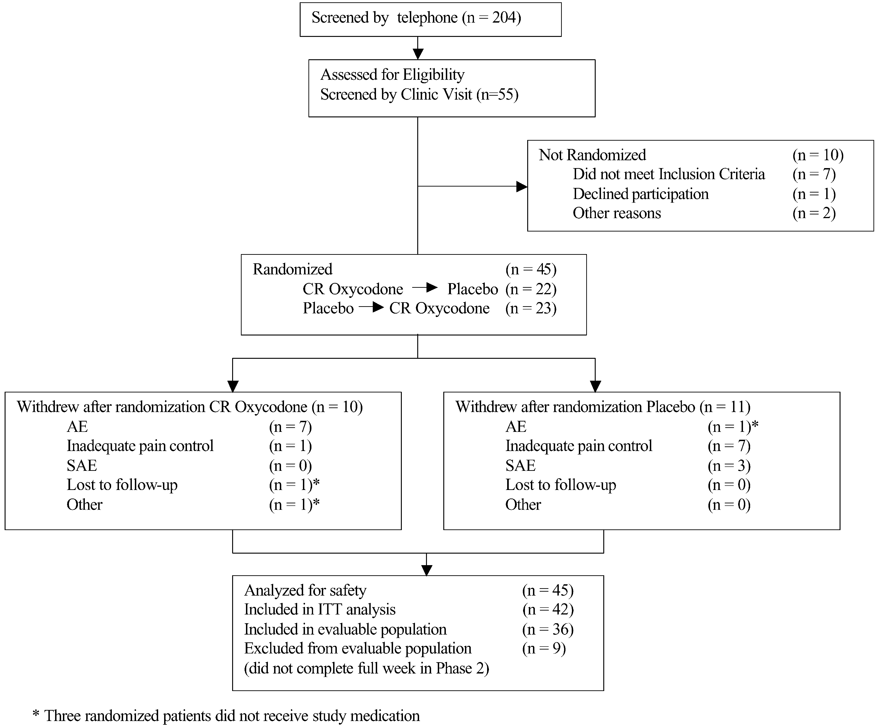

Fig. 1. Profile of the randomized crossover trial.

Primary outcome measures for the ITT patient popu- lation also showed pain intensity VAS scores (26.3 ^ 24.7 vs. 46.7 ^ 26.9, P ¼ 0:0001), categorical (1.3 ^ 0.9 vs.
1.9 ^ 0.9, P ¼ 0:0001) and pain relief scores (1.8 ^ 1.4 vs.
2.7 ^ 1.2, P ¼ 0:0006) that were significantly better during CR oxycodone treatment than placebo treatment with no evidence of a sequence effect ðP ¼ 0:8171Þ. ITT population results were similar to the evaluable population for all other efficacy measurements.
All scores in the pain and sleep index were significantly better in the CR oxycodone phase compared to placebo except “needed sleeping medication to sleep” and “how often partner awakened”. The overall pain and sleep scores were significantly better for CR oxycodone compared to placebo ðP ¼ 0:0003Þ.
All variables in the PDI were significantly better in the
CR oxycodone phase with the exception of sexual behaviour, which showed no difference between the two treatments (Table 1).
For the SF-36, opioids made a positive difference in relation to most health-related QOL domains (Fig. 3).
Results were significantly better during the CR oxycodone treatment period than the placebo treatment period for the Physical Functioning ðP ¼ 0:0029Þ, Pain Index ðP ¼ 0:0001Þ, Vitality ðP ¼ 0:0005Þ, Social Functioning ðP ¼ 0:0369Þ and Mental Health Index ðP ¼ 0:0317Þ domains of the SF-36. Both the Standardized Physical Component ðP ¼ 0:0002Þ and the Standardized Mental Component ðP ¼ 0:0338Þ were significantly better during the CR oxycodone treatment period than the placebo treatment period.
The calculated NNT was 2.6 based on the number of patients with least moderate pain relief.
CR oxycodone was preferred by 88% of patients ðP ¼ 0:0001Þ and in 80% of the cases by the investigator ðP ¼ 0:0001Þ. Ninety-five percent of patients completing the study rated oxycodone as moderately or highly effective and 73% of patients indicated that they were satisfied with CR oxycodone.
At the end of the study, both patients and investigators were asked to guess in which phase CR oxycodone was administered. Eighty-eight percent of investigators and 88%

Table 1
Pain intensity, pain relief and PDI
 |  | Final Week and Treatment
 | Baseline | Placebo | CR oxycodone
Pain intensitya (VAS)  Pain intensitya (categorical) Pain reliefa (categorical) | 67.0 ^ 14.9  2.7 ^ 0.6  N/A | 48.6 ^ 26.6  2.0 ^ 0.8  2.8 ^ 1.1 | 21.8 ^ 20.7*  1.2 ^ 0.8*  1.7 ^ 1.3**
Pain and Disability Indicator
Family/home responsibilities | 4.64 ^ 2.42 | 3.8 ^ 2.7 | 2.5 ^ 2.5***
Recreation | 5.82 ^ 2.93 | 4.4 ^ 3.0 | 2.6 ^ 2.2***
Social activity | 4.44 ^ 2.76 | 3.5 ^ 2.7 | 2.3 ^ 2.7***
Occupation | 4.97 ^ 2.54 | 3.9 ^ 2.9 | 2.4 ^ 2.6**
Sexual behaviour | 4.96 ^ 3.57 | 4.5 ^ 3.9 | 3.4 ^ 3.8
Self-care | 2.75 ^ 2.31 | 2.5 ^ 2.5 | 1.7 ^ 1.8***
Life-support activity | 4.14 ^ 3.19 | 3.1 ^ 2.8 | 1.9 ^ 2.4***
Total pain and disability | 31.25 ^ 14.91 | 25.2 ^ 16.7 | 16.8 ^ 15.6***

*P ¼ 0:0001; **P # 0:0005; ***P # 0:05.
a Lower scores indicate less pain and better pain relief.
of patients correctly identified the active CR oxycodone phase ðP , 0:0001Þ.
Of the 34 evaluable patients having diary data from both phases, 15 did not receive any concomitant analgesic medication during the OxyContin and placebo treatment phases. The mean pain intensity scores (100 mm VAS) for these patients, during OxyContin and placebo treatments, were 19.7 ^ 16.6 and 45.7 ^ 25.8 ðP ¼ 0:0007Þ. For the 19 patients that did receive concomitant medication the corresponding scores were 23.6 ^ 23.7 and 50.8 ^ 27.5 ðP ¼ 0:0026Þ. Similar results were obtained for ordinal pain intensity and pain relief.

The incidence of adverse events was the same for both treatments (131 for CR oxycodone, 107 for placebo). Of these cases, seven patients withdrew while being treated with CR oxycodone and one patient withdrew while on placebo. Nausea, constipation, dizziness and sweating were all more frequent with CR oxycodone than placebo (Table 2).
Four patients experienced serious adverse events during the study. One patient suffered severe withdrawal symptoms during the washout period, a second patient had an angina attack, the third severe heartburn and vomiting and the fourth chest pain, shortness of breath and cold symptoms.

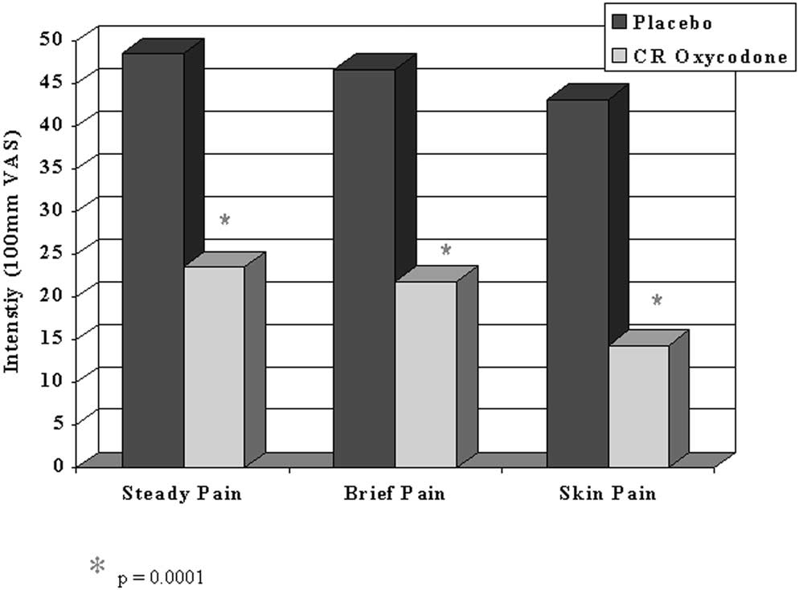

Fig. 2. Mean steady, brief and skin pain at the final week of each treatment.

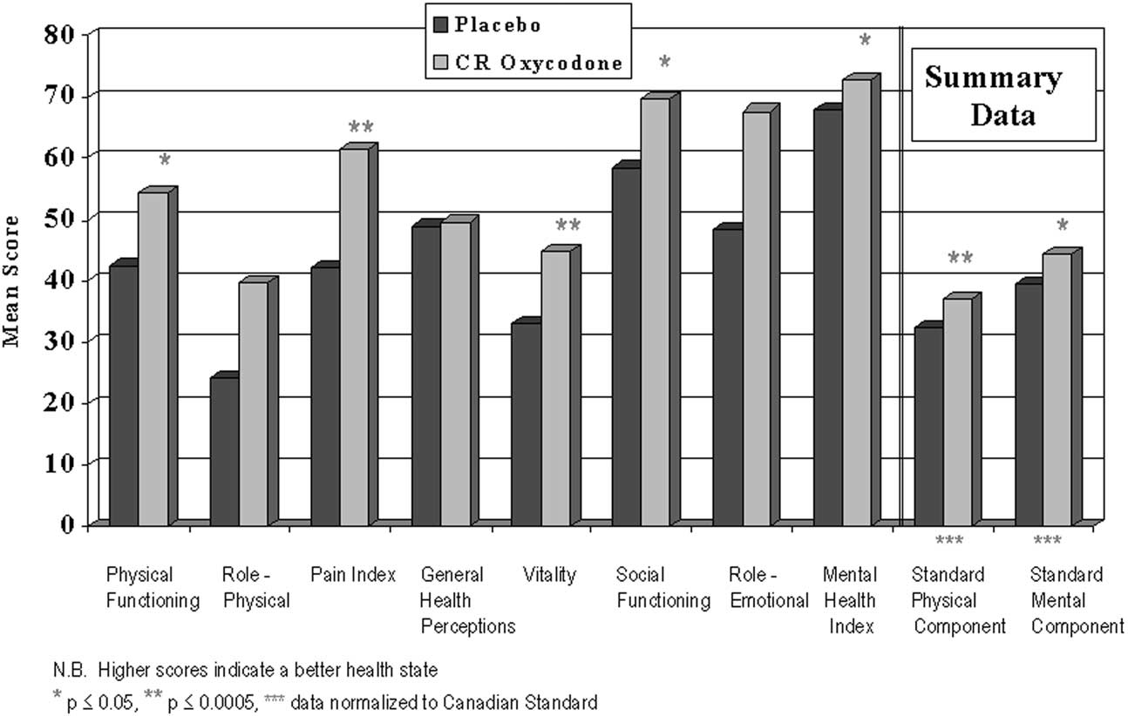

Fig. 3. SF-36 health survey at the Final Week of each Treatment.

The latter three serious adverse events occurred in patients while receiving benztropine.
Thirty patients began the open label CR oxycodone treatment, of whom 27 (90%) completed six months and 19 (63%) returned for the one year visit. Of the 11 patients that did not return for their one year assessments, five continued to receive CR oxycodone, three were lost to follow up, two
had mild pain and stopped therapy, and one patient stopped treatment due to an adverse reaction (abdominal pain). Four patients required a dose greater then 40 mg q12h, and all four were stabilized at 60 mg q12h or less throughout the open label phase.

- Discussion

Table 2
Incidence of Adverse Events Adverse Eventa

Number of Patientsb

CR Oxycodone Placebo P value

This is the first blinded randomized crossover trial of a major opioid analgesic in the management of PDN (Watson et al., 2001). In this RCT, CR oxycodone has demonstrated superior pain relief and an improvement in QOL.
According to Farrar et al. (2001) a change in pain scores

Nausea 16 (6) 8 (1) 0.09
Somnolence 9 (2) 11 (3) 0.56
Constipation 13 (3) 4 (0) 0.02
Dry mouth 3 (1) 12 (4) 0.02
Diarrhea 4 (4) 6 (3) 0.53
Dizziness 7 (4) 3 (0) 0.16
Headache 5 (3) 3 (1) 0.32
Asthenia 2 (1) 5 (1) 0.26
Vomiting 5 (1) 2 (2) 0.26
Insomnia 3 (0) 4 (1) 0.71
Pruritus 4 (2) 1 (0) 0.180
Sweating 4 (3) 1 (1) 0.18
Total of all adverse events 35 (22) 33 (14) 0.56
a Events experienced by five or more patients.
b Number rated as severe appears in brackets.
of 30% is clinically meaningful and other more conservative reports cite a 50% change in pain score as a meaningful improvement (Moore et al., 1996). The 67.5% decrease in VAS pain scores from baseline to last week of treatment with CR oxycodone reported in this study indicates that the response is clinically meaningful when compared to a 28% decrease in pain scores from baseline to last week of treatment with an active placebo.
An important aspect of this study is that the opioid, oxycodone, improved health-related QOL for patients with the neuropathic pain disorder of PDN. Measurement of the psychological and social well-being in these patients showed favourable outcomes for all domains of the SF-36

with the exception of role limitations (physical and emo- tional) and general health perceptions. Results of the PDI also indicate significantly less disability in all areas, with the exception of sexual behaviour, during treatment with CR oxycodone. These data do not support Arner’s conclusions that long-term opioid treatment would reduce the QOL in neuropathic pain patients because of side effects (Arner, 2000). The majority of patients (88%) stated a preference for and were satisfied with CR oxycodone.
Since there are few head-to-head comparisons of opioids with other treatments, the NNT for at least 50% pain relief was calculated as a basis of comparison with the efficacy of other treatments. The NNT from trials in patients with PDN has been reported as 3.5 for tricyclic antidepressants and 2.7 for anticonvulsants (Collins et al., 2000). The NNT for anticonvulsants in PDN is based on results from three studies: 2.3 for carbamazepine (Rull et al., 1969), 2.1 for phenytoin (Chadda and Mathur, 1978), and 3.8 for gabapentin (Backonja et al., 1998). The effectiveness of phenytoin reported by Chadda and Mathur (1978) was not supported by a second study by Saudek et al. (1977). The NNT calculated for CR oxycodone in this study was 2.6 which was very similar to the NNT (2.5) calculated in our previous study of CR oxycodone in PHN (Watson and Babul, 1998).
In contrast to the clinical trial of gabapentin in PDN (Backonja et al., 1998), stable doses of concomitant anti- depressants, anticonvulsants, or other non-opioid anal- gesics, taken prior to this crossover study, were continued in both treatment phases. Patients responded equally well to treatment with CR oxycodone with or without background concomitant antidepressants, anticonvulsants or other analgesics. This further supports a high level of opioid responsiveness for neuropathic pain.
A recent placebo-controlled study of gabapentin in PHN patients resulted in significant improvement in pain control and some QOL measures (Rice and Maton, 2001). However, the study indicated no dose response and reported only about 30% of patients having 50% or more reduction in mean pain scores between baseline and end of treatment, with a calculated NNT of 5.0. Improvement was shown in only three of the eight domains for the SF-36. Somewhat better results were found in a study by Rowbotham et al. (1988) who reported an NNT of 3.2, also using gabapentin in PHN patients. In another study by Harati et al. (1998) in PDN patients that received tramadol, the calculated NNT was 3.1. Overall, these results suggest a responsiveness of neuropathic pain to CR oxycodone that is equal or greater than that to gabapentin or tramadol.
The long-term efficacy and tolerability of CR oxycodone was demonstrated in the open label extension. The majority of the patients who started open label CR oxycodone therapy, continued to benefit from the medication for 6 and 12 months.
In this study, benztropine was employed to preserve blinding by mimicking opioid-related side effects such as

somnolence, nausea, constipation and dry mouth. Since patients experienced a clinically significant greater degree of pain relief on CR oxycodone, and the study design was a within-patient comparison, it is not surprising that both patients and investigators were able to correctly guess the active treatment phase. It is important to note that con- cealment of treatment allocation was maintained throughout the study. This is considered to be more important in pre- venting bias than patients’ ability to correctly guess treat- ment assignment, based on superior efficacy of the active treatment (Schulz, 2002).
In conclusion, the results of this trial in patients with PDN corroborate our previous study (Watson and Babul, 1998) demonstrating that CR oxycodone provides clinically meaningful relief of pain and improves QOL in patients with these neuropathic pain disorders.

Acknowledgements

This study was supported by a research grant from Purdue Pharma.

References

American Diabetes Association and the American Academy of Neurology. Report and recommendations of the San Antonio Conference on Diabetic Neuropathy. Diabetes Care 1988;11:592 – 7.
Arner S. Opioids and long-lasting pain conditions: 25-year perspective on mechanism-based treatment strategies. Pain Rev 2000;7:81 – 96.
Backonja M, Beydoun A, Edwards KR, Schwartz SL, Fonseca V, Hes M, La Moreaux L, Garofalo E. Gabapentin for the symptomatic treatment of painful neuropathy in patients with diabetes mellitus: a randomized controlled trial. J Am Med Assoc 1998;280:1831 – 6.
Calissi PT, Jaber LA. Peripheral diabetic neuropathy: current concepts in treatment. Ann Pharmacother 1995;29:769 – 77.
Chadda VS, Mathur MS. Double blind study of the effects of
diphenylhydantoin sodium on diabetic neuropathy. J Assoc Physicians India 1978;26:403 – 6.
Cherny NI, Thaler HT, Friedlander-Klar H, Lapin J, Foley KM, Houde R,
Portenoy RK. Opioid responsiveness of cancer pain syndromes caused by neuropathic pain or nociceptive mechanisms: a combined analysis of controlled single-dose studies. Neurology 1994;44:857 – 61.
Clark CM, Lee DA. Prevention and treatment of the complications of diabetes mellitus. N Engl J Med 1995;332:1210 – 7.
Collins SL, Moore RA, McQuay HJ, Wiffen P. Antidepressants and
anticonvulsants for diabetic neuropathy and postherpetic neuralgia: a quantitative systemic review. J Pain Symptom Manage 2000;20: 449 – 58.
Cook RJ, Sackett DL. The number needed to treat: a clinically useful measure of treatment effect. Br Med J 1995;310:452– 4.
Dellemijn PL, van Duijn H, Vanneste JA. Prolonged treatment with
transdermal fentanyl in neuropathic pain. J Pain Symptom Manage 1998;16:220 – 9.
Dyck PJ. Resolvable problems in diabetic neuropathy. J NIH Res 1990;2:
57 – 62.
Farrar JT, Young Jr JP, LaMoreaux L, Werth JL, Poole RM. Clinical importance of changes in changes in chronic pain intensity measured on an 11-point numerical pain rating scale. Pain 2001;94:149 – 58.

Greene D, Stevens M. Diabetic peripheral neuropathy: new approaches to treatment, classification, and staging. Diabetes Spectrum 1993;6: 223 – 57.
Hagen NA, Babul N. Comparative clinical efficacy and safety of a novel controlled-release oxycodone formulation and controlled-release hydromorphone in the treatment of cancer pain. Cancer 1997;79: 1428 – 37.
Harati Y, Gooch C, Swenson M, Edelman S, Greene D, Raskin P, Donofrio P, Cornblath D, Sachdeo R, Siu CO, Kamin M. Double-blind randomized trial of tramadol for the treatment of the pain of diabetic neuropathy. Neurology 1998;50:1842 – 6.
Hopman WM, Towheed T, Anastassiades T, Tenenhouse A, Poliquin S, Berger C, et al. Canadian normative data for the SF-36 health survey. Multicentre Osteoporosis Study Research Group. Can Med Assoc J 2000;163:265– 71.
Kvinesdal B, Molin J, Frøland A, Gram LF. Imipramine treatment in painful diabetic neuropathy. J Am Med Assoc 1984;251:1727 – 30.
Max MB, Culnane M, Schafer SC, Gracely RH, Walther DJ, Smoller B, Dubner R. Amitriptyline relieves diabetic neuropathy pain in patients with normal or depressed mood. Neurology 1987;37:589 – 96.
Max MB, Kishore-Kumar R, Schafer SC, Meister B, Gracely RH, Smoller B, Dubner R. Efficacy of desipramine in painful diabetic neuropathy: a placebo controlled trial. Pain 1991;45:3 – 9.
Max MB, Lynch SA, Muir J, Shoaf SE, Smoller B, Dubner R. Effects of
desipramine, amitriptyline, and fluoxetine on pain in diabetic neuro- pathy. N Engl J Med 1992;326:1250 – 6.
McHorney CA, Ware Jr JE, Lu RJ, Sherbourne CD. The MOS 36-item Short-Form Health Survey (SF-36): III Tests of data quality, scaling assumptions, and reliability across diverse patient groups. Med Care 1994;32:40 – 66.
McQuay HJ, Tramer M, Nye BA, Carroll D, Wiffen PJ, Moore RA. A systematic review of antidepressants in neuropathic pain. Pain 1996;68: 217 – 27.
Moore A, McQuay H, Gavaghan D. Deriving dichotomous outcome measures from continuous data in randomised controlled trials of analgesics. Pain 1996;66:229 – 37.
Pappagallo M, Campbell JN. Chronic opioid therapy as alternative treatment for postherpetic neuralgia. Ann Neurol 1994;35(Suppl): S54 – 6.
Peloso PM, Bellamy N, Bensen W, Thomson GT, Harsanyi Z, Babul N, Darke AC. Double blind randomised placebo control trial of controlled release codeine in the treatment of osteoarthritis of the hip or knee. J Rheumatol 2000;27:764 – 71.
Portenoy RK, Coyle N. Controversies in the long-term management of analgesic therapy in patients with advanced cancer. J Pain Symptom Manage 1990;5:307 – 19.
Porter J, Jick H. Addiction rare in patients treated with narcotics. N Engl J Med 1980;302:123.
Rice AS, Maton S, Postherpetic Neuralgia Study Group. Gabapentin in postherpetic neuralgia: a randomised, double-blind, placebo controlled study. Pain 2001;94:215 – 24.
Roth SH, Fleischmann RM, Burch FX, Dietz F, Bockow B, Rapoport RJ, Rutstein J, Lacouture PG. Around-the clock, controlled-release oxycodone therapy for osteoarthritis-related pain: placebo-controlled trial and long-term evaluation. Arch Intern Med 2000;160:853– 60.
Rowbotham MC, Reisner-Keller LA, Fields HL. Both intravenous lidocaine and morphine reduce pain of postherpetic neuralgia. Neurology 1991;41:102 – 28.
Rowbotham M, Harden N, Stacey B, Berstein P, Magnus-Miller L.
Gabapentin for the treatment of postherpetic neuralgia: a randomized controlled trial. J Am Med Assoc 1998;280:1837 – 42.
Rull JA, Quibrera R, Gonzalez-Millan H, Lozano Castaneda O. Sympto- matic treatment of peripheral diabetic neuropathy with carbamazepine (Tegretol): double-blind crossover trial. Diabetologia 1969;5:215 – 8.
Saudek CD, Werns S, Reidenberg MM. Phenytoin in the treatment of diabetic symmetrical polyneuropathy. Clin Pharmacol Ther 1977;22: 196 – 9.
Schulz KF. The landscape and lexicon of blinding in randomized trials.
American College of Physicians– American Society of Internal Medicine. Ann Intern Med 2002;136(3):254 – 9.
Sindrup SH, Jensen TS. Efficacy of pharmacological treatments of neuropathic pain: an update and effect related to mechanism of drug
action. Pain 1999;83:389 – 400.
Sindrup SH, Ejlertsen B, Frøland A, Sindrup EH, Brosen K, Gram LF. Imipramine treatment in diabetic neuropathy: relief of subjective symptoms without changes in peripheral and autonomic nerve function. Eur J Clin Pharmacol 1989;37:151 – 3.
Sindrup SH, Anderson G, Madsen C, Smith T, Brasen K, Jensen TS. Tramadol relieves pain and allodynia in polyneuropathy: a randomized, double-blind controlled trial. Pain 1999;83:85 – 90.
Tait RC, Pollard CA, Margolis RB, Duckro PN, Krause SJ. The Pain Disability Index: psychometric and validity data. Arch Phys Med Rehabil 1987;68:438 – 41.
Vinik A, Holland MT, Le Beau JM, Liuzzi FJ, Stansberry KB, Colen LB.
Diabetic neuropathies. Diabetes Care 1992;15:1926 – 75.
Watson CP, Babul N. Efficacy of oxycodone in neuropathic pain: a randomized trial in postherpetic neuralgia. Neurology 1998;50: 1837 – 41.
Watson CP, Watt-Watson JH. Treatment of neuropathic pain: focus on
antidepressants, opioids and gabapentin. Pain Res Manag 1999;4: 168 – 78.
Watson CPN, Moulin D, Gordon A, Watt-Watson J, Eisenhoffer J, Quigley P, Harsany Z, Darke A. A randomised, double-blind, crossover
comparison of the efficacy and safety of oral controlled-release oxycodone and active placebo in patients with painful diabetic neuropathy [abstract]. Pain 2001;2(Suppl 1):43.
Wilton TD. Tegretol in the treatment of diabetic neuropathy. S Afr Med J
1974;48:869 – 72.
Young RJ, Ewing DJ, Clarke BF. Chronic and remitting painful diabetic polyneuropathy: correlations with clinical features and subsequent changes in neurophysiology. Diabetes Care 1988;11:34 – 40.

